|  |
| --- |
|  |
| Capstone Project Document |

**Carrier Trading Center**

Report #1 – Project Introduction

|  |  |  |
| --- | --- | --- |
| **Carrier Trading Center** | | |
| **Group Members** | Lê Văn Dương | SE03290 |
| Vũ Văn Quyết | SE03344 |
| Đặng Lê Tuấn | SE03807 |
| Trịnh Đình Quyết | SE03159 |
| Lê Gia Hoàng | SE03200 |
| **Supervisor** | Mr. Nguyễn Văn Sang | |
| **Project code** | CTC | |

**- Hanoi, 01/2017-**

SIGNATURE PAGE

AUTHOR: Trịnh Đình Quyết 10/01/2017

Team member

REVIEWERS: Lê Văn Dương 11/01/2017

Project manager

APPROVAL: Nguyễn Văn Sang --/--/2017

Supervisor

**Record of change**

*A - Added M - Modified D – Deleted

|  |  |  |  |  |  |
| --- | --- | --- | --- | --- | --- |
| Effective Date | Changed Item | A,M,D | Change Description | Reason for Change | Rev. Number |
| 10/01/2017 | Create Introduction | A | Create Introduction | First version | 1.0 |
|  |  |  |  |  |  |
|  |  |  |  |  |  |
|  |  |  |  |  |  |
|  |  |  |  |  |  |
|  |  |  |  |  |  |
|  |  |  |  |  |  |
|  |  |  |  |  |  |
|  |  |  |  |  |  |
|  |  |  |  |  |  |
|  |  |  |  |  |  |
|  |  |  |  |  |  |
|  |  |  |  |  |  |
|  |  |  |  |  |  |
|  |  |  |  |  |  |
|  |  |  |  |  |  |
|  |  |  |  |  |  |
|  |  |  |  |  |  |
|  |  |  |  |  |  |
|  |  |  |  |  |  |
|  |  |  |  |  |  |
|  |  |  |  |  |  |
|  |  |  |  |  |  |
|  |  |  |  |  |  |

Table Contents

1 INTRODUCTION 5

1.1 INTRODUCTION 7

1.1.1 Purpose 7

1.1.2 Acronyms and Definitions 7

1.2 ABSTRACT 7

1.3 LITERATURE REVIEW 7

1.4 PROPOSAL 8

1.4.1 The idea 8

1.4.2 Objectives 8

1.4.3 Brief description about system 9

1.4.4 System features 9

1.5 BENEFIT FROM PROJECT 12

1.5.1 For our group 12

1.5.2 For Community 13

1.6 CRITICAL ASSUMPTION AND CONSTRAINTS 13

1.7 POTENTIAL RISKS 13

1.8 REFERENCES 13

2 PROJECT PLAN 13

2.1 INTRODUCTION 13

2.1.1 Purpose 13

2.1.2 Definitions and Acronyms 14

2.2 PROJECT OVERVIEW 14

2.2.1 Project description 14

2.2.2 Scope 14

2.2.3 Standard objectives 16

2.2.4 Milestones and deliverables 16

2.3 PPROJECT ORGANIZATION 17

2.3.1 Software Process Model 17

2.3.2 Roles and Responsibilities 20

2.3.3 Organization Structure 20

2.3.4 Project Team Member 20

2.4 TOOLS AND INFRASTRUCTURES 21

2.4.1 Tool and Techniques 21

2.4.2 Hardware requirement 21

2.4.3 Software requirements 21

2.5 SCHEDULE 22

2.5.1 Detailed schedule 22

2.5.2 Meeting Minutes 23

2.5.3 Communication Plan 23

2.6 RISK MANAGEMENT PLAN 24

2.7 EFFORT ESTIMATION 25

2.8 CODING CONVENTION 25

3 SOFTWARE REQUIREMENT SPECIFICATION 25

3.1 INTRODUCTION 25

3.1.1 Purpose 25

3.1.2 Definitions and Acronyms 25

3.1.3 System Purpose 26

3.2 OVERALL DESCRIPTION 26

3.2.1 System overview 26

3.2.2 Product Features 27

3.2.3 Entity Relation Model 29

3.3 FUNCTIONAL SPECIFICATION 34

3.3.1 Business Rules 34

3.3.2 Use Cases 36

3.4 NON-FUNCTIONAL SPECIFICATION 128

3.4.1 Reliability 128

3.4.2 Performance Requirements 128

4 SOFTWARE DESIGN DOCUMENT 129

4.1 ARCHITECTURE DESIGN 130

4.1.1 Choice of Architecture Design 130

4.1.2 Architectural Presentation 135

4.1.3 Package Design 136

4.2 DETAILED DESIGN 136

4.2.1 Common Class Description 136

4.2.2 Class Detail Design 188

4.3 DATABASE DESIGN 331

4.3.1 Database Diagram 331

4.3.2 Table Descriptions 331

4.4 SIGNATURE PAGE 339

5 SOFTWARE TEST DOCUMENT 342

5.1 INTRODUCTION 343

5.1.1 Purpose 343

5.1.2 System overview 343

5.2 TEST PLAN 346

5.3 Scope of testing 346

5.3.1 Requirement for testing 346

5.3.2 Test strategy 348

5.4 TEST CASE 352

5.5 CHECK LIST 0

5.5.1 Checklists about general 0

5.5.2 Checklists for user interface testing 0

5.6 TEST LOGS 2

5.6.1 Defect log 2

5.6.2 Test report 2

6 USER’S GUIDE 4

6.1 1 INTRODUCTION 4

6.1.1 Environment 4

6.1.2 Deployment Guide 4

6.2 USER’S GUIDE 22

6.2.1 Guest 22

6.2.2 Goods Owner 28

6.2.3 Carrier 45

6.2.4 Admin 62

6.3 PROJECT RESULT REPORT 89

6.3.1 Product Judging 89

6.3.2 Project Summary 90

6.3.3 Lessons Learnt 91

# INTRODCTION

## Introduction

### Purpose

This document is created as the introduction for project Carrier Trading Center – our Capstone Project at FPT University. In this document, we will describe the overview of some existing systems, the initial idea for our project, a brief description about our expected system and some potential risks, critical assumptions, constrains. Moreover, this document also shows opportunities that it offers to users.

### Acronyms and Definitions

|  |  |
| --- | --- |
| **Acronym & Abbreviation** | **Definition** |
| CTC | Carrier Trading Center |
| FPTU | FPT University |
| Q&A | Question and Answer |
| Goods Owner | Everyone who has account and accessed into Carrier Trading Center Website to register bill of lading. |
| Carrier | Everyone who has account and accessed into Carrier Trading Center Website to auction bill of lading. |
| Guest | Everyone who does not have account and accessed into the websites. |
| Administrator | A person who has the highest permission level and is responsible for managing the website |

**Table 1.1-1:** **Definitions and Acronyms**

## Abstract

In fact, in nowadays, when the business of carriage, with two-ways carriage especially, there is a high rate of empty trucks on return; it leads to low economic efficiency. Therefore, we create this software to resolve the problem. Our software which supports driver participates in an auction to transport cargo. Someone who interested in carriage will be served with the cheapest fee as possible and drivers will not return on the empty trucks. Our software is a transport trading floor on internet. The owner of goods can post their cargo, ceiling fee,.…on the trading floor and the drivers or transportation company can joint in the bidding. This is beneficial for both sides. We hope our software not only improve the economic efficiency but also the social life.

## Literature review

There are some applications or websites have worked about this subject. You can post an article to looking for transport service or searching someone who have demand on carriage. For example: <http://sanvanchuyen.vn/>

“Sanvanchuyen.vn” is a social networking website which connects the owner of goods and carrier.

* Advantages:
* User can post bill of lading very quickly.
* Finding partner easily.
* User can use system free.
* Carrier can auction bill of lading in system
* Disadvantages:
* There is no reliable verified information
* It is difficult to auction.

**Sanvanchuyen.vn**

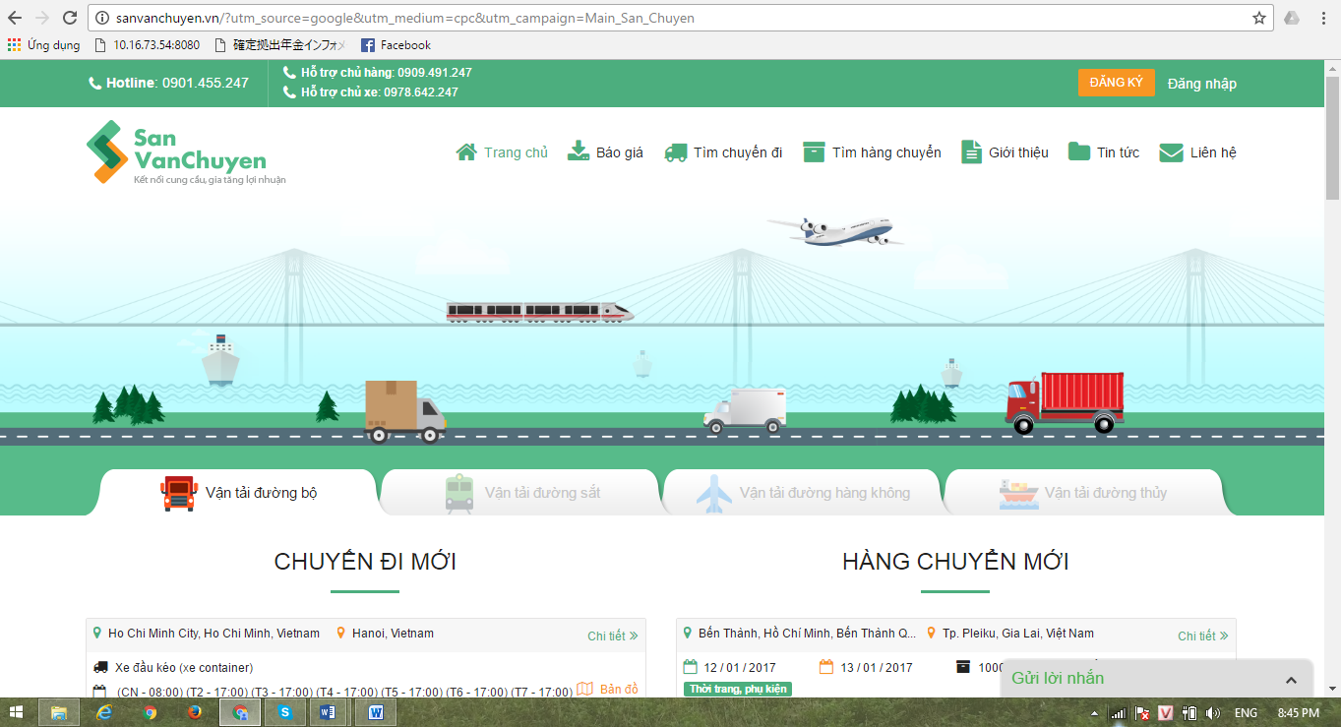

Figure 1.3‑1: Website sanvanchuyen

## Proposal

### The idea

Today there are many who need freight but are not know how to transport as well as being subject to a relatively high fee for it. Not only this will make them just only don’t want to using carriage anymore, it will also make the fee of the carriage will higher due to shortage of customers. It’s a dilemma. Our projects - Carrier Trading Center born to addressing these issues. Help people get higher economic profit.

### Objectives

This project is the Capstone Project in FPT University studying program.

First, this project is responsibility for all team members. We must complete all requirements from teacher and FU. During the time doing project, we can learn how to develop a project, how to manage project, how to communicate better between team member, how to control time, how to perform teamwork effectively. Moreover, we also have experience in Java technology, website designing, software testing. Therefore, we think this project is very necessary for us to improve skills, knowledge which we studied in FU. This project also makes our CV more beautiful after graduating from FU. This is also an opportunity for us to prove our abilities with recruiters.

We want to help people around us and we also want to improve the conditions of life. Also, if this project successfully, we will also contribute a bit on Vietnam’s carriage business, and help the trafficking issues in Vietnam gets better. Especially our website displayed entirely in Vietnamese. Vietnamese can use this website easier

### Brief description about system

This software is a major platform for crowdfunding with friendly and attractive interface, users can post their information goods to system to find carrier or carrier can find customer very easy. This greatly improves the economic productivity of the user.

CTC uses familiar technologies as: JSF, spring framework, Hibernate… And we are planning to develop a mobile version for easily connecting.

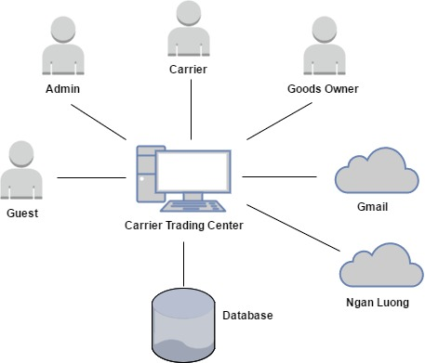

Figure 1.4‑1: Brief descriptions diagram of CTC system

### System features

About the features of CTC, we focus to provide for user main features as searching, filter project, create new project, return project, etc. Admin can manage members, manage projects, manage database, manage contribute database and manage Q&A.

In here, we focus on features which can help users can understand the best way what user want to have with features of CTC. There are the detailed features of CTC:

#### Client features

##### Guest features

* **Register:**
* Register a new account: guest can register a new account to become a new user to use CTC service.
* **List bill of lading:**
* Search bill of lading: guest can search bill of lading on CTC with key words
* View bill of lading list: guest can view bill of lading are auctioning on CTC.
* **Fee list:**
* View fee: guest can view fee list on CTC.
* Reference fee: guest can reference fee with actual fee system updated.

##### Goods owner features

* **List bill of lading:**
* View bill of lading list: goods owner can view bill of lading are auctioning on CTC.
* View bill of lading detail: goods owner can view bill of lading detail on CTC.
* Search bill of lading: goods owner can search bill of lading on CTC with key words.
* View carrier auction success: When bill of lading of goods owner is successful, they can view who got their bill of lading.
* Confirm complete transaction: when receiver received goods, goods owner had to confirm with system to get the arrange payment.
* Register a new bill of lading: when goods owner has goods for transport they can create a bill of lading to post on CTC to find carrier.
* Cancel bill of lading: when goods owner don’t want to send their goods, they can be using cancel function to remove their bill of lading.
* **Manage profile:**
* Edit profile: goods owner can edit their profile on system.
* View profile: goods owner can view their profile on system.
* Change password: goods owner can change their password for raise security.
* Forget password: when goods owner do not remember their password, they can send request to system to reset password.
* Add company: goods owner can add company’s information to their detail.
* **Manage report:**
* Send report: goods owner can send report to admin.
* Search report: goods owner can search report in their report list with title of report, time sent.
* View report list: goods owner can view their report on their report list.
* Cancel report: goods owner can cancel report if they want.
* **Fee list:**
* Reference fee: goods owner can view fee list on CTC.
* View fee list: goods owner can reference fee actual fee system updated.
* Account recharge: goods owner can recharge to their account for use CTC’s services.
* **Transaction history:**
* Transaction history: goods owner can check money in their account and check what did they do with their money.
* **Login:**
* User login: goods owner can login to CTC to use CTC’s service.
* **Logout:**
* User logout: goods owner can logout CTC.
* **Connect to carrier:**
* Connect to carrier: when goods owner is success on auction bill of lading, they can contact to carrier who got the auction and will carry their goods.

##### Carrier feature

* **List bill of lading**
* View bill of lading list: carrier can view bill of lading are auctioning on CTC.
* Confirm complete transaction: when receiver got goods, carrier have to confirm with system to get down payment.
* View bill of lading detail: carrier can view bill of lading detail on CTC
* Auction bill of lading: when carrier want to transport goods, they can find a bill of lading and then auction it.
* Search bill of lading: carrier can search bill of lading on CTC with key words.
* Cancel bill of lading: because some reason carrier cannot transport continue, they can be cancel bill of lading.
* **Manage profile:**
* Edit profile: carrier can edit their profile on system.
* View profile: carrier can view their profile on system.
* Change password: carrier can change their password for raise security.
* Forget password: carrier do not remember their password, they can send request to system to reset password.
* Add company: carrier can add company’s information to their detail.
* **Manage report:**
* Send report: carrier can send report to admin.
* Search report: carrier can search report in their report list with title of report, time sent.
* View report list: carrier can view their report on their report list.
* Cancel report: carrier can cancel report if they want.
* **Fee list:**
* Reference fee: carrier can view fee list on CTC.
* View fee list: carrier can reference fee actual fee system updated.
* **Account recharge:**
* Account recharge: carrier can recharge to their account for use CTC’s services.
* Transaction history: carrier can check money in their account and keep track what did they do with their money.
* **Login:**
* User login: carrier can login to CTC to use CTC’s service.
* **Logout:**
* User logout: carrier can logout CTC.
* **Connect to goods owner:**
* Connect to goods owner: when goods owner is success on auction bill of lading, they can connect to goods owner who have goods they carry.

#### Admin features

* **List bill of lading:**
* View bill of lading list: admin can view bill of lading are auctioning on CTC.
* View bill of lading detail: admin can view bill of lading detail on CTC.
* Search bill of lading: admin can search bill of lading on CTC with key words.
* View carrier auction success: When bill of lading of goods owner is successful, admin can view how are get their bill of lading.
* Summary all bill of lading: admin can summary all bill of lading.
* View carrier list who are auctioning: admin can view how many carrier are auctioning a bill of lading and who are auctioning bill of lading.
* **Manage user:**
* Search user: admin can search user with name of user, email address, province, role of user keyword.
* View user profile: admin can view user profile.
* Edit user profile: admin can edit user profile.
* Active user: admin can active user to allow this user can use CTC’s service.
* Deactivate user: admin can deactivate user to disallow user use CTC’s service.
* Add company: admin can add company’s information to user detail.
* Account recharge for user: admin can recharge directly to account of user.
* Edit company information: admin can edit user’s company’s information.
* **Fee list:**
* Reference fee: admin can view fee list on CTC.
* View fee list: admin can reference fee actual fee system updated.
* Add a new fee: admin can add a new fee to fee list on CTC.
* Edit fee list: admin can edit fee on fee list on CTC.
* View fee table history: admin can view history of fee table.
* Edit reference fee: admin can edit reference fee.
* **Manage report:**
* Send report: admin can response report to goods owner and carrier.
* Search report: admin can search report in their report list with title of report, time sent.
* View report list: admin can view their report on their report list.
* **Transaction history:**
* Transaction history: admin can check money in their account and keep track what did they do with their money.
* **Login:**
* User login: admin can login to CTC to use CTC’s service.
* **Logout:**
* User logout: admin can logout CTC.
* **Manage profile:**
* Edit profile: admin can edit their profile on system.
* View profile: admin can view their profile on system.
* Change password: admin can change their password for raise security.
* Forget password: admin do not remember their password, they can send request to system to reset password.

## Benefit from project

### For our group

After developing and implementing this project, our group will get some benefits:

* Have more experience for software project management on how to manage plan, time, members and risk.
* Have more knowledge and skill about JSF, spring framework, Hibernate.
* Know how to communicate with team members and how to teamwork more effective.

### For Community

Just need to have a device that connects to the internet and any web browser and personal information user can:

* Easy create a new transaction
* Easy join to Carrier Trading Center
* Easy search for detail transaction information
* Easy to auction new transaction

## Critical assumption and constraints

* Critical assumption:
* Human resources: Assume that all members in team have a good healthy to do their tasks.
* Constraints:
* Time and deadline: We must complete task on time. We work on 14 weeks, each member works 5 hours/day and 5 days/week. We do not have more time for us to complete developing and deliver application to teachers. Besides, we must submit report documents before deadline to teacher so teacher can have a final review.
* Quality: The products must be run well when users perform main functions in Google Chrome 40 and Firefox 30 or higher.
* Process: We have to follow the software processing of FPT Software
* Human resources: There are 5 members in our team, each member must study 3 subjects at school.

## Potential risks

After studying about this project, we find out some problem that we may be encountered:

* Underestimate scope and time or miss deadline because lack of experience in group working, managing and controlling work.
* Loss data, source code before uploading data to server because of careless.
* Equipment got broken because of careless or accident.
* Human resources: Team member cannot complete their works because of health reasons, key member leaves team or un-cooperating on team.
* Change requirements: Requirement changed when some functions cannot be completed or some technologies is not suitable.
* Some issues related to legislation.

## References

* **Sanvanchuyen: “San Van Chuyen”. Updated 19/02/2017.** <http://sanvanchuyen.vn/>
* **Trucking:** “Trucking”. Updated 19/02/2017. http://trucking.vn/

# PROJECT PLAN

## Introduction

### Purpose

This part is the project management plan of Carrier Trading Center (CTC) Project – our Capstone Project in FPT University. It is included the project overview, project organization, tools and infrastructures, schedule, risk management, quality management and some coding convention of this project

### Definitions and Acronyms

|  |  |  |
| --- | --- | --- |
| Acronym &  Abbreviation | Definition | Note |
| CTC | Carrier Trading Center |  |
| FU | FPT University |  |
| ERD | Entity Relationship Diagram |  |
| RUP | Rational Unified Process |  |
| SRS | Software Requirement Specification |  |
| SAD | Software Architecture Design |  |

**Table 2.1-1**: **Definitions and Acronyms**

## Project overview

### Project description

|  |  |  |  |
| --- | --- | --- | --- |
| Project Code | **CTC** | Contract Type | **None** |
| Customer | FPT University | 2nd Customer | None |
| Project Level | Group | Project Rank | None |
| Application Type | Website | Project Manager | Lê Văn Dương |
| Project Category | Development | Business Domain | E-commerce |

Table 2.2-1: Project Description

### Scope

|  |  |  |  |
| --- | --- | --- | --- |
| UC No. | Group Of Functions | Function | Glossary |
| **Guest** | | | |
| UC001 | **Register** | Register a new account |  |
| UC002 | **Bill of lading list** | Search bill of lading |  |
| UC003 | View bill of lading list |  |
| UC004 | **Fee list** | View fee |  |
| UC005 | Reference fee |  |
| **Admin** | | | |
| UC006 | **Bill of lading list** | View bill of lading detail |  |
| UC007 | Search bill of lading |  |
| UC008 | View bill of lading list |  |
| UC009 | View carrier auction success |  |
| UC010 | Summary all bill of lading |  |
| UC011 | View carrier list who are auctioning |  |
| UC012 | **Manage user** | Search user |  |
| UC013 | View user profile |  |
| UC014 | Edit user profile |  |
| UC015 | Add company |  |
| UC016 | Account recharge for user |  |
| UC017 | Active user |  |
| UC018 | Deactivate user |  |
| UC019 | Edit company information |  |
| UC020 | View user list |  |
| UC021 | **Fee list** | View fee list |  |
| UC022 | Add a new fee |  |
| UC023 | View fee table history |  |
| UC024 | Edit fee list |  |
| UC025 | Reference fee |  |
| UC026 | Edit reference fee |  |
| UC027 | **Transaction history** | Transaction History |  |
| UC028 | **Login** | Login |  |
| UC029 | **Logout** | Logout |  |
| UC030 | **Manage report** | Search report |  |
| UC031 | Response report |  |
| UC032 | View report list |  |
| UC033 | **Manage profile** | View profile |  |
| UC034 | Edit profile |  |
| UC035 | Forget password |  |
| UC036 | Change password |  |
| **Goods owner** | | | |
| UC037 | **Bill of lading list** | View bill of lading list |  |
| UC038 | View bill of lading detail |  |
| UC039 | Search bill of lading |  |
| UC040 | View carrier auction success |  |
| UC041 | Confirm complete transaction |  |
| UC042 | Post a new bill of lading |  |
| UC043 | Cancel bill of lading |  |
| UC044 | **Manage profile** | Edit profile |  |
| UC045 | View profile |  |
| UC046 | Change password |  |
| UC047 | Forget password |  |
| UC048 | Add company |  |
| UC049 | **Manage report** | Send report |  |
| UC050 | Search report |  |
| UC051 | Cancel report |  |
| UC052 | View report list |  |
| UC053 | **Fee list** | Reference fee |  |
| UC054 | View fee list |  |
| UC055 | **Account recharge** | Account recharge |  |
| UC056 | **Transaction history** | Transaction history |  |
| UC057 | **Login** | Login |  |
| UC058 | **Logout** | Logout |  |
| UC059 | **Connect to carrier** | Connect to carrier |  |
| **Carrier** | | | |
| UC060 | **Bill of lading list** | View bill of lading list |  |
| UC061 | Confirm complete transaction |  |
| UC062 | View bill of lading detail |  |
| UC063 | Auction bill of lading |  |
| UC064 | Search bill of lading |  |
| UC065 | Cancel bill of lading |  |
| UC066 | **Manage profile** | Edit profile |  |
| UC067 | View profile |  |
| UC068 | Change password |  |
| UC069 | Forget password |  |
| UC070 | Add company |  |
| UC071 | **Manage report** | View report list |  |
| UC072 | Search report |  |
| UC073 | Cancel report |  |
| UC074 | Send report |  |
| UC075 | **Fee list** | Reference fee |  |
| UC076 | View fee list |  |
| UC077 | **Transaction history** | Transaction history |  |
| UC078 | **Login** | Login |  |
| UC079 | **Logout** | Logout |  |
| UC080 | **Connect to goods owner** | Connect to goods owner |  |
| UC081 | **Account recharge** | Account recharge |  |

Table 2.2‑2: Scope of CTC

### Standard objectives

|  |  |  |  |  |
| --- | --- | --- | --- | --- |
| Metrics | Unit | Committed | Re-committed | Note |
| Start Date |  | 03/01/2017 |  |  |
| End Date |  | 19/04/2017 |  |  |
| Duration | Day | 105 |  |  |
| Team Size | Person | 5 |  |  |
| Billable Effort | Person-day | 520 |  |  |
| Calendar effort | Person-day | 520 |  |  |
| Effort Usage | % | 100 |  |  |

Table 2.2-3: Standard objectives

### Milestones and deliverables

|  |  |  |  |  |  |  |
| --- | --- | --- | --- | --- | --- | --- |
| No | Stage | Deliverable/ Milestone | Delivery Date | Inspect | Final | Delivery Location |
| 1 | Initiation | Deliver Report No.1 | 09/01/2017 |  |  | Supervisor |
| 3 | Initiation | Deliver Report No.2 | 16/01/2017 |  |  | Supervisor |
| 4 | Solution | Software  Requirement  Specification | 10/02/2017 |  |  | Supervisor |
| 5 | Solution | System  Architectural Design | 24/02/2017 |  |  | Supervisor |
| 6 | Construction | Complete Coding | 18/03/2017 |  |  | Supervisor |
| 7 | Construction | Deliver Report No.5 | 24/03/2017 |  |  | Supervisor |
| 8 | Construction | Deliver Report No.6 | 17/04/2017 |  |  | Supervisor |
| 9 | Termination | The last  Document and  CD source code | 19/04/2017 |  |  | FU |
| 10 | Termination | Project completed | 26/04/2017 |  |  | FU |

Figure 2.2‑4: Milestones and deliverables

## Project organization

### Software Process Model

#### FPT Software Process Model



Figure 2.3‑1: FPT Software process model

The software lifecycle is broken into *cycles*, each cycle working on a new generation of the product. The FPT Software process divides one development cycle in six consecutive *phases*:

1. Initiation phase
2. Definition phase
3. Solution phase
4. Construction phase
5. Transition
6. Termination

#### Project Life Cycle

Basing on FPT Software process and real-world project, we decided to divide the project into 4 phases: Initiation, Solution, Construction, and Termination:

* **Initiation Phase:** This is the explanatory phase of the project. Project objective and description is described at this stage. The purpose of this phase is to collect and understand business requirements, detail the project plan and agree upon a high level statement of work. Our primary objectives are complete project identification and project plan. After these are completed, the project is checked against the following criteria:
  + Identify business functions of the system
  + Determining the scope, conditions and limitations of the project
  + List the main functions of the system
  + List one or more suitable architecture for the system
  + Identify project risks
  + Complete Report #1, and Report #2
* **Solution Phase**: In this phase, the architecture of the system is designed. The goal is to translate requirements and specification into a technical solution to produce Technical Design.
  + Our *primary objectives* are completeRequirement Specification, Architecture Design and Database Design.
  + Finally, the plan must be provided (including estimates of cost and time) for the construction phase. The plan must ensure proper and accurate based on experience.
  + Complete Report #3 and Report #4
* **Construction Phase**: This is the longest phase of a project life cycle.
  + In this phase, all functions of the system will be installed. The installation will be divided into small stages, each stage of the installation a few functions. The results of each phase will be the release of the module function could be executed.
  + Construction and improvement of products until the final product is ready to deliver to the user. During this phase, all the components and other features of the application is developed and integrated into the product.
  + This phase emphasizes the resource management and control operations to optimize cost, time and quality.
  + Complete software packages and Report #5 and report #6
* **Termination Phase**: This is the final phase in the life cycle of a project.
  + Their products will be deployed to the client. The feedback received during the transfer process will be recorded and put on the new functional requirements or functionality enhancements in the next version of the product.
  + Phase transfer switch also includes the training system and the new system for the user.
  + Complete capstone project

### **roles and responsibilities**

Figure 2.3‑2: Roles and responsibilities

### Organization Structure

|  |  |
| --- | --- |
| **Role** | **Responsibility** |
| Project Manager | Planning, developing schedules, coordinating communication, generally responsible for keeping the team’s focus on the main goal. |
| Technical Leader | Responsible for choosing and deciding what technologies should be used, as well as for overseeing the work being done by other developers. |
| Quality Assurance Manager | Ensuring the product meets the certain standards of quality from requirements. |
| Test Leader | Responsible for test execution, including test set-up and test run, evaluation of test run and error recovery, defect logging and test results recording. |
| Developer | Involve coding the product and reviewing code of other developers. |
| Designer | Involve designing product’s user interface. |
| Tester | Involve testing the product. |

Table 2.3-1: Project Structure

### Project Team Member

|  |  |
| --- | --- |
| **Team Member** | **Role** |
| DuongLV | Project Manager, Developer |
| QuyetVV | Technical Leader, Developer |
| QuyetTD | Tester Leader / QA, Developer |
| HoangLG | Developer, Designer |
| TuanDL | Designer, Tester, Developer |

Table 2.3-2: Project Team Member

## Tools and infrastructures

### Tool and Techniques

|  |  |
| --- | --- |
| **Programming languages** | JavaScript, Java, Html |
| **Framework** | Java Server Face, Hibernate |
| **Software architecture** | Java Server Face |
| **Version control** | SVN |
| **IDEs/Editors** | Eclipse |
| **UML tools** | Astah Professional 7.0 |
| **Web server** | Apache Tomcat 7 |
| **DBMS** | MySQL |
| **Deployment server** | Apache Tomcat 7 |
| **Project management tool** | Microsoft Project 2010 |
| **Development process** | Rational Unified Process |

Table 2.3-3: Project Team Member

### Hardware requirement

- Personal computers for developing with the recommended configuration: 4GB of Ram DDR3, 100GB of hard disk SSD, Processor: 2.4GHz Intel Core i5

- A sever computers for testing with the Recommended configuration: 4GB of Ram DDR3, 100GB of hard disk SSD, Processor: 2.4GHz Intel Core i5

### Software requirements

- Operating system: Window 8.1, 10

- Web server: Apache Tomcat

- IDE: Eclipse

- DBMS: MySQL

- Soured control: Microsoft Project Plan

- Design Graphic: Adobe Photoshop 6

- Contact tool: Skype

- Architecture design: Astah

## Schedule

### Detailed schedule

Refers to “CTC_Project_Schedule_v1.0_EN” file.

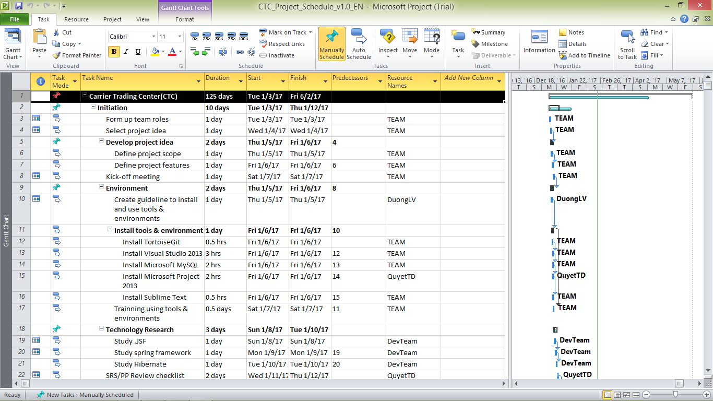

Figure 2.5‑1: CTC Project Management file

### Meeting Minutes

All meeting minutes will be written following this template:

| ***Meeting/Project Name:*** | *CTC* | | | |
| --- | --- | --- | --- | --- |
| ***Date of Meeting:*** |  | ***Time: (Type)*** | *hours (Face-to-face)* | |
| ***Meeting Called by:*** | *QuyetVV* | ***Location:*** | *FPT University‘s Library* | |
| ***Note Taker:*** | *QuyetTD* | ***Time Keeper:*** | *DuongLV* | |
| 1. Meeting Objective | | | | |
| * Choose names, ideas for project | | | | |
| 2. Attendance | | | | |
| ***Name*** | ***Roles*** | ***E-mail*** | | ***Phone*** |
| Lê Văn Dương | Project Manager | [DuongLVSE03190@fpt.edu.vn](mailto:DuongLVSE03190@fpt.edu.vn) | | 0166-977-5349 |
| Lê Gia Hoàng | Developer | [HoangLGSE03200@fpt.edu.vn](mailto:HoangLGSE03200@fpt.edu.vn) | | 0165-901-2428 |
| Đặng Lê Tuấn | Designer | [TuanDLSE03807@fpt.edu.vn](mailto:TuanDLSE03807@fpt.edu.vn) | | 0968-095-029 |
| Vũ Văn Quyết | Technical Leader | [QuyetVVSE03344@fpt.edu.vn](mailto:QuyetVVSE03344@fpt.edu.vn) | | 0972-381-151 |
| Trịnh Đình Quyết | Test Leader/QA | [QuyetTDSE03159@fpt.edu.vn](mailto:QuyetTDSE03159@fpt.edu.vn) | | 0964-657-385 |
| 3. Content | | | | |
|  | | | | |
| 4. Note | | | | |
|  | | | | |

Table 2.5-1: Meeting Minutes Template

### Communication Plan

*Weekly meeting schedule:* We use Iterative and Incremental Process Model, then we divide the system into two sub-systems (CTC services and CTC Front-end), each sub-system is divided into a bunch of small tasks. Each task is recorded to Trello then estimated depending on difficulty and the amount of work by the whole team, after that the Team Leader will assign the task to team members and depending on difficulty, the Technical Leader will assign deadlines for each task. We will have a meeting every Monday to inform to all team about what each member finished last week, the status (over-schedule, on time or behind-schedule), the issues met and how to solve them. If any member raises any issue, the whole team will help to find out a solution together. After that, the team will define detailed stories for next week tasks and estimate how long it takes to finish them.

*Daily discussing schedule*: Each sub-system has one development team with different schedule. Whenstarting work-day, each team will have a stand-up meeting to inform to others: “What did I do yesterday?”, “What will I do today?” and “Are there any impediments in my ways?”. By focusing on what each person accomplished yesterday and will accomplish today, the team gains an excellent understanding of what work has been done and what work remains.

*Unscheduled meeting*: If someone has an important problem that he wants to solve immediately, we will have a meeting for discussion, usually via some online channel: Facebook, Skype, or Phone.

## Risk management plan

|  |  |  |  |  |
| --- | --- | --- | --- | --- |
| **No** | **Description** | **Avoidance plan** | **Contigency plan** | **Status** |
| R1 | **Illness or absence of team members** | Member has to notice to the team about absence period and the plan of how to keep up with the work process. | Ensure that the absence of a member will not affect others and always have plans to deal with this problem. | Closed |
| R2 | **Business problem** | Any ideas are welcome but members have to discuss with others and always focus on the reality and possibility. | Make sure the business logic of any ideas is carefully analyzed. | Closed |
| R3 | **Change management overload** | A large number of change requests dramatically raises the complexity of the project and distracts key resources. | If there is a “must be changed” requirement, all team members must join the meeting to decide whether it should be implemented or not. | Closed |
| R4 | **Project team misunderstand requirements** | When the project team a gap misinterprets requirements develops between expectations, requirements and work packages. | Make sure any miscommunication has to be resolved. | Closed |
| R5 | **New technology** | Choosing technology based on member’s qualification. There are some issues canot resolve | When someone chooses a new technology, he/she has to explain to all team members about the decision. | Closed |

Table 2.6.1: Risk Management

*Communication channel*: Our main communication channel is Skype. On the other hand, we used face-to-face meeting, Email, Messenger. However, we sometimes make a phone call or instant message if someone has a problem.

## Effort estimation

|  |  |  |  |  |
| --- | --- | --- | --- | --- |
| Task name | Worst case (days) | Best case (days) | Most likely (days) | Expected case (days) |
| **Initiation** | **100** | **95** | **97** | **98** |
| **Solution** | **100** | **95** | **97** | **98** |
| **Construction** | **200** | **190** | **195** | **195** |
| **Termination** | **125** | **120** | **120** | **120** |
| Total | 525 | 500 | 509 | 511 |

Table 2.7‑1: Effort Estimation

## Coding convention

Reference to CTC_Coding_Convention_Oracle_EN

# SOFTWARE REQUIREMENT SPECIFICATION

## Introduction

### Purpose

This is chapter outlines functional and non-functional requirements of our website. It also provides some format constraints in common requirements and project success criteria. All members will work (design, code, test) based on the information provided in this chapter.

### Definitions and Acronyms

|  |  |  |
| --- | --- | --- |
| **Acronym** | **Definition** | **Note** |
| CTC | Carrier trading center |  |
| SRS | Software Requirements Specifications |  |
| Guest | CTC’s user who did not register |  |
| GWN | CTC’s user who registered and they are goods owner |  |
| CRE | CTC’s user who registered and they are carrier |  |
| Admin | Who manage CTC system |  |
| User | Who use CTC system |  |

Table 3.1-1: Definition and Acronyms

### System Purpose

Today we have a lot of ideas to make life better. With the development of information technology, it is easier to implement that idea. The CTC system creates a convenient auction environment where owners and owners can find each other easily and at the most affordable fees. CTC system helps to increase profit for customers and helps society develop better. The CTC system is for everyone, everyone can use CTC as a tool as long as they are following our rules.

## Overall description

### System overview

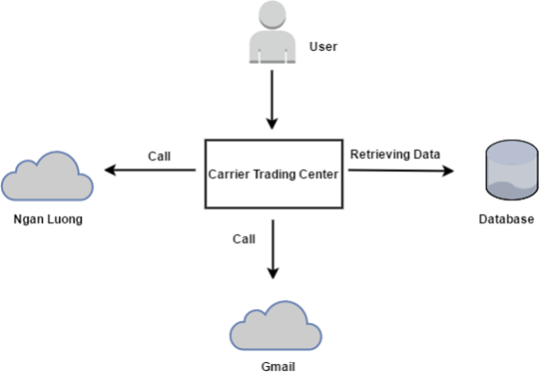

Figure 3.2‑1: System Overview

### Product Features

|  |  |  |  |
| --- | --- | --- | --- |
| UC No. | Group Of Functions | Function | Glossary |
| **Guest** | | | |
| UC001 | **Register** | Register a new account |  |
| UC002 | **Bill of lading list** | Search bill of lading |  |
| UC003 | View bill of lading list |  |
| UC004 | **Fee list** | View fee |  |
| UC005 | Reference fee |  |
| **Admin** | | | |
| UC006 | **Bill of lading list** | View bill of lading detail |  |
| UC007 | Search bill of lading |  |
| UC008 | View bill of lading list |  |
| UC009 | View carrier auction success |  |
| UC010 | Summary all bill of lading |  |
| UC011 | View carrier list who are auctioning |  |
| UC012 | **Manage user** | Search user |  |
| UC013 | View user profile |  |
| UC014 | Edit user profile |  |
| UC015 | Add company |  |
| UC016 | Account recharge for user |  |
| UC017 | Active user |  |
| UC018 | Deactivate user |  |
| UC019 | Edit company information |  |
| UC020 | View user list |  |
| UC021 | **Fee list** | View fee list |  |
| UC022 | Add a new fee |  |
| UC023 | View fee table history |  |
| UC024 | Edit fee list |  |
| UC025 | Reference fee |  |
| UC026 | Edit reference fee |  |
| UC027 | **Transaction history** | Transaction History |  |
| UC028 | **Login** | Login |  |
| UC029 | **Logout** | Logout |  |
| UC030 | **Manage report** | Search report |  |
| UC031 | Response report |  |
| UC032 | View report list |  |
| UC033 | **Manage profile** | View profile |  |
| UC034 | Edit profile |  |
| UC035 | Forget password |  |
| UC036 | Change password |  |
| **Goods owner** | | | |
| UC037 | **Bill of lading list** | View bill of lading list |  |
| UC038 | View bill of lading detail |  |
| UC039 | Search bill of lading |  |
| UC040 | View carrier auction success |  |
| UC041 | Confirm complete transaction |  |
| UC042 | Post a new bill of lading |  |
| UC043 | Cancel bill of lading |  |
| UC044 | **Manage profile** | Edit profile |  |
| UC045 | View profile |  |
| UC046 | Change password |  |
| UC047 | Forget password |  |
| UC048 | Add company |  |
| UC049 | **Manage report** | Send report |  |
| UC050 | Search report |  |
| UC051 | Cancel report |  |
| UC052 | View report list |  |
| UC053 | **Fee list** | Reference fee |  |
| UC054 | View fee list |  |
| UC055 | **Account recharge** | Account recharge |  |
| UC056 | **Transaction history** | Transaction history |  |
| UC057 | **Login** | Login |  |
| UC058 | **Logout** | Logout |  |
| UC059 | **Connect to carrier** | Connect to carrier |  |
| **Carrier** | | | |
| UC060 | **Bill of lading list** | View bill of lading list |  |
| UC061 | Confirm complete transaction |  |
| UC062 | View bill of lading detail |  |
| UC063 | Auction bill of lading |  |
| UC064 | Search bill of lading |  |
| UC065 | Cancel bill of lading |  |
| UC066 | **Manage profile** | Edit profile |  |
| UC067 | View profile |  |
| UC068 | Change password |  |
| UC069 | Forget password |  |
| UC070 | Add company |  |
| UC071 | **Manage report** | View report list |  |
| UC072 | Search report |  |
| UC073 | Cancel report |  |
| UC074 | Send report |  |
| UC075 | **Fee list** | Reference fee |  |
| UC076 | View fee list |  |
| UC077 | **Transaction history** | Transaction history |  |
| UC078 | **Login** | Login |  |
| UC079 | **Logout** | Logout |  |
| UC080 | **Connect to goods owner** | Connect to goods owner |  |
| UC081 | **Account recharge** | Account recharge |  |

Table 3.2-1: List of use case diagram

#### User Characteristics

The Carrier Trading Center's transport floor is aiming at everyone who wants to use the service. Just follow the rules and steps have been programmed. Those with goods wanting to be transported and those with vehicles wanting to transport goods and improve economic productivity.

Carrier Trading Center has 4 user groups:

* **Guest:** Everyone who does not have account and accessed into the websites.
* **Goods Owner:** Everyone who has account and accessed into Carrier Trading Center Website to register bill of lading.
* **Carrier:** Everyone who has account and accessed into Carrier Trading Center Website to auction bill of lading.
* **Administrator:** A person who has the highest permission level and is responsible for managing the website

#### User Documentation

|  |  |
| --- | --- |
| Name | Description |
| User Guide | Provide detailed explanation about the system, screens and guide users how to use all features of CTC. |

Table 3.2-2: User Documentation

#### Assumption

* Receive the guidance and good support of teacher.
* None of members got sick in the software development process.
* In the development process, no devices got failed.
* Every reports, tasks meets the deadline.
* Team members do not conflict in the work process.

### Entity Relation Model

#### Entity-Relationship Diagram

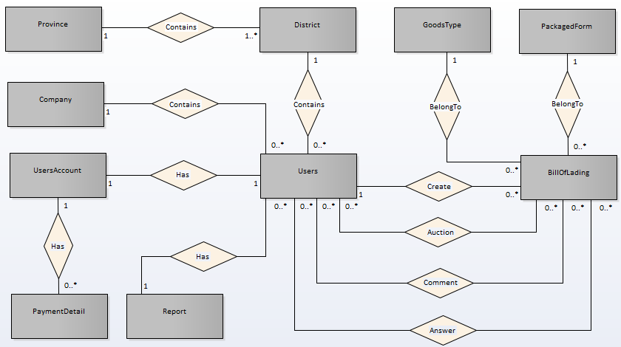

Figure 3.2‑2: Entity Relationship Diagram

#### Entity Detail

##### Table answer comment

|  |  |  |  |  |
| --- | --- | --- | --- | --- |
| NO. | Attribute | Type | Mandatory | Description |
| 1 | Content | Text | Yes | Content of comment |
| 2 | Created User | Text | Yes | Who create comment |
| 3 | Created | Text | NO | Create date |

Table 3.2‑3: table answer comment

##### Table bill of lading

|  |  |  |  |  |
| --- | --- | --- | --- | --- |
| NO | Attribute | Type | Mandatory | Description |
| 1 | Goods Image | Text | NO | Image of goods |
| 2 | Weight | Number | YES | Number of goods |
| 3 | Volume | Number | YES | Volume of goods |
| 4 | Quantity | Number | NO | Quality of goods |
| 5 | Length | Number | YES | Length of goods |
| 6 | Width | Number | YES | Width of goods |
| 7 | Height | Number | YES | Height of goods |
| 8 | Description | Text | NO | Goods description |
| 9 | Sender | Text | NO | Name of sender |
| 10 | Sender Phone Number | Text | NO | Phone number of sender |
| 11 | Departure Address | Text | YES | Departure Address |
| 12 | Departure Date | Text | YES | Departure Date |
| 13 | Receiver | Text | NO | Name of receiver |
| 14 | Receiver Phone Number | Text | NO | Phone number of receiver |
| 15 | Arrival Address | Text | NO | Address of arrival |
| 16 | Arrival Date | Text | YES | Date of arrival |
| 17 | Distance | Number | YES | Distance of receiver and sender |
| 18 | Fee | Number | Yes | Bid fee |
| 19 | Status | Number | Yes | Status of bill of lading |
| 20 | Created User | Text | NO | Name of user create bill of lading |
| 21 | Created | Text | Yes | Create date |
| 22 | Modified | Text | Yes | Date of modified |

Table 3.2‑4: Table bill of lading

##### Table carrierauction

|  |  |  |  |  |
| --- | --- | --- | --- | --- |
| NO | Attribute | Type | Mandatory | Description |
| 1 | Carrier | Text | NO | Who have account to carry goods |
| 2 | Auction Date | Text | YES | Date of auction |
| 3 | Modified | Text | NO | Date of modified |
| 4 | Auction Fee | Number | YES | Fee of auction carrier want to get |
| 5 | Status | Text | YES | Status of bill of lading |

Table 2‑5: Table carrier auction

##### Table comment

|  |  |  |  |  |
| --- | --- | --- | --- | --- |
| NO | Attribute | Type | Mandatory | Description |
| 1 | Content | Text | YES | Content of comment |
| 2 | Created User | Text | YES | Who create comment |
| 3 | Created | Text | YES | Create date |

Table 3.2‑6: Table comment

##### Table company

|  |  |  |  |  |
| --- | --- | --- | --- | --- |
| NO | Attribute | Type | Mandatory | Description |
| 1 | Name | Text | YES | Name of company |
| 2 | Tax Code | Text | YES | Tax code of company |
| 3 | Email | Text | YES | Email of company |
| 4 | Phone Number | Number | YES | Phone number of company |
| 5 | Fax | Text | NO | Fax of company |
| 6 | address | Text | YES | Address of company |

Table 2‑7: Table company

##### Table district

|  |  |  |  |  |
| --- | --- | --- | --- | --- |
| NO | Attribute | Type | Mandatory | Description |
| 1 | Name | Text | YES | Name of district |

Table 3.2‑8: Table district

##### Table goods type

|  |  |  |  |  |
| --- | --- | --- | --- | --- |
| NO | Attribute | Type | Mandatory | Description |
| 1 | Name | Text | YES | Name type of goods |
| 2 | Description | Text | NO | Description of goods type |
| 3 | Reference Fee | Number | NO | Reference fee of goods type |

Table 3.2‑9: Table goods type

##### Table operation fee

|  |  |  |  |  |
| --- | --- | --- | --- | --- |
| NO | Attribute | Type | Mandatory | Description |
| 1 | Fee Name | Text | YES | Name of fee |
| 2 | Fee | Number | NO | How much of fee |
| 3 | Description | Text | NO | Description of fee |

Table 3.2‑10: Table operation fee

##### Table packagedform

|  |  |  |  |  |
| --- | --- | --- | --- | --- |
| NO | Attribute | Type | Mandatory | Description |
| 1 | Name | Text | YES | Name of package form |
| 2 | Description | Text | NO | Description of package form |

**Table 3.2-11: Table package form**

##### Payment detail

|  |  |  |  |  |
| --- | --- | --- | --- | --- |
| NO | Attribute | Type | Mandatory | Description |
| 1 | Amounts | Text | YES | Amounts of payment |
| 2 | Payment Date | Text | NO | Date of payment |
| 3 | Description | Text | NO | Description of payment |
| 4 | Balance | float | NO | Account balance |

Table 3.2‑12: Table payment detail

##### Table province

|  |  |  |  |  |
| --- | --- | --- | --- | --- |
| NO | Attribute | Type | Mandatory | Description |
| 1 | Name | Text | YES | Name of province |

Table 3.2‑3: Table payment province

##### Table rport

|  |  |  |  |  |
| --- | --- | --- | --- | --- |
| NO | Attribute | Type | Mandatory | Description |
| 1 | Created User | Text | YES | Who create report |
| 2 | Report Date | Text | YES | Date of create report |
| 3 | Report Title | Text | YES | Title of report |
| 4 | Report Question | Text | NO | Question of report |
| 5 | Report Solution | Text | NO | Solution of report |
| 6 | Report Content | Text | NO | Content of report |
| 7 | Report Reply | Text | NO | Reply content of report |
| 8 | Status | Boolean | NO | Status of report |

Table 3.2‑14: Table payment report

##### Table users

|  |  |  |  |  |
| --- | --- | --- | --- | --- |
| NO | Attribute | Type | Mandatory | Description |
| 1 | Full Name | Text | YES | Name of user |
| 2 | Email | Text | YES | Email of user |
| 3 | Phone Number | Text | YES | Phone number of user |
| 4 | Address | Text | YES | Address of user |
| 5 | Identity Card Information | Text | YES | Identity card information of user |
| 6 | Role | Text | YES | Kind of user |
| 7 | Created | Text | YES | Date of create user |
| 8 | Company Information | Text | NO | Company information of user |

Table 3.2‑15: Table users

##### Table users account

|  |  |  |  |  |
| --- | --- | --- | --- | --- |
| NO | Attribute | Type | Mandatory | Description |
| 1 | Balance | Number | YES | Account balance |
| 2 | Modified | Text | YES | Date of modified |

Table 3.2‑16: Table user account

## Functional specification

### Business Rules

|  |  |
| --- | --- |
| **No** | **Description** |
| **B1** | The full name must be not empty |
| **B2** | The email address must not be empty |
| **B3** | The email must be valid. |
| **B4** | The phone number must be not empty |
| **B5** | The address must be not empty |
| **B6** | The province must be not empty |
| **B7** | The district must be not empty |
| **B8** | The identity card must be not empty |
| **B9** | The identity card place must be not empty |
| **B10** | The identity card date must be not empty |
| **B11** | The password must not be empty |
| **B12** | The password length must be in the range at least 8 character |
| **B13** | Check box kind of user (goods owner or carrier) must be not empty |
| **B14** | The auction is successfully |
| **B15** | The confirm password must be matched with the new password |
| **B16** | Receiver and sender must be not empty |
| **B17** | Received date must be not empty |
| **B18** | Send date must be not empty |
| **B19** | Receiver address and sender address must be not empty |
| **B20** | Auction end date must be not empty |
| **B21** | Proposed fee must be not empty |
| **B22** | The email when reset password must be registered before |
| **B23** | One phone number must use for only one account |
| **B24** | One identity card must use for only one account |
| **B25** | One email address must use for only one account |
| **B25** | There are only one kind of goods in a bill of lading |
| **B26** | Account balance more than 0 |
| **B27** | There is at least one user use CTC |
| **B28** | Name of cost must be not empty |
| **B29** | Code of cost must be not empty |
| **B30** | Kind of goods must be not empty |
| **B31** | Cost must be not empty |
| **B32** | Description must be not empty |
| **B33** | There is at least one bill of lading on CTC |
| **B34** | Bill of lading code must be not empty |
| **B35** | Kind of goods must be not empty |
| **B36** | Name of sender must be not empty |
| **B37** | Phone number must be not empty |
| **B38** | Receiver name must be not empty |
| **B39** | Receiver place must be not empty |
| **B40** | All district must be not empty |
| **B41** | All province must be not empty |
| **B42** | Destination must be not empty |
| **B43** | The place to go must be not empty |
| **B44** | Date sent must be not empty |
| **B45** | Date receive must be not empty |
| **B46** | Distance must be not empty |
| **B47** | weigh must be not empty |
| **B48** | number must be not empty |
| **B49** | size must be not empty |
| **B50** | End of auction date must be not empty |

Table 3.3‑1: Business rules

### Use Cases

|  |  |
| --- | --- |
| **Actor** | **Description** |
| Guest | Everyone who does not have account and accesses into the websites. |
| Carrier | Everyone who has account and accesses into Carrier Trading Center Website to auction bill of lading. |
| Goods Owner | Everyone who has account and accesses into Carrier Trading Center Website to register bill of lading. |
| Administrator | A person who has the highest permission level and is responsible for managing the website. |

Table 3.3‑2: Actor description

#### Guest Group Function

##### Register group function

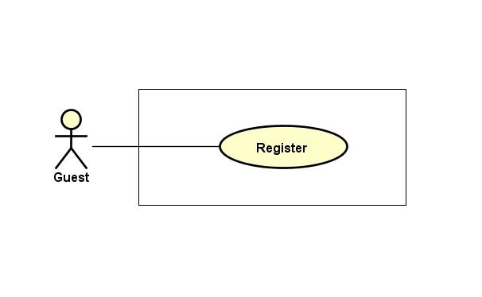

Figure 3.3‑1: Register

###### Register

|  |  |  |  |  |  |
| --- | --- | --- | --- | --- | --- |
| **Created by:** | | QuyetTD | | **Date Created:** | 08/03/2017 |
| **Primary Actor** | | Guest | | **Secondary Actor** |  |
| **Description:** | | Guest can create new account to use more function as an unregistered user | | | |
| **Preconditions:** | | The registration button appears on the home screen | | | |
| **Trigger:** | | “Đăng ký” button on the website is clicked | | | |
| **Post conditions:** | | 1. Add exactly account information to database 2. Logs user into system 3. Redirect user to Homepage and display as Member | | | |
| **Normal Flow** | | | | | |
| **Step** | **Actor** | | **Action** | | |
| 1 | Guest | | Click “Đăng ký” in header | | |
| 2 | CTC | | Display Register page includes:   * “Tên đầy đủ” input text * “Email” input text * “Số điện thoại” input text * “Địa chỉ” input text * “Tỉnh/Thành phố” input text * “Quận/Huyện” input text * “Chứng minh thư” input text * “Nơi cấp” input text * “Ngày cấp” date picker * “Chọn ảnh” file chooser * “Mật khẩu” input text * “Xác nhận mật khẩu” input text * “Loại ngườiduùng” check box * “Đăng ký” button | | |
| 3 | Guest | | Enters data in fields | | |
| 4 | Guest | | Click “Đăng ký” button | | |
| 5 | CTC | | Send confirm email, display message “Đăng ký thành công” on register page | | |
| 6 | Guest | | Confirm email | | |
| 7 | CTC | | Activate user account to system | | |
| **Alternative Flows:** | | | | | |
| **AT1** | At step 4 in the main flows, if guest click other hyperlinks or buttons | | | | |
| **Step** | **Actor** | | **Action** | | |
| 4.1 | CTC | | Redirects user to chosen hyperlink or button | | |
| **Exceptions:** | | | | | |
| **EC1** | At step 4, required fields are not entered | | | | |
| **Step** | **Actor** | **Action** | | | |
| 4.1 | CTC | Display Register page with message error | | | |
| 4.2 | CTC | Mark error fields | | | |
| **EC2** | At step 4, fields are entered with wrong type of data | | | | |
| **Step** | **Actor** | **Action** | | | |
| 4.1 | CTC | Display Register page with message error | | | |
| 4.2 | CTC | Mark error fields | | | |
|  | | | | | |
| **Priority** | | High | | | |
| **Frequency of Use:** | | High | | | |
| **Business Rules:** | | B1, B2, B3, B4, B5, B6, B7, B8, B9, B10, B11, B12, B13, 23, 24, 25 | | | |
| **Other Information:** | | N/A | | | |

##### Fee list group function

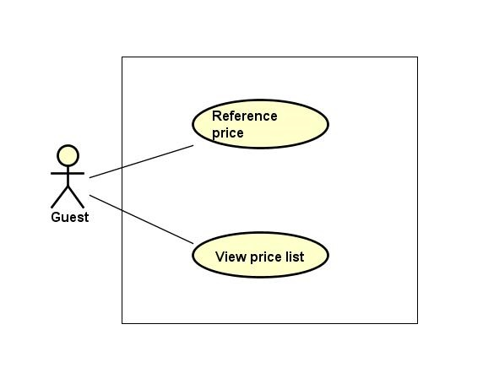

Figure 3.3‑2: Fee list group function

###### Reference fee list

|  |  |  |  |  |
| --- | --- | --- | --- | --- |
| **Created by:** | | QuyetTD | **Date Created:** | 08/03/2017 |
| **Primary Actor** | | Guest | **Secondary Actor** |  |
| **Description:** | | Guest want to reference actual fee system updated | | |
| **Preconditions:** | | 1. “Tham Chiếu” item appear on header of website 2. “BÁO GIÁ” navigator appear on header of website | | |
| **Trigger:** | | “Tham Chiếu” item is clicked | | |
| **Post conditions:** | | Display reference fee list | | |
| **Normal Flow** | | | | |
| **Step** | **Actor** | **Action** | | |
| 1 | Guest | Hover mouse to “BÁO GIÁ” navigator and Click “Tham chiếu” button | | |
| 2 | CTC | Display reference fee list | | |
| **Alternative Flows: N/A** | | | | |
| **Exceptions: N/A** | | | | |
| **Priority** | | Medium | | |
| **Frequency of Use:** | | Medium | | |
| **Business Rules:** | | N/A | | |
| **Other Information:** | | N/A | | |

Table 3‑4: Reference fee list

###### View fee list

|  |  |  |  |  |
| --- | --- | --- | --- | --- |
| **Created by:** | | QuyetTD | **Date Created:** | 08/03/2017 |
| **Primary Actor** | | Guest | **Secondary Actor** |  |
| **Description:** | | Guest want to view fee list | | |
| **Preconditions:** | | 1. “Hệ Thống” item appear on header of website 2. “BÁO GIÁ” navigator appear on header of website | | |
| **Trigger:** | | “Hệ Thống” item is clicked | | |
| **Post conditions:** | | Display fee list on this page | | |
| **Normal Flow** | | | | |
| **Step** | **Actor** | **Action** | | |
| 1 | User | Hover mouse to “Tham chiếu” navigator and click “Hệ Thống” on homepage | | |
| 2 | CTC | Display fee list | | |
| **Alternative Flows: N/A** | | | | |
| **Exceptions: N/A** | | | | |
| **Priority** | | High | | |
| **Frequency of Use:** | | High | | |
| **Business Rules:** | | N/A | | |
| **Other Information:** | | N/A | | |

##### Bill of lading list group function

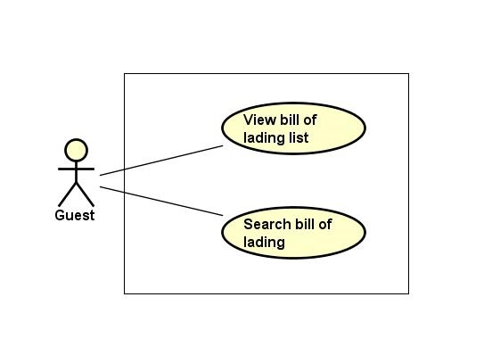

Figure 3.3‑3: Bill of lading list group function

###### View bill of lading list

|  |  |  |  |  |
| --- | --- | --- | --- | --- |
| **Created by:** | | QuyetTD | **Date Created:** | 08/03/2017 |
| **Primary Actor** | | Guest | **Secondary Actor** |  |
| **Description:** | | Guest want to view bill of lading list | | |
| **Preconditions:** | | “Tìm Hàng Chuyển” navigator appear header of website | | |
| **Trigger:** | | “Tìm Hàng Chuyển” navigator is cllicked | | |
| **Post conditions:** | | Display bill of lading list on common page | | |
| **Normal Flow** | | | | |
| **Step** | **Actor** | **Action** | | |
| 1 | Guest | Click on “Tìm Hàng Chuyển” navigator on the website | | |
| 2 | CTC | Display bill of lading list on common page | | |
| **Alternative Flows: N/A** | | | | |
| **Exceptions: N/A** | | | | |
| **Priority** | | High | | |
| **Frequency of Use:** | | High | | |
| **Business Rules:** | | N/A | | |
| **Other Information:** | | N/A | | |

###### Search bill of lading

|  |  |  |  |  |
| --- | --- | --- | --- | --- |
| **Created by:** | | QuyetTD | **Date Created:** | 08/03/2017 |
| **Primary Actor** | | Guest | **Secondary Actor** |  |
| **Description:** | | Guest want to find a bill of lading | | |
| **Preconditions:** | | 1. “Tìm Hàng Chuyển” navigator appear on header of website 2. Search box appear on common page | | |
| **Trigger:** | | “Tìm Hàng Chuyển” navigator is clicked | | |
| **Post conditions:** | | Display bill of lading system found on common page | | |
| **Normal Flow** | | | | |
| **Step** | **Actor** | **Action** | | |
| 1 | Guest | Click “Tìm Hàng Chuyển” navigator | | |
| 2 | CTC | Display search page includes:   * “Loại hàng” select box * “Hình thức đóng gói” select box * “Khối lượng” input text * “Thể tích” input text * “Địa điểm đi” select box * “Địa điểm đến” select box * “Thời gian đi” Date picker * “Thời gian đến” Date picker * “Tìm Kiếm” buttons | | |
| 3 | Guest | Enter data in this fields | | |
| 4 | Guest | Click “Tìm Kiếm” button | | |
| 5 | CTC | Display result bill of lading list system found | | |
| **Alternative Flows:** | | | | |
| **AT1** | At step 4 in the main flows, if guest click other hyperlinks or buttons | | | |
| **Step** | **Actor** | **Action** | | |
| 5.1 | CTC | Redirect user to chosen hyperlink or button | | |
| **Exceptions: N/A** | | | | |
| **Priority** | | Medium | | |
| **Frequency of Use:** | | Medium | | |
| **Business Rules:** | | N/A | | |
| **Other Information:** | | N/A | | |

#### Carrier Group Function

##### Bill of lading list group function

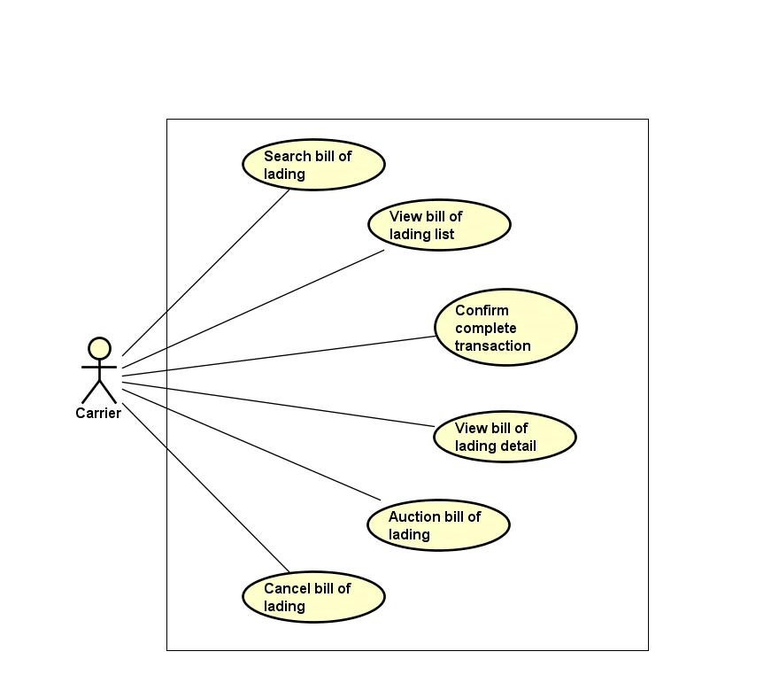

Figure 3.3‑4: of lading list group function

###### View bill of lading list

|  |  |  |  |  |
| --- | --- | --- | --- | --- |
| **Created by:** | | QuyetTD | **Date Created:** | 08/03/2017 |
| **Primary Actor** | | Carrier | **Secondary Actor** |  |
| **Description:** | | CRE want to view all bill of lading | | |
| **Preconditions:** | | “Tìm Hàng Chuyển” navigator appear on header of website | | |
| **Trigger:** | | “Tìm Hàng Chuyển” navigator is clicked | | |
| **Post conditions:** | | Display bill of lading list on common page | | |
| **Normal Flow** | | | | |
| **Step** | **Actor** | **Action** | | |
| 1 | CRE | Click “Tìm Hàng Chuyển” navigator | | |
| 2 | CTC | Display bill of lading list on common page | | |
| **Alternative Flows: N/A** | | | | |
| **Exceptions: N/A** | | | | |
| **Priority** | | Medium | | |
| **Frequency of Use:** | | High | | |
| **Business Rules:** | | N/A | | |
| **Other Information:** | | N/A | | |

###### View bill of lading detail

|  |  |  |  |  |
| --- | --- | --- | --- | --- |
| **Created by:** | | QuyetTD | **Date Created:** | 08/03/2017 |
| **Primary Actor** | | Carrier | **Secondary Actor** |  |
| **Description:** | | CRE want to view bill of lading detail, they send request to system and then get result | | |
| **Preconditions:** | | 1. “Tìm Hàng Chuyển” navigator appear on homepage 2. Detail icon appear on bill of lading detail page | | |
| **Trigger:** | | Detail icon of bill of lading is clicked | | |
| **Post conditions:** | | Display bill of lading detail on this page | | |
| **Normal Flow** | | | | |
| **Step** | **Actor** | **Action** | | |
| 1 | CRE | Click “Tim Hàng Vận Chuyển” navigator | | |
| 2 | CTC | Display bill of lading list page | | |
| 3 | CRE | Click “Chi Tiết” on bill of lading | | |
| 4 | CTC | Display bill of lading detail on bill of lading detail page | | |
| **Alternative Flows: N/A** | | | | |
| **Exceptions: N/A** | | | | |
| **Priority** | | High | | |
| **Frequency of Use:** | | High | | |
| **Business Rules:** | | B33 | | |
| **Other Information:** | | N/A | | |

###### Confirm complete transaction

|  |  |  |  |  |
| --- | --- | --- | --- | --- |
| **Created by:** | | QuyetTD | **Date Created:** | 08/03/2017 |
| **Primary Actor** | | Carrier | **Secondary Actor** |  |
| **Description:** | | Carrier want to confirm to system that they are complete bill of lading. It’s mean that their customer got goods. They will get down payment back | | |
| **Preconditions:** | | 1. Bill of lading was successful 2. “Đã Giao Hàng” button appear detail bill of lading page | | |
| **Trigger:** | | “Đã Giao Hàng” button in bill of lading detail page is clicked | | |
| **Post conditions:** | | Return down payment of customer to account and update bill of lading detail page | | |
| **Normal Flow** | | | | |
| **Step** | **Actor** | **Action** | | |
| 1 | CRE | Click “Đã Giao Hàng” button | | |
| 2 | CTC | Display bill of lading detail page update | | |
| 3 | CTC | Refund deposit for carrier | | |
| **Alternative Flows: N/A** | | | | |
| **Exceptions: N/A** | | | | |
| **Priority** | | Medium | | |
| **Frequency of Use:** | | Medium | | |
| **Business Rules:** | | B14 | | |
| **Other Information:** | | N/A | | |

###### Auction bill of lading

|  |  |  |  |  |  |
| --- | --- | --- | --- | --- | --- |
| **Created by:** | | QuyetTD | | **Date Created:** | 08/03/2017 |
| **Primary Actor** | | Carrier | | **Secondary Actor** |  |
| **Description:** | | Carrier want to transport goods and then they auction bill of lading on CTC | | | |
| **Preconditions:** | | 1. There is a bill of lading auctioning | | | |
| **Trigger:** | | “Đấu Thầu” button on bill of lading detail page is clicked | | | |
| **Post conditions:** | | Auction bill of lading on system | | | |
| **Normal Flow** | | | | | |
| **Step** | **Actor** | **Action** | | | |
| 1 | CRE | Click “Đấu Thầu” button on bill of lading detail page | | | |
| 2 | CTC | Display “Đấu Giá” pop-up includes:   * Account balance * Ceiling fee * Service charge * “Fee Đấu Thầu” input text * “Xác Nhận” button * “Hủy Bỏ” button | | | |
| 3 | CRE | Enter data in “Fee Đấu Thầu” input text | | | |
| 4 | CRE | Click “Xác Nhận” button | | | |
| 5 | CTC | Save data in database | | | |
| 6 | CTC | Update bill of lading detail page. | | | |
| **Alternative Flows:** | | | | | |
| **AT1** | At step 4, CRE click “Hủy Bỏ” button | | | | |
| **Step** | **Actor** | **Action** | | | |
| 6.1 | CTC | Return bill of lading detail page | | | |
| **AT2** | At step 4 in the main flows, if CRE click other hyperlinks or buttons | | | | |
| **Step** | **Actor** | | **Action** | | |
| 6.1 | CTC | | Redirects user to chosen hyperlink or button | | |
| **Exceptions: N/A** | | | | | |
| **Priority** | | High | | | |
| **Frequency of Use:** | | High | | | |
| **Business Rules:** | | B33 | | | |
| **Other Information:** | | N/A | | | |

###### Search bill of lading

|  |  |  |  |  |
| --- | --- | --- | --- | --- |
| **Created by:** | | QuyetTD | **Date Created:** | 08/03/2017 |
| **Primary Actor** | | Carrier | **Secondary Actor** |  |
| **Description:** | | CRE want to find a bill of lading | | |
| **Preconditions:** | | 1. “Tìm Hàng Chuyển” navigator appear on header of website 2. Search box appear on common page | | |
| **Trigger:** | | “Tìm Hàng Chuyển” navigator is clicked | | |
| **Post conditions:** | | Display bill of lading system found on common page | | |
| **Normal Flow** | | | | |
| **Step** | **Actor** | **Action** | | |
| 1 | CRE | Click “Tìm Hàng Chuyển” navigator one website | | |
| 2 | CTC | Display summary bill of lading page includes:   * “Loại hàng select box * “Hình thức đóng gói” select box * “Khối lượng” input text * “Thể tích” input text * “Địa điểm đi” select box * “Địa điểm đến” select box * “Thời gian đi” Date picker * “Thời gian đến” Date picker * “Tìm Kiếm” buttons | | |
| 1 | CRE | Enter data in this fields | | |
| 2 | CRE | Click “Tìm Kiếm” button search page | | |
| 3 | CTC | Display result on common page | | |
| **Alternative Flows: N/A** | | | | |
| **Exceptions: N/A** | | | | |
| **Priority** | | High | | |
| **Frequency of Use:** | | High | | |
| **Business Rules:** | | N/A | | |
| **Other Information:** | | N/A | | |

###### Cancel bill of lading

|  |  |  |  |  |
| --- | --- | --- | --- | --- |
| **Created by:** | | QuyetTD | **Date Created:** | 08/03/2017 |
| **Primary Actor** | | Carrier | **Secondary Actor** |  |
| **Description:** | | CRE do not want to transport their goods. So they cancel bill of lading | | |
| **Preconditions:** | | Cancel button appear on bill of lading detail page | | |
| **Trigger:** | | “Hủy Đấu Giá” button is clicked | | |
| **Post conditions:** | | Bill of lading will be disable | | |
| **Normal Flow** | | | | |
| **Step** | **Actor** | **Action** | | |
| 1 | CRE | Click “Hủy Đấu Giá” button | | |
| 2 | CTC | Cancel bill of lading | | |
| 3 | CTC | Update bill of lading detail page | | |
| **Alternative Flows:** | | | | |
| **Exceptions: N/A** | | | | |
| **Priority** | | High | | |
| **Frequency of Use:** | | High | | |
| **Business Rules:** | | N/A | | |
| **Other Information:** | | N/A | | |

##### Manage profile group function

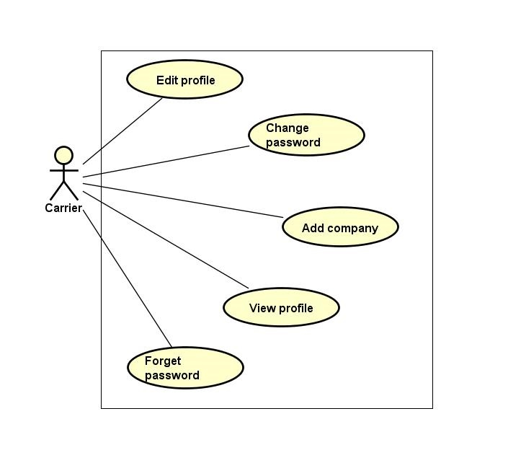

Figure 3.3‑5: Manage profile group function

###### Edit profile

|  |  |  |  |  |
| --- | --- | --- | --- | --- |
| **Created by:** | | QuyetTD | **Date Created:** | 08/03/2017 |
| **Primary Actor** | | Carrier | **Secondary Actor** |  |
| **Description:** | | CRE want to edit goods owner profile | | |
| **Preconditions:** | | “Thay Đổi” button appear on detail user view page | | |
| **Trigger:** | | “Thay Đổi” button on detail user view page is clicked | | |
| **Post conditions:** | | Save carrier profile in database and updated detail user view page | | |
| **Normal Flow** | | | | |
| **Step** | **Actor** | **Action** | | |
| 1 | CRE | Carrier click “Thay Đổi” button | | |
| 2 | CTC | Display pop-up includes:   * “Chọn ảnh” file chooser * “Họ tên” input text * “Bạn là” (phân quyền quản trị) check box * “Email” input text * “Địa chỉ” input text * “Chứng minh thư” input text * “Ngày cấp thẻ” date picker * “Ngày tham gia” date picker * “Thay Đổi” button | | |
| 3 | CRE | Change data in this fields | | |
| 4 | CRE | Click “Lưu Thay Đổi” button | | |
| 5 | CTC | Save changed in database | | |
| 6 | CTC | Display changed on user detail page | | |
| **Alternative Flows:** | | | | |
| **AT1** | At step 4, carrier click “x” in pop-up | | | |
| **Step** | **Actor** | **Action** | | |
| 4.1 | CRE | click “x” in pop-up | | |
| 6.1 | CTC | Display user detail page | | |
| **AT2** | At step 4 in the main flows, if CRE click other hyperlinks or buttons | | | |
| **Step** | **Actor** | **Action** | | |
| 6.1 | CTC | Redirects admin to chosen hyperlink or button | | |
| **Exceptions: N/A** | | | | |
| **Priority** | | Medium | | |
| **Frequency of Use:** | | Medium | | |
| **Business Rules:** | | N/A | | |
| **Other Information:** | | N/A | | |

###### View profile

|  |  |  |  |  |
| --- | --- | --- | --- | --- |
| **Created by:** | | QuyetTD | **Date Created:** | 08/03/2017 |
| **Primary Actor** | | Carrier | **Secondary Actor** |  |
| **Description:** | | Carrier want to view their profile | | |
| **Preconditions:** | | “Thông Tin Cá Nhân” item appear on top navigator | | |
| **Trigger:** | | “Thông Tin Cá Nhân” item is clicked | | |
| **Post conditions:** | | Display carrier profile | | |
| **Normal Flow** | | | | |
| **Step** | **Actor** | **Action** | | |
| 1 | CRE | Hover mouse to user name label and click “Thông Tin Cá Nhân” item | | |
| 2 | CTC | Display CRE detail on user detail view page | | |
| **Alternative Flows:** N/A | | | | |
| **Exceptions: N/A** | | | | |
| **Priority** | | Medium | | |
| **Frequency of Use:** | | High | | |
| **Business Rules:** | | N/A | | |
| **Other Information:** | | N/A | | |

###### Forget password

|  |  |  |  |  |
| --- | --- | --- | --- | --- |
| **Created by:** | | QuyetTD | **Date Created:** | 08/03/2017 |
| **Primary Actor** | | Carrier | **Secondary Actor** |  |
| **Description:** | | CRE forget password. They want to reset password | | |
| **Preconditions:** | | “Quên mật khẩu” label appear on login page | | |
| **Trigger:** | | “Quên mật khẩu” label on login page is clicked | | |
| **Post conditions:** | | System send new password to goods owner’s email | | |
| **Normal Flow** | | | | |
| **Step** | **Actor** | **Action** | | |
| 1 | CRE | CRE click “Quên mật khẩu” on login page | | |
| 2 | CTC | Display forget password page includes:   * “Email đăng ký” input text * “Gửi” button | | |
| 3 | CRE | Enter email address they use for register goods owner account | | |
| 4 | CTC | Send new password to goods owner’s email address | | |
| **Alternative Flows: N/A** | | | | |
| **Exceptions: N/A** | | | | |
| **Priority** | | Medium | | |
| **Frequency of Use:** | | High | | |
| **Business Rules:** | | B22 | | |
| **Other Information:** | | N/A | | |

###### Add company

|  |  |  |  |  |  |
| --- | --- | --- | --- | --- | --- |
| **Created by:** | | | QuyetTD | **Date Created:** | 08/03/2017 |
| **Primary Actor** | | | Carrier | **Secondary Actor** |  |
| **Description:** | | | Carrier want to add company information to their profile. | | |
| **Preconditions:** | | | “Thêm mới” button appear below “THÔNG TIN CÔNG TY” label | | |
| **Trigger:** | | | “Thêm mới” button on view user detail page is cliecked | | |
| **Post conditions:** | | | Add company information to user | | |
| **Normal Flow** | | | | | |
| **Step** | **Actor** | | **Action** | | |
| 1 | CRE | | Click “Thêm mới” button on view user detail page | | |
| 2 | CTC | | Display add company information for user pop-up includes:   * “Tên công ty” input text * “Email” input text * “Số điện thoại” input text * “Fax” input text * “Địa chỉ” input text * “Mã số thuế” input text * “Hủy bỏ” button | | |
| 3 | CRE | | * Enter data on fields * Click “Xác nhận” button | | |
| 4 | CTC | | * Add company information for user | | |
| **Alternative Flows: N/A** | | | | | |
| **AT1** | At step 3 in the main flows, CRE click “Hủy bỏ” button | | | | |
| **Step** | **Actor** | | **Action** | | |
| 4.1 | CTC | | Close “Thêm thông tin công ty” pop-up | | |
| **Exceptions: N/A** | | | | | |
| **EC1** | | At step 3, required fields are not entered | | | |
| **Step** | | **Actor** | **Action** | | |
| 6.1 | | CTC | Display Register page with message error | | |
| 6.2 | | CTC | Mark error fields | | |
| **EC2** | | At step 3, fields are entered with wrong type of data | | | |
| **Step** | | **Actor** | **Action** | | |
| 6.1 | | CTC | Display Register page with message error | | |
| 6.2 | | CTC | Mark error fields | | |
| **Priority** | | | Medium | | |
| **Frequency of Use:** | | | Medium | | |
| **Business Rules:** | | | N/A | | |
| **Other Information:** | | | N/A | | |

###### Change password

|  |  |  |  |  |  |  |
| --- | --- | --- | --- | --- | --- | --- |
| **Created by:** | | | QuyetTD | | **Date Created:** | 08/03/2017 |
| **Primary Actor** | | | Carrier | | **Secondary Actor** |  |
| **Description:** | | | Carrier want to change password for security | | | |
| **Preconditions:** | | | “Thay đổi mật khẩu” item appear on top navigator | | | |
| **Trigger:** | | | “Thay đổi mật khẩu” item is clicked | | | |
| **Post conditions:** | | | Change password of goods owner | | | |
| **Normal Flow** | | | | | | |
| **Step** | **Actor** | | **Action** | | | |
| 1 | CRE | | Click “Thay đổi mật khẩu” label | | | |
| 2 | CTC | | Display change password page includes:   * “Mật khẩu cũ” input text * “Mật khẩu mới” input text * “Xác nhận mật khẩu” input text * “Đổi mật khẩu” button | | | |
| 3 | CRE | | Enter data in this fields | | | |
| 4 | CRE | | Click “Đổi mật khẩu” button | | | |
| 5 | CTC | | Save new password in database | | | |
| 6 | CTC | | Display “Thay đổi thành công” message on pop-up | | | |
| **Alternative Flows:** | | | | | | |
| **AT1** | At step 4 in the main flows, if CRE click other hyperlinks or buttons | | | | | |
| **Step** | **Actor** | | **Action** | | | |
| 6.1 | CTC | | Redirects CRE to chosen hyperlink or button | | | |
| **Exceptions:** | | | | | | |
| **EC1** | | At step 3, required fields are not entered | | | | |
| **Step** | | **Actor** | | **Action** | | |
| 6.1 | | CTC | | Display Register page with message error | | |
| 6.2 | | CTC | | Mark error fields | | |
| **EC2** | | At step 3, fields are entered with wrong type of data | | | | |
| **Step** | | **Actor** | | **Action** | | |
| 6.1 | | CTC | | Display Register page with message error | | |
| 6.2 | | CTC | | Mark error fields | | |
| **EC3** | | At step 3, password is wrong | | | | |
| **Step** | | **Actor** | | **Action** | | |
| 6.1 | | CTC | | Display Register page with message error | | |
| 6.2 | | CTC | | Mark error fields | | |
| **EC4** | | At step 3, new password and confirm password are not match | | | | |
| **Step** | | **Actor** | | **Action** | | |
| 6.1 | | CTC | | Display Register page with message error | | |
| 6.2 | | CTC | | Mark error fields | | |
| **Priority** | | | Medium | | | |
| **Frequency of Use:** | | | Medium | | | |
| **Business Rules:** | | | B12, B15 | | | |
| **Other Information:** | | | N/A | | | |

Table 3‑18: Change password

##### Account recharge group function

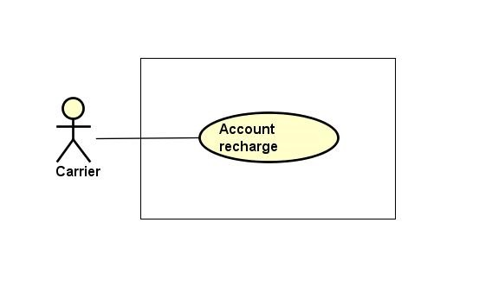

Figure 3.3‑6: Account recharge group function

###### Account recharge

|  |  |  |  |  |
| --- | --- | --- | --- | --- |
| **Created by:** | | QuyetTD | **Date Created:** | 08/03/2017 |
| **Primary Actor** | | Carrier | **Secondary Actor** |  |
| **Description:** | | Carrier want to account recharge for account for auction bill of lading | | |
| **Preconditions:** | | “Nạp tiền vào tài khoản” item appear on top navigator | | |
| **Trigger:** | | “Nạp tiền vào tài khoản” item is clicked | | |
| **Post conditions:** | | Recharge the user account | | |
| **Normal Flow** | | | | |
| **Step** | **Actor** | **Action** | | |
| 1 | CRE | Hover mouse to user name and Click “Nạp tiền vào tài khoản” item | | |
| 2 | CTC | Display “nganluong.vn” website includes 3 items for 3 ways to recharge for account:   * “Ví điện thứ Ngân Lượng” button * “Thẻ cào điện thoại” button * “Online bằng thẻ ATM\Internet banking” button * “Chuyển khoản ngân hàng” button | | |
| 3 | CRE | Click one of three button for choose how to recharge to account | | |
| 4 | CTC | Display the way user chose to recharge account | | |
| 5 | CRE | GWN do something follow “Ngân Lượng” guide | | |
| 6 | CTC | Add money to user account | | |
| **Alternative Flows:** | | | | |
| **AT1** | At step 4 in the main flows, if CRE click other hyperlinks or buttons | | | |
| **Step** | **Actor** | **Action** | | |
| 5.1 | CTC | Redirects user to chosen hyperlink or button | | |
| **Exceptions: N/A** | | | | |
| **Priority** | | High | | |
| **Frequency of Use:** | | High | | |
| **Business Rules:** | | N/A | | |
| **Other Information:** | | N/A | | |

##### Manage report group function

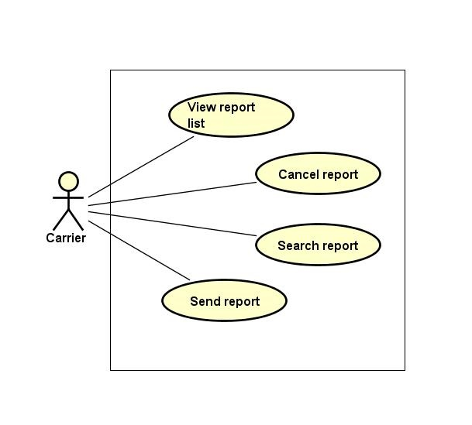

Figure 3.3‑7: Manage report group function

###### Send report

|  |  |  |  |  |  |
| --- | --- | --- | --- | --- | --- |
| **Created by:** | | | QuyetTD | **Date Created:** | 08/03/2017 |
| **Primary Actor** | | | Carrier | **Secondary Actor** |  |
| **Description:** | | | Carrier want to send report to admin | | |
| **Preconditions:** | | | 1. “BÁO CÁO CỦA TÔI” navigator appear on header of website 2. “Tạo báo cáo mới” button appear on list report user page | | |
| **Trigger:** | | | “Tạo mới báo cáo” button is clicked | | |
| **Post conditions:** | | | Send report to admin | | |
| **Normal Flow** | | | | | |
| **Step** | **Actor** | | **Action** | | |
| 1 | CRE | | Click “Tạo mới báo cáo” button | | |
| 2 | CTC | | Display add new report page includes:   * “Chủ đề bạn muốn báo cáo là gì” input text * “Câu hỏi của bạn là gì” input text * “Bạn mong muốn xử lý như thế nào” input text * “Nội dung báo cáo của bạn” input text * “Gửi phản hồi” button * “Quay lại” button | | |
| 3 | CRE | | Enter data in fields | | |
| 4 | CRE | | Click “Gửi phản hồi” button | | |
| 5 | CTC | | Send report to admin | | |
| **Alternative Flows:** | | | | | |
| **AT1** | At step 4, CRE click “Quay lại” button | | | | |
| **Step** | **Actor** | | **Action** | | |
| 5.1 | CTC | | Return report list page | | |
| **AT2** | At step 4 in the main flows, if CRE click other hyperlinks or buttons | | | | |
| **Step** | **Actor** | | **Action** | | |
| 5.1 | CTC | | Redirects CRE to chosen hyperlink or button | | |
| **Exceptions:** | | | | | |
| **EC1** | | At step 3, required fields are not entered | | | |
| **Step** | | **Actor** | **Action** | | |
| 5.1 | | CTC | Display Register page with message error | | |
| 5.2 | | CTC | Mark error fields | | |
| **Priority** | | | Medium | | |
| **Frequency of Use:** | | | Medium | | |
| **Business Rules:** | | | N/A | | |
| **Other Information:** | | | N/A | | |

###### View report list

|  |  |  |  |  |
| --- | --- | --- | --- | --- |
| **Created by:** | | QuyetTD | **Date Created:** | 08/03/2017 |
| **Primary Actor** | | Carrier | **Secondary Actor** |  |
| **Description:** | | CRE want to view report list | | |
| **Preconditions:** | | “BÁO CÁO CỦA TÔI” navigator appear on header of website | | |
| **Trigger:** | | “BÁO CÁO CỦA TÔI” navigator is clicked | | |
| **Post conditions:** | | Display report list on report list page | | |
| **Normal Flow** | | | | |
| **Step** | **Actor** | **Action** | | |
| 1 | CRE | Click “Báo Cáo Của Tôi” navigator | | |
| 2 | CTC | Display report list on report list page | | |
| **Alternative Flows: N/A** | | | | |
| **Exceptions: N/A** | | | | |
| **Priority** | | Medium | | |
| **Frequency of Use:** | | High | | |
| **Business Rules:** | | N/A | | |
| **Other Information:** | | N/A | | |

###### Search report

|  |  |  |  |  |  |  |
| --- | --- | --- | --- | --- | --- | --- |
| **Created by:** | | | QuyetTD | | **Date Created:** | 08/03/2017 |
| **Primary Actor** | | | Carrier | | **Secondary Actor** |  |
| **Description:** | | | Carrier want to find a report in report list | | | |
| **Preconditions:** | | | 1. “BÁO CÁO CỦA TÔI” navigator appear header of website 2. Search box appear on list report user page | | | |
| **Trigger:** | | | “BÁO CÁO CỦA TÔI” navigator appear header of website | | | |
| **Post conditions:** | | | Display report on report list page | | | |
| **Normal Flow** | | | | | | |
| **Step** | **Actor** | | **Action** | | | |
| 1 | CRE | | CRE click “Quản Lý Report” navigator | | | |
| 2 | CTC | | Display search page includes:   * “Tên tài khoản” * “Tên người dùng” * “Tiêu đề báo cáo” * “ngày bắt đầu” input text * “ngày kết thúc” input text * “Tìm kiếm” button | | | |
| 3 | CRE | | Enter data in fields | | | |
| 4 | CRE | | Click “Tìm kiếm” button | | | |
| 5 | CTC | | Display result on report list page | | | |
| **Alternative Flows:** | | | | | | |
| **AT1** | | At step 4 in the main flows, if CRE click other hyperlinks or buttons | | | | |
| **Step** | | **Actor** | | **Action** | | |
| 5.1 | | CTC | | Redirects user to chosen hyperlink or button | | |
| **Exceptions: N/A** | | | | | | |
| **Priority** | | | Medium | | | |
| **Frequency of Use:** | | | Medium | | | |
| **Business Rules:** | | | N/A | | | |
| **Other Information:** | | | N/A | | | |

###### Cancel report

|  |  |  |  |  |
| --- | --- | --- | --- | --- |
| **Created by:** | | QuyetTD | **Date Created:** | 08/03/2017 |
| **Primary Actor** | | Carrier | **Secondary Actor** |  |
| **Description:** | | CRE want to cancel their report | | |
| **Preconditions:** | | “BÁO CÁO CỦA TÔI” navigator appear on header of website | | |
| **Trigger:** | | “BÁO CÁO CỦA TÔI” navigator is clicked | | |
| **Post conditions:** | | Cancel this report | | |
| **Normal Flow** | | | | |
| **Step** | **Actor** | **Action** | | |
| 1 | CRE | Click “Báo Cáo Của Tôi” navigator | | |
| 2 | CRE | Click cancel report icon | | |
| 2 | CTC | Cancel this report | | |
| **Alternative Flows: N/A** | | | | |
| **Exceptions: N/A** | | | | |
| **Priority** | | Medium | | |
| **Frequency of Use:** | | High | | |
| **Business Rules:** | | N/A | | |
| **Other Information:** | | N/A | | |

##### Fee list group function

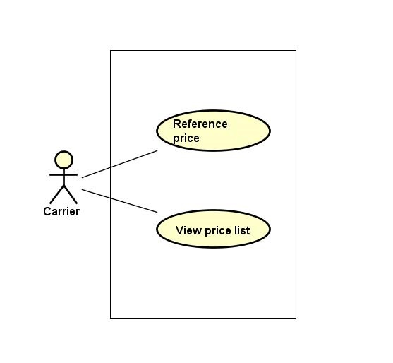

Figure 3.3‑8: Fee list group function

###### Reference fee

|  |  |  |  |  |
| --- | --- | --- | --- | --- |
| **Created by:** | | QuyetTD | **Date Created:** | 08/03/2017 |
| **Primary Actor** | | Carrier | **Secondary Actor** |  |
| **Description:** | | Carrier want to reference actual fee system updated | | |
| **Preconditions:** | | 1. “Tham Chiếu” item appear on header of website 2. “BÁO GIÁ” navigator appear on header of website | | |
| **Trigger:** | | “Tham chiếu” item is clicked | | |
| **Post conditions:** | | Display fee list on fee list page | | |
| **Normal Flow** | | | | |
| **Step** | **Actor** | **Action** | | |
| 1 | CRE | Click “Tham chiếu” button | | |
| 2 | CTC | Display fee list from other website | | |
| **Alternative Flows: N/A** | | | | |
| **Exceptions: N/A** | | | | |
| **Priority** | | Medium | | |
| **Frequency of Use:** | | Medium | | |
| **Business Rules:** | | N/A | | |
| **Other Information:** | | N/A | | |

###### View fee list

|  |  |  |  |  |
| --- | --- | --- | --- | --- |
| **Created by:** | | QuyetTD | **Date Created:** | 08/03/2017 |
| **Primary Actor** | | Carrier | **Secondary Actor** |  |
| **Description:** | | CRE want to view list of fee | | |
| **Preconditions:** | | 1. “Hệ Thống” item appear on header of website 2. “BÁO GIÁ” navigator appear on header of website | | |
| **Trigger:** | | “Hệ Thống” item is clicked | | |
| **Post conditions:** | | Display fee list on fee list page | | |
| **Normal Flow** | | | | |
| **Step** | **Actor** | **Action** | | |
| 1 | CRE | Click “BÁO GIÁ” navigator and then choose “Hệ Thống” item | | |
| 2 | CTC | Display fee list on fee list page | | |
| **Alternative Flows:** N/A | | | | |
| **Exceptions: N/A** | | | | |
| **Priority** | | High | | |
| **Frequency of Use:** | | High | | |
| **Business Rules:** | | N/A | | |
| **Other Information:** | | N/A | | |

##### Connect to goods owner group function

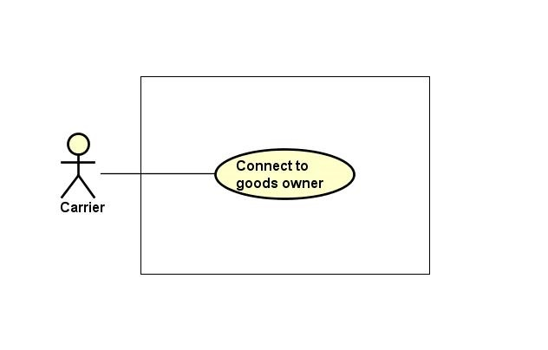

Figure 3.3‑9: Connect to goods owner group function

###### Connect to goods owner

|  |  |  |  |  |
| --- | --- | --- | --- | --- |
| **Created by:** | | QuyetTD | **Date Created:** | 08/03/2017 |
| **Primary Actor** | | Carrier | **Secondary Actor** |  |
| **Description:** | | Carrier want to connect to Goods owner | | |
| **Preconditions:** | | Bill of lading is successful | | |
| **Trigger:** | | “Reply” item on bill of lading detail page is clicked | | |
| **Post conditions:** | | Send comment to goods owner | | |
| **Normal Flow** | | | | |
| **Step** | **Actor** | **Action** | | |
| 1 | CRE | Click “Chi Tiết” on a bill of lading | | |
| 2 | CTC | Display bill of lading detail comment includes:   * “Hỏi Đáp” input text | | |
| 3 | CRE | Enter data in fields | | |
| 4 | CRE | Press enter key word on keyboard | | |
| 5 | CTC | Send comment to goods owner | | |
| **Alternative Flows:** | | | | |
| **AT1** | At step 4 in the main flows, if CRE click other hyperlinks or buttons | | | |
| **Step** | **Actor** | **Action** | | |
| 5.1 | CTC | Redirects CRE to chosen hyperlink or button | | |
| **Exceptions: N/A** | | | | |
| **Priority** | | Medium | | |
| **Frequency of Use:** | | Medium | | |
| **Business Rules:** | | B14 | | |
| **Other Information:** | | N/A | | |

##### Transaction history group function

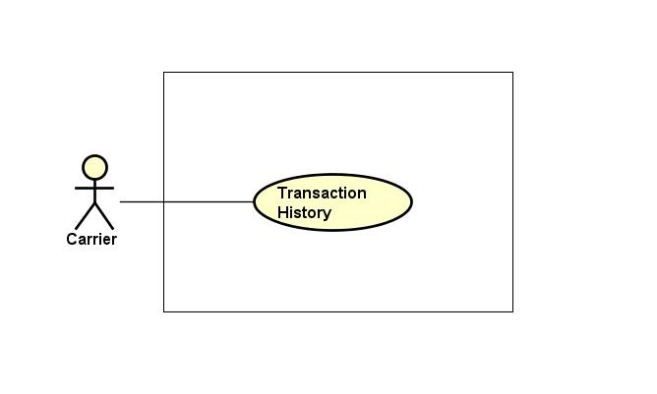

Figure 3.3‑10: Transaction history group function

###### Transaction history

|  |  |  |  |  |
| --- | --- | --- | --- | --- |
| **Created by:** | | QuyetTD | **Date Created:** | 08/03/2017 |
| **Primary Actor** | | Carrier | **Secondary Actor** |  |
| **Description:** | | Carrier want to check money in account and what did they do with money | | |
| **Preconditions:** | | “Thông tin giao dịch” item appear on top navigator | | |
| **Trigger:** | | “Thông tin giao dịch” item is clicked | | |
| **Post conditions:** | | Display money in account and transaction history | | |
| **Normal Flow** | | | | |
| **Step** | **Actor** | **Action** | | |
| 1 | Carrier | Hover mouse to user name and Click “Thông tin giao dịch” item | | |
| 2 | CTC | Display money in account and transaction history | | |
| **Alternative Flows: N/A** | | | | |
| **Exceptions: N/A** | | | | |
| **Priority** | | Medium | | |
| **Frequency of Use:** | | Medium | | |
| **Business Rules:** | | N/A | | |
| **Other Information:** | | N/A | | |

##### Login group function

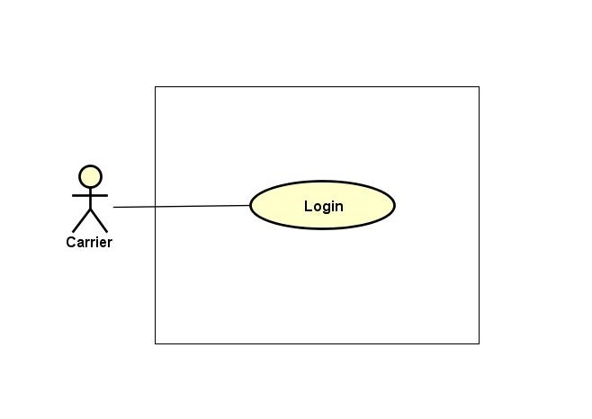

Figure 3.3‑11: Login group function

###### Login

|  |  |  |  |  |  |  |
| --- | --- | --- | --- | --- | --- | --- |
| **Created by:** | | | QuyetTD | | **Date Created:** | 08/03/2017 |
| **Primary Actor** | | | Carrier | | **Secondary Actor** |  |
| **Description:** | | | CRE want to login to CTC system for work | | | |
| **Preconditions:** | | | “Đăng nhập” button appear on login page | | | |
| **Trigger:** | | | “Đăng nhập” button on login page is clicked | | | |
| **Post conditions:** | | | Carrier login to CTC system | | | |
| **Normal Flow** | | | | | | |
| **Step** | **Actor** | | **Action** | | | |
| 1 | CRE | | Click “Đăng nhập” on homepage | | | |
| 2 | CTC | | Display login page includes:   * “Email” input text * “Mật khẩu” input text * “Đăng nhập” button | | | |
| 3 | CRE | | Enter data in fields | | | |
| 4 | CTC | | Login account to CTC | | | |
| **Alternative Flows: N/A** | | | | | | |
| **Exceptions:** | | | | | | |
| **EC1** | | At step 4, required fields are not entered | | | | |
| **Step** | | **Actor** | | **Action** | | |
| 4.1 | | CTC | | Display Register page with message error | | |
| 4.2 | | CTC | | Mark error fields | | |
| **EC2** | | At step 4, fields are entered with wrong type of data | | | | |
| **Step** | | **Actor** | | **Action** | | |
| 4.1 | | CTC | | Display Register page with message error | | |
| 4.2 | | CTC | | Mark error fields | | |
| **Priority** | | | High | | | |
| **Frequency of Use:** | | | High | | | |
| **Business Rules:** | | | B2, B11 | | | |
| **Other Information:** | | | N/A | | | |

##### Logout group function

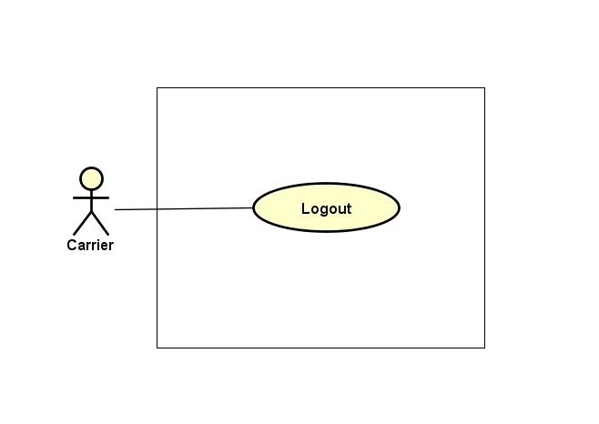

Figure 3.3‑12: Logout group function

###### Logout

|  |  |  |  |  |
| --- | --- | --- | --- | --- |
| **Created by:** | | QuyetTD | **Date Created:** | 08/03/2017 |
| **Primary Actor** | | Carrier | **Secondary Actor** |  |
| **Description:** | | CRE want to logout CTC system | | |
| **Preconditions:** | | “Đăng xuất” button appear on top navigator | | |
| **Trigger:** | | “Đăng xuất” button is clicked | | |
| **Post conditions:** | | Logout carrier account | | |
| **Normal Flow** | | | | |
| **Step** | **Actor** | **Action** | | |
| 1 | CRE | Click “Đăng xuất” in website | | |
| 2 | CTC | Logout Goods owner account | | |
| 3 | CTC | Return homepage | | |
| **Alternative Flows: N/A** | | | | |
| **Exceptions: N/A** | | | | |
| **Priority** | | High | | |
| **Frequency of Use:** | | High | | |
| **Business Rules:** | | N/A | | |
| **Other Information:** | | N/A | | |

#### Goods Owner Group Function

##### Bill of lading list group function

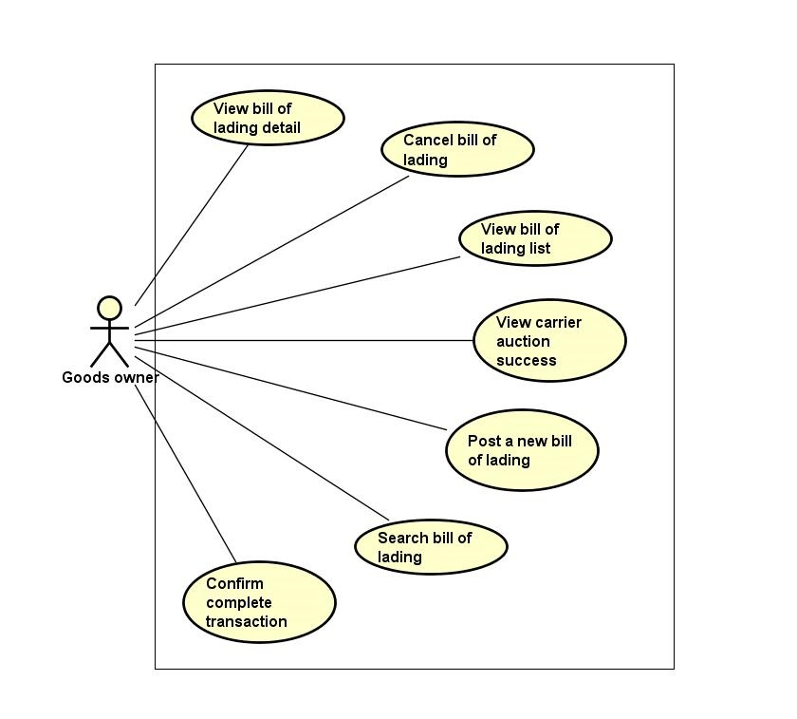

Figure 3.3‑13: Bill of lading list group function

###### View bill of lading list

|  |  |  |  |  |
| --- | --- | --- | --- | --- |
| **Created by:** | | QuyetTD | **Date Created:** | 08/03/2017 |
| **Primary Actor** | | Goods owner | **Secondary Actor** |  |
| **Description:** | | User want to view all bill of lading | | |
| **Preconditions:** | | “Tìm Hàng Chuyển” navigator appear on header of website | | |
| **Trigger:** | | “Tìm Hàng Chuyển” navigator is clicked | | |
| **Post conditions:** | | Display bill of lading list on common page | | |
| **Normal Flow** | | | | |
| **Step** | **Actor** | **Action** | | |
| 1 | GWN | Click “Tìm Hàng Chuyển” navigator | | |
| 2 | CTC | Display bill of lading list on bill of lading list page | | |
| **Alternative Flows: N/A** | | | | |
| **Exceptions: N/A** | | | | |
| **Priority** | | Medium | | |
| **Frequency of Use:** | | High | | |
| **Business Rules:** | | N/A | | |
| **Other Information:** | | N/A | | |

###### Confirm complete transaction

|  |  |  |  |  |
| --- | --- | --- | --- | --- |
| **Created by:** | | QuyetTD | **Date Created:** | 08/03/2017 |
| **Primary Actor** | | Goods owner | **Secondary Actor** |  |
| **Description:** | | Goods owner want to confirm that they are complete bill of lading to the system. It means that their customer got goods. They will get down payment back | | |
| **Preconditions:** | | 1. CTC must be connected to the Internet 2. GWN browsed CTC website 3. Go to bill of lading detail | | |
| **Trigger:** | | Click “Hoàn thành giao dịch” button in bill of lading detail page | | |
| **Post conditions:** | | Return down payment of customer to account and update bill of lading detail page | | |
| **Normal Flow** | | | | |
| **Step** | **Actor** | **Action** | | |
| 1 | GWN | Click “Hoàn thành giao dịch” button | | |
| 2 | CTC | Display bill of lading detail page update | | |
| **Alternative Flows: N/A** | | | | |
| **Exceptions: N/A** | | | | |
| **Priority** | | Medium | | |
| **Frequency of Use:** | | Medium | | |
| **Business Rules:** | | B14 | | |
| **Other Information:** | | N/A | | |

###### View bill of lading detail

|  |  |  |  |  |
| --- | --- | --- | --- | --- |
| **Created by:** | | QuyetTD | **Date Created:** | 08/03/2017 |
| **Primary Actor** | | Goods owner | **Secondary Actor** |  |
| **Description:** | | GWN want to view bill of lading detail, they send request to system and then get result | | |
| **Preconditions:** | | 1. “Tìm Hàng Chuyển” navigator appear on homepage 2. Detail icon appear on bill of lading detail page | | |
| **Trigger:** | | Detail icon of bill of lading is clicked | | |
| **Post conditions:** | | Display bill of lading detail on bill of lading detail page | | |
| **Normal Flow** | | | | |
| **Step** | **Actor** | **Action** | | |
| 1 | GWN | Click “Tim Hàng Vận Chuyển” navigator | | |
| 2 | CTC | Display bill of lading list page | | |
| 3 | GWN | Click “Chi Tiết” on bill of lading | | |
| 4 | CTC | Display bill of lading detail on bill of lading detail page | | |
| **Alternative Flows: N/A** | | | | |
| **Exceptions: N/A** | | | | |
| **Priority** | | High | | |
| **Frequency of Use:** | | High | | |
| **Business Rules:** | | B33 | | |
| **Other Information:** | | N/A | | |

###### Cancel bill of lading

|  |  |  |  |  |
| --- | --- | --- | --- | --- |
| **Created by:** | | QuyetTD | **Date Created:** | 08/03/2017 |
| **Primary Actor** | | Goods owner | **Secondary Actor** |  |
| **Description:** | | Goods owner do not want to transport their goods. So they cancel bill of lading | | |
| **Preconditions:** | | Cancel button appear on bill of lading detail page | | |
| **Trigger:** | | “Hủy Đấu Giá” button is clicked | | |
| **Post conditions:** | | Bill of lading will be disable | | |
| **Normal Flow** | | | | |
| **Step** | **Actor** | **Action** | | |
| 1 | GWN | Click “Hủy Đấu Giá” button | | |
| 2 | CTC | Cancel bill of lading | | |
| 3 | CTC | Update bill of lading detail page | | |
| **Alternative Flows: N/A** | | | | |
| **Exceptions: N/A** | | | | |
| **Priority** | | High | | |
| **Frequency of Use:** | | High | | |
| **Business Rules:** | | N/A | | |
| **Other Information:** | | N/A | | |

###### Search bill of lading

|  |  |  |  |  |
| --- | --- | --- | --- | --- |
| **Created by:** | | QuyetTD | **Date Created:** | 08/03/2017 |
| **Primary Actor** | | Goods owner | **Secondary Actor** |  |
| **Description:** | | GWN want to find a bill of lading | | |
| **Preconditions:** | | 1. “Tìm Hàng Chuyển” navigator appear on header of website 2. Search box appear on common page | | |
| **Trigger:** | | “Tìm Hàng Chuyển” navigator is clicked | | |
| **Post conditions:** | | Display bill of lading system found on common page | | |
| **Normal Flow** | | | | |
| **Step** | **Actor** | **Action** | | |
| 1 | GWN | Click “Tìm Hàng Chuyển” navigator one website | | |
| 2 | CTC | Display summary bill of lading page includes:   * “Loại hàng select box * “Hình thức đóng gói” select box * “Khối lượng” input text * “Thể tích” input text * “Địa điểm đi” select box * “Địa điểm đến” select box * “Thời gian đi” Date picker * “Thời gian đến” Date picker * “Tìm Kiếm” buttons | | |
| 3 | GWN | Enter data in this fields | | |
| 4 | GWN | Click “Tìm Kiếm” button search page | | |
| 5 | CTC | Display bill of lading system found on common page | | |
| **Alternative Flows:** | | | | |
| **AT1** | At step 4 in the main flows, if GWN click other hyperlinks or buttons | | | |
| **Step** | **Actor** | **Action** | | |
| 5.1 | CTC | Redirects GWN to chosen hyperlink or button | | |
| **Exceptions: N/A** | | | | |
| **Priority** | | High | | |
| **Frequency of Use:** | | High | | |
| **Business Rules:** | | N/A | | |
| **Other Information:** | | N/A | | |

###### View carrier auction success

|  |  |  |  |  |
| --- | --- | --- | --- | --- |
| **Created by:** | | QuyetTD | **Date Created:** | 08/03/2017 |
| **Primary Actor** | | Goods owner | **Secondary Actor** |  |
| **Description:** | | GWN want to view who auction bill of lading successful | | |
| **Preconditions:** | | 1. Bill of lading is successful 2. Detail icon of bill of lading appear bill of lading detail page | | |
| **Trigger:** | | Detail icon of bill of lading appear bill of lading detail page is clicked | | |
| **Post conditions:** | | Display who are auction success on bill of lading detail page | | |
| **Normal Flow** | | | | |
| **Step** | **Actor** | **Action** | | |
| 1 | GWN | Click “GIAO DỊCH CỦA TÔI” navigator | | |
| 2 | CTC | Display bill of lading list page | | |
| 3 | GWN | Click detail icon of bill of lading on Goods Owner Bill Of Lading page | | |
| 4 | CTC | Display who are auction success on detail page | | |
| **Alternative Flows: N/A** | | | | |
| **Exceptions: N/A** | | | | |
| **Priority** | | Medium | | |
| **Frequency of Use:** | | Medium | | |
| **Business Rules:** | | B33 | | |
| **Other Information:** | | N/A | | |

###### Post a new bill of lading

|  |  |  |  |  |  |  |
| --- | --- | --- | --- | --- | --- | --- |
| **Created by:** | | | QuyetTD | | **Date Created:** | 08/03/2017 |
| **Primary Actor** | | | Goods owner | | **Secondary Actor** |  |
| **Description:** | | | Goods owner want to transport their goods so create a new bill of lading in CTC system | | | |
| **Preconditions:** | | | “TẠO VẬN ĐƠN” navigator appear on header of website | | | |
| **Trigger:** | | | “TẠO VẬN ĐƠN” navigator is clicked | | | |
| **Post conditions:** | | | Register new bill of lading in CTC system | | | |
| **Normal Flow** | | | | | | |
| **Step** | **Actor** | | **Action** | | | |
| 1 | GWN | | Click “Tạo Vận Đơn” navigator | | | |
| 2 | CTC | | Display post bill of lading page includes:   * “Mã vận đơn” input text * “loại hàng” select box * “Hình thức đóng gói” select box * “Họ tên người gửi” input text * “Số điện thoại” input text * “Họ tên người nhận” input text * “Địa điểm gửi” select box * “Địa điểm nhận” select box * “Từ quận/huyện” select box * “Đến quận/huyện” select box * “Địa chỉ nơi gửi” input text * “Địa chỉ nơi nhận” input text * “Đặc điểm nơi gửi” input text * “Đặc điểm nơi nhận” input text * “Ngày gửi” date time picker * “Ngày nhận” date time picker * “Quãng đường” input text * “Khối lượng” input text * “Số lượng” input text * “Dài” input text * “Rộng” input text * “Cao” input text * “Hàng đông lạnh” check box * “Hàng dễ vỡ” check box * “Hình ảnh” button upload * “Mô tả” ricd texbox * “Fee đề xuất” input text * “Thời gian kết thúc Đấu Giá” date time picker * “Đăng ký” button * “Hủy bỏ” button | | | |
| 3 | GWN | | Enter data in fields | | | |
| 4 | GWN | | Click “Đăng ký” button on post bill of lading page | | | |
| 5 | CTC | | Save data in database (register bill of lading in database) | | | |
| 6 | CTC | | Display new bill of lading on bill of lading detail | | | |
| **Alternative Flows:** | | | | | | |
| **AT1** | at step 4, GWN click “Hủy bỏ” button | | | | | |
| **Step** | **Actor** | | **Action** | | | |
| 6.1 | CTC | | Return bill of lading list page | | | |
| **AT2** | At step 4 in the main flows, if GWN click other hyperlinks or buttons | | | | | |
| **Step** | **Actor** | | **Action** | | | |
| 6.1 | CTC | | Redirects GWN to chosen hyperlink or button | | | |
| **Exceptions:** | | | | | | |
| **EC1** | | At step 4, required fields are not entered | | | | |
| **Step** | | **Actor** | | **Action** | | |
| 4.1 | | CTC | | Display Register page with message error | | |
| 4.2 | | CTC | | Mark error fields | | |
| **EC2** | | At step 4, fields are entered with wrong type of data | | | | |
| **Step** | | **Actor** | | **Action** | | |
| 4.1 | | CTC | | Display Register page with message error | | |
| 4.2 | | CTC | | Mark error fields | | |
| **Priority** | | | High | | | |
| **Frequency of Use:** | | | High | | | |
| **Business Rules:** | | | B4, B21, B34, B35, B36, B37, B38, B39, B40, B41, B42, B43, B44, B45, B46, B47, B48, B49, B50 | | | |
| **Other Information:** | | | N/A | | | |

##### Fee list group function

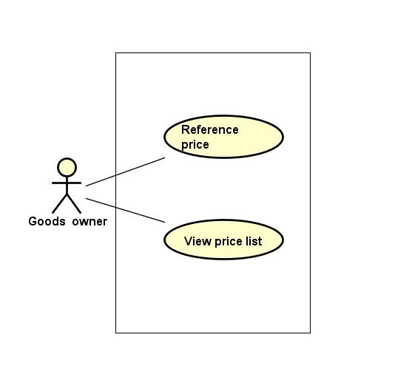

Figure 3.3‑14: Fee list group function

###### View fee list

|  |  |  |  |  |
| --- | --- | --- | --- | --- |
| **Created by:** | | QuyetTD | **Date Created:** | 08/03/2017 |
| **Primary Actor** | | Goods owner | **Secondary Actor** |  |
| **Description:** | | Goods owner want to view list of fee | | |
| **Preconditions:** | | 1. “Hệ Thống” item appear on header of website 2. “BÁO GIÁ” navigator appear on header of website | | |
| **Trigger:** | | “Hệ Thống” item is clicked | | |
| **Post conditions:** | | Display fee list on fee list page | | |
| **Normal Flow** | | | | |
| **Step** | **Actor** | **Action** | | |
| 1 | GWN | Click “BÁO GIÁ” navigator and then choose “Hệ Thống” | | |
| 2 | CTC | Display fee list on fee list page | | |
| **Exceptions: N/A** | | | | |
| **Priority** | | High | | |
| **Frequency of Use:** | | High | | |
| **Business Rules:** | | N/A | | |
| **Other Information:** | | N/A | | |

###### Reference fee

|  |  |  |  |  |
| --- | --- | --- | --- | --- |
| **Created by:** | | QuyetTD | **Date Created:** | 08/03/2017 |
| **Primary Actor** | | Goods owner | **Secondary Actor** |  |
| **Description:** | | Goods owner want to reference actual fee system updated | | |
| **Preconditions:** | | 1. “Tham Chiếu” item appear on header of website 2. “BÁO GIÁ” navigator appear on header of website | | |
| **Trigger:** | | “Tham chiếu” item is clicked | | |
| **Post conditions:** | | Display fee list on fee list page | | |
| **Normal Flow** | | | | |
| **Step** | **Actor** | **Action** | | |
| 1 | GWN | Click “Tham chiếu” item | | |
| 2 | CTC | Display fee list from other website | | |
| **Alternative Flows: N/A** | | | | |
| **Exceptions: N/A** | | | | |
| **Priority** | | Medium | | |
| **Frequency of Use:** | | Medium | | |
| **Business Rules:** | | N/A | | |
| **Other Information:** | | N/A | | |

##### Manage report group function

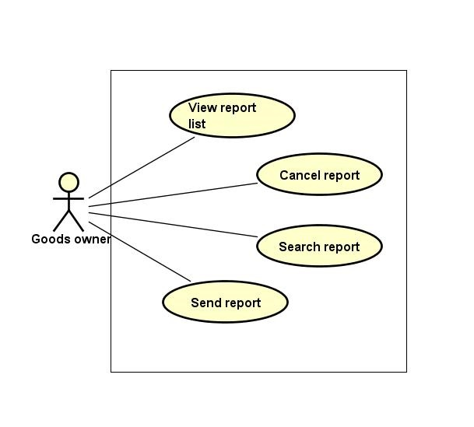

Figure 3.3‑15: Manage report group function

###### Send report

|  |  |  |  |  |  |  |
| --- | --- | --- | --- | --- | --- | --- |
| **Created by:** | | | QuyetTD | | **Date Created:** | 08/03/2017 |
| **Primary Actor** | | | Goods owner | | **Secondary Actor** |  |
| **Description:** | | | Goods owner want to send report to admin | | | |
| **Preconditions:** | | | 1. “BÁO CÁO CỦA TÔI” navigator appear on header of website 2. “Tạo báo cáo mới” button appear on list report user page | | | |
| **Trigger:** | | | “Tạo mới báo cáo” button is clicked | | | |
| **Post conditions:** | | | Send report to admin | | | |
| **Normal Flow** | | | | | | |
| **Step** | **Actor** | | **Action** | | | |
| 1 | GWN | | Click “Tạo mới báo cáo” button | | | |
| 2 | CTC | | Display add new report page includes:   * “Chủ đề bạn muốn báo cáo là gì” input text * “Câu hỏi của bạn là gì” input text * “Bạn mong muốn xử lý như thế nào” input text * “Nội dung báo cáo của bạn” input text * “Gửi phản hồi” button * “Quay lại” button | | | |
| 3 | GWN | | Enter data in fields | | | |
| 4 | GWN | | Click “Gửi phản hồi” button | | | |
| 5 | CTC | | Send report to admin | | | |
| **Alternative Flows:** | | | | | | |
| **AT1** | At step 4, GWN click “Quay lại” button | | | | | |
| **Step** | **Actor** | | **Action** | | | |
| 5.1 | CTC | | Return report list page | | | |
| **AT2** | At step 4 in the main flows, if GWN click other hyperlinks or buttons | | | | | |
| **Step** | **Actor** | | **Action** | | | |
| 5.1 | CTC | | Redirects GWN to chosen hyperlink or button | | | |
| **Exceptions:** | | | | | | |
| **EC1** | | At step 3, required fields are not entered | | | | |
| **Step** | | **Actor** | | **Action** | | |
| 5.1 | | CTC | | Display Register page with message error | | |
| 5.2 | | CTC | | Mark error fields | | |
| **Priority** | | | Medium | | | |
| **Frequency of Use:** | | | Medium | | | |
| **Business Rules:** | | | N/A | | | |
| **Other Information:** | | | N/A | | | |

###### View report list

|  |  |  |  |  |
| --- | --- | --- | --- | --- |
| **Created by:** | | QuyetTD | **Date Created:** | 08/03/2017 |
| **Primary Actor** | | Goods owner | **Secondary Actor** |  |
| **Description:** | | GWN want to view report list | | |
| **Preconditions:** | | “BÁO CÁO CỦA TÔI” navigator appear on header of website | | |
| **Trigger:** | | “BÁO CÁO CỦA TÔI” navigator is clicked | | |
| **Post conditions:** | | Display report list on report list page | | |
| **Normal Flow** | | | | |
| **Step** | **Actor** | **Action** | | |
| 1 | GWN | Click “Báo Cáo Của Tôi” navigator | | |
| 2 | CTC | Display report list on report list page | | |
| **Alternative Flows: N/A** | | | | |
| **Exceptions: N/A** | | | | |
| **Priority** | | Medium | | |
| **Frequency of Use:** | | High | | |
| **Business Rules:** | | N/A | | |
| **Other Information:** | | N/A | | |

###### Search report

|  |  |  |  |  |  |  |
| --- | --- | --- | --- | --- | --- | --- |
| **Created by:** | | | QuyetTD | | **Date Created:** | 08/03/2017 |
| **Primary Actor** | | | Goods owner | | **Secondary Actor** |  |
| **Description:** | | | Goods owner want to find a report in report list | | | |
| **Preconditions:** | | | 1. “BÁO CÁO CỦA TÔI” navigator appear header of website 2. Search box appear on list report user page | | | |
| **Trigger:** | | | “BÁO CÁO CỦA TÔI” navigator appear header of website | | | |
| **Post conditions:** | | | Display report on report list page | | | |
| **Normal Flow** | | | | | | |
| **Step** | **Actor** | | **Action** | | | |
| 1 | GWN | | GWN click “Quản Lý Report” navigator | | | |
| 2 | CTC | | Display search page includes:   * “Tên tài khoản” * “Tên người dung” * “Tiêu đề báo cáo” * “Tìm kiếm” button * “ngày bắt đầu” input text * “ngày kết thúc” input text | | | |
| 3 | GWN | | Enter data in fields | | | |
| 4 | GWN | | Click “Tìm kiếm” button | | | |
| 5 | CTC | | Display result on report list page | | | |
| **Alternative Flows:** | | | | | | |
| **AT1** | | At step 4 in the main flows, if GWN click other hyperlinks or buttons | | | | |
| **Step** | | **Actor** | | **Action** | | |
| 5.1 | | CTC | | Redirects GWN to chosen hyperlink or button | | |
| **Exceptions: N/A** | | | | | | |
| **Priority** | | | Medium | | | |
| **Frequency of Use:** | | | Medium | | | |
| **Business Rules:** | | | N/A | | | |
| **Other Information:** | | | N/A | | | |

###### Cancel report

|  |  |  |  |  |
| --- | --- | --- | --- | --- |
| **Created by:** | | QuyetTD | **Date Created:** | 08/03/2017 |
| **Primary Actor** | | Goods owner | **Secondary Actor** |  |
| **Description:** | | GWN want to cancel their report | | |
| **Preconditions:** | | “BÁO CÁO CỦA TÔI” navigator appear on header of website | | |
| **Trigger:** | | “BÁO CÁO CỦA TÔI” navigator is clicked | | |
| **Post conditions:** | | Cancel this report | | |
| **Normal Flow** | | | | |
| **Step** | **Actor** | **Action** | | |
| 1 | GWN | Click “Báo Cáo Của Tôi” navigator | | |
| 2 | GWN | Click cancel report icon | | |
| 2 | CTC | Cancel this report | | |
| **Alternative Flows: N/A** | | | | |
| **Exceptions: N/A** | | | | |
| **Priority** | | Medium | | |
| **Frequency of Use:** | | High | | |
| **Business Rules:** | | N/A | | |
| **Other Information:** | | N/A | | |

##### Manage profile group function

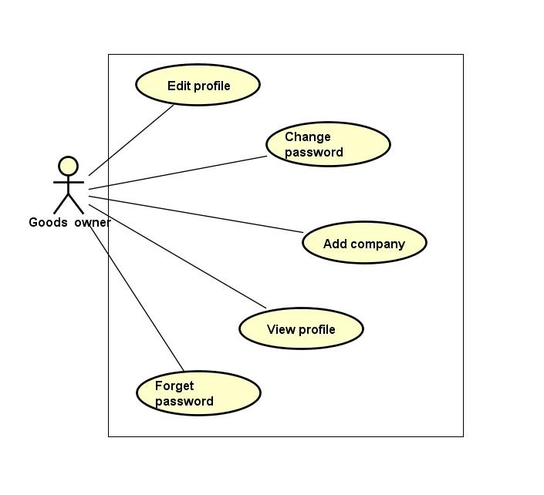

Figure 3.3‑16: Manage profile group function

###### Edit profile

|  |  |  |  |  |
| --- | --- | --- | --- | --- |
| **Created by:** | | QuyetTD | **Date Created:** | 08/03/2017 |
| **Primary Actor** | | Goods owner | **Secondary Actor** |  |
| **Description:** | | Goods owner want to edit goods owner profile | | |
| **Preconditions:** | | “Thay Đổi” button appear on detail user view page | | |
| **Trigger:** | | “Thay Đổi” button on detail user view page is clicked | | |
| **Post conditions:** | | Save goods owner profile in database | | |
| **Normal Flow** | | | | |
| **Step** | **Actor** | **Action** | | |
| 1 | GWN | Hover mouser to user name label and click “Chỉnh Sửa Thông Tin” item | | |
| 2 | CTC | Display pop-up includes:   * “Chọn ảnh” file chooser * “Họ tên” input text * “Bạn là” (phân quyền quản trị) check box * “Email” input text * “Địa chỉ” input text * “Chứng minh thư” input text * “Ngày cấp thẻ” date picker * “Ngày tham gia” date picker * “Thay Đổi” button | | |
| 3 | GWN | Change data in this fields | | |
| 4 | GWN | Click “Lưu Thay Đổi” button | | |
| 5 | CTC | Save changed in database | | |
| 6 | CTC | Display changed on user detail page | | |
| **Alternative Flows:** | | | | |
| **AT1** | At step 4, GWN click “x” in pop-up | | | |
| **Step** | **Actor** | **Action** | | |
| 4.1 | GWN | click “x” in pop-up | | |
| 6.1 | CTC | Display user detail page | | |
| **AT2** | At step 4 in the main flows, if GWN click other hyperlinks or buttons | | | |
| **Step** | **Actor** | **Action** | | |
| 6.1 | CTC | Redirects GWN to chosen hyperlink or button | | |
| **Exceptions: N/A** | | | | |
| **Priority** | | Medium | | |
| **Frequency of Use:** | | Medium | | |
| **Business Rules:** | | N/A | | |
| **Other Information:** | | N/A | | |

###### Change password

|  |  |  |  |  |  |  |
| --- | --- | --- | --- | --- | --- | --- |
| **Created by:** | | | QuyetTD | | **Date Created:** | 08/03/2017 |
| **Primary Actor** | | | Goods owner | | **Secondary Actor** |  |
| **Description:** | | | GWN want to change their password for security | | | |
| **Preconditions:** | | | “Thay đổi mật khẩu” item appear on top navigator | | | |
| **Trigger:** | | | “Thay đổi mật khẩu” item is clicked | | | |
| **Post conditions:** | | | Change password of goods owner | | | |
| **Normal Flow** | | | | | | |
| **Step** | **Actor** | | **Action** | | | |
| 1 | GWN | | Hover mouse to user name label and click “Đổi mật khẩu” item | | | |
| 2 | CTC | | Display change password page includes:   * “Mật khẩu cũ” input text * “Mật khẩu mới” input text * “Xác nhận mật khẩu” input text * “Đổi mật khẩu” button | | | |
| 3 | GWN | | Enter data in this fields | | | |
| 4 | GWN | | Click “Đổi mật khẩu” button | | | |
| 5 | CTC | | Save new password in database | | | |
| 6 | CTC | | Display “Thay đổi thành công” message on pop-up | | | |
| **Alternative Flows: N/A** | | | | | | |
| **AT1** | At step 4 in the main flows, if GWN click other hyperlinks or buttons | | | | | |
| **Step** | **Actor** | | **Action** | | | |
| 6.1 | CTC | | Redirects GWN to chosen hyperlink or button | | | |
| **Exceptions:** | | | | | | |
| **EC1** | | At step 3, required fields are not entered | | | | |
| **Step** | | **Actor** | | **Action** | | |
| 6.1 | | CTC | | Display Register page with message error | | |
| 6.2 | | CTC | | Mark error fields | | |
| **EC2** | | At step 3, fields are entered with wrong type of data | | | | |
| **Step** | | **Actor** | | **Action** | | |
| 6.1 | | CTC | | Display Register page with message error | | |
| 6.2 | | CTC | | Mark error fields | | |
| **EC3** | | At step 3, password is wrong | | | | |
| **Step** | | **Actor** | | **Action** | | |
| 6.1 | | CTC | | Display Register page with message error | | |
| 6.2 | | CTC | | Mark error fields | | |
| **EC4** | | At step 3, new password and confirm password are not match | | | | |
| **Step** | | **Actor** | | **Action** | | |
| 6.1 | | CTC | | Display Register page with message error | | |
| 6.2 | | CTC | | Mark error fields | | |
| **Priority** | | | Medium | | | |
| **Frequency of Use:** | | | Medium | | | |
| **Business Rules:** | | | B12, B15 | | | |
| **Other Information:** | | | N/A | | | |

###### Add company

|  |  |  |  |  |  |
| --- | --- | --- | --- | --- | --- |
| **Created by:** | | | QuyetTD | **Date Created:** | 08/03/2017 |
| **Primary Actor** | | | Goods owner | **Secondary Actor** |  |
| **Description:** | | | Goods owner want to add company information to their profile. | | |
| **Preconditions:** | | | “Thêm mới” button appear below “THÔNG TIN CÔNG TY” label | | |
| **Trigger:** | | | “Thêm mới” button on view user detail page is clicked | | |
| **Post conditions:** | | | Add company information to user | | |
| **Normal Flow** | | | | | |
| **Step** | **Actor** | | **Action** | | |
| 1 | GWN | | Click “Thêm thông tin công ty” button on view user detail page | | |
| 2 | CTC | | Display add company information for user pop-up includes:   * “Tên công ty” input text * “Email” input text * “Số điện thoại” input text * “Fax” input text * “Địa chỉ” input text * “Mã số thuế” input text * “Hủy bỏ” button | | |
| 3 | GWN | | * Enter data on fields * Click “Xác nhận” button | | |
| 4 | CTC | | * Add company information for user | | |
| **Alternative Flows: N/A** | | | | | |
| **AT1** | At step 3 in the main flows, GWN click “Hủy bỏ” button | | | | |
| **Step** | **Actor** | | **Action** | | |
| 4.1 | CTC | | Close “Thêm thông tin công ty” pop-up | | |
| **Exceptions: N/A** | | | | | |
| **EC1** | | At step 3, required fields are not entered | | | |
| **Step** | | **Actor** | **Action** | | |
| 6.1 | | CTC | Display Register page with message error | | |
| 6.2 | | CTC | Mark error fields | | |
| **EC2** | | At step 3, fields are entered with wrong type of data | | | |
| **Step** | | **Actor** | **Action** | | |
| 6.1 | | CTC | Display Register page with message error | | |
| 6.2 | | CTC | Mark error fields | | |
| **Priority** | | | Medium | | |
| **Frequency of Use:** | | | Medium | | |
| **Business Rules:** | | | N/A | | |
| **Other Information:** | | | N/A | | |

###### Forget password

|  |  |  |  |  |
| --- | --- | --- | --- | --- |
| **Created by:** | | QuyetTD | **Date Created:** | 08/03/2017 |
| **Primary Actor** | | Goods owner | **Secondary Actor** |  |
| **Description:** | | Goods owner forget password. They want to reset password | | |
| **Preconditions:** | | “Quên mật khẩu” label appear on login page | | |
| **Trigger:** | | “Quên mật khẩu” label on login page is clicked | | |
| **Post conditions:** | | System send new password to goods owner’s email | | |
| **Normal Flow** | | | | |
| **Step** | **Actor** | **Action** | | |
| 1 | GWN | GWN click “Quên mật khẩu” on login page | | |
| 2 | CTC | Display forget password page includes:   * “Email đăng ký” input text * “Gửi” button | | |
| 3 | GWN | Enter email address they use for register goods owner account | | |
| 4 | CTC | Send new password to goods owner’s email address | | |
| **Alternative Flows: N/A** | | | | |
| **Exceptions: N/A** | | | | |
| **Priority** | | Medium | | |
| **Frequency of Use:** | | High | | |
| **Business Rules:** | | B22 | | |
| **Other Information:** | | N/A | | |

###### View profile

|  |  |  |  |  |
| --- | --- | --- | --- | --- |
| **Created by:** | | QuyetTD | **Date Created:** | 08/03/2017 |
| **Primary Actor** | | Goods owner | **Secondary Actor** |  |
| **Description:** | | Goods owner want to view admin’s profile | | |
| **Preconditions:** | | “Thông Tin Cá Nhân” item appear on top navigator | | |
| **Trigger:** | | “Thông Tin Cá Nhân” item is clicked | | |
| **Post conditions:** | | Display GWN profile | | |
| **Normal Flow** | | | | |
| **Step** | **Actor** | **Action** | | |
| 1 | GWN | Hover mouse to user name label and click “Thông Tin Cá Nhân” item | | |
| 2 | CTC | Display user detail on user detail page | | |
| **Alternative Flows: N/A** | | | | |
| **Exceptions: N/A** | | | | |
| **Priority** | | Medium | | |
| **Frequency of Use:** | | High | | |
| **Business Rules:** | | N/A | | |
| **Other Information:** | | N/A | | |

##### Transaction history group function

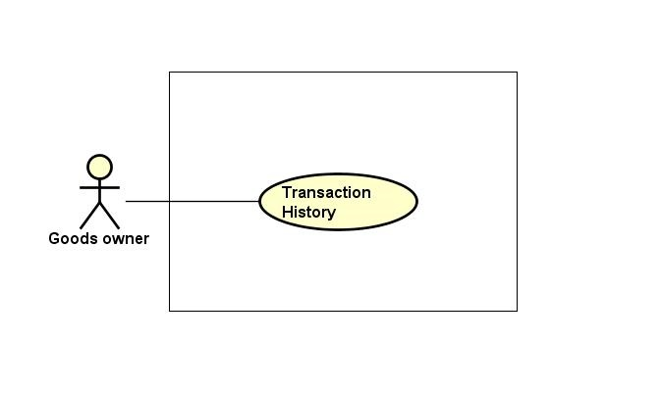

Figure 3.3‑17: Transaction group function

###### Transaction history

|  |  |  |  |  |
| --- | --- | --- | --- | --- |
| **Created by:** | | QuyetTD | **Date Created:** | 08/03/2017 |
| **Primary Actor** | | Goods owner | **Secondary Actor** |  |
| **Description:** | | Goods owner want to check money in account and what did they do with money | | |
| **Preconditions:** | | “Thông tin giao dịch” item appear on top navigator | | |
| **Trigger:** | | “Thông tin giao dịch” item is clicked | | |
| **Post conditions:** | | Display money in account and transaction history | | |
| **Normal Flow** | | | | |
| **Step** | **Actor** | **Action** | | |
| 1 | GWN | Hover mouse to user name and Click “Thông tin giao dịch” item | | |
| 2 | CTC | Display money in account and transaction history | | |
| **Alternative Flows: N/A** | | | | |
| **Exceptions: N/A** | | | | |
| **Priority** | | Medium | | |
| **Frequency of Use:** | | Medium | | |
| **Business Rules:** | | N/A | | |
| **Other Information:** | | N/A | | |

##### Account recharge group function

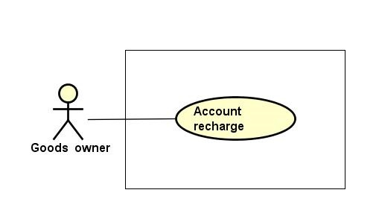

Figure 3.3‑18: Account recharge group function

###### Account recharge

|  |  |  |  |  |
| --- | --- | --- | --- | --- |
| **Created by:** | | QuyetTD | **Date Created:** | 08/03/2017 |
| **Primary Actor** | | Goods owner | **Secondary Actor** |  |
| **Description:** | | Goods owner want to account recharge to account for post bill of lading | | |
| **Preconditions:** | | “Nạp tiền vào tài khoản” item appear on top navigator | | |
| **Trigger:** | | “Nạp tiền vào tài khoản” item is clicked | | |
| **Post conditions:** | | Recharge the user account | | |
| **Normal Flow** | | | | |
| **Step** | **Actor** | **Action** | | |
| 1 | GWN | Hover mouse to user name and Click “Nạp tiền vào tài khoản” button | | |
| 2 | CTC | Display “nganluong.vn” website includes 3 item for 3 way to recharge to account:   * “Ví điện thứ Ngân Lượng” button * “Thẻ cào điện thoại” button * “Online bằng thẻ ATM\Internet banking” button * “Chuyển khoản ngân hàng” button | | |
| 3 | GWN | Click one of three button for choose how to recharge to account | | |
| 4 | CTC | Display the way user chose to recharge account | | |
| 5 | GWN | GWN do something follow “Ngân Lượng” guide | | |
| 6 | CTC | Add money to user account | | |
| **Alternative Flows:** | | | | |
| **AT1** | At step 4 in the main flows, if GWN click other hyperlinks or buttons | | | |
| **Step** | **Actor** | **Action** | | |
| 5.1 | CTC | Redirects user to chosen hyperlink or button | | |
| **Exceptions: N/A** | | | | |
| **Priority** | | High | | |
| **Frequency of Use:** | | High | | |
| **Business Rules:** | | N/A | | |
| **Other Information:** | | N/A | | |

##### Connect to carrier group function

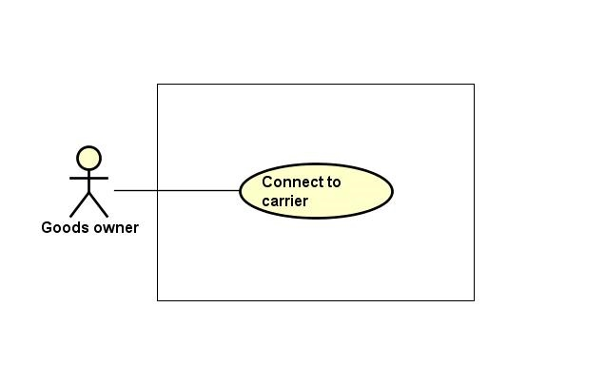

Figure 3.3‑19: Connect to carrier group function

###### Connect to carrier

|  |  |  |  |  |
| --- | --- | --- | --- | --- |
| **Created by:** | | QuyetTD | **Date Created:** | 08/03/2017 |
| **Primary Actor** | | Goods owner | **Secondary Actor** |  |
| **Description:** | | Goods owner want to connect to carrier | | |
| **Preconditions:** | | Bill of lading is successful | | |
| **Trigger:** | | “Reply” item on bill of lading detail page is clicked | | |
| **Post conditions:** | | Send comment to carrier | | |
| **Normal Flow** | | | | |
| **Step** | **Actor** | **Action** | | |
| 1 | GWN | Click “Chi Tiết” on a bill of lading | | |
| 2 | CTC | Display bill of lading detail comment includes:   * “Hỏi Đáp” input text | | |
| 3 | GWN | Enter data in fields | | |
| 4 | GWN | Press enter key word on keyboard | | |
| 5 | CTC | Send comment to carrier | | |
| **Alternative Flows:** | | | | |
| **AT1** | At step 4 in the main flows, if GWN click other hyperlinks or buttons | | | |
| **Step** | **Actor** | **Action** | | |
| 5.1 | CTC | Redirects user to chosen hyperlink or button | | |
| **Exceptions: N/A** | | | | |
| **Priority** | | Medium | | |
| **Frequency of Use:** | | Medium | | |
| **Business Rules:** | | B14 | | |
| **Other Information:** | | N/A | | |

##### Login group function

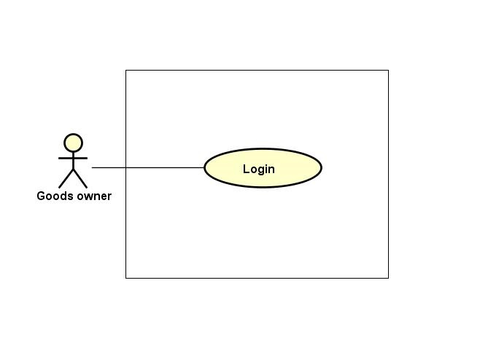

Figure 3.3‑20: Login group function

###### Login

|  |  |  |  |  |  |
| --- | --- | --- | --- | --- | --- |
| **Created by:** | | | QuyetTD | **Date Created:** | 08/03/2017 |
| **Primary Actor** | | | Goods owner | **Secondary Actor** |  |
| **Description:** | | | Goods owner want to login to CTC system for work | | |
| **Preconditions:** | | | “Đăng nhập” button appear on login page | | |
| **Trigger:** | | | “Đăng nhập” button on login page is clicked | | |
| **Post conditions:** | | | GWN login to CTC system | | |
| **Normal Flow** | | | | | |
| **Step** | **Actor** | | **Action** | | |
| 1 | GWN | | Click “Đăng nhập” on homepage | | |
| 2 | CTC | | Display login page includes:   * “Email” input text * “Mật khẩu” input text * “Đăng nhập” button | | |
| 3 | GWN | | Enter data in fields | | |
| 4 | CTC | | Login account to CTC | | |
| **Alternative Flows: N/A** | | | | | |
| **Exceptions:** | | | | | |
| **EC1** | | At step 4, required fields are not entered | | | |
| **Step** | | **Actor** | **Action** | | |
| 4.1 | | CTC | Display Register page with message error | | |
| 4.2 | | CTC | Mark error fields | | |
| **EC2** | | At step 4, fields are entered with wrong type of data | | | |
| **Step** | | **Actor** | **Action** | | |
| 4.1 | | CTC | Display Register page with message error | | |
| 4.2 | | CTC | Mark error fields | | |
| **Priority** | | | High | | |
| **Frequency of Use:** | | | High | | |
| **Business Rules:** | | | B2, B11 | | |
| **Other Information:** | | | N/A | | |

##### Logout group function

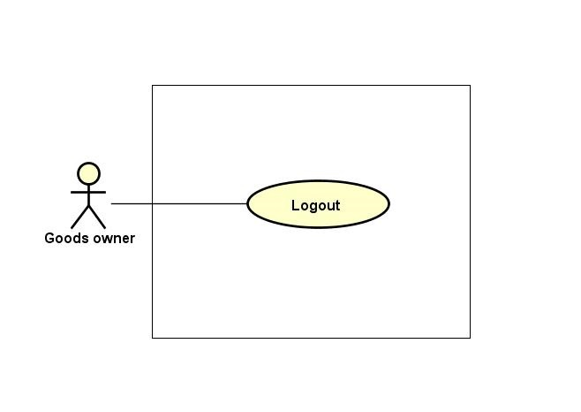

Figure 3.3‑21: Logout group function

###### Logout

|  |  |  |  |  |
| --- | --- | --- | --- | --- |
| **Created by:** | | QuyetTD | **Date Created:** | 08/03/2017 |
| **Primary Actor** | | Goods owner | **Secondary Actor** |  |
| **Description:** | | Goods owner want to logout CTC system | | |
| **Preconditions:** | | “Đăng xuất” button appear on top navigator | | |
| **Trigger:** | | “Đăng xuất” button is clicked | | |
| **Post conditions:** | | Logout Goods owner account | | |
| **Normal Flow** | | | | |
| **Step** | **Actor** | **Action** | | |
| 1 | GWN | Click “Đăng xuất” in website | | |
| 2 | CTC | Logout Goods owner account | | |
| 3 | CTC | Return homepage | | |
| **Alternative Flows: N/A** | | | | |
| **Exceptions: N/A** | | | | |
| **Priority** | | High | | |
| **Frequency of Use:** | | High | | |
| **Business Rules:** | | N/A | | |
| **Other Information:** | | N/A | | |

#### Admin Group Function

##### Bill of lading list group function

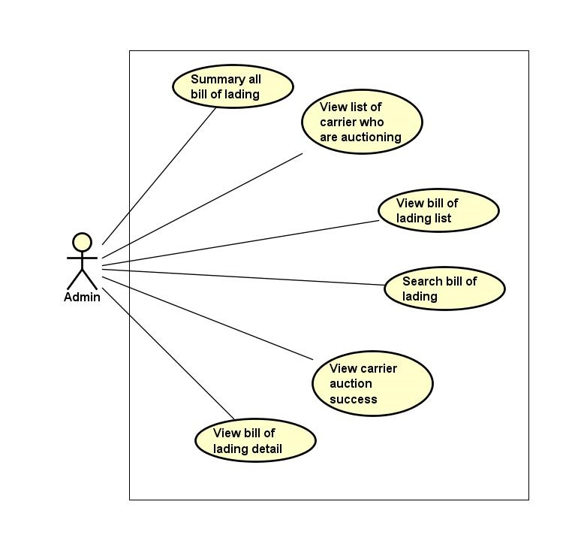

Figure 3.3‑22: Bill of lading list group function

###### Summary all bill of lading

|  |  |  |  |  |  |  |
| --- | --- | --- | --- | --- | --- | --- |
| **Created by:** | | | QuyetTD | | **Date Created:** | 08/03/2017 |
| **Primary Actor** | | | Administration | | **Secondary Actor** |  |
| **Description:** | | | Admin want to summary all bill of lading by bill of lading detail | | | |
| **Preconditions:** | | | “THỐNG KÊ VẬN ĐƠN” navigator appear on header of website | | | |
| **Trigger:** | | | “THỐNG KÊ VẬN ĐƠN” navigator on header is clicked | | | |
| **Post conditions:** | | | Summary all bill of lading and display result on summary bill of lading page | | | |
| **Normal Flow** | | | | | | |
| **Step** | **Actor** | | **Action** | | | |
| 1 | Admin | | Click “Thống Kê Vận Đơn” navigator | | | |
| 2 | CTC | | Display summary bill of lading page includes:   * “Loại hàng select box * “Hình thức đóng gói” select box * “Khối lượng” input text * “Thể tích” input text * “Địa điểm đi” select box * “Địa điểm đến” select box * “Thời gian đi” input text * “Thời gian đến” input text * “Tìm Kiếm” buttons | | | |
| 3 | Admin | | Enter data in this fields | | | |
| 4 | Admin | | Click “Tìm Kiếm” button | | | |
| 5 | CTC | | Summary all bill of lading | | | |
| 6 | CTC | | Display result on this page | | | |
| **Alternative Flows:** | | | | | | |
| **AT1** | | At step 4 in the main flows, if admin click other hyperlinks or buttons | | | | |
| **Step** | | **Actor** | | **Action** | | |
| 6.1 | | CTC | | Redirects user to chosen hyperlink or button | | |
| **Exceptions: N/A** | | | | | | |
| **Priority** | | | Medium | | | |
| **Frequency of Use:** | | | Medium | | | |
| **Business Rules:** | | | N/A | | | |
| **Other Information:** | | | N/A | | | |

###### View bill of lading list

|  |  |  |  |  |
| --- | --- | --- | --- | --- |
| **Created by:** | | QuyetTD | **Date Created:** | 08/03/2017 |
| **Primary Actor** | | Administration | **Secondary Actor** |  |
| **Description:** | | Admin want to view all bill of lading | | |
| **Preconditions:** | | “Tìm Hàng Chuyển” navigator appear on header of website | | |
| **Trigger:** | | “Tìm Hàng Chuyển” navigator is clicked | | |
| **Post conditions:** | | Display bill of lading list on common page | | |
| **Normal Flow** | | | | |
| **Step** | **Actor** | **Action** | | |
| 1 | Admin | Click “Tìm Hàng Chuyển” navigator | | |
| 2 | CTC | Display bill of lading list on common page | | |
| **Alternative Flows: N/A** | | | | |
| **Exceptions: N/A** | | | | |
| **Priority** | | Medium | | |
| **Frequency of Use:** | | High | | |
| **Business Rules:** | | N/A | | |
| **Other Information:** | | N/A | | |

###### Search bill of lading

|  |  |  |  |  |
| --- | --- | --- | --- | --- |
| **Created by:** | | QuyetTD | **Date Created:** | 08/03/2017 |
| **Primary Actor** | | Administration | **Secondary Actor** |  |
| **Description:** | | User want to find a bill of lading | | |
| **Preconditions:** | | 1. “Tìm Hàng Chuyển” navigator appear on header of website 2. Search box appear on common page | | |
| **Trigger:** | | “Tìm Hàng Chuyển” navigator is clicked | | |
| **Post conditions:** | | Display bill of lading system found | | |
| **Normal Flow** | | | | |
| **Step** | **Actor** | **Action** | | |
| 1 | Admin | Click “Tìm Hàng Chuyển” navigator one website | | |
| 2 | CTC | Display summary bill of lading page includes:   * “Loại hàng select box * “Hình thức đóng gói” select box * “Khối lượng” input text * “Thể tích” input text * “Địa điểm đi” select box * “Địa điểm đến” input text * “Thời gian đi” Date picker * “Thời gian đến” Date text * “Trạng thái” select box * “Tìm Kiếm” buttons | | |
| 3 | Admin | Enter data in this fields | | |
| 4 | Admin | Click “Tìm Kiếm” button search page | | |
| 5 | CTC | Display result on common page | | |
| **Alternative Flows:** | | | | |
| **AT1** | At step 4 in the main flows, if user click other hyperlinks or buttons | | | |
| **Step** | **Actor** | **Action** | | |
| 5.1 | CTC | Redirects user to chosen hyperlink or button | | |
| **Exceptions: N/A** | | | | |
| **Priority** | | High | | |
| **Frequency of Use:** | | High | | |
| **Business Rules:** | | N/A | | |
| **Other Information:** | | N/A | | |

###### View bill of lading detail

|  |  |  |  |  |
| --- | --- | --- | --- | --- |
| **Created by:** | | QuyetTD | **Date Created:** | 08/03/2017 |
| **Primary Actor** | | Administration | **Secondary Actor** |  |
| **Description:** | | Admin want to view bill of lading detail, they send request to system and then get result | | |
| **Preconditions:** | | 1. “Tìm Hàng Chuyển” navigator appear on homepage 2. Detail icon appear on bill of lading detail page | | |
| **Trigger:** | | Detail icon of bill of lading is clicked | | |
| **Post conditions:** | | Display bill of lading detail on this page | | |
| **Normal Flow** | | | | |
| **Step** | **Actor** | **Action** | | |
| 1 | Admin | Click “Tim Hàng Vận Chuyển” navigator | | |
| 2 | CTC | Display bill of lading list page | | |
| 3 | Admin | Click “Chi Tiết” on bill of lading | | |
| 4 | CTC | Display bill of lading detail on this page | | |
| **Alternative Flows: N/A** | | | | |
| **Exceptions: N/A** | | | | |
| **Priority** | | High | | |
| **Frequency of Use:** | | High | | |
| **Business Rules:** | | B33 | | |
| **Other Information:** | | N/A | | |

###### View carrier auction success

|  |  |  |  |  |
| --- | --- | --- | --- | --- |
| **Created by:** | | QuyetTD | **Date Created:** | 08/03/2017 |
| **Primary Actor** | | Administration | **Secondary Actor** |  |
| **Description:** | | Admin want to view who auction bill of lading successful | | |
| **Preconditions:** | | 1. Bill of lading is successful 2. Detail icon of bill of lading appear bill of lading detail page | | |
| **Trigger:** | | Detail icon of bill of lading appear bill of lading detail page is clicked | | |
| **Post conditions:** | | Display who are auction success on bill of lading detail page | | |
| **Normal Flow** | | | | |
| **Step** | **Actor** | **Action** | | |
| 1 | Admin | Click “Tim Hàng Vận Chuyển” navigator | | |
| 2 | CTC | Display bill of lading list page | | |
| 3 | Admin | Click “Chi Tiết” on “Tìm Hàng Chuyển” page | | |
| 4 | CTC | Display who are auction success on detail page | | |
| **Alternative Flows: N/A** | | | | |
| **Exceptions: N/A** | | | | |
| **Priority** | | Medium | | |
| **Frequency of Use:** | | Medium | | |
| **Business Rules:** | | B33 | | |
| **Other Information:** | | N/A | | |

###### View list carrier who are auctioning

|  |  |  |  |  |
| --- | --- | --- | --- | --- |
| **Created by:** | | QuyetTD | **Date Created:** | 08/03/2017 |
| **Primary Actor** | | Administration | **Secondary Actor** |  |
| **Description:** | | Admin want to know who are auctioning. Admin send request to system and get result | | |
| **Preconditions:** | | 1. Bill of lading is auctioning 2. Detail icon of bill of lading appear bill of lading detail page | | |
| **Trigger:** | | Detail icon of bill of lading appear bill of lading detail page is clicked | | |
| **Post conditions:** | | Display who are auctioning on bill of lading detail page | | |
| **Normal Flow** | | | | |
| **Step** | **Actor** | **Action** | | |
| 1 | Admin | Click “Tim Hàng Vận Chuyển” navigator | | |
| 2 | CTC | Display bill of lading list page | | |
| 3 | Admin | Click detail icon on bill of lading | | |
| 4 | CTC | Display who are auctioning on bill of lading detail page | | |
| **Alternative Flows: N/A** | | | | |
| **Exceptions: N/A** | | | | |
| **Priority** | | Medium | | |
| **Frequency of Use:** | | High | | |
| **Business Rules:** | | N/A | | |
| **Other Information:** | | N/A | | |

##### Manage user group function

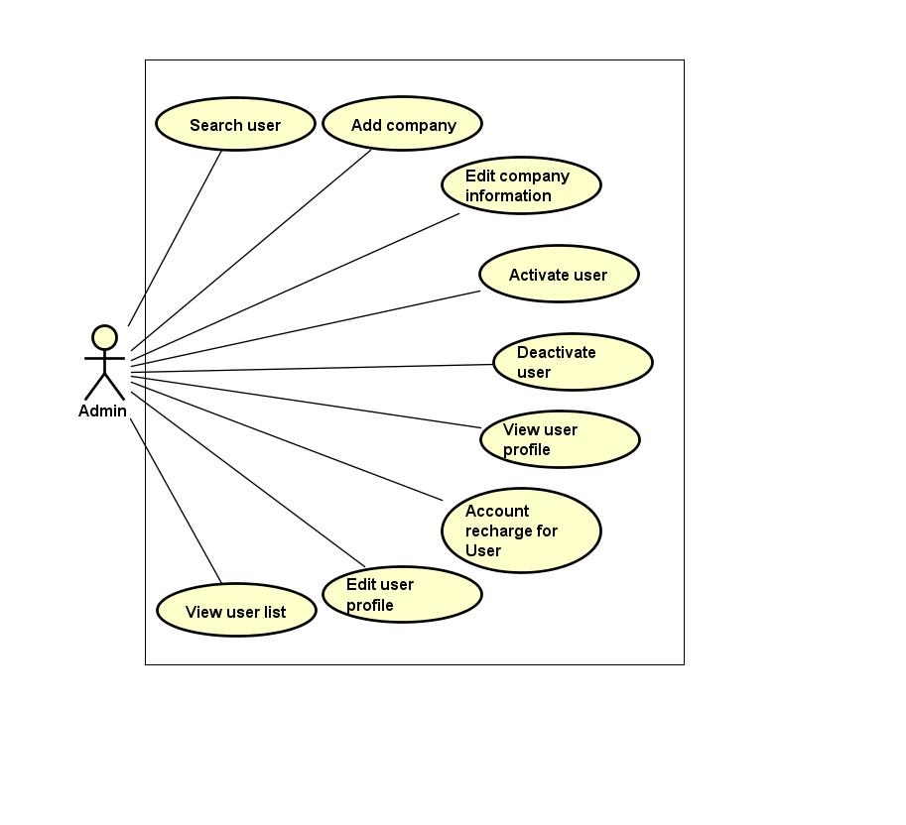

Figure 3.3‑23: Manage user group function

###### Search user

|  |  |  |  |  |
| --- | --- | --- | --- | --- |
| **Created by:** | | QuyetTD | **Date Created:** | 08/03/2017 |
| **Primary Actor** | | Administration | **Secondary Actor** |  |
| **Description:** | | Admin want to find a user in user list. Admin send request to system and then get result | | |
| **Preconditions:** | | 1. “QUẢN LÝ NGƯỜI DÙNG” navigator appear on header of website 2. Search box appear on list user page | | |
| **Trigger:** | | “QUẢN LÝ NGƯỜI DÙNG” navigator is clicked | | |
| **Post conditions:** | | Display user list by require of admin on list user page | | |
| **Normal Flow** | | | | |
| **Step** | **Actor** | **Action** | | |
| 1 | Admin | Click “Quản Lý User” navigator | | |
| 2 | CTC | Display search user page includes:   * “Tên người dùng” input text * “email” input text * “Tỉnh” input text * “Quyền truy cập”select box * “Tìm kiếm” button | | |
| 3 | Admin | Enter data in all or more than one fields | | |
| 4 | Admin | Click “Tìm Kiếm” button on manage user page | | |
| 5 | CTC | Display user list by require of admin on list user page | | |
| **Alternative Flows:** | | | | |
| **AT1** | At step 4 in the main flows, if user click other hyperlinks or buttons | | | |
| **Step** | **Actor** | **Action** | | |
| 5.1 | CTC | Redirects admin to chosen hyperlink or button | | |
| **Exceptions: N/A** | | | | |
| **Priority** | | Medium | | |
| **Frequency of Use:** | | Medium | | |
| **Business Rules:** | | N/A | | |
| **Other Information:** | | N/A | | |

###### View user profile

|  |  |  |  |  |
| --- | --- | --- | --- | --- |
| **Created by:** | | QuyetTD | **Date Created:** | 08/03/2017 |
| **Primary Actor** | | Administration | **Secondary Actor** |  |
| **Description:** | | Admin want to view user profile | | |
| **Preconditions:** | | 1. “QUẢN LÝ NGƯỜI DÙNG” navigator appear on header of website 2. Detail icon of bill of lading appear on list user page | | |
| **Trigger:** | | Detail icon of bill of lading is clicked | | |
| **Post conditions:** | | Display user detail on user detail page | | |
| **Normal Flow** | | | | |
| **Step** | **Actor** | **Action** | | |
| 1 | Admin | Click “Chi Tiết” on user detail page | | |
| 2 | CTC | Display user detail on user detail page | | |
| **Alternative Flows: N/A** | | | | |
| **Exceptions: N/A** | | | | |
| **Priority** | | Medium | | |
| **Frequency of Use:** | | Medium | | |
| **Business Rules:** | | B27 | | |
| **Other Information:** | | N/A | | |

###### Edit company information

|  |  |  |  |  |  |
| --- | --- | --- | --- | --- | --- |
| **Created by:** | | | QuyetTD | **Date Created:** | 08/03/2017 |
| **Primary Actor** | | | Administration | **Secondary Actor** |  |
| **Description:** | | | Admin want to add company information to user. | | |
| **Preconditions:** | | | 1. “QUẢN LÝ NGƯỜI DÙNG” navigator appear on header of website 2. Detail icon of user detail appear on user detail page 3. “Thay Đổi” button appear on “Thông Tin Công Ty” box | | |
| **Trigger:** | | | “Thay Đổi” button is clicked | | |
| **Post conditions:** | | | Edit company information to user | | |
| **Normal Flow** | | | | | |
| **Step** | **Actor** | | **Action** | | |
| 1 | Admin | | Click “Thay đổi” button on view user company detail | | |
| 2 | CTC | | Display add company information for user pop-up includes:   * “Tên công ty” input text * “Email” input text * “Số điện thoại” input text * “Fax” input text * “Địa chỉ” input text * “Mã số thuế” input text * “Hủy bỏ” button | | |
| 3 | Admin | | * Enter data on fields * Click “Xác nhận” button | | |
| 4 | CTC | | * Edit company information for user | | |
| **Alternative Flows: N/A** | | | | | |
| **AT1** | At step 3 in the main flows, admin click “Hủy bỏ” button | | | | |
| **Step** | **Actor** | | **Action** | | |
| 4.1 | CTC | | Close “Chỉnh sửa thông tin công ty” pop-up | | |
| **Exceptions: N/A** | | | | | |
| **EC1** | | At step 3, required fields are not entered | | | |
| **Step** | | **Actor** | **Action** | | |
| 6.1 | | CTC | Display Register page with message error | | |
| 6.2 | | CTC | Mark error fields | | |
| **EC2** | | At step 3, fields are entered with wrong type of data | | | |
| **Step** | | **Actor** | **Action** | | |
| 6.1 | | CTC | Display Register page with message error | | |
| 6.2 | | CTC | Mark error fields | | |
| **Priority** | | | Medium | | |
| **Frequency of Use:** | | | Medium | | |
| **Business Rules:** | | | N/A | | |
| **Other Information:** | | | N/A | | |

###### Edit user profile

|  |  |  |  |  |
| --- | --- | --- | --- | --- |
| **Created by:** | | QuyetTD | **Date Created:** | 08/03/2017 |
| **Primary Actor** | | Administration | **Secondary Actor** |  |
| **Description:** | | Admin want to change user profile | | |
| **Preconditions:** | | 1. “QUẢN LÝ NGƯỜI DÙNG” navigator appear on header of website 2. Detail icon of user detail appear on user detail page 3. “Thay Đổi” button appear on “Thông Tin Cá Nhân” box | | |
| **Trigger:** | | “Thay Đổi” button appear on “Thông Tin Cá Nhân” box is clicked | | |
| **Post conditions:** | | Save user profile in database and display user profile one detail user view page | | |
| **Normal Flow** | | | | |
| **Step** | **Actor** | **Action** | | |
| 1 | Admin | Admin click “Thay Đổi” button | | |
| 2 | CTC | Display pop-up includes:   * “Chọn ảnh” file chooser * “Họ tên” input text * “Bạn là” (phân quyền quản trị) check box * “Email” input text * “Địa chỉ” input text * “Chứng minh thư” input text * “Ngày cấp thẻ” date picker * “Ngày tham gia” date picker * “Thay Đổi” button | | |
| 3 | Admin | Change data in this fields | | |
| 4 | Admin | Click “Lưu Thay Đổi” button | | |
| 5 | CTC | Save changed in database | | |
| 6 | CTC | Display changed on detail user view page | | |
| **Alternative Flows:** | | | | |
| **AT1** | At step 4, admin click “x” in pop-up | | | |
| **Step** | **Actor** | **Action** | | |
| 6.1 | CTC | Display user detail page | | |
| **AT2** | At step 4 in the main flows, if user click other hyperlinks or buttons | | | |
| **Step** | **Actor** | **Action** | | |
| 6.1 | CTC | Redirects user to chosen hyperlink or button | | |
| **Exceptions: N/A** | | | | |
| **Priority** | | Medium | | |
| **Frequency of Use:** | | Medium | | |
| **Business Rules:** | | B27 | | |
| **Other Information:** | | N/A | | |

###### Account recharge for user

|  |  |  |  |  |
| --- | --- | --- | --- | --- |
| **Created by:** | | QuyetTD | **Date Created:** | 08/03/2017 |
| **Primary Actor** | | Administration | **Secondary Actor** |  |
| **Description:** | | Admin want to recharge account for user | | |
| **Preconditions:** | | 1. “QUẢN LÝ NGƯỜI DÙNG” navigator appear on header of website 2. Detail icon of user detail appear on user detail page 3. “Nạp tiền” button appear on “Thông Tin Cá Nhân” box | | |
| **Trigger:** | | “Nạp Tiền” button on view user detail page is clicked | | |
| **Post conditions:** | | Recharge account for user | | |
| **Normal Flow** | | | | |
| **Step** | **Actor** | **Action** | | |
| 1 | Admin | Click “Nạp Tiền” button on view user detail page | | |
| 2 | CTC | Display Recharge account for user pop-up includes:   * “Số tiền” input text * “Xác nhận” button * “Hủy bỏ” button | | |
| 3 | Admin | * Enter data on “Số tiền” input text * Click “Xác nhận” button | | |
| 4 | Admin | * Recharge account for user * Updated view user detail page | | |
| **Alternative Flows: N/A** | | | | |
| **AT1** | At step 3 in the main flows, admin click “Hủy bỏ” button | | | |
| **Step** | **Actor** | **Action** | | |
| 4.1 | CTC | Close “Nạp Tiền” pop-up | | |
| **Exceptions: N/A** | | | | |
| **Priority** | | Medium | | |
| **Frequency of Use:** | | Medium | | |
| **Business Rules:** | | N/A | | |
| **Other Information:** | | N/A | | |

###### Activate user

|  |  |  |  |  |
| --- | --- | --- | --- | --- |
| **Created by:** | | QuyetTD | **Date Created:** | 08/03/2017 |
| **Primary Actor** | | Administration | **Secondary Actor** |  |
| **Description:** | | Admin want to active user account. This user can do something on website | | |
| **Preconditions:** | | 1. “QUẢN LÝ NGƯỜI DÙNG” navigator appear on header of website 2. Activate icon of user appear on user detail page 3. User is deactivated | | |
| **Trigger:** | | Activate icon of user appear on user detail page is clicked | | |
| **Post conditions:** | | User become active status | | |
| **Normal Flow** | | | | |
| **Step** | **Actor** | **Action** | | |
| 1 | Admin | Click “Active” button one user list page | | |
| 2 | CTC | Active account to active status | | |
| **Alternative Flows: N/A** | | | | |
| **Exceptions: N/A** | | | | |
| **Priority** | | High | | |
| **Frequency of Use:** | | Medium | | |
| **Business Rules:** | | B27 | | |
| **Other Information:** | | N/A | | |

###### Deactivate user

|  |  |  |  |  |
| --- | --- | --- | --- | --- |
| **Created by:** | | QuyetTD | **Date Created:** | 08/03/2017 |
| **Primary Actor** | | Administration | **Secondary Actor** |  |
| **Description:** | | Admin want to make an account to deactivate. This account can’t work on website | | |
| **Preconditions:** | | 1. “QUẢN LÝ NGƯỜI DÙNG” navigator appear on header of website 2. Activate icon of user appear on user detail page 3. User is active | | |
| **Trigger:** | | Deactivate icon on user list page is clicked | | |
| **Post conditions:** | | Admin is deactivation status and this user can’t work on website | | |
| **Normal Flow** | | | | |
| **Step** | **Actor** | **Action** | | |
| 1 | Admin | Click “Deactivate” button on user list page | | |
| 2 | CTC | Set user to deactivation status | | |
| **Alternative Flows: N/A** | | | | |
| **Exceptions: N/A** | | | | |
| **Priority** | | High | | |
| **Frequency of Use:** | | Medium | | |
| **Business Rules:** | | B27 | | |
| **Other Information:** | | N/A | | |

###### Add company

|  |  |  |  |  |  |
| --- | --- | --- | --- | --- | --- |
| **Created by:** | | | QuyetTD | **Date Created:** | 08/03/2017 |
| **Primary Actor** | | | Administration | **Secondary Actor** |  |
| **Description:** | | | Admin want to add company information to user. | | |
| **Preconditions:** | | | 1. “QUẢN LÝ NGƯỜI DÙNG” navigator appear on header of website 2. Detail icon of user appear on user detail page 3. “Thêm mới” button appear on “Thông tin công ty” box | | |
| **Trigger:** | | | “Thêm mới” button on view user detail page is clicked | | |
| **Post conditions:** | | | Add company information to user | | |
| **Normal Flow** | | | | | |
| **Step** | **Actor** | | **Action** | | |
| 1 | Admin | | Click “Thêm mới” button on view user detail page | | |
| 2 | CTC | | Display add company information for user pop-up includes:   * “Tên công ty” input text * “Email” input text * “Số điện thoại” input text * “Fax” input text * “Địa chỉ” input text * “Mã số thuế” input text * “Hủy bỏ” button | | |
| 3 | Admin | | * Enter data on fields * Click “Xác nhận” button | | |
| 4 | CTC | | * Add company information for user | | |
| **Alternative Flows: N/A** | | | | | |
| **AT1** | At step 3 in the main flows, admin click “Hủy bỏ” button | | | | |
| **Step** | **Actor** | | **Action** | | |
| 4.1 | CTC | | Close “Thêm thông tin công ty” pop-up | | |
| **Exceptions: N/A** | | | | | |
| **EC1** | | At step 3, required fields are not entered | | | |
| **Step** | | **Actor** | **Action** | | |
| 6.1 | | CTC | Display Register page with message error | | |
| 6.2 | | CTC | Mark error fields | | |
| **EC2** | | At step 3, fields are entered with wrong type of data | | | |
| **Step** | | **Actor** | **Action** | | |
| 6.1 | | CTC | Display Register page with message error | | |
| 6.2 | | CTC | Mark error fields | | |
| **Priority** | | | Medium | | |
| **Frequency of Use:** | | | Medium | | |
| **Business Rules:** | | | N/A | | |
| **Other Information:** | | | N/A | | |

###### View user list

|  |  |  |  |  |
| --- | --- | --- | --- | --- |
| **Created by:** | | QuyetTD | **Date Created:** | 08/03/2017 |
| **Primary Actor** | | Administration | **Secondary Actor** |  |
| **Description:** | | Admin want to view user list of CTC | | |
| **Preconditions:** | | “QUẢN LÝ NGƯỜI DÙNG” navigator appear on header of website | | |
| **Trigger:** | | “QUẢN LÝ NGƯỜI DÙNG” navigator is clicked | | |
| **Post conditions:** | | Display user list on list user page | | |
| **Normal Flow** | | | | |
| **Step** | **Actor** | **Action** | | |
| 1 | Admin | Click “Quản lý người dùng” navigator | | |
| 2 | CTC | Display user list on list user page | | |
| **Alternative Flows: N/A** | | | | |
| **Exceptions: N/A** | | | | |
| **Priority** | | Medium | | |
| **Frequency of Use:** | | Medium | | |
| **Business Rules:** | | N/A | | |
| **Other Information:** | | N/A | | |

##### Fee list group function

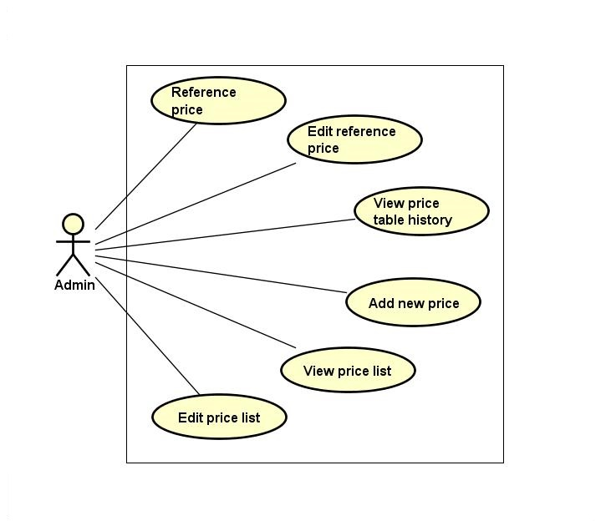

Figure 3.3‑24: Fee list group function

###### View fee list

|  |  |  |  |  |
| --- | --- | --- | --- | --- |
| **Created by:** | | QuyetTD | **Date Created:** | 08/03/2017 |
| **Primary Actor** | | Administration | **Secondary Actor** |  |
| **Description:** | | Admin want to view list of fee | | |
| **Preconditions:** | | 1. “Hệ Thống” item appear on header of website 2. “BÁO GIÁ” navigator appear on header of website | | |
| **Trigger:** | | “Hệ Thống” item is clicked | | |
| **Post conditions:** | | Display fee list on fee list page | | |
| **Normal Flow** | | | | |
| **Step** | **Actor** | **Action** | | |
| 1 | Admin | Hover mouse to “BÁO GIÁ” navigator and then click “Hệ Thống” item | | |
| 2 | CTC | Display fee list on fee list page | | |
| **Alternative Flows: N/A** | | | | |
| **Exceptions: N/A** | | | | |
| **Priority** | | High | | |
| **Frequency of Use:** | | High | | |
| **Business Rules:** | | N/A | | |
| **Other Information:** | | N/A | | |

###### Edit fee list

|  |  |  |  |  |
| --- | --- | --- | --- | --- |
| **Created by:** | | QuyetTD | **Date Created:** | 08/03/2017 |
| **Primary Actor** | | Administration | **Secondary Actor** |  |
| **Description:** | | Admin want to edit fee for match with real fee | | |
| **Preconditions:** | | 1. “Hệ Thống” item appear on header of website 2. “BÁO GIÁ” navigator appear on header of website 3. Detail icon of fee appear on list operation free page | | |
| **Trigger:** | | Detail icon of fee is clicked | | |
| **Post conditions:** | | Save changed in database and display “chỉnh sửa thành công” message on pop-up. | | |
| **Normal Flow** | | | | |
| **Step** | **Actor** | **Action** | | |
| 1 | Admin | Enter some fields on edit fee page | | |
| 2 | Admin | Click “Xác Nhận” on edit fee page | | |
| 3 | CTC | Save changed in database and display “chỉnh sửa thành công” message on pop-up | | |
| **Alternative Flows:** | | | | |
| **AT1** | At step 2, admin click “Hủy Bỏ” button on edit page | | | |
| **Step** | **Actor** | **Action** | | |
| 3.1 | CTC | System return to fee list page | | |
| **AT2** | At step 4 in the main flows, if admin click other hyperlinks or buttons | | | |
| **Step** | **Actor** | **Action** | | |
| 3.1 | CTC | Redirects user to chosen hyperlink or button | | |
| **Exceptions: N/A** | | | | |
| **Priority** | | High | | |
| **Frequency of Use:** | | Medium | | |
| **Business Rules:** | | N/A | | |
| **Other Information:** | | N/A | | |

###### View fee table history

|  |  |  |  |  |
| --- | --- | --- | --- | --- |
| **Created by:** | | QuyetTD | **Date Created:** | 08/03/2017 |
| **Primary Actor** | | Administration | **Secondary Actor** |  |
| **Description:** | | Admin want to view history of fee table | | |
| **Preconditions:** | | 1. “Hệ Thống” item appear on header of website 2. “BÁO GIÁ” navigator appear on header of website 3. Search box appear on list operation free page | | |
| **Trigger:** | | “Hệ Thống” item is clicked | | |
| **Post conditions:** | | Display fee history list | | |
| **Normal Flow** | | | | |
| **Step** | **Actor** | **Action** | | |
| 1 | Admin | Hover mouse to “BÁO GIÁ” navigator and click “Tham chiếu” item | | |
| 2 | CTC | Display fee list from other website includes:   * Cost types status Select box * “Tìm kiếm” button | | |
| 3 | Admin | * Select “Lịch sử” item or “đang áp dụng” item * Click “Tìm kiếm” button | | |
| 4 | Admin | * Display fee table history | | |
| **Alternative Flows: N/A** | | | | |
| **Exceptions: N/A** | | | | |
| **Priority** | | Medium | | |
| **Frequency of Use:** | | Medium | | |
| **Business Rules:** | | N/A | | |
| **Other Information:** | | N/A | | |

###### Add a new fee

|  |  |  |  |  |
| --- | --- | --- | --- | --- |
| **Created by:** | | QuyetTD | **Date Created:** | 08/03/2017 |
| **Primary Actor** | | Administration | **Secondary Actor** |  |
| **Description:** | | Admin want to add a new fee to system | | |
| **Preconditions:** | | 1. “HỆ THỐNG” item appear on header of website 2. “THÊM MỚI” item appear on header of website | | |
| **Trigger:** | | “THÊM MỚI” item appear on header of website is clicked | | |
| **Post conditions:** | | Add new fee to database and display “thêm mới thành công” message on pop-up | | |
| **Normal Flow** | | | | |
| **Step** | **Actor** | **Action** | | |
| 1 | Admin | Hover mouse to “BÁO GIÁ” navigator and click “Thêm Mới” item | | |
| 2 | CTC | Display add new fee includes:   * “Tên chi phí” input text * “Mã chi phí” input text * “Loại” check box * “Chi phí” input text * “Tỷ lệ chi phí” input text * “Mô tả” input text * “Thêm mới” button * “Hủy bỏ” button | | |
| 3 | Admin | Enter some fields on add new fee page | | |
| 4 | Admin | Click “Thêm Mới” on add new fee page | | |
| 5 | CTC | Add a new fee to database | | |
| 6 | CTC | Add new fee to database and display “thêm mới thành công” message on pop-up | | |
| **Alternative Flows:** | | | | |
| **AT1** | At step 4, admin click “Hủy Bỏ” button | | | |
| **Step** | **Actor** | **Action** | | |
| 6 | CTC | System return to fee list page | | |
| **AT2** | At step 4 in the main flows, if user click other hyperlinks or buttons | | | |
| **Step** | **Actor** | **Action** | | |
| 5.1 | CTC | Redirects user to chosen hyperlink or button | | |
| **Exceptions:** | | | | |
| **EC1** | At step 2, required fields are not entered | | | |
| **Step** | **Actor** | **Action** | | |
| 2.1 | CTC | Display Register page with message error | | |
| 2.2 | CTC | Mark error fields | | |
| **EC2** | At step 4, fields are entered with wrong type of data | | | |
| **Step** | **Actor** | **Action** | | |
| 2.1 | CTC | Display Register page with message error | | |
| 2.1 | CTC | Mark error fields | | |
| **Priority** | | High | | |
| **Frequency of Use:** | | High | | |
| **Business Rules:** | | B28, B29, B30, B31, B32 | | |
| **Other Information:** | | N/A | | |

###### Reference fee

|  |  |  |  |  |
| --- | --- | --- | --- | --- |
| **Created by:** | | QuyetTD | **Date Created:** | 08/03/2017 |
| **Primary Actor** | | Administration | **Secondary Actor** |  |
| **Description:** | | Admin want to reference real fee | | |
| **Preconditions:** | | 1. “Tham Chiếu” item appear on header of website 2. “BÁO GIÁ” navigator appear on header of website | | |
| **Trigger:** | | “Tham chiếu” item is clicked | | |
| **Post conditions:** | | Display fee list | | |
| **Normal Flow** | | | | |
| **Step** | **Actor** | **Action** | | |
| 1 | Admin | Hover mouse to “BÁO GIÁ” navigator and Click “Tham chiếu” item | | |
| 2 | CTC | Display fee list from other website | | |
| **Alternative Flows: N/A** | | | | |
| **Exceptions: N/A** | | | | |
| **Priority** | | Medium | | |
| **Frequency of Use:** | | Medium | | |
| **Business Rules:** | | N/A | | |
| **Other Information:** | | N/A | | |

###### Edit reference fee

|  |  |  |  |  |  |
| --- | --- | --- | --- | --- | --- |
| **Created by:** | | QuyetTD | | **Date Created:** | 08/03/2017 |
| **Primary Actor** | | Administration | | **Secondary Actor** |  |
| **Description:** | | Admin want to edit reference fee list | | | |
| **Preconditions:** | | 1. “THAM CHIẾU” item appear on header of website 2. “BÁO GIÁ” navigator appear on header of website 3. Detail icon of fee appear on list operation free | | | |
| **Trigger:** | | Detail icon of fee appear on list operation free is clicked | | | |
| **Post conditions:** | | Update new reference fee | | | |
| **Normal Flow** | | | | | |
| **Step** | **Actor** | **Action** | | | |
| 1 | Admin | Hover mouse to “BÁO GIÁ” navigator and click “Tham chiếu” item and click detail icon of fee | | | |
| 2 | CTC | Display reference fee list | | | |
| 3 | Admin | Click detail icon | | | |
| 4 | CTC | Display “Nhập fee tham chiếu” popup includes:  “Fee tham chiếu” input text  “Xác nhận” button  “Hủy bỏ” button | | | |
| 5 | Admin | Enter data in field | | | |
| 6 | Admin | Click “Xác Nhận” button | | | |
| 7 | CTC | Display “Chỉnh sửa thành công” message in popup | | | |
| **Alternative Flows: N/A** | | | | | |
| **AT1** | At step 6, admin click “Hủy Bỏ” button | | | | |
| **Step** | **Actor** | | **Action** | | |
| 6.1 | CTC | | System return to fee list page | | |
| **AT2** | At step 6 in the main flows, if user click other hyperlinks or buttons | | | | |
| **Step** | **Actor** | | **Action** | | |
| 6.1 | CTC | | Redirects user to chosen hyperlink or button | | |
| **Exceptions: N/A** | | | | | |
| **Priority** | | Medium | | | |
| **Frequency of Use:** | | Medium | | | |
| **Business Rules:** | | N/A | | | |
| **Other Information:** | | N/A | | | |

##### Manage report group list

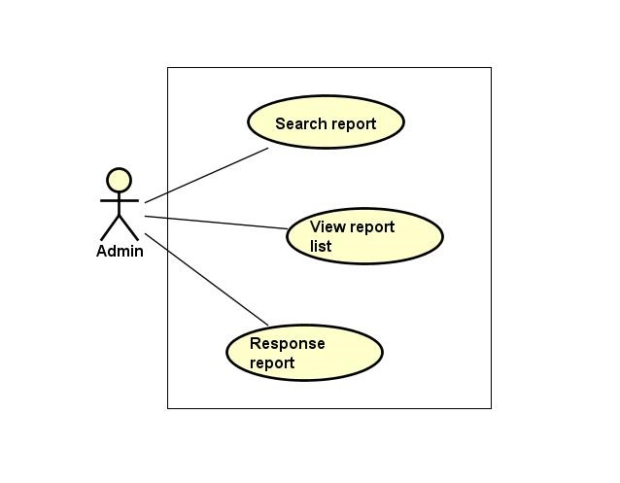

Figure 3.3‑25: Manage report group list

###### Search report

|  |  |  |  |  |  |  |
| --- | --- | --- | --- | --- | --- | --- |
| **Created by:** | | | QuyetTD | | **Date Created:** | 08/03/2017 |
| **Primary Actor** | | | Administration | | **Secondary Actor** |  |
| **Description:** | | | Admin want to find a report in report list | | | |
| **Preconditions:** | | | 1. “BÁO CÁO TỪ NGƯỜI DÙNG” navigator appear header of website 2. Search box appear on list report user page | | | |
| **Trigger:** | | | “BÁO CÁO CỦA TÔI” navigator appear header of website | | | |
| **Post conditions:** | | | Display report on report list page | | | |
| **Normal Flow** | | | | | | |
| **Step** | **Actor** | | **Action** | | | |
| 1 | Admin | | Admin click “Quản Lý Report” navigator | | | |
| 2 | CTC | | Display search page includes:   * “Tên tài khoản” input text * “Tên người dung” input text * “Tiêu đề báo cáo” input text * “ngày bắt đầu” input text * “ngày kết thúc” input text * “Tìm kiếm” button | | | |
| 3 | Admin | | Enter data in fields | | | |
| 4 | Admin | | Click “Tìm kiếm” button | | | |
| 5 | CTC | | Display result on report list page | | | |
| **Alternative Flows:** | | | | | | |
| **AT1** | | At step 4 in the main flows, if admin click other hyperlinks or buttons | | | | |
| **Step** | | **Actor** | | **Action** | | |
| 5.1 | | CTC | | Redirects user to chosen hyperlink or button | | |
| **Exceptions: N/A** | | | | | | |
| **Priority** | | | Medium | | | |
| **Frequency of Use:** | | | Medium | | | |
| **Business Rules:** | | | N/A | | | |
| **Other Information:** | | | N/A | | | |

###### View report list

|  |  |  |  |  |
| --- | --- | --- | --- | --- |
| **Created by:** | | QuyetTD | **Date Created:** | 08/03/2017 |
| **Primary Actor** | | Administration | **Secondary Actor** |  |
| **Description:** | | Admin want to view report list | | |
| **Preconditions:** | | “BÁO CÁO TỪ NGƯỜI DÙNG” navigator appear header of website | | |
| **Trigger:** | | “BÁO CÁO CỦA TÔI” navigator appear header of website | | |
| **Post conditions:** | | Display report list on report list page | | |
| **Normal Flow** | | | | |
| **Step** | **Actor** | **Action** | | |
| 1 | Admin | Click “Báo Cáo Của Tôi” navigator | | |
| 2 | CTC | Display report list on report list page | | |
| **Alternative Flows: N/A** | | | | |
| **Exceptions: N/A** | | | | |
| **Priority** | | Medium | | |
| **Frequency of Use:** | | High | | |
| **Business Rules:** | | N/A | | |
| **Other Information:** | | N/A | | |

###### Response report

|  |  |  |  |  |
| --- | --- | --- | --- | --- |
| **Created by:** | | QuyetTD | **Date Created:** | 08/03/2017 |
| **Primary Actor** | | Administration | **Secondary Actor** |  |
| **Description:** | | Admin want to response report to goods owner or carrier | | |
| **Preconditions:** | | 1. “BÁO CÁO TỪ NGƯỜI DÙNG” navigator appear header of website | | |
| **Trigger:** | | “Tiêu Đề Báo Cáo” is clicked | | |
| **Post conditions:** | | Response report to goods owner or carrier | | |
| **Normal Flow** | | | | |
| **Step** | **Actor** | **Action** | | |
| 1 | Admin | Click “Tiêu Đề Báo Cáo” link | | |
| 2 | CTC | Display response report page includes:   * Report of user detail (sender, receiver, account of sender, send date, question from sender, suggest solution) * “Nội dung” input text * “Phản hồi” button * “Quay lại” button | | |
| 3 | Admin | Enter data in fields | | |
| 4 | Admin | Click “Xác nhận” button | | |
| 5 | CTC | Response report to sender | | |
| **Alternative Flows:** | | | | |
| **AT1** | At step 4, admin click “Quay lại” button | | | |
| **Step** | **Actor** | **Action** | | |
| 5.1 | CTC | Display report list page | | |
| **AT2** | At step 4 in the main flows, if admin click other hyperlinks or buttons | | | |
| **Step** | **Actor** | **Action** | | |
| 5.1 | CTC | Redirects user to chosen hyperlink or button | | |
| **Exceptions: N/A** | | | | |
| **Priority** | | Medium | | |
| **Frequency of Use:** | | Medium | | |
| **Business Rules:** | | N/A | | |
| **Other Information:** | | N/A | | |

##### Manage profile group function

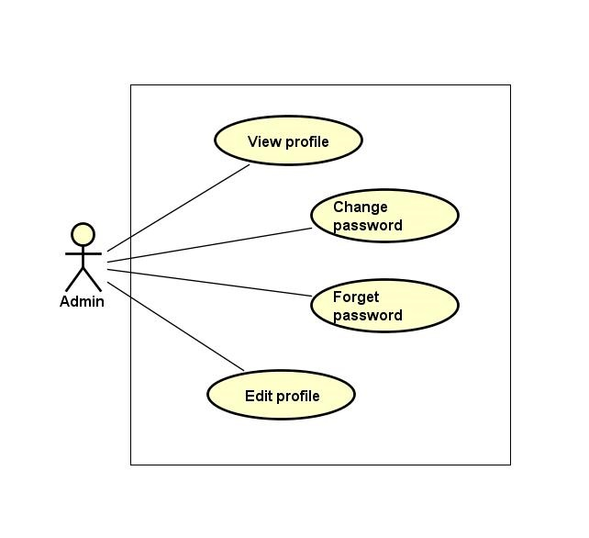

Figure 3.3‑26: Manage profile group function

###### View profile

|  |  |  |  |  |
| --- | --- | --- | --- | --- |
| **Created by:** | | QuyetTD | **Date Created:** | 08/03/2017 |
| **Primary Actor** | | Administration | **Secondary Actor** |  |
| **Description:** | | Admin want to view admin’s profile | | |
| **Preconditions:** | | “Thông Tin Cá Nhân” item appear on top navigator | | |
| **Trigger:** | | “Thông Tin Cá Nhân” item is clicked | | |
| **Post conditions:** | | Display admin profile on detail user view page | | |
| **Normal Flow** | | | | |
| **Step** | **Actor** | **Action** | | |
| 1 | Admin | Hover mouse to user name label and click “Thông Tin Cá Nhân” item | | |
| 2 | CTC | Display admin profile on detail user view page | | |
| **Alternative Flows: N/A** | | | | |
| **Exceptions: N/A** | | | | |
| **Priority** | | Medium | | |
| **Frequency of Use:** | | High | | |
| **Business Rules:** | | N/A | | |
| **Other Information:** | | N/A | | |

###### Edit profile

|  |  |  |  |  |
| --- | --- | --- | --- | --- |
| **Created by:** | | QuyetTD | **Date Created:** | 08/03/2017 |
| **Primary Actor** | | Administration | **Secondary Actor** |  |
| **Description:** | | Admin want to edit admin profile | | |
| **Preconditions:** | | “Thay Đổi” button appear on detail user view page | | |
| **Trigger:** | | “Thay Đổi” button on detail user view page is clicked | | |
| **Post conditions:** | | Save admin profile in database and display successful message | | |
| **Normal Flow** | | | | |
| **Step** | **Actor** | **Action** | | |
| 1 | Admin | Hover mouser to user name label and clicj “Chỉnh Sửa Thông Tin” item | | |
| 2 | CTC | Display pop-up includes:   * “Chọn ảnh” file chooser * “Họ tên” input text * “Bạn là” (phân quyền quản trị) check box * “Email” input text * “Địa chỉ” input text * “Chứng minh thư” input text * “Ngày cấp thẻ” date picker * “Ngày tham gia” date picker * “Thay Đổi” button | | |
| 3 | Admin | Change data in this fields | | |
| 4 | Admin | Click “Lưu Thay Đổi” button | | |
| 5 | CTC | Save changed in database | | |
| 6 | CTC | Display successful message | | |
| **Alternative Flows:** | | | | |
| **AT1** | At step 4, admin click “x” in pop-up | | | |
| **Step** | **Actor** | **Action** | | |
| 6.1 | CTC | Display user detail page | | |
| **AT2** | At step 4 in the main flows, if admin click other hyperlinks or buttons | | | |
| **Step** | **Actor** | **Action** | | |
| 6.1 | CTC | Redirects admin to chosen hyperlink or button | | |
| **Exceptions: N/A** | | | | |
| **Priority** | | Medium | | |
| **Frequency of Use:** | | Medium | | |
| **Business Rules:** | | N/A | | |
| **Other Information:** | | N/A | | |

###### Change password

|  |  |  |  |  |  |
| --- | --- | --- | --- | --- | --- |
| **Created by:** | | | QuyetTD | **Date Created:** | 08/03/2017 |
| **Primary Actor** | | | Administration | **Secondary Actor** |  |
| **Description:** | | | Admin want to change password for security | | |
| **Preconditions:** | | | “Thay đổi mật khẩu” item appear on top navigator | | |
| **Trigger:** | | | “Thay đổi mật khẩu” item is clicked | | |
| **Post conditions:** | | | Change admin’s password | | |
| **Normal Flow** | | | | | |
| **Step** | **Actor** | | **Action** | | |
| 1 | Admin | | Hover mouse to user name label and click “Đổi mật khẩu” item | | |
| 2 | CTC | | Display change password page includes:   * “Mật khẩu cũ” input text * “Mật khẩu mới” input text * “Xác nhận mật khẩu” input text * “Đổi mật khẩu” button input text | | |
| 3 | Admin | | Enter data in this fields | | |
| 4 | Admin | | Click “Đổi mật khẩu” button | | |
| 5 | CTC | | Save new password in database | | |
| 6 | CTC | | Return to homepage | | |
| **Alternative Flows:** | | | | | |
| **AT1** | At step 4 in the main flows, if admin click other hyperlinks or buttons | | | | |
| **Step** | **Actor** | | **Action** | | |
| 6.1 | CTC | | Redirects admin to chosen hyperlink or button | | |
| **Exceptions:** | | | | | |
| **EC1** | | At step 3, required fields are not entered | | | |
| **Step** | | **Actor** | **Action** | | |
| 6.1 | | CTC | Display Register page with message error | | |
| 6.2 | | CTC | Mark error fields | | |
| **EC2** | | At step 3, fields are entered with wrong type of data | | | |
| **Step** | | **Actor** | **Action** | | |
| 6.1 | | CTC | Display Register page with message error | | |
| 6.2 | | CTC | Mark error fields | | |
| **EC3** | | At step 3, password is wrong | | | |
| **Step** | | **Actor** | **Action** | | |
| 6.1 | | CTC | Display Register page with message error | | |
| 6.2 | | CTC | Mark error fields | | |
| **EC4** | | At step 3, new password and confirm password are not match | | | |
| **Step** | | **Actor** | **Action** | | |
| 6.1 | | CTC | Display Register page with message error | | |
| 6.2 | | CTC | Mark error fields | | |
| **Priority** | | | Medium | | |
| **Frequency of Use:** | | | Medium | | |
| **Business Rules:** | | | B12, B15 | | |
| **Other Information:** | | | N/A | | |

###### Forget password

|  |  |  |  |  |
| --- | --- | --- | --- | --- |
| **Created by:** | | QuyetTD | **Date Created:** | 08/03/2017 |
| **Primary Actor** | | Administration | **Secondary Actor** |  |
| **Description:** | | Admin forget password. They want to reset password | | |
| **Preconditions:** | | “Quên mật khẩu” label appear on login page | | |
| **Trigger:** | | “Quên mật khẩu” label on login page is clicked | | |
| **Post conditions:** | | System send new password to admin’s email | | |
| **Normal Flow** | | | | |
| **Step** | **Actor** | **Action** | | |
| 1 | Admin | Admin click “Quên mật khẩu” label on login page | | |
| 2 | CTC | Display forget password page includes:   * “Email đăng ký” input text * “Gửi” button | | |
| 3 | Admin | Enter email address they use for register admin account | | |
| 4 | CTC | Send new password to admin’s email address | | |
| **Alternative Flows:** | | | | |
| **AT1** | At step 4 in the main flows, if admin click other hyperlinks or buttons | | | |
| **Step** | **Actor** | **Action** | | |
| 6.1 | CTC | Redirects admin to chosen hyperlink or button | | |
| **Exceptions: N/A** | | | | |
| **Priority** | | Medium | | |
| **Frequency of Use:** | | High | | |
| **Business Rules:** | | B22 | | |
| **Other Information:** | | N/A | | |

##### Transaction history group function

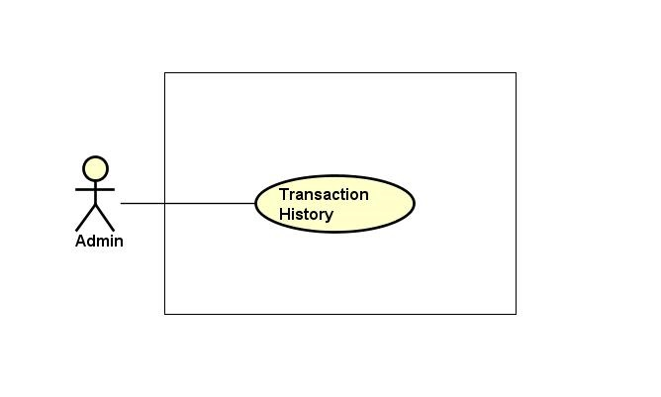

Figure 3.3‑27: Transaction history group function

###### Transaction history

|  |  |  |  |  |
| --- | --- | --- | --- | --- |
| **Created by:** | | QuyetTD | **Date Created:** | 08/03/2017 |
| **Primary Actor** | | Administration | **Secondary Actor** |  |
| **Description:** | | Admin want to check money in account and what did they do with money | | |
| **Preconditions:** | | “Thông tin giao dịch” item appear on top navigator | | |
| **Trigger:** | | “Thông tin giao dịch” item is clicked | | |
| **Post conditions:** | | Display money in account and transaction history | | |
| **Normal Flow** | | | | |
| **Step** | **Actor** | **Action** | | |
| 1 | Admin | Hover mouse to user name and Click “Thông tin giao dịch” item | | |
| 2 | CTC | Display money in account and transaction history | | |
| **Alternative Flows: N/A** | | | | |
| **Exceptions: N/A** | | | | |
| **Priority** | | Medium | | |
| **Frequency of Use:** | | Medium | | |
| **Business Rules:** | | N/A | | |
| **Other Information:** | | N/A | | |

##### Login group function

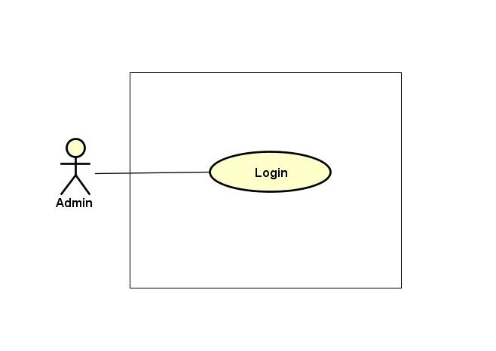

Figure 3.3‑28: Login group function

###### Login

|  |  |  |  |  |  |  |
| --- | --- | --- | --- | --- | --- | --- |
| **Created by:** | | | QuyetTD | | **Date Created:** | 08/03/2017 |
| **Primary Actor** | | | Administration | | **Secondary Actor** |  |
| **Description:** | | | Admin want to login to CTC system for work | | | |
| **Preconditions:** | | | “Đăng nhập” button appear on login page | | | |
| **Trigger:** | | | “Đăng nhập” button on login page is clicked | | | |
| **Post conditions:** | | | Admin login to CTC system | | | |
| **Normal Flow** | | | | | | |
| **Step** | **Actor** | | **Action** | | | |
| 1 | Admin | | Click “Đăng nhập” label on homepage | | | |
| 2 | CTC | | Display login page includes:   * “Email” input text * “Mật khẩu” input text * “Đăng nhập” button | | | |
| 3 | Admin | | Enter data in fields | | | |
| 4 | Admin | | Click “Đăng nhập” button | | | |
| 5 | CTC | | Login account to CTC | | | |
| **Alternative Flows:** | | | | | | |
| **AT1** | At step 4 in the main flows, if admin click other hyperlinks or buttons | | | | | |
| **Step** | **Actor** | | **Action** | | | |
| 5.1 | CTC | | Redirects admin to chosen hyperlink or button | | | |
| **Exceptions: N/A** | | | | | | |
| **EC1** | | At step 3, required fields are not entered | | | | |
| **Step** | | **Actor** | | **Action** | | |
| 4.1 | | CTC | | Display Register page with message error | | |
| 4.2 | | CTC | | Mark error fields | | |
| **EC2** | | At step 3, fields are entered with wrong type of data | | | | |
| **Step** | | **Actor** | | **Action** | | |
| 4.1 | | CTC | | Display Register page with message error | | |
| 4.2 | | CTC | | Mark error fields | | |
| **Priority** | | | High | | | |
| **Frequency of Use:** | | | High | | | |
| **Business Rules:** | | | B2, B11 | | | |
| **Other Information:** | | | N/A | | | |

##### Logout group function

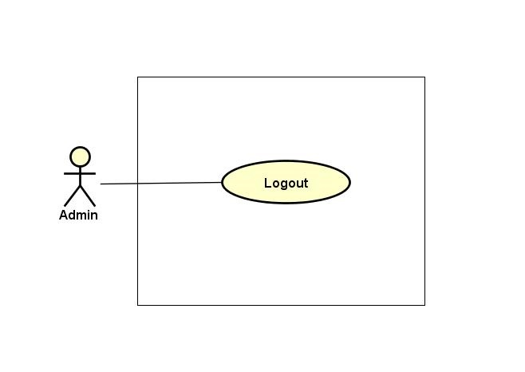

Figure 3.3‑29: Logout group function

###### Logout

|  |  |  |  |  |
| --- | --- | --- | --- | --- |
| **Created by:** | | QuyetTD | **Date Created:** | 08/03/2017 |
| **Primary Actor** | | Administration | **Secondary Actor** |  |
| **Description:** | | Admin want to logout CTC system | | |
| **Preconditions:** | | “Đăng xuất” button appear on top navigator | | |
| **Trigger:** | | “Đăng xuất” button is clicked | | |
| **Post conditions:** | | Logout admin account | | |
| **Normal Flow** | | | | |
| **Step** | **Actor** | **Action** | | |
| 1 | Admin | Click “Đăng xuất” label in website | | |
| 2 | CTC | Logout admin account | | |
| 3 | CTC | Return homepage | | |
| **Alternative Flows: N/A** | | | | |
| **Exceptions: N/A** | | | | |
| **Priority** | | High | | |
| **Frequency of Use:** | | High | | |
| **Business Rules:** | | N/A | | |
| **Other Information:** | | N/A | | |

## Non-functional specification

### Reliability

* Mean time between failures: The mean time between each failure is expected to be about 500 hours of using.
* Database data is not deleted, for data restoration or recall history when we needed
* The maximum bugs per function are 1 bugs/a function when user uses software within 2 months.
* System errors must be repaired no more than 3 days after detected.

### Performance Requirements

#### Availability

The application must be available 99% of time. Users can access to it everywhere from their

Web browser with internet connection.

#### Response time

In term of response time, waiting time of processing will be 2 to 5 seconds; time to process any functions no more than 3 seconds

#### Maintainability

* Strictly follow the coding convention to help improve readability of source code and make the website more maintainable.
* Develop website based on Object Oriented Programming paradigm in order to increase maintainability and extendibility.

#### Usability

Usability Requirements support the following from the perspective of its primary users:

* Efficiency of use: user can complete each function in less than 40 actions
* Intuitiveness: User can understand approximately 95% help/ error messages
* All of screen should be elegant and simple.
* All attributes are provided for non-text elements, such as images and maps.
* Search box is wide enough, so that users can see what they have typed.
* Links are easily recognizable. They look clickable. Items that are not links do not look clickable, for example underlining text is avoided.
* Colors must be uniform
* The buttons must be large enough and not too large

#### Security Requirements

* When registering, user must use the correct email address. So they can access to confirm link in email.
* Sensitive information is stored in md5 format in database.
* Using access control.
* Sensitive information is encrypted before transmission.
* Use SSL certificate number.

#### Hardware/Software Requirements

* Hardware requirement:

- Server: Web service 2013, IIS8

- Client: PC/Laptop (window 7, window 8, window 10)

* Software requirements: Web browser (Chrome 40.0, Firefox 30.0) with internet connection

# SOFTWARE DESIGN DOCUMENT

## Architecture design

### Choice of Architecture Design

Carrier Trading Center (CTC) is an e-commerce website. The main function of CTC system is provides users the ability to bid online bill of lading to help the Goods Owner minimum their shipping cost and help Carrier connect to Goods Owner more easily.

Traditionally used for desktop graphical user interfaces (GUIs), this architecture has become popular for designing web applications and even mobile, desktop and other clients. Popular programming languages like Java, C#, Ruby, PHP and others have popular MVC frameworks that are currently being used in web application development straight out of the box.

#### MVC Model Overview

##### What is the MVC

Model–View–Controller (MVC) is a software architectural pattern for implementing user interfaces on computers. It divides a given application into three interconnected parts in order to separate internal representations of information from the ways that information is presented to and accepted from the user. The MVC design pattern decouples these major components allowing for efficient code reuse and parallel development.

##### Components

###### Model

**The model** is the central component of the pattern. It expresses the application's behaviour in terms of the problem domain, independent of the user interface. It directly manages the data, logic and rules of the application.

###### View

**A view** can be any output representation of information, such as a chart or a diagram. Multiple views of the same information are possible, such as a bar chart for management and a tabular view for accountants.

###### Controller

**The controller** accepts input and converts it to commands for the model or view.

##### Interactions

###### Model

**A model** stores data that is retrieved according to commands from the controller and displayed in the view.

###### View

**A view** generates new output to the user based on changes in the model.

###### Controller

**A controller** can send commands to the model to update the model's state (e.g., editing a document). It can also send commands to its associated view to change the view's presentation of the model (e.g., scrolling through a document).

##### Advantages and Disadvantages

###### Advantages

* Simultaneous development - Multiple developers can work simultaneously on the model, controller and views.
* High cohesion - MVC enables logical grouping of related actions on a controller together. The views for a specific model are also grouped together.
* Low coupling - The very nature of the MVC framework is such that there is low coupling among models, views or controllers
* Ease of modification - Because of the separation of responsibilities, future development or modification is easier
* Multiple views for a model - Models can have multiple views

###### Disadvantages

* Code navigability – The framework navigation can be complex; hence it introduces new layers of abstractions and requires users to adapt its decomposition criteria to MVC.
* Multi-artefact consistency - Decomposing a feature into three artefacts causes scattering. Thus, requiring developer(s) to maintain the consistency of multiple representations at once.
* Pronounced learning curve - Knowledge on multiple technologies becomes the norm. Developers using MVC need to be skilled in multiple technologies.

#### JSF Framework

JSF is a server-side user interface component framework for Java-based Web applications. JSF contains an API for representing UI components and managing their state; handling events, server-side validation, and data conversion; defining page navigation; supporting internationalization and accessibility; and providing extensibility for all these features.

#### JSF and MVC

JSF fits well with the MVC-based presentation-tier architecture. It offers a clean separation between behaviour and presentation. It leverages familiar UI-component and Web-tier concepts without limiting you to a particular scripting technology or mark-up language.

JSF backing beans are the model layer (more about backing beans in a later section). They also contain actions, which are an extension of the controller layer and delegate the user request to the business-logic tier. Please note, from the perspective of the overall application architecture, the business-logic tier can also be referred to as the model layer.

#### Why JSF?

JSF is not just another Web framework. The following features differentiate JSF from other Web frameworks:

* Swing-like object-oriented Web application development: The server-side tasteful UI component model with event listeners and handlers initiates object-oriented Web application development.
* Backing-bean management: Backing beans are JavaBeans components associated with UI components used in a page. Backing-bean management separates the definition of UI component objects from objects that perform application-specific processing and hold data. JSF implementation stores and manages these backing-bean instances in the proper scope.
* Extensible UI component model: JSF UI components are configurable, reusable elements that compose the user interfaces of JSF applications. You can extend the standard UI component and develop a more complex component, e.g., menu bar and tree component.
* A renderer separates a UI component's functionality and view. Multiple renderers can be created and used to define different appearances of the same component for the same client or for different clients.
* Extensible conversion and validation model: Based on the standard converters and validators, you can develop customized converters and validators, which provide better model protection.

Despite its strength, JSF is not mature at its current stage. The components, converters, and validators that ship with JSF are basic. And the per-component validation model cannot handle many-to-many validation between components and validators. In addition, JSF custom tags cannot integrate with JSTL (JSP Standard Tag Library) seamlessly.

#### Managed Bean, Backing Bean, View Object, and Domain Object Model

JSF introduces two new terms: managed bean and backing bean. JSF provides a strong managed-bean facility. JavaBean objects managed by a JSF implementation are called managed beans. A managed bean describes how a bean is created and managed. It has nothing to do with the bean's functionalities.

The backing bean defines properties and handling-logics associated with the UI components used on the page. Each backing-bean property is bound to either a component instance or its value. A backing bean also defines a set of methods that perform functions for the component, such as validating the component's data, handling events that the component fires and performing processing associated with navigation when the component activates.

A typical JSF application couples a backing bean with each page in the application. However, sometimes in the real world, forcing a one-to-one relationship between a backing bean and a page is not the ideal solution. It can cause problems like code duplication. In a real-world scenario, several pages may need to share the same backing bean behind the scenes. For example, in JCatalog, the CreateProduct and EditProduct page share the same ProductBean definition.

A view object is a model object used specifically in the presentation tier. It contains the data that must display in the view layer and the logic to validate user input, handle events, and interact with the business-logic tier. The backing bean is the view object in a JSF-based application. Backing bean and view object are interchangeable terms in this article.

Compared to the ActionForm and Action approach in Struts, development with backing beans in JSF follows better object-oriented design practices. A backing bean not only contains view data, but also behaviour related to that data. In Struts, Action and ActionForm contain data and logic separately.

We've all heard about the domain object model. So, what's the difference between the domain object model and a view object? In a simple Web application, a domain object model can be used across all tiers, however, in a more complex Web application, a separate view object model needs to be used. Domain object model is about the business object and should belong in the business-logic tier. It contains the business data and business logic associated with the specific business object. A view object contains presentation-specific data and behaviour. JCatalog's ProductListBean offers a good example. It contains data and logic specific to the presentation tier, e.g., pagination-related data and logic. The drawback to separating the view objects from the domain object model is that data mapping must occurs between the two object models. In JCatalog, ProductBeanBuilder and UserBeanBuilder use the reflection-based Commons BeanUtils to implement the data mapping©.

#### Hibernate

Hibernate ORM (Hibernate in short) is an object-relational mapping tool for the Java programming language supported by SPRING framework. It provides a framework for mapping an object-oriented domain model to a relational database.

Hibernate core features:

* Natural programming model - Hibernate supports natural OO idiom; inheritance, polymorphism, composition and the Java collections framework
* Support for fine-grained object models - a rich variety of mappings for collections and dependent objects
* No build-time byte code enhancement - there's no extra code generation or byte code processing steps in your build procedure
* Extreme scalability - Hibernate is extremely performing, has a dual-layer cache architecture, and may be used in a cluster
* The query options - Hibernate addresses both sides of the problem; not only how to get objects into the database, but also how to get them out again
* Support for conversations - Hibernate supports both long-lived persistence contexts, detach/reattach of objects, and takes care of optimistic locking automatically
* Free/open source - Hibernate is licensed under the LGPL (Lesser GNU Public License)

Hibernate Architecture

* The Hibernate architecture includes many objects persistent object, session factory, transaction factory, connection factory, session, transaction etc. There are 4 layers in hibernate architecture java application layer, hibernate framework layer, backhand API layer and database layer.



Figure 4.1‑1 Hibernate Architecture

### Architectural Presentation

c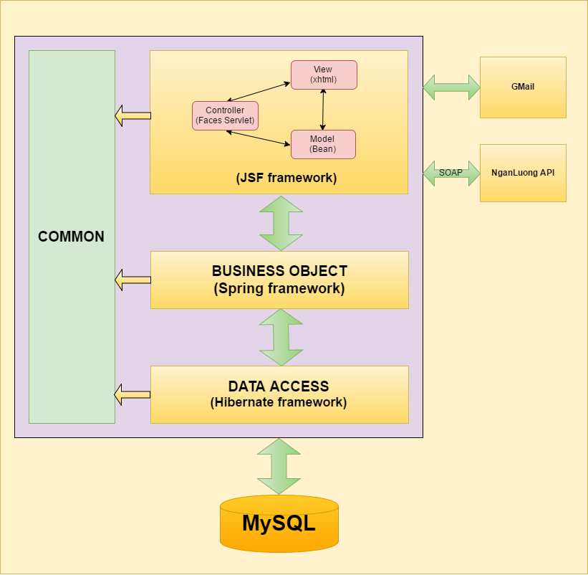

Figure 4.1‑2 Architecture Overview

### Package Design



Figure 4.1‑3 Package Diagram

## Detailed design

### Common Class Description

#### Object-relational mapping

##### AnswerComment

|  |  |  |  |
| --- | --- | --- | --- |
| Class | AnswerComment | | |
| **Description** | AnswerComment Object manages the mapping details between a set of objects and underlying relational databases. | | |
| **Base Class** | N/A | | |
| **Constructor** | N/A | | |
| **Prototype** | N/A | | |
| **Source File** | AnswerComment.java | | |
| **Namespace** | vn.co.cex.orm | | |
| **Attributes** | Name | Type | Description |
| id | Integer |  |
| content | String |  |
| commentId | int |  |
| comment | Comment |  |
| createdUserId | int |  |
| user | Users |  |
| created | Date |  |

##### BillOfLading

|  |  |  |  |
| --- | --- | --- | --- |
| Class | BillOfLading | | |
| **Description** | BillOfLading Object manages the mapping details between a set of objects and underlying relational databases. | | |
| **Base Class** | N/A | | |
| **Constructor** | BillOfLading(String code, **int** goodsTypeId, **int** packagedFormId, String goodsImage, **float** weight, **float** volume,Integer quantity, **float** length, **float** width, **float** height, String description, **boolean** isFrozen **boolean** isFragile, String sender, String senderPhoneNumber, String departureProvince, String departureDistrict, String departureAddress, String departureCharacteristicPlace, Date departureDate, String receiver, String receiverPhoneNumber, String arrivalProvince, String arrivalDistrict, String arrivalAddress, String arrivalCharacteristicPlace, Date arrivalDate, **float** distance, **float** fee, Date auctionPeriod, **int** status, **boolean** notification, **int** createdUserId, Date created, Date modified) | | |
| **Prototype** | N/A | | |
| **Source File** | Users.java | | |
| **Namespace** | vn.co.cex.orm | | |
| **Attributes** | Name | Type | Description |
| id | Integer |  |
| code | String |  |
| goodsTypeId | Int |  |
| goodsType | GoodsType |  |
| packagedFormId | Int |  |
| packagedForm | PackagedForm |  |
| goodsImage | String |  |
| weight | Float |  |
| volume | Float |  |
| quantity | Integer |  |
| length | Float |  |
| width | Float |  |
| height | Float |  |
| description | String |  |
| isFrozen | Boolean |  |
| isFragile | Boolean |  |
| sender | String |  |
| senderPhoneNumber | String |  |
| departureProvince | String |  |
| departureDistrict | String |  |
| departureAddress | String |  |
| departureCharacterisicPlace | String |  |
| departureDate | Date |  |
| receiver | String |  |
| receiverPhoneNumber | String |  |
| arrivalProvince | String |  |
| arrivalDistrict | String |  |
| arrivalAddress | String |  |
| arrivalCharacteristicPlace | String |  |
| arrivalDate | Date |  |
| distance | Float |  |
| fee | Float |  |
| auctionPeriod | Date |  |
| status | Int |  |
| notification | Boolean |  |
| createdUserId | Int |  |
| user | Users |  |
| created | Date |  |
| modified | Date |  |

##### Comment

|  |  |  |  |
| --- | --- | --- | --- |
| Class | Comment | | |
| **Description** | Comment Object manages the mapping details between a set of objects and underlying relational databases. | | |
| **Base Class** | N/A | | |
| **Constructor** | Comment(**int** id) | | |
| **Prototype** | N/A | | |
| **Source File** | Comment.java | | |
| **Namespace** | vn.co.cex.orm | | |
| **Attributes** | Name | Type | Description |
| id | Integer |  |
| content | String |  |
| billOfLadingId | int |  |
| billOfLading | BillOfLading |  |
| createdUserId | int |  |
| user | Users |  |
| created | Date |  |

##### Company

|  |  |  |  |
| --- | --- | --- | --- |
| Class | Company | | |
| **Description** | Company Object manages the mapping details between a set of objects and underlying relational databases. | | |
| **Base Class** | N/A | | |
| **Constructor** | Company(String name, String taxCode, String email, String phoneNumber, String fax, String address) | | |
| **Prototype** | N/A | | |
| **Source File** | Company.java | | |
| **Namespace** | vn.co.cex.orm | | |
| **Attributes** | Name | Type | Description |
| Id | Integer |  |
| Name | String |  |
| TaxCode | String |  |
| Email | String |  |
| PhoneNumber | String |  |
| Fax | String |  |
| address | String |  |

##### District

|  |  |  |  |
| --- | --- | --- | --- |
| Class | District | | |
| **Description** | District Object manages the mapping details between a set of objects and underlying relational databases. | | |
| **Base Class** | N/A | | |
| **Constructor** | District(Integer id) | | |
| **Prototype** | N/A | | |
| **Source File** | District.java | | |
| **Namespace** | vn.co.cex.orm | | |
| **Attributes** | Name | Type | Description |
| Id | Integer |  |
| Code | String |  |
| Name | String |  |
| Type | String |  |
| ProvinceCode | Province |  |

##### Goodstype

|  |  |  |  |
| --- | --- | --- | --- |
| Class | Goodstype | | |
| **Description** | Goodstype Object manages the mapping details between a set of objects and underlying relational databases. | | |
| **Base Class** | N/A | | |
| **Constructor** | District(Integer id) | | |
| **Prototype** | N/A | | |
| **Source File** | Goodstype.java | | |
| **Namespace** | vn.co.cex.orm | | |
| **Attributes** | Name | Type | Description |
| Id | Integer |  |
| Code | String |  |
| Name | String |  |
| Description | String |  |
| ReferenceFee | Float |  |

##### OperationFee

|  |  |  |  |
| --- | --- | --- | --- |
| Class | OperationFee | | |
| **Description** | OpearationFee Object manages the mapping details between a set of objects and underlying relational databases. | | |
| **Base Class** | N/A | | |
| **Constructor** | OperationFee(Integer id, String code, String feeName, **boolean** type, Float fee, Float percent, String description, **int** status, Date modified, Date created) | | |
| **Prototype** | N/A | | |
| **Source File** | OperationFee.java | | |
| **Namespace** | vn.co.cex.orm | | |
| **Attributes** | Name | Type | Description |
| id | Integer |  |
| code | String |  |
| feeName | String |  |
| type | boolean |  |
| fee | Float |  |
| percent | Float |  |
| description | String |  |
| status | int |  |

##### PackagedForm

|  |  |  |  |
| --- | --- | --- | --- |
| Class | PackagedForm | | |
| **Description** | PackagedForm Object manages the mapping details between a set of objects and underlying relational databases. | | |
| **Base Class** | N/A | | |
| **Constructor** | PackagedForm (Integer id) | | |
| **Prototype** | N/A | | |
| **Source File** | PackagedForm.java | | |
| **Namespace** | vn.co.cex.orm | | |
| **Attributes** | Name | Type | Description |
| id | Integer |  |
| code | String |  |
| name | String |  |
| description | String |  |

##### PaymentDetail

|  |  |  |  |
| --- | --- | --- | --- |
| Class | PaymentDetail | | |
| **Description** | PaymentDetail Object manages the mapping details between a set of objects and underlying relational databases. | | |
| **Base Class** | N/A | | |
| **Constructor** | N/A | | |
| **Prototype** | N/A | | |
| **Source File** | PaymentDetail.java | | |
| **Namespace** | vn.co.cex.orm | | |
| **Attributes** | Name | Type | Description |
| Id | Integer |  |
| Amounts | float |  |
| PaymentDate | Date |  |
| Type | boolean |  |
| Description | String |  |
| Balance | Float |  |
| BillOfLadingId | Integer |  |
| UserId | int |  |

##### Province

|  |  |  |  |
| --- | --- | --- | --- |
| Class | Province | | |
| **Description** | Province Object manages the mapping details between a set of objects and underlying relational databases. | | |
| **Base Class** | N/A | | |
| **Constructor** | Province (Integer id) | | |
| **Prototype** | N/A | | |
| **Source File** | Province.java | | |
| **Namespace** | vn.co.cex.orm | | |
| **Attributes** | Name | Type | Description |
| Id | Integer |  |
| Code | String |  |
| Name | String |  |
| Type | String |  |

##### Report

|  |  |  |  |
| --- | --- | --- | --- |
| Class | Report | | |
| **Description** | Report Object manages the mapping details between a set of objects and underlying relational databases. | | |
| **Base Class** | N/A | | |
| **Constructor** | Report(**int** id, **int** userId, Date reportDate, String reportTitle, String reportQuestion, String reportSolution, String reportContent, String reportReply, **boolean** status) | | |
| **Prototype** | N/A | | |
| **Source File** | Report.java | | |
| **Namespace** | vn.co.cex.orm | | |
| **Attributes** | Name | Type | Description |
| Id | int |  |
| UserId | int |  |
| ReportDate | Date |  |
| ReportTitle | String |  |
| ReportQuestio | String |  |
| ReportSolutio | String |  |
| ReportContent | String |  |
| ReportReply | String |  |
| Status | boolean |  |

##### Users

|  |  |  |  |
| --- | --- | --- | --- |
| Class | Users | | |
| **Description** | User Object manages the mapping details between a set of objects and underlying relational databases. | | |
| **Base Class** | N/A | | |
| **Constructor** | Users(String fullName, String email, String password, String phoneNumber, String address, String districtCode, String identityCard, String identityCardPlace, Date, identityCardDate, String identityCardImage, **int** role, **int** status, Date created, Integer companyId, String userAvatar) | | |
| **Prototype** | N/A | | |
| **Source File** | Users.java | | |
| **Namespace** | vn.co.cex.orm | | |
| **Attributes** | Name | Type | Description |
| id | Integer |  |
| fullName | String |  |
| email | String |  |
| password | String |  |
| phoneNumber | String |  |
| address | String |  |
| identityCard | String |  |
| identityCardPlace | String |  |
| identityCardDate | Date |  |
| identityCardImage | String |  |
| role | int |  |
| status | int |  |
| created | Date |  |
| companyId | Integer |  |
| userAvatar | String |  |

##### UsersAccount

|  |  |  |  |
| --- | --- | --- | --- |
| Class | UsersAccount | | |
| **Description** | UsersAccount Object manages the mapping details between a set of objects and underlying relational databases. | | |
| **Base Class** | N/A | | |
| **Constructor** | UsersAccount (Integer id) | | |
| **Prototype** | N/A | | |
| **Source File** | UsersAccount.java | | |
| **Namespace** | vn.co.cex.orm | | |
| **Attributes** | Name | Type | Description |
| UserId | Integer |  |
| Balance | float |  |
| Modified | Date |  |

#### Bean class

##### BaseBean

|  |  |  |  |  |
| --- | --- | --- | --- | --- |
| Class | BaseBean | | | |
| **Description** | Common class for Decision Center beans | | | |
| **Base Class** | N/A | | | |
| **Constructor** | BaseBean() | | | |
| **Prototype** | N/A | | | |
| **Source File** | BaseBean.java | | | |
| **Namespace** | vn.co.cex.bean | | | |
| **Methods** | Name | Input | Output | Description |
| getHTTPRequest() |  | HttpServletRequest |  |
| getHTTPResponse() |  | HttpServletResponse |  |

##### RegisterBean

|  |  |  |  |  |
| --- | --- | --- | --- | --- |
| Class | RegisterBean | | | |
| **Description** | Register an user | | | |
| **Base Class** | BaseBean | | | |
| **Constructor** | N/A | | | |
| **Prototype** | N/A | | | |
| **Source File** | RegisterBean.java | | | |
| **Namespace** | vn.co.cex.bean.login | | | |
| **Attributes** | Name | Type | Description | |
| FullName | String |  | |
| Email | String |  | |
| Password | String |  | |
| PhoneNumber | String |  | |
| address | String |  | |
| identityCard | String |  | |
| identityCardPlace | String |  | |
| identityCardDate | Date |  | |
| identityCardImage | String |  | |
| role | int |  | |
| status | int |  | |
| created | Date |  | |
| companyId | Integer |  | |
| userAvatar | String |  | |
| **Methods** | Name | Input | Output | Description |
|  |  |  |  |
| registerUser() |  | String |  |
| sendMailRegister(Users) | Users |  |  |

##### GetGoodsImagesBean

|  |  |  |  |  |
| --- | --- | --- | --- | --- |
| Class | getGoodsImagesBean | | | |
| **Description** | Get goods image. | | | |
| **Base Class** | BaseBean | | | |
| **Constructor** | N/A | | | |
| **Prototype** | N/A | | | |
| **Source File** | getGoodsImagesBean.java | | | |
| **Namespace** | vn.co.cex.bean | | | |
| **Attributes** | Name | Type | Description | |
|  |  |  | |
| **Methods** | Name | Input | Output | Description |
| getGoodsImage() |  | StreamedContent |  |

##### getUserAvatarBean

|  |  |  |  |  |
| --- | --- | --- | --- | --- |
| Class | getUserAvatarBean | | | |
| **Description** | Get goods image. | | | |
| **Base Class** | BaseBean | | | |
| **Constructor** | N/A | | | |
| **Prototype** | N/A | | | |
| **Source File** | getUserAvatarBean.java | | | |
| **Namespace** | vn.co.cex.bean | | | |
| **Attributes** | Name | Type | Description | |
|  |  |  | |
| **Methods** | Name | Input | Output | Description |
| getUserAvatar() |  | StreamedContent |  |

##### goodsTypeBean

|  |  |  |  |  |
| --- | --- | --- | --- | --- |
| Class | goodsTypeBean | | | |
| **Description** | Do business logic with goodsType. | | | |
| **Base Class** | BaseBean | | | |
| **Constructor** | N/A | | | |
| **Prototype** | N/A | | | |
| **Source File** | goodsTypeBean.java | | | |
| **Namespace** | vn.co.cex.bean | | | |
| **Attributes** | Name | Type | Description | |
|  |  |  | |
| **Methods** | Name | Input | Output | Description |
| getGoodsTypeBO() |  | GoodsTypeBO |  |
| setGoodsTypeBO(GoodsTypeBO) |  |  |  |
| getGoodsTypeList() |  | List<GoodsType> |  |
| setGoodsTypeList(List<GoodsType>) |  |  |  |

##### NganLuongBean

|  |  |  |  |  |
| --- | --- | --- | --- | --- |
| Class | NganLuongBean | | | |
| **Description** | Account recharge through Ngan Luong. | | | |
| **Base Class** | BaseBean | | | |
| **Constructor** | N/A | | | |
| **Prototype** | N/A | | | |
| **Source File** | NganLuongBean.java | | | |
| **Namespace** | vn.co.cex.bean | | | |
| **Attributes** | Name | Type | Description | |
| link_checkout | String |  | |
| order_code | String |  | |
| token_code | String |  | |
| result | boolean |  | |
| balance | Float |  | |
| email | String |  | |
| fullname | String |  | |
| **Methods** | Name | Input | Output | Description |
| onPlusMoneyAccount() |  |  |  |
| sentRequest () |  |  |  |

##### ProvinceBean

|  |  |  |  |  |
| --- | --- | --- | --- | --- |
| Class | ProvinceBean | | | |
| **Description** |  | | | |
| **Base Class** | BaseBean | | | |
| **Constructor** | N/A | | | |
| **Prototype** | N/A | | | |
| **Source File** | ProvinceBean.java | | | |
| **Namespace** | vn.co.cex.bean | | | |
| **Attributes** | Name | Type | Description | |
| provinceBO | ProvinceBO |  | |
| provinceList | List<Province> |  | |
| provinceName | String |  | |
| **Methods** | Name | Input | Output | Description |
| getProvinceName() |  | String |  |
| setProvinceName(String) | String |  |  |
| getProvinceBO() |  | ProvinceBO |  |
| setProvinceBO(ProvinceBO) | ProvinceBO |  |  |
| getProvinceList() |  | List<Province> |  |
| setProvinceList(List<Province>) | List<Province> |  |  |

##### DistrictBean

|  |  |  |  |  |
| --- | --- | --- | --- | --- |
| Class | DistrictBean | | | |
| **Description** |  | | | |
| **Base Class** | BaseBean | | | |
| **Constructor** | N/A | | | |
| **Prototype** | N/A | | | |
| **Source File** | DistrictBean.java | | | |
| **Namespace** | vn.co.cex.bean | | | |
| **Attributes** | Name | Type | Description | |
|  |  |  | |
| **Methods** | Name | Input | Output | Description |
| getDistrictByProvinceCode(String) | String | List<District> |  |
| getDistrict2ByProvinceCode(String) | String | List<District> |  |
| getDistrictNameByCode(String) | String | String |  |
| getProvinceCodeByCode(String) | String | String |  |

##### SummaryBillOfLadingBean

|  |  |  |  |  |
| --- | --- | --- | --- | --- |
| Class | SummaryBillOfLadingBean | | | |
| **Description** | Show summary bill of lading. | | | |
| **Base Class** | BaseBean | | | |
| **Constructor** | N/A | | | |
| **Prototype** | N/A | | | |
| **Source File** | SummaryBillOfLadingBean.java | | | |
| **Namespace** | vn.co.cex.bean.admin | | | |
| **Attributes** | Name | Type | Description | |
| goodsTypeId | Integer |  | |
| packagedFormId | Integer |  | |
| weight | Float |  | |
| volume | Float |  | |
| departureProvinceCode | String |  | |
| arrivalProvinceCode | String |  | |
| **Methods** | Name | Input | Output | Description |
| searchBillOfLading() |  |  |  |

##### BillOfLadingDetailBean

|  |  |  |  |  |
| --- | --- | --- | --- | --- |
| Class | BillOfLadingDetailBean | | | |
| **Description** | Show detail bill of lading. | | | |
| **Base Class** | BaseBean | | | |
| **Constructor** | N/A | | | |
| **Prototype** | N/A | | | |
| **Source File** | BillOfLadingDetailBean.java | | | |
| **Namespace** | vn.co.cex.bean.billoflading | | | |
| **Methods** | Name | Input | Output | Description |
| auction(int) | billofLadingId |  |  |
| goodsOwnerCancelAuction() |  |  |  |
| carrierCancelAuction() |  |  |  |
| confirmCompleted() |  |  |  |
| writeComment() |  |  |  |
| writeAnswerComment(int) | commentId |  |  |
| updateComment() |  |  |  |

##### CommonBean

|  |  |  |  |  |
| --- | --- | --- | --- | --- |
| Class | CommonBean | | | |
| **Description** | Show bill of lading and search bill of lading. | | | |
| **Base Class** | BaseBean | | | |
| **Constructor** | N/A | | | |
| **Prototype** | N/A | | | |
| **Source File** | CommonBean.java | | | |
| **Namespace** | vn.co.cex.bean.billoflading | | | |
| **Attributes** | Name | Type | Description | |
| goodsTypeId | Integer |  | |
| packagedFormId | Integer |  | |
| weight | Float |  | |
| volume | Float |  | |
| departureProvinceCode | String |  | |
| arrivalProvinceCode | String |  | |
| status | Integer |  | |
| timeRemaining | int |  | |
| **Methods** | Name | Input | Output | Description |
| searchBillOfLading() |  |  |  |

##### PostBillOfLadingBean

|  |  |  |  |  |
| --- | --- | --- | --- | --- |
| Class | PostBillOfLadingBean | | | |
| **Description** | Show bill of lading and search bill of lading. | | | |
| **Base Class** | BaseBean | | | |
| **Constructor** | N/A | | | |
| **Prototype** | N/A | | | |
| **Source File** | PostBillOfLadingBean.java | | | |
| **Namespace** | vn.co.cex.bean.billoflading | | | |
| **Methods** | Name | Input | Output | Description |
| postBillOfLading() |  |  |  |
| uploadGoodsImage(FileUploadEvent) |  |  |  |
| gotoListBillOfLading() |  |  |  |

##### CarrierBillOfLadingBean

|  |  |  |  |  |
| --- | --- | --- | --- | --- |
| Class | CarrierBillOfLadingBean | | | |
| **Description** | Show bill of lading and search bill of lading by Carrier. | | | |
| **Base Class** | BaseBean | | | |
| **Constructor** | N/A | | | |
| **Prototype** | N/A | | | |
| **Source File** | CarrierBillOfLadingBean.java | | | |
| **Namespace** | vn.co.cex.bean.carrier | | | |
| **Methods** | Name | Input | Output | Description |
| searchBillOfLadingByCarrier() |  |  |  |

##### GoodsOwnerBillOfLadingBean

|  |  |  |  |  |
| --- | --- | --- | --- | --- |
| Class | GoodsOwnerBillOfLadingBean | | | |
| **Description** | Show bill of lading and search bill of lading by GoodsOwner. | | | |
| **Base Class** | BaseBean | | | |
| **Constructor** | N/A | | | |
| **Prototype** | N/A | | | |
| **Source File** | GoodsOwnerBillOfLadingBean.java | | | |
| **Namespace** | vn.co.cex.bean.goodsOwner | | | |
| **Methods** | Name | Input | Output | Description |
| searchBillOfLadingByCarrier() |  |  |  |

##### ForgotPasswordBean

|  |  |  |  |  |
| --- | --- | --- | --- | --- |
| Class | ForgotPasswordBean | | | |
| **Description** | Support user change password when forgot. | | | |
| **Base Class** | BaseBean | | | |
| **Constructor** | N/A | | | |
| **Prototype** | N/A | | | |
| **Source File** | ForgotPasswordBean.java | | | |
| **Namespace** | vn.co.cex.bean.login | | | |
| **Attributes** | Name | Type | Description | |
| email | String |  | |
| password | String |  | |
| state | int |  | |
| oldPassword | String |  | |
| passwordGenerated | String |  | |
| **Methods** | Name | Input | Output | Description |
| resetPassword () |  |  |  |
| sendMailResetPassword() |  |  |  |
| encryptPassword() |  |  |  |

##### LoginBean

|  |  |  |  |  |
| --- | --- | --- | --- | --- |
| Class | LoginBean | | | |
| **Description** | Login to the system. | | | |
| **Base Class** | BaseBean | | | |
| **Constructor** | N/A | | | |
| **Prototype** | N/A | | | |
| **Source File** | LoginBean.java | | | |
| **Namespace** | vn.co.cex.bean.login | | | |
| **Attributes** | Name | Type | Description | |
| email | String |  | |
| password | String |  | |
| role | int |  | |
| fullName | String |  | |
| status | int |  | |
| **Methods** | Name | Input | Output | Description |
| checkLogin () |  |  |  |

##### UserDetailBean

|  |  |  |  |  |
| --- | --- | --- | --- | --- |
| Class | OperationFeeBean | | | |
| **Description** | Show bill of lading and search bill of lading. | | | |
| **Base Class** | BaseBean | | | |
| **Constructor** | N/A | | | |
| **Prototype** | N/A | | | |
| **Source File** | UsersDetailBean.java | | | |
| **Namespace** | vn.co.cex.bean.users | | | |
| **Attributes** | Name | Name | Name | |
| name | String | name | |
| taxCode | String | taxCode | |
| email | String | email | |
| phoneNumber | String | phoneNumber | |
| fax | String | fax | |
| filename | String | filename | |
| districtName | String | districtName | |
| provinceName | String | provinceName | |
| address | String | address | |
| issuccess | bolean | issuccess | |
| amount | Float | amount | |
| **Methods** | Name | Input | Output | Description |
| updateUsersInfo() |  |  |  |
| uploadUserAvatar(FileUploadEvent) | FileUploadEvent |  |  |
| updatePassword() |  |  |  |
| rechargeUserAccount() |  |  |  |
| redirectUsersAccountInformation() |  | String |  |
| updateCompany() |  |  |  |
| addCompany() |  |  |  |
| rechargeUserAccount() |  |  |  |

##### UsersAccountBean

|  |  |  |  |  |
| --- | --- | --- | --- | --- |
| Class | LoginBean | | | |
| **Description** | Login to the system. | | | |
| **Base Class** | BaseBean | | | |
| **Constructor** | N/A | | | |
| **Prototype** | N/A | | | |
| **Source File** | LoginBean.java | | | |
| **Namespace** | vn.co.cex.bean.login | | | |
| **Attributes** | Name | Type | Description | |
|  |  |  | |
| **Methods** | Name | Input | Output | Description |
| redirectUsersAccountInformation() |  | String |  |

##### OperationFeeAddBean

|  |  |  |  |  |
| --- | --- | --- | --- | --- |
| Class | OperationFeeAddBean | | | |
| **Description** | Add Operation fee. | | | |
| **Base Class** | BaseBean | | | |
| **Constructor** | N/A | | | |
| **Prototype** | N/A | | | |
| **Source File** | OperationFeeAddBean.java | | | |
| **Namespace** | vn.co.cex.bean.operationfee | | | |
| **Methods** | Name | Input | Output | Description |
| addNewFee() |  |  |  |

##### OperationFeeBean

|  |  |  |  |  |
| --- | --- | --- | --- | --- |
| Class | OperationFeeBean | | | |
| **Description** | Show Operation fee. | | | |
| **Base Class** | BaseBean | | | |
| **Constructor** | N/A | | | |
| **Prototype** | N/A | | | |
| **Source File** | OperationFeeBean.java | | | |
| **Namespace** | vn.co.cex.bean.operationfee | | | |
| **Attributes** | Name | Type | Description | |
| operationFees | List<OpẻationFee> |  | |
| status | Integer |  | |
| **Methods** | Name | Input | Output | Description |
| getOperationFeeBO() |  | OperationFeeBO |  |
| setOperationFeeBO(OperationFeeBO) |  |  |  |
| getOperationFees() |  | List<OperationFee> |  |
| setOperationFees(List<OperationFee>) |  |  |  |
| getStatus() |  | Integer |  |
| setStatus(Integer) |  |  |  |
| searchOperationFee() |  |  |  |

##### OperationFeeEditBean

|  |  |  |  |  |
| --- | --- | --- | --- | --- |
| Class | OperationFeeEditBean | | | |
| **Description** | Add Operation fee. | | | |
| **Base Class** | BaseBean | | | |
| **Constructor** | N/A | | | |
| **Prototype** | N/A | | | |
| **Source File** | OperationFeeEditBean.java | | | |
| **Namespace** | vn.co.cex.bean.operationfee | | | |
| **Methods** | Name | Input | Output | Description |
| editFee() |  |  |  |

##### ReferenceFeeEditBean

|  |  |  |  |  |
| --- | --- | --- | --- | --- |
| Class | ReferenceFeeEditBean | | | |
| **Description** | Edit reference fee. | | | |
| **Base Class** | BaseBean | | | |
| **Constructor** | N/A | | | |
| **Prototype** | N/A | | | |
| **Source File** | ReferenceFeeEditBean.java | | | |
| **Namespace** | vn.co.cex.bean.operationfee | | | |
| **Attributes** | Name | Type | Description | |
|  |  |  | |
| **Methods** | Name | Input | Output | Description |
| updateReferenceFee() |  |  |  |
| gotoListReferenceFee() |  | String |  |

##### PaymentDetailBean

|  |  |  |  |  |
| --- | --- | --- | --- | --- |
| Class | LoginBean | | | |
| **Description** | Show payment detail of user. | | | |
| **Base Class** | BaseBean | | | |
| **Constructor** | N/A | | | |
| **Prototype** | N/A | | | |
| **Source File** | PaymentDetailBean.java | | | |
| **Namespace** | vn.co.cex.bean.payment | | | |
| **Attributes** | Name | Type | Description | |
| id | Integer |  | |
| amount | Float |  | |
| type | boolean |  | |
| description | String |  | |
| userId | int |  | |
| **Methods** | Name | Input | Output | Description |
| searchPaymentDetailUser () |  |  |  |

##### ReportBean

|  |  |  |  |  |
| --- | --- | --- | --- | --- |
| Class | ReportBean | | | |
| **Description** | Show Operation fee. | | | |
| **Base Class** | BaseBean | | | |
| **Constructor** | N/A | | | |
| **Prototype** | N/A | | | |
| **Source File** | ReportBean.java | | | |
| **Namespace** | vn.co.cex.bean.report | | | |
| **Attributes** | Name | Type | Description | |
| userName | String |  | |
| fullName | String |  | |
| reportTitle | String |  | |
| reportContent | String |  | |
| reportReply | String |  | |
| status | boolean |  | |
| **Methods** | Name | Input | Output | Description |
| searchReportForAdmin() |  |  |  |
| searchReportForUser() |  |  |  |
| deleteReport() |  |  |  |

##### ReportDetailBean

|  |  |  |  |  |
| --- | --- | --- | --- | --- |
| Class | ReportDetailBean | | | |
| **Description** | Show detail report and response. | | | |
| **Base Class** | BaseBean | | | |
| **Constructor** | N/A | | | |
| **Prototype** | N/A | | | |
| **Source File** | ReportDetailBean.java | | | |
| **Namespace** | vn.co.cex.bean.report | | | |
| **Attributes** | Name | Type | Description | |
| isSuccess | boolean |  | |
| id | int |  | |
| userID | int |  | |
| reportTitle | String |  | |
| reportQuestion | String |  | |
| reportSolution | String |  | |
| reportContent | String |  | |
| reportReply | String |  | |
| status | boolean |  | |
| **Methods** | Name | Input | Output | Description |
| addNewReport() |  |  |  |
| updateReportReply() |  |  |  |
| goToListReportUser() |  |  |  |

##### UpdatePasswordBean

|  |  |  |  |  |
| --- | --- | --- | --- | --- |
| Class | UpdatePasswordBean | | | |
| **Description** | Support user change password. | | | |
| **Base Class** | BaseBean | | | |
| **Constructor** | N/A | | | |
| **Prototype** | N/A | | | |
| **Source File** | UpdatePasswordBean.java | | | |
| **Namespace** | vn.co.cex.bean.login | | | |
| **Attributes** | Name | Type | Description | |
| oldPassword | String |  | |
| passwordGenerated | String |  | |
| **Methods** | Name | Input | Output | Description |
| updatePassword () |  |  |  |
| encryptPassword() |  |  |  |

##### UsersBean

|  |  |  |  |  |
| --- | --- | --- | --- | --- |
| Class | UsersBean | | | |
| **Description** | Show List Users. | | | |
| **Base Class** | BaseBean | | | |
| **Constructor** | N/A | | | |
| **Prototype** | N/A | | | |
| **Source File** | UsersBean.java | | | |
| **Namespace** | vn.co.cex.bean.users | | | |
| **Attributes** | Name | Type | Description | |
| id | Integer |  | |
| code | String |  | |
| fullName | String |  | |
| email | String |  | |
| password | String |  | |
| phoneNumber | String |  | |
| address | String |  | |
| province | String |  | |
| district | String |  | |
| identityCard | String |  | |
| identityCardPlace | String |  | |
| role | Integer |  | |
| status | int |  | |
| companyId | Integer |  | |
| **Methods** | Name | Input | Output | Description |
| searchUser() |  |  |  |
| deactiveUser() |  |  |  |
| activateUser() |  |  |  |

#### BO class

##### BaseBO

|  |  |
| --- | --- |
| Class | BaseBO |
| **Description** | An interface of BaseBOImpl |
| **Base Class** | N/A |
| **Constructor** | N/A |
| **Prototype** | N/A |
| **Source File** | BaseBO.java |
| **Namespace** | vn.co.cex.bo |

##### BillOfLadingBO

|  |  |  |  |  |
| --- | --- | --- | --- | --- |
| Class | BillOfLadingBO | | | |
| **Description** | An interface of BillOfLadingBOImpl | | | |
| **Base Class** | BaseBO | | | |
| **Constructor** | N/A | | | |
| **Prototype** | N/A | | | |
| **Source File** | BillOfLadingBO.java | | | |
| **Namespace** | vn.co.cex.bo | | | |
| **Methods** | Name | Input | Output | Description |
| countTotalBillOfLading(int) | int | int |  |
| getBillOfLadingSummary() |  |  |  |
| searchBillOfLadingSummary(Integer, Integer, Float, Float, String, String, Date, Date) | goodsTypeId  packFormId  weight  volume  departureProvince  arrivalProvince  departureDate  arrivalDate | List<BillOfLadingDTO> |  |
| getChartView() | ListM<ChartView> |  |  |
| addNewBillOfLading(BillOfLading) | BillOfLading | boolean |  |
| updateBillOfLading(BillOfLading) | BillOfLading | boolean |  |
| getBillOfLadingById(int) | int | BillOfLading |  |
| getBillOfLadingDTOById(int) | int | BillOfLading |  |
| searchBillOfLading(Integer, Integer, Float, Float, String, String, Date, Date, Integer, int, int) | goodsTypeId  packagedFormId  weight  volume  departureProvince  arrivalProvince  departureDate  arrivalDate  status  pageSize  pageIndex | List<BillOfLadingDTO> |  |
| searchBillOfLadingOfGoodsOwner(Integer, Integer, Float, Float, String, String, Date, Date, int, int, int) | goodsTypeId  packagedFormId  weight  volume  departureProvince  arrivalProvince  departureDate  arrivalDate  userId | List<BillOfLadingDTO> |  |
| countBillOfLadingOfGoodsOwner(Integer, Integer, Float, Float, String, String, Date, Date, int) | goodsTypeId  packagedFormId  weight  volume  departureProvince  arrivalProvince  departureDate  arrivalDate  userId | int |  |

##### CarrierAuctionBO

|  |  |  |  |  |
| --- | --- | --- | --- | --- |
| Class | CarrierAuctionBO | | | |
| **Description** | An interface of CarrierAuctionBOImpl | | | |
| **Base Class** | BaseBO | | | |
| **Constructor** | N/A | | | |
| **Prototype** | N/A | | | |
| **Source File** | CarrierAuctionBO.java | | | |
| **Namespace** | vn.co.cex.bo | | | |
| **Methods** | Name | Input | Output | Description |
| addNewCarrierAuction(CarrierAuction) | CarrierAuction | boolean |  |
| updateCarrierAuction(CarrierAuction) | CarrierAuction | boolean |  |
| getCarrierAuction(int, int) | carrierId  billOfLadingId | CarrierAuction |  |
| getCarrierAuctionList(int) | billOfLadingId | List<CarrierAuctionDTO> |  |
| getCarrierAuctionSuccess(int) | billOfLadingId | CarrierAuctionDTO |  |
| getCarrierAuctionNotification() |  | List<CarrierAuctionNotificationDTO> |  |

##### CommentBO

|  |  |  |  |  |
| --- | --- | --- | --- | --- |
| Class | CommentBO | | | |
| **Description** | An interface of CommentBOImpl | | | |
| **Base Class** | BaseBO | | | |
| **Constructor** | N/A | | | |
| **Prototype** | N/A | | | |
| **Source File** | CommentBO.java | | | |
| **Namespace** | vn.co.cex.bo | | | |
| **Methods** | Name | Input | Output | Description |
| getComments(int) | billOfLadingId | List<CommentDTO> |  |
| addNewComment(Comment) | comment | boolean |  |
| addNewAnswerComment(AnswerComment) | answerComment | boolean |  |

##### CompanyBO

|  |  |  |  |  |
| --- | --- | --- | --- | --- |
| Class | CompanyBO | | | |
| **Description** | An interface of CompanyBOImpl | | | |
| **Base Class** | BaseBO | | | |
| **Constructor** | N/A | | | |
| **Prototype** | N/A | | | |
| **Source File** | CompanyBO.java | | | |
| **Namespace** | vn.co.cex.bo | | | |
| **Methods** | Name | Input | Output | Description |
| getCompanyById(int) | id | Company |  |
| getCompanyByEmail(String) | id | Company |  |
| updateCompany(Company) | Company | boolean |  |
| InsertCompany(Company) | Company | boolean |  |

##### DistrictBO

|  |  |  |  |  |
| --- | --- | --- | --- | --- |
| Class | DistrictBO | | | |
| **Description** | An interface of DistrictBOImpl | | | |
| **Base Class** | BaseBO | | | |
| **Constructor** | N/A | | | |
| **Prototype** | N/A | | | |
| **Source File** | DistrictBO.java | | | |
| **Namespace** | vn.co.cex.bo | | | |
| **Methods** | Name | Input | Output | Description |
| getAllDistrict() |  | List<District> |  |
| getDistrictByProvinceCode(String) | provinceCode | List<District> |  |
| getDistrictNameByCode(String) | code | String |  |
| getProvinceCodeByCode(String) | code | String |  |

##### GoodsTypeBO

|  |  |  |  |  |
| --- | --- | --- | --- | --- |
| Class | GoodsTypeBO | | | |
| **Description** | An interface of GoodsTypeBOImpl | | | |
| **Base Class** | BaseBO | | | |
| **Constructor** | N/A | | | |
| **Prototype** | N/A | | | |
| **Source File** | GoodsTypeBO.java | | | |
| **Namespace** | vn.co.cex.bo | | | |
| **Methods** | Name | Input | Output | Description |
| getAllGoodsType() |  | List<District> |  |
| getGoodsType(int) | Id | List<District> |  |
| updateGoodsType(GoodsType) | goodsType | boolean |  |

##### OperationFeeBO

|  |  |  |  |  |
| --- | --- | --- | --- | --- |
| Class | OperationFeeBO | | | |
| **Description** | An interface of OperationFeeBOImpl | | | |
| **Base Class** | BaseBO | | | |
| **Constructor** | N/A | | | |
| **Prototype** | N/A | | | |
| **Source File** | OperationFeeBO.java | | | |
| **Namespace** | vn.co.cex.bo | | | |
| **Methods** | Name | Input | Output | Description |
| getAllOperationFee(Integer) | Status | List<OperationFe> |  |
| addNewOperationFee(OperationFee) | OperationFee | boolean |  |
| updateOperationFee(OperationFee) | OperationFee | boolean |  |
| getOperationFeeById(int) | id | OperationFee |  |
| getOperationFeeByCode(String) | code | OperationFee |  |

##### PackagedFormBO

|  |  |  |  |  |
| --- | --- | --- | --- | --- |
| Class | PackagedFormBO | | | |
| **Description** | An interface of PackagedFormBOImpl | | | |
| **Base Class** | BaseBO | | | |
| **Constructor** | N/A | | | |
| **Prototype** | N/A | | | |
| **Source File** | PackagedFormBO.java | | | |
| **Namespace** | vn.co.cex.bo | | | |
| **Methods** | Name | Input | Output | Description |
| getAllPackagedForm () |  | List<getPackagedForm> |  |

##### PaymentDetailBO

|  |  |  |  |  |
| --- | --- | --- | --- | --- |
| Class | PaymentDetailBO | | | |
| **Description** | An interface of PaymentDetailBOImpl | | | |
| **Base Class** | BaseBO | | | |
| **Constructor** | N/A | | | |
| **Prototype** | N/A | | | |
| **Source File** | PaymentDetailBO.java | | | |
| **Namespace** | vn.co.cex.bo | | | |
| **Methods** | Name | Input | Output | Description |
| addPaymentDetail(PaymentDetail) | paymentDetail | boolean |  |
| searchPaymentDetailUser(Date, Date, int, int, int) | beginPaymentDate  endPaymentDate  userId, pageSize  pageIndex | List<PaymentDetail> |  |
| countPaymentDetailUser(Date, Date, int) | beginPaymentDate  endPaymentDate  userId | int |  |

##### ProvinceBO

|  |  |  |  |  |
| --- | --- | --- | --- | --- |
| Class | ProvinceBO | | | |
| **Description** | An interface of ProvinceBOImpl | | | |
| **Base Class** | BaseBO | | | |
| **Constructor** | N/A | | | |
| **Prototype** | N/A | | | |
| **Source File** | ProvinceBO.java | | | |
| **Namespace** | vn.co.cex.bo | | | |
| **Methods** | Name | Input | Output | Description |
| getAllProvince() | paymentDetail | List< Province > |  |
| getProcinveByCode(String) | code | Province |  |

##### ReportBO

|  |  |  |  |  |
| --- | --- | --- | --- | --- |
| Class | ReportBO | | | |
| **Description** | An interface of ReportBOImpl | | | |
| **Base Class** | BaseBO | | | |
| **Constructor** | N/A | | | |
| **Prototype** | N/A | | | |
| **Source File** | ReportBO.java | | | |
| **Namespace** | vn.co.cex.bo | | | |
| **Methods** | Name | Input | Output | Description |
| getAllReport() |  | List<Report> |  |
| searchReportByAdmin(String, Date, Date, String, String, int, int) | id  userId  userName  reportDateBegin  reportDateEnd  reportTitle  reportQuestion  reportSolution  reportContent  reportReply  status | List<Report> |  |
| countReportByAdmin(String, Date, Date, String, String) | userName  reportDateBegin  reportDateEnd  reportTitle  reportReply | int |  |
| getReportById(int) | id | ReportDTO |  |
| updateReport(Report) | Report | boolean |  |
| searchReportByUser(int, Date, Date, String, boolean, int, int) | reportDateBegin  reportDateEnd  reportTitle  status  pageSize  pageIndex | List<Report> |  |
| countReportByUser(int, Date, Date, String, boolean) | reportDateBegin  reportDateEnd  reportTitle  status | int |  |
| addNewReport(Report) | Report | boolean |  |
| getAllReportByUserId(int) | userID | List< Province > |  |
| deleteReport(int) | id |  |  |

##### UsersAccountBO

|  |  |  |  |  |
| --- | --- | --- | --- | --- |
| Class | UsersAccountBO | | | |
| **Description** | An interface of UsersAccountBOImpl | | | |
| **Base Class** | BaseBO | | | |
| **Constructor** | N/A | | | |
| **Prototype** | N/A | | | |
| **Source File** | UsersAccountBO.java | | | |
| **Namespace** | vn.co.cex.bo | | | |
| **Methods** | Name | Input | Output | Description |
| createNewAccount(int) | userId | boolean |  |
| getAccountByUserId(int) | userId | UserAccount |  |
| checkAccount(int) | userId | float |  |
| plusMoneyAccount(int, float) | userId  amount | boolean |  |
| minusMoneyAccount(int, float) | userId  amount | boolean |  |

##### UsersBO

|  |  |  |  |  |
| --- | --- | --- | --- | --- |
| Class | UsersBO | | | |
| Description | An interface of UsersBOImpl | | | |
| Base Class | BaseBO | | | |
| Constructor | BaseBean() | | | |
| Prototype | N/A | | | |
| Source File | UsersBO.java | | | |
| Namespace | vn.co.cex.bo | | | |
| Methods | Name | Input | Output | Description |
| getUserById(int) | Id | Users |  |
| checkLogin(String, String) | Email, Password | Users |  |
| updateUsers(Users) | Users | Boolean |  |
| getUserByEmail(String) | Email | Users |  |
| register(Users) | Users | int |  |
| checkEmail(String) | Email | Boolean |  |
| checkPhoneNumber(String) | Phone no | Boolean |  |
| checkIdentityCard(String) | Identity card number | Boolean |  |
| searchUser(String, String, String, Integer, int, int, int) | fullName  email  province  role  status | List<Users> |  |
| countUsers(String, String, String, Integer, int) | fullName  email  province  role  status | Int |  |
| activateUser(int) | Id |  |  |
| deactivateUser(int) | Id |  |  |

#### BOImpl Class

##### BaseBOImpl

|  |  |  |  |  |
| --- | --- | --- | --- | --- |
| Class | BaseBOImpl | | | |
| **Description** | Object manages the mapping details between a set of objects and underlying relational databases. | | | |
| **Base Class** | N/A | | | |
| **Constructor** | BaseBOImpl() | | | |
| **Prototype** | N/A | | | |
| **Source File** | BaseBOImpl.java | | | |
| **Namespace** | vn.co.cex.bo.Impl | | | |
| **Methods** | Name | Input | Output | Description |
| getCompanyDAO() |  | CompanyDAO |  |
| setCompanyDAO(CompanyDAO) | CompanyDAO |  |  |
| getMailerBean() |  | MailerBean |  |
| setMailerBean(MailerBean) | MailerBean |  |  |
| getUsersDAO() |  | UsersDAO |  |
| setUsersDAO(UsersDAO) | UsersDAO |  |  |
| getReportDAO() |  | ReportDAO |  |
| setReportDAO(ReportDAO) | ReportDAO |  |  |
| getBillOfLadingDAO() |  | BillOfLadingDAO |  |
| setBillOfLadingDAO(BillOfLadingDAO) | BillOfLadingDAO |  |  |
| getGoodsTypeDAO() |  | GoodsTypeDAO |  |
| setGoodsTypeDAO(GoodsTypeDAO) | GoodsTypeDAO |  |  |
| getPackagedFormDAO() |  | PackagedFormDAO |  |
| setPackagedFormDAO(PackagedFormDAO) | PackagedFormDAO |  |  |
| getProvinceDAO() |  | ProvinceDAO |  |
| setProvinceDAO(ProvinceDAO) | ProvinceDAO |  |  |
| getDistrictDAO() |  | DistrictDAO |  |
| setDistrictDAO(DistrictDAO) | DistrictDAO |  |  |
| getOperationFeeDAO() |  | OperationFeeDAO |  |
| setOperationFeeDAO(OperationFeeDAO) | OperationFeeDAO |  |  |
| getCarrierAuctionDAO() |  | CarrierAuctionDAO |  |
| setCarrierAuctionDAO(CarrierAuctionDAO) | CarrierAuctionDAO |  |  |
| getCommentDAO() |  | CommentDAO |  |
| setCommentDAO(CommentDAO) | CommentDAO |  |  |
| getUsersAccountDAO() |  | UsersAccountDAO |  |
| setUsersAccountDAO(UsersAccountDAO) | UsersAccountDAO |  |  |
| getPaymentDetailDAO() |  | PaymentDetailDAO |  |
| setPaymentDetailDAO(PaymentDetailDAO) | PaymentDetailDAO |  |  |

|  |  |  |  |
| --- | --- | --- | --- |
| Class | BaseBOImpl | | |
| **Description** | Object manages the mapping details between a set of objects and underlying relational databases. | | |
| **Base Class** | N/A | | |
| **Constructor** | BaseBOImpl() | | |
| **Prototype** | N/A | | |
| **Source File** | BaseBOImpl.java | | |
| **Namespace** | vn.co.cex.bo.impl | | |
|  |  | | |
| **Attributes** | Name | Type | Description |
| Id | Integer |  |
| FullName | String |  |
| Email | String |  |
| Password | String |  |
| PhoneNumber | String |  |
| address | String |  |
| identityCard | String |  |
| identityCardPlace | String |  |
| identityCardDate | Date |  |
| identityCardImage | String |  |
| role | int |  |
| status | int |  |
| created | Date |  |
| companyId | Integer |  |
| userAvatar | String |  |

##### BillOfLadingBOImpl

|  |  |  |  |  |
| --- | --- | --- | --- | --- |
| Class | BillOfLadingBOImpl | | | |
| **Description** | Implement the business logic by calling BillOfLadingDAO. | | | |
| **Base Class** | BaseBOImpl | | | |
| **Constructor** | N/A | | | |
| **Prototype** | N/A | | | |
| **Source File** | BillOfLadingBOImpl.java | | | |
| **Namespace** | vn.co.cex.bo.impl | | | |
| **Methods** | Name | Input | Output | Description |
| countTotalBillOfLading(int) | int | int |  |
| getBillOfLadingSummary() |  |  |  |
| searchBillOfLadingSummary(Integer, Integer, Float, Float, String, String, Date, Date) | goodsTypeId  packFormId  weight  volume  departureProvince  arrivalProvince  departureDate  arrivalDate | List<BillOfLadingDTO> |  |
| getChartView() | ListM<ChartView> |  |  |
| addNewBillOfLading(BillOfLading) | BillOfLading | boolean |  |
| updateBillOfLading(BillOfLading) | BillOfLading | boolean |  |
| getBillOfLadingById(int) | int | BillOfLading |  |
| getBillOfLadingDTOById(int) | int | BillOfLading |  |
| searchBillOfLading(Integer, Integer, Float, Float, String, String, Date, Date, Integer, int, int) | goodsTypeId  packagedFormId  weight  volume  departureProvince  arrivalProvince  departureDate  arrivalDate  status  pageSize  pageIndex | List<BillOfLadingDTO> |  |
| searchBillOfLadingOfGoodsOwner(Integer, Integer, Float, Float, String, String, Date, Date, int, int, int) | goodsTypeId  packagedFormId  weight  volume  departureProvince  arrivalProvince  departureDate  arrivalDate  userId | List<BillOfLadingDTO> |  |
| countBillOfLadingOfGoodsOwner(Integer, Integer, Float, Float, String, String, Date, Date, int) | goodsTypeId  packagedFormId  weight  volume  departureProvince  arrivalProvince  departureDate  arrivalDate  userId | int |  |

##### CarrierAuctionBOImpl

|  |  |  |  |  |
| --- | --- | --- | --- | --- |
| Class | CarrierAuctionBOImpl | | | |
| **Description** | Implement the business logic by calling CarrierAuctionDAO. | | | |
| **Base Class** | BaseBOImpl | | | |
| **Constructor** | N/A | | | |
| **Prototype** | N/A | | | |
| **Source File** | CarrierAuctionBOImpl.java | | | |
| **Namespace** | vn.co.cex.bo.impl | | | |
| **Methods** | Name | Input | Output | Description |
| addNewCarrierAuction(CarrierAuction) | CarrierAuction | boolean |  |
| updateCarrierAuction(CarrierAuction) | CarrierAuction | boolean |  |
| getCarrierAuction(int, int) | carrierId  billOfLadingId | CarrierAuction |  |
| getCarrierAuctionList(int) | billOfLadingId | List<CarrierAuctionDTO> |  |
| getCarrierAuctionSuccess(int) | billOfLadingId | CarrierAuctionDTO |  |
| getCarrierAuctionNotification() |  | List<CarrierAuctionNotificationDTO> |  |

##### CommentBOImpl

|  |  |  |  |  |
| --- | --- | --- | --- | --- |
| Class | CommentBOImpl | | | |
| **Description** | Implement the business logic by calling CommentDAO. | | | |
| **Base Class** | BaseBOImpl | | | |
| **Constructor** | N/A | | | |
| **Prototype** | N/A | | | |
| **Source File** | CommentBOImpl.java | | | |
| **Namespace** | vn.co.cex.bo.impl | | | |
| **Methods** | Name | Input | Output | Description |
| getComments(int) | billOfLadingId | List<CommentDTO> |  |
| addNewComment(Comment) | comment | boolean |  |
| addNewAnswerComment(AnswerComment) | answerComment | boolean |  |

##### CompanyBOImpl

|  |  |  |  |  |
| --- | --- | --- | --- | --- |
| Class | CompanyBOImpl | | | |
| **Description** | Implement the business logic by calling CompanyDAO. | | | |
| **Base Class** | BaseBOImpl | | | |
| **Constructor** | N/A | | | |
| **Prototype** | N/A | | | |
| **Source File** | CompanyBOImpl.java | | | |
| **Namespace** | vn.co.cex.bo.impl | | | |
| **Methods** | Name | Input | Output | Description |
| getCompanyById(int) | id | Company |  |
| getCompanyByEmail(String) | id | Company |  |
| updateCompany(Company) | Company | boolean |  |
| InsertCompany(Company) | Company | boolean |  |

##### DistrictBOImpl

|  |  |  |  |  |
| --- | --- | --- | --- | --- |
| Class | DistrictBO | | | |
| **Description** | Implement the business logic by calling DistrictDAO. | | | |
| **Base Class** | BaseBOImpl | | | |
| **Constructor** | N/A | | | |
| **Prototype** | N/A | | | |
| **Source File** | DistrictBOImpl.java | | | |
| **Namespace** | vn.co.cex.bo.impl | | | |
| **Methods** | Name | Input | Output | Description |
| getAllDistrict() |  | List<District> |  |
| getDistrictByProvinceCode(String) | provinceCode | List<District> |  |
| getDistrictNameByCode(String) | code | String |  |
| getProvinceCodeByCode(String) | code | String |  |

##### GoodsTypeBOImpl

|  |  |  |  |  |
| --- | --- | --- | --- | --- |
| Class | GoodsTypeBOImpl | | | |
| **Description** | Implement the business logic by calling GoodsTypeDAO. | | | |
| **Base Class** | BaseBOImpl | | | |
| **Constructor** | N/A | | | |
| **Prototype** | N/A | | | |
| **Source File** | GoodsTypeBOImpl.java | | | |
| **Namespace** | vn.co.cex.bo.impl | | | |
| **Methods** | Name | Input | Output | Description |
| getAllGoodsType() |  | List<District> |  |
| getGoodsType(int) | Id | List<District> |  |
| updateGoodsType(GoodsType) | goodsType | boolean |  |

##### OperationFeeBOImpl

|  |  |  |  |  |
| --- | --- | --- | --- | --- |
| Class | OperationFeeBOImpl | | | |
| **Description** | Implement the business logic by calling OpeartionFeeDAO. | | | |
| **Base Class** | BaseBOImpl | | | |
| **Constructor** | N/A | | | |
| **Prototype** | N/A | | | |
| **Source File** | OperationFeeBOImpl.java | | | |
| **Namespace** | vn.co.cex.bo.impl | | | |
| **Methods** | Name | Input | Output | Description |
| getAllOperationFee(Integer) | Status | List<OperationFe> |  |
| addNewOperationFee(OperationFee) | OperationFee | boolean |  |
| updateOperationFee(OperationFee) | OperationFee | boolean |  |
| getOperationFeeById(int) | id | OperationFee |  |

##### PackagedFormBOImpl

|  |  |  |  |  |
| --- | --- | --- | --- | --- |
| Class | PackagedFormBOImpl | | | |
| **Description** | Implement the business logic by calling PackagedFormDAO. | | | |
| **Base Class** | BaseBOImpl | | | |
| **Constructor** | N/A | | | |
| **Prototype** | N/A | | | |
| **Source File** | PackagedFormBOImpl.java | | | |
| **Namespace** | vn.co.cex.bo.impl | | | |
| **Methods** | Name | Input | Output | Description |
| getAllPackagedForm () |  | List<PackagedForm> |  |

##### PaymentDetailBOImpl

|  |  |  |  |  |
| --- | --- | --- | --- | --- |
| Class | PaymentDetailBO | | | |
| **Description** | Implement the business logic by calling PaymentDetailDAO. | | | |
| **Base Class** | BaseBOImpl | | | |
| **Constructor** | N/A | | | |
| **Prototype** | N/A | | | |
| **Source File** | PaymentDetailBOImpl.java | | | |
| **Namespace** | vn.co.cex.bo.impl | | | |
| **Methods** | Name | Input | Output | Description |
| addPaymentDetail(  PaymentDetail) | paymentDetail | boolean |  |
| searchPaymentDetailUser(Date, Date, int, int, int) | beginPaymentDate  endPaymentDate  userId  pageSize  pageIndex | List<PaymentDetail> |  |
| countPaymentDetailUser(Date, Date, int) | beginPaymentDate  endPaymentDate  userId | int |  |

##### ProvinceBOImpl

|  |  |  |  |  |
| --- | --- | --- | --- | --- |
| Class | ProvinceBOImpl | | | |
| **Description** | Implement the business logic by calling ProvinceDAO. | | | |
| **Base Class** | BaseBOImpl | | | |
| **Constructor** | N/A | | | |
| **Prototype** | N/A | | | |
| **Source File** | ProvinceBOImpl.java | | | |
| **Namespace** | vn.co.cex.bo.impl | | | |
| **Methods** | Name | Input | Output | Description |
| getAllProvince() | paymentDetail | List< Province > |  |
| getProcinveByCode(String) | code | Province |  |

##### ReportBOImpl

|  |  |  |  |  |
| --- | --- | --- | --- | --- |
| Class | ReportBO | | | |
| **Description** | Implement the business logic by calling ReportDAO. | | | |
| **Base Class** | BaseBOImpl | | | |
| **Constructor** | N/A | | | |
| **Prototype** | N/A | | | |
| **Source File** | ReportBOImpl.java | | | |
| **Namespace** | vn.co.cex.bo.impl | | | |
| **Methods** | Name | Input | Output | Description |
| getAllReport() |  | List<Report> |  |
| searchReportByAdmin(String, Date, Date, String, String, int, int) | id  userId  userName  reportDateBegin  reportDateEnd  reportTitle  reportQuestion  reportSolution  reportContent  reportReply  status | List<Report> |  |
| countReportByAdmin(String, Date, Date, String, String) | userName  reportDateBegin  reportDateEnd  reportTitle  reportReply | int |  |
| getReportById(int) | id | ReportDTO |  |
| updateReport(Report) | Report | boolean |  |
| searchReportByUser(int, Date, Date, String, boolean, int, int) | reportDateBegin  reportDateEnd  reportTitle  status  pageSize  pageIndex | List<Report> |  |
| countReportByUser(int, Date, Date, String, boolean) | reportDateBegin  reportDateEnd  reportTitle  status | int |  |
| addNewReport(Report) | Report | boolean |  |
| getAllReportByUserId(int) | userID | List< Province > |  |
| deleteReport(int) | id |  |  |

##### UsersAccountBOImpl

|  |  |  |  |  |
| --- | --- | --- | --- | --- |
| Class | UsersAccountBOImpl | | | |
| **Description** | Implement the business logic by calling UserAcountDAO. | | | |
| **Base Class** | BaseBOImpl | | | |
| **Constructor** | N/A | | | |
| **Prototype** | N/A | | | |
| **Source File** | UsersAccountBOImpl.java | | | |
| **Namespace** | vn.co.cex.bo.impl | | | |
| **Methods** | Name | Input | Output | Description |
| createNewAccount(int) | userId | boolean |  |
| getAccountByUserId(int) | userId | UserAccount |  |
| checkAccount(int) | userId | float |  |
| plusMoneyAccount(int, float) | userId  amount | boolean |  |
| minusMoneyAccount(int, float) | userId  amount | boolean |  |

##### UsersBOImpl

|  |  |  |  |  |
| --- | --- | --- | --- | --- |
| Class | UsersBOImpl | | | |
| **Description** | Implement the business logic by calling UserDAO. | | | |
| **Base Class** | BaseBOImpl | | | |
| **Constructor** | BaseBean() | | | |
| **Prototype** | N/A | | | |
| **Source File** | UsersBOImpl.java | | | |
| **Namespace** | vn.co.cex.bo.impl | | | |
| **Methods** | Name | Input | Output | Description |
| getUserById(int) | Id | Users |  |
| checkLogin(String, String) | Email,  Password | Users |  |
| updateUsers(Users) | Users | Boolean |  |
| getUserByEmail(String) | Email | Users |  |
| register(Users) | Users | int |  |
| checkEmail(String) | Email | Boolean |  |
| checkPhoneNumber(String) | Phone no | Boolean |  |
| checkIdentityCard(String) | Identity  card number | Boolean |  |
| searchUser(String, String, String, Integer, int, int, int) | fullName,  email,  province,  role,  status | List<Users> |  |
| countUsers(String, String, String, Integer, int) | fullName,  email  province  role, status | Int |  |
| activateUser(int) | Id |  |  |
| deactivateUser(int) | Id |  |  |

#### DAO class

##### BaseDAO

|  |  |
| --- | --- |
| Class | BaseDAO |
| **Description** | An interface of BaseDAOImpl |
| **Base Class** | N/A |
| **Constructor** | N/A |
| **Prototype** | N/A |
| **Source File** | BaseDAO.java |
| **Namespace** | vn.co.cex.dao |

##### BillOfLadingDAO

|  |  |  |  |  |
| --- | --- | --- | --- | --- |
| Class | BillOfLadingDAO | | | |
| **Description** | An interface of BillOfLadingDAOImpl | | | |
| **Base Class** | BaseDAO | | | |
| **Constructor** | N/A | | | |
| **Prototype** | N/A | | | |
| **Source File** | BillOfLadingDAO.java | | | |
| **Namespace** | vn.co.cex.dao | | | |
| **Methods** | Name | Input | Output | Description |
| countTotalBillOfLading(int) | int | int |  |
| getBillOfLadingSummary() |  |  |  |
| searchBillOfLadingSummary(  Integer, Integer, Float, Float, String, String, Date, Date) | goodsTypeId  packFormId  weight  volume  departureProvince  arrivalProvince  departureDate  arrivalDate | List<BillOfLadingDTO> |  |
| getChartView() | ListM<ChartView> |  |  |
| addNewBillOfLading(  BillOfLading) | BillOfLading | boolean |  |
| updateBillOfLading(  BillOfLading) | BillOfLading | boolean |  |
| getBillOfLadingById(int) | int | BillOfLading |  |
| getBillOfLadingDTOById(int) | int | BillOfLading |  |
| searchBillOfLading(Integer, Integer, Float, Float, String, String, Date, Date, Integer, int, int) | goodsTypeId  packagedFormId  weight  volume  departureProvince  arrivalProvince  departureDate  arrivalDate  status  pageSize  pageIndex | List<BillOfLadingDTO> |  |

##### CarrierAuctionDAO

|  |  |  |  |  |
| --- | --- | --- | --- | --- |
| Class | CarrierAuctionDAO | | | |
| **Description** | An interface of CarrierAuctionDAOImpl | | | |
| **Base Class** | BaseDAO | | | |
| **Constructor** | N/A | | | |
| **Prototype** | N/A | | | |
| **Source File** | CarrierAuctionDAO.java | | | |
| **Namespace** | vn.co.cex.dao | | | |
| **Methods** | Name | Input | Output | Description |
| addNewCarrierAuction(  CarrierAuction) | CarrierAuction | boolean |  |
| updateCarrierAuction(  CarrierAuction) | CarrierAuction | boolean |  |
| getCarrierAuction(int, int) | carrierId  billOfLadingId | CarrierAuction |  |
| getCarrierAuctionList(int) | billOfLadingId | List<CarrierAuctionDTO> |  |
| getCarrierAuctionSuccess(int) | billOfLadingId | CarrierAuctionDTO |  |
| getCarrierAuctionNotification() |  | List<CarrierAuctionNotificationDTO> |  |

##### CommentDAO

|  |  |  |  |  |
| --- | --- | --- | --- | --- |
| Class | CommentDAO | | | |
| **Description** | An interface of CommentDAOImpl | | | |
| **Base Class** | BaseDAO | | | |
| **Constructor** | N/A | | | |
| **Prototype** | N/A | | | |
| **Source File** | CommentDAO.java | | | |
| **Namespace** | vn.co.cex.dao | | | |
| **Methods** | Name | Input | Output | Description |
| getComments(int) | billOfLadingId | List<CommentDTO> |  |
| addNewComment(Comment) | comment | boolean |  |
| addNewAnswerComment(AnswerComment) | answerComment | boolean |  |

##### CompanyDAO

|  |  |  |  |  |
| --- | --- | --- | --- | --- |
| Class | CompanyDAO | | | |
| **Description** | An interface of CompanyDAOImpl | | | |
| **Base Class** | BaseDAO | | | |
| **Constructor** | N/A | | | |
| **Prototype** | N/A | | | |
| **Source File** | CompanyBO.java | | | |
| **Namespace** | vn.co.cex.dao | | | |
| **Methods** | Name | Input | Output | Description |
| getCompanyById(int) | id | Company |  |
| getCompanyByEmail(String) | id | Company |  |
| updateCompany(Company) | Company | boolean |  |
| InsertCompany(Company) | Company | boolean |  |

##### DistrictDAO

|  |  |  |  |  |
| --- | --- | --- | --- | --- |
| Class | DistrictDAO | | | |
| Description | An interface of DistrictDAOImpl | | | |
| Base Class | BaseDAO | | | |
| Constructor | N/A | | | |
| Prototype | N/A | | | |
| Source File | DistrictDAO.java | | | |
| Namespace | vn.co.cex.dao | | | |
| Methods | Name | Input | Output | Description |
| getAllDistrict() |  | List<District> |  |
| getDistrictByProvinceCode(String) | provinceCode | List<District> |  |
| getDistrictNameByCode(String) | code | String |  |
| getProvinceCodeByCode(String) | code | String |  |

##### GoodsTypeDAO

|  |  |  |  |  |
| --- | --- | --- | --- | --- |
| Class | GoodsTypeDAO | | | |
| **Description** | An interface of GoodsTypeDAOImpl | | | |
| **Base Class** | BaseDAO | | | |
| **Constructor** | N/A | | | |
| **Prototype** | N/A | | | |
| **Source File** | GoodsTypeDAO.java | | | |
| **Namespace** | vn.co.cex.dao | | | |
| **Methods** | Name | Input | Output | Description |
| getAllGoodsType() |  | List<District> |  |
| getGoodsType(int) | Id | List<District> |  |
| updateGoodsType(GoodsType) | goodsType | boolean |  |

##### OperationFeeDAO

|  |  |  |  |  |
| --- | --- | --- | --- | --- |
| Class | OperationFeeDAO | | | |
| Description | An interface of OperationFeeDAOImpl | | | |
| Base Class | BaseDAO | | | |
| Constructor | N/A | | | |
| Prototype | N/A | | | |
| Source File | OperationFeeDAO.java | | | |
| Namespace | vn.co.cex.dao | | | |
| Methods | Name | Input | Output | Description |
| getAllOperationFee(Integer) | Status | List<OperationFe> |  |
| addNewOperationFee(OperationFee) | OperationFee | boolean |  |
| updateOperationFee(OperationFee) | OperationFee | boolean |  |
| getOperationFeeById(int) | id | OperationFee |  |
| getOperationFeeByCode(String) | code | OperationFee |  |

##### PackagedFormDAO

|  |  |  |  |  |
| --- | --- | --- | --- | --- |
| Class | PackagedFormDAO | | | |
| **Description** | An interface of PackagedFormDAOImpl | | | |
| **Base Class** | BaseDAO | | | |
| **Constructor** | N/A | | | |
| **Prototype** | N/A | | | |
| **Source File** | PackagedFormBO.java | | | |
| **Namespace** | vn.co.cex.dao | | | |
| **Methods** | Name | Input | Output | Description |
| getAllPackagedForm () |  | List<getPackagedForm> |  |

##### PaymentDetailDAO

|  |  |  |  |  |
| --- | --- | --- | --- | --- |
| Class | PaymentDetailDAO | | | |
| **Description** | An interface of PaymentDetailDAOImpl | | | |
| **Base Class** | BaseBO | | | |
| **Constructor** | N/A | | | |
| **Prototype** | N/A | | | |
| **Source File** | PaymentDetailBO.java | | | |
| **Namespace** | vn.co.cex.dao | | | |
| **Methods** | Name | Input | Output | Description |
| addPaymentDetail(  PaymentDetail) | paymentDetail | boolean |  |
| searchPaymentDetailUser(Date, Date, int, int, int) | beginPaymentDate  endPaymentDate  userId, pageSize  pageIndex | List<PaymentDetail> |  |
| countPaymentDetailUser(Date, Date, int) | beginPaymentDate  endPaymentDate  userId | int |  |

##### ProvinceDAO

|  |  |  |  |  |
| --- | --- | --- | --- | --- |
| Class | ProvinceDAO | | | |
| **Description** | An interface of ProvinceDAOImpl | | | |
| **Base Class** | BaseDAO | | | |
| **Constructor** | N/A | | | |
| **Prototype** | N/A | | | |
| **Source File** | ProvinceDAO.java | | | |
| **Namespace** | vn.co.cex.dao | | | |
| **Methods** | Name | Input | Output | Description |
| getAllProvince() | paymentDetail | List< Province > |  |
| getProcinveByCode(String) | code | Province |  |

##### ReportDAO

|  |  |  |  |  |
| --- | --- | --- | --- | --- |
| Class | ReportDAO | | | |
| **Description** | An interface of ReportDAOImpl | | | |
| **Base Class** | BaseDAO | | | |
| **Constructor** | N/A | | | |
| **Prototype** | N/A | | | |
| **Source File** | ReportDAO.java | | | |
| **Namespace** | vn.co.cex.dao | | | |
| **Methods** | Name | Input | Output | Description |
| getAllReport() |  | List<Report> |  |
| searchReportByAdmin(String, Date, Date, String, String, int, int) | id  userId  userName  reportDateBegin  reportDateEnd  reportTitle  reportQuestion  reportSolution  reportContent  reportReply  status | List<Report> |  |
| countReportByAdmin(String, Date, Date, String, String) | userName  reportDateBegin  reportDateEnd  reportTitle  reportReply | int |  |
| getReportById(int) | id | ReportDTO |  |
| updateReport(Report) | Report | boolean |  |
| searchReportByUser(int, Date, Date, String, boolean, int, int) | reportDateBegin  reportDateEnd  reportTitle  status  pageSize  pageIndex | List<Report> |  |
| countReportByUser(int, Date, Date, String, boolean) | reportDateBegin  reportDateEnd  reportTitle  status | int |  |
| addNewReport(Report) | Report | boolean |  |
| getAllReportByUserId(int) | userID | List< Province > |  |
| deleteReport(int) | id |  |  |

##### UsersAccountDAO

|  |  |  |  |  |
| --- | --- | --- | --- | --- |
| Class | UsersAccountDAO | | | |
| Description | An interface of UsersAccountDAOImpl | | | |
| Base Class | BaseDAO | | | |
| Constructor | N/A | | | |
| Prototype | N/A | | | |
| Source File | UsersAccountDAO.java | | | |
| Namespace | vn.co.cex.dao | | | |
| Methods | Name | Input | Output | Description |
| createNewAccount(int) | userId | boolean |  |
| getAccountByUserId(int) | userId | UserAccount |  |
| checkAccount(int) | userId | float |  |
| plusMoneyAccount(int, float) | userId  amount | boolean |  |
| minusMoneyAccount(int, float) | userId  amount | boolean |  |

##### UsersDAO

|  |  |  |  |  |
| --- | --- | --- | --- | --- |
| Class | UsersDAO | | | |
| **Description** | An interface of UsersDAOImpl | | | |
| **Base Class** | BaseDAO | | | |
| **Constructor** | BaseBean() | | | |
| **Prototype** | N/A | | | |
| **Source File** | UsersDAO.java | | | |
| **Namespace** | vn.co.cex.dao | | | |
| **Methods** | Name | Input | Output | Description |
| getUserById(int) | Id | Users |  |
| checkLogin(String, String) | Email  Password | Users |  |
| updateUsers(Users) | Users | Boolean |  |
| getUserByEmail(String) | Email | Users |  |
| register(Users) | Users | int |  |
| checkEmail(String) | Email | Boolean |  |
| checkPhoneNumber(String) | Phone no | Boolean |  |
| checkIdentityCard(String) | Identity card number | Boolean |  |
| searchUser(String, String, String, Integer, int, int, int) | fullName  email  province  role  status | List<Users> |  |
| countUsers(String, String, String, Integer, int) | fullName  email  province  role  status | Int |  |
| activateUser(int) | Id |  |  |
| deactivateUser(int) | Id |  |  |

#### DAOImpl class

##### BaseDAOImpl

|  |  |
| --- | --- |
| Class | BaseDAOImpl |
| **Description** | Access the Database and implement the business logic. |
| **Base Class** | N/A |
| **Constructor** | N/A |
| **Prototype** | N/A |
| **Source File** | BaseDAOImpl.java |
| **Namespace** | vn.co.cex.dao.impl |

##### BillOfLadingDAOImpl

|  |  |  |  |  |
| --- | --- | --- | --- | --- |
| Class | BillOfLadingDAOImpl | | | |
| **Description** | Access the Database and implement the business logic. | | | |
| **Base Class** | BaseDAOImpl | | | |
| **Constructor** | N/A | | | |
| **Prototype** | N/A | | | |
| **Source File** | BillOfLadingDAOImpl.java | | | |
| **Namespace** | vn.co.cex.dao.impl | | | |
| **Methods** | Name | Input | Output | Description |
| countTotalBillOfLading(int) | int | int |  |
| getBillOfLadingSummary() |  |  |  |
| searchBillOfLadingSummary(Integer, Integer, Float, Float, String, String, Date, Date) | goodsTypeId  packFormId  weight  volume  departureProvince  arrivalProvince  departureDate  arrivalDate | List<BillOfLadingDTO> |  |
| getChartView() | ListM<ChartView> |  |  |
| addNewBillOfLading(BillOfLading) | BillOfLading | boolean |  |
| updateBillOfLading(BillOfLading) | BillOfLading | boolean |  |
| getBillOfLadingById(int) | int | BillOfLading |  |
| getBillOfLadingDTOById(int) | int | BillOfLading |  |
| searchBillOfLading(Integer, Integer, Float, Float, String, String, Date, Date, Integer, int, int) | goodsTypeId  packagedFormId  weight  volume  departureProvince  arrivalProvince  departureDate  arrivalDate  status  pageSize  pageIndex | List<BillOfLadingDTO> |  |
| searchBillOfLadingOfGoodsOwner(Integer, Integer, Float, Float, String, String, Date, Date, int, int, int) | goodsTypeId  packagedFormId  weight  volume  departureProvince  arrivalProvince  departureDate  arrivalDate  userId | List<BillOfLadingDTO> |  |
| countBillOfLadingOfGoodsOwner(Integer, Integer, Float, Float, String, String, Date, Date, int) | goodsTypeId  packagedFormId  weight  volume  departureProvince  arrivalProvince  departureDate  arrivalDate  userId | int |  |

##### CarrierAuctionDAOImpl

|  |  |  |  |  |
| --- | --- | --- | --- | --- |
| Class | CarrierAuctionDAOImpl | | | |
| **Description** | Access the Database and implement the business logic. | | | |
| **Base Class** | BaseDAOImpl | | | |
| **Constructor** | N/A | | | |
| **Prototype** | N/A | | | |
| **Source File** | CarrierAuctionDAOImpl.java | | | |
| **Namespace** | vn.co.cex.dao.impl | | | |
| **Methods** | Name | Input | Output | Description |
| addNewCarrierAuction(CarrierAuction) | CarrierAuction | boolean |  |
| updateCarrierAuction(CarrierAuction) | CarrierAuction | boolean |  |
| getCarrierAuction(int, int) | carrierId  billOfLadingId | CarrierAuction |  |
| getCarrierAuctionList(int) | billOfLadingId | List<CarrierAuctionDTO> |  |
| getCarrierAuctionSuccess(int) | billOfLadingId | CarrierAuctionDTO |  |
| getCarrierAuctionNotification() |  | List<CarrierAuctionNotificationDTO> |  |

##### CommentDAOImpl

|  |  |  |  |  |
| --- | --- | --- | --- | --- |
| Class | CommentDAOImpl | | | |
| **Description** | Access the Database and implement the business logic. | | | |
| **Base Class** | BaseDAOImpl | | | |
| **Constructor** | N/A | | | |
| **Prototype** | N/A | | | |
| **Source File** | CommentDAOImpl.java | | | |
| **Namespace** | vn.co.cex.dao.impl | | | |
| **Methods** | Name | Input | Output | Description |
| getComments(int) | billOfLadingId | List<CommentDTO> |  |
| addNewComment(Comment) | comment | boolean |  |
| addNewAnswerComment(AnswerComment) | answerComment | boolean |  |

##### CompanyDAOImpl

|  |  |  |  |  |
| --- | --- | --- | --- | --- |
| Class | CompanyDAOImpl | | | |
| **Description** | Access the Database and implement the business logic. | | | |
| **Base Class** | BaseDAOImpl | | | |
| **Constructor** | N/A | | | |
| **Prototype** | N/A | | | |
| **Source File** | CompanyBOImpl.java | | | |
| **Namespace** | vn.co.cex.dao.impl | | | |
| **Methods** | Name | Input | Output | Description |
| getCompanyById(int) | id | Company |  |
| getCompanyByEmail(String) | id | Company |  |
| updateCompany(Company) | Company | boolean |  |
| InsertCompany(Company) | Company | boolean |  |

##### DistrictDAOImpl

|  |  |  |  |  |
| --- | --- | --- | --- | --- |
| Class | DistrictDAOImpl | | | |
| **Description** | Access the Database and implement the business logic. | | | |
| **Base Class** | BaseDAOImpl | | | |
| **Constructor** | N/A | | | |
| **Prototype** | N/A | | | |
| **Source File** | DistrictDAOImpl.java | | | |
| **Namespace** | vn.co.cex.dao.impl | | | |
| **Methods** | Name | Input | Output | Description |
| getAllDistrict() |  | List<District> |  |
| getDistrictByProvinceCode(String) | provinceCode | List<District> |  |
| getDistrictNameByCode(String) | code | String |  |
| getProvinceCodeByCode(String) | code | String |  |

##### GoodsTypeDAOImpl

|  |  |  |  |  |
| --- | --- | --- | --- | --- |
| Class | GoodsTypeDAOImpl | | | |
| **Description** | Access the Database and implement the business logic. | | | |
| **Base Class** | BaseDAOImpl | | | |
| **Constructor** | N/A | | | |
| **Prototype** | N/A | | | |
| **Source File** | GoodsTypeDAOImpl.java | | | |
| **Namespace** | vn.co.cex.dao.impl | | | |
| **Methods** | Name | Input | Output | Description |
| getAllGoodsType() |  | List<District> |  |
| getGoodsType(int) | Id | List<District> |  |
| updateGoodsType(GoodsType) | goodsType | boolean |  |

##### OperationFeeDAOImpl

|  |  |  |  |  |
| --- | --- | --- | --- | --- |
| Class | OperationFeeDAOImpl | | | |
| **Description** | Access the Database and implement the business logic. | | | |
| **Base Class** | BaseDAOImpl | | | |
| **Constructor** | N/A | | | |
| **Prototype** | N/A | | | |
| **Source File** | OperationFeeDAOImpl.java | | | |
| **Namespace** | vn.co.cex.dao.impl | | | |
| **Methods** | Name | Input | Output | Description |
| getAllOperationFee(Integer) | Status | List<OperationFe> |  |
| addNewOperationFee(OperationFee) | OperationFee | boolean |  |
| updateOperationFee(OperationFee) | OperationFee | boolean |  |
| getOperationFeeById(int) | id | OperationFee |  |
| getOperationFeeByCode(String) | code | OperationFee |  |

##### PackagedFormDAOImpl

|  |  |  |  |  |
| --- | --- | --- | --- | --- |
| Class | PackagedFormDAOImpl | | | |
| **Description** | Access the Database and implement the business logic. | | | |
| **Base Class** | BaseDAOImpl | | | |
| **Constructor** | N/A | | | |
| **Prototype** | N/A | | | |
| **Source File** | PackagedFormBOImpl.java | | | |
| **Namespace** | vn.co.cex.dao.impl | | | |
| **Methods** | Name | Input | Output | Description |
| getAllPackagedForm () |  | List<getPackagedForm> |  |

##### PaymentDetailDAOImpl

|  |  |  |  |  |
| --- | --- | --- | --- | --- |
| Class | PaymentDetailDAOImpl | | | |
| **Description** | Access the Database and implement the business logic. | | | |
| **Base Class** | BaseBOImpl | | | |
| **Constructor** | N/A | | | |
| **Prototype** | N/A | | | |
| **Source File** | PaymentDetailBOImpl.java | | | |
| **Namespace** | vn.co.cex.dao.impl | | | |
| **Methods** | Name | Input | Output | Description |
| addPaymentDetail(  PaymentDetail) | paymentDetail | boolean |  |
| searchPaymentDetailUser(Date, Date, int, int, int) | beginPaymentDate  endPaymentDate  userId, pageSize  pageIndex | List<PaymentDetail> |  |
| countPaymentDetailUser(Date, Date, int) | beginPaymentDate  endPaymentDate  userId | int |  |

##### ProvinceDAOImpl

|  |  |  |  |  |
| --- | --- | --- | --- | --- |
| Class | ProvinceDAOImpl | | | |
| **Description** | Access the Database and implement the business logic. | | | |
| **Base Class** | BaseDAOImpl | | | |
| **Constructor** | N/A | | | |
| **Prototype** | N/A | | | |
| **Source File** | ProvinceDAOImpl.java | | | |
| **Namespace** | vn.co.cex.dao.impl | | | |
| **Methods** | Name | Input | Output | Description |
| getAllProvince() | paymentDetail | List< Province > |  |
| getProcinveByCode(String) | code | Province |  |

##### ReportDAOImpl

|  |  |  |  |  |
| --- | --- | --- | --- | --- |
| Class | ReportDAOImpl | | | |
| **Description** | Access the Database and implement the business logic. | | | |
| **Base Class** | BaseDAOImpl | | | |
| **Constructor** | N/A | | | |
| **Prototype** | N/A | | | |
| **Source File** | ReportDAOImpl.java | | | |
| **Namespace** | vn.co.cex.dao.impl | | | |
| **Methods** | Name | Input | Output | Description |
| getAllReport() |  | List<Report> |  |
| searchReportByAdmin(String, Date, Date, String, String, int, int) | id  userId  userName  reportDateBegin  reportDateEnd  reportTitle  reportQuestion  reportSolution  reportContent  reportReply  status | List<Report> |  |
| countReportByAdmin(String, Date, Date, String, String) | userName  reportDateBegin  reportDateEnd  reportTitle  reportReply | int |  |
| getReportById(int) | id | ReportDTO |  |
| updateReport(Report) | Report | boolean |  |
| searchReportByUser(int, Date, Date, String, boolean, int, int) | reportDateBegin  reportDateEnd  reportTitle  status  pageSize  pageIndex | List<Report> |  |
| countReportByUser(int, Date, Date, String, boolean) | reportDateBegin  reportDateEnd  reportTitle  status | int |  |
| addNewReport(Report) | Report | boolean |  |
| getAllReportByUserId(int) | userID | List< Province > |  |
| deleteReport(int) | id |  |  |

##### UsersAccountDAOImpl

|  |  |  |  |  |
| --- | --- | --- | --- | --- |
| Class | UsersAccountDAOImpl | | | |
| **Description** | Access the Database and implement the business logic. | | | |
| **Base Class** | BaseDAOImpl | | | |
| **Constructor** | N/A | | | |
| **Prototype** | N/A | | | |
| **Source File** | UsersAccountDAOImpl.java | | | |
| **Namespace** | vn.co.cex.dao.impl | | | |
| **Methods** | Name | Input | Output | Description |
| createNewAccount(int) | userId | boolean |  |
| getAccountByUserId(int) | userId | UserAccount |  |
| checkAccount(int) | userId | float |  |
| plusMoneyAccount(int, float) | userId  amount | boolean |  |
| minusMoneyAccount(int, float) | userId  amount | boolean |  |

##### UsersDAOImpl

|  |  |  |  |  |
| --- | --- | --- | --- | --- |
| Class | UsersDAOImpl | | | |
| **Description** | Access the Database and implement the business logic. | | | |
| **Base Class** | BaseDAOImpl | | | |
| **Constructor** | BaseBean() | | | |
| **Prototype** | N/A | | | |
| **Source File** | UsersDAOImpl.java | | | |
| **Namespace** | vn.co.cex.dao.impl | | | |
| **Methods** | Name | Input | Output | Description |
| getUserById(int) | Id | Users |  |
| checkLogin(String, String) | Email  Password | Users |  |
| updateUsers(Users) | Users | Boolean |  |
| getUserByEmail(String) | Email | Users |  |
| register(Users) | Users | int |  |
| checkEmail(String) | Email | Boolean |  |
| checkPhoneNumber(String) | Phone no | Boolean |  |
| checkIdentityCard(String) | Identity card number | Boolean |  |
| searchUser(String, String, String, Integer, int, int, int) | fullName  email  province  role  status | List<Users> |  |
| countUsers(String, String, String, Integer, int) | fullName  email  province  role  status | Int |  |
| activateUser(int) | Id |  |  |
| deactivateUser(int) | Id |  |  |

### Class Detail Design

#### Guest register a new account

##### Class Diagram



Figure 4.2‑1 Register Class Diagram



Figure 4.2‑2 Mail Confirm Class Diagram

##### Screen Design



Figure 4.2‑3 Register

|  |  |  |  |  |  |  |
| --- | --- | --- | --- | --- | --- | --- |
| **No** | **Object/Control Name** | **Object/Control Name in English** | **Type** | **Required** | **Length** | **Description** |
| 1 | Tên đầy đủ | fullName | inputText | Yes | 50 |  |
| 2 | Địa chỉ Emaill | email | inputText | Yes | 50 |  |
| 3 | Số điện thoại | phonenNmber | inputText | Yes | 20 |  |
| 4 | Địa chỉ | Address | inputText | Yes | 100 |  |
| 5 | Tỉnh/Thành phố | province | selectOneMenu | Yes | 50 |  |
| 6 | Quận/Huyện | district | selectOneMenu | Yes | 50 |  |
| 7 | Chứng minh thư | identityCard | inputText | Yes | 20 |  |
| 8 | Nơi cấp | identityCardPlace | inputText | Yes | 100 |  |
| 9 | Ngày cấp | identityCardDate | calendar | Yes |  |  |
| 10 | Ảnh chứng minh thư | identityCardImage | fileUpload | Yes |  |  |
| 11 | Mật khẩu | password | password | Yes | 50 |  |
| 12 | Xác nhận mật khẩu | reEnterPassword | password | Yes | 50 |  |
| 13 | Loại người dùng | role | selectOneRadio | Yes |  |  |
| 14 | Đăng ký | register | commandButton |  |  |  |

##### Sequence Diagram



Figure 4.2‑4 Register Sequence Diagram



Figure 4.2‑5 Mail Confirm sequence Diagram

#### Guest reference fee

##### Class Diagram



Figure 4.2‑6 View Reference Fee Class Diagram

##### Screen Design



Figure 4.2‑7 Reference Fee (part 1)



Figure 4.2‑8 Reference Fee (part 2)



Figure 4.2‑9 Reference Fee (part 3)

|  |  |  |  |  |  |  |
| --- | --- | --- | --- | --- | --- | --- |
| **No** | **Object/Control Name** | **Object/Control Name in English** | **Type** | **Required** | **Length** | **Description** |
| 1 | Bảng giá tham chiếu chi phí vận chuyển | goodsTypeList | dataTable |  |  |  |
| 2 | Bảng giá cước vận chuyển hàng hóa đường bộ từ TP.HCM đi các tỉnh |  | graphicImage |  |  |  |
| 3 | Bảng giá cước vận chuyển hàng hóa đường bộ từ Hà Nội đi các tỉnh |  | graphicImage |  |  |  |

##### Sequence Diagram



Figure 4.2‑10 View Reference Fee Sequence Diagram

#### Guest view fee

##### Class Diagram



Figure 4.2‑11 Operation Fee Class Diagram

##### Screen Design



Figure 4.2‑12 View Fee

|  |  |  |  |  |  |  |
| --- | --- | --- | --- | --- | --- | --- |
| **No** | **Object/Control Name** | **Object/Control Name in English** | **Type** | **Required** | **Length** | **Description** |
| 1 | Danh sách các khoản phí | feeDataTable | dataTable |  |  |  |

##### Sequence Diagram



Figure 4.2‑13 Operation Fee Sequence Diagram

#### Guest search bill of lading

##### Class Diagram



Figure 4.2‑14 Search Bills of Lading Class Diagram

##### Screen Design



Figure 4.2‑15 Search Bill of Lading

|  |  |  |  |  |  |  |
| --- | --- | --- | --- | --- | --- | --- |
| **No** | **Object/Control Name** | **Object/Control Name in English** | **Type** | **Required** | **Length** | **Description** |
| 1 | Loại Hàng | goodTypeId | selectOneMenu | No |  |  |
| 2 | Hình thức đóng gói | packageFormId | selectOneMenu | No |  |  |
| 3 | Khối lượng | weight | inputText | No |  |  |
| 4 | Thể tích | volume | inputText | No |  |  |
| 5 | Địa điểm đi | slbDepartureProvinceID | selectOneMenu | No |  |  |
| 6 | Địa điêm đến | slbArrivalProvinceID | selectOneMenu | No |  |  |
| 7 | Thời gian đi | departureDate | calendar | No |  |  |
| 8 | Thời gian đến | arrivalDate | calendar | No |  |  |
| 9 | Tìm kiếm | search | commandButton |  |  |  |
| 10 | Danh sách đơn hàng | table_billoflading | dataTable |  |  |  |

##### Sequence Diagram



Figure 4.2‑16 Search Bill of Lading Sequence Diagram

#### Guest view list bill of lading

##### Class Diagram



Figure 4.2‑17 View List Bill of Lading

##### Screen Design



Figure 4.2‑18 Bills of Lading

|  |  |  |  |  |  |  |
| --- | --- | --- | --- | --- | --- | --- |
| **No** | **Object/Control Name** | **Object/Control Name in English** | **Type** | **Required** | **Length** | **Description** |
| 1. 11 | Loại Hàng | goodTypeId | selectOneMenu | No |  |  |
| 2 | Hình thức đóng gói | packageFormId | selectOneMenu | No |  |  |
| 3 | Khối lượng | weight | inputText | No |  |  |
|  | Thể tích | volume | inputText | No |  |  |
|  | Địa điểm đi | slbDepartureProvinceID | selectOneMenu | No |  |  |
|  | Địa điêm đến | slbArrivalProvinceID | selectOneMenu | No |  |  |
|  | Thời gian đi | departureDate | calendar | No |  |  |
|  | Thời gian đến | arrivalDate | calendar | No |  |  |
|  | Tìm kiếm | search | commandButton |  |  |  |
|  | Danh sách đơn hàng | table_billoflading | dataTable |  |  |  |

##### Sequence Diagram



Figure 4.2‑19 View Bill of Lading Sequence Diagram

#### Admin view user list

##### Class Diagram



Figure 4.2‑20 Users List Class Diagram

##### Screen Design



Figure 4.2‑21 Admin View List User

|  |  |  |  |  |  |  |
| --- | --- | --- | --- | --- | --- | --- |
| **No** | **Object/Control Name** | **Object/Control Name in English** | **Type** | **Required** | **Length** | **Description** |
| 1 | Tên người dung | fullName | inputText | No |  |  |
| 2 | Email | email | inputText | No |  |  |
| 3 | Tỉnh | province | selectOneMenu | No |  |  |
| 4 | Quyền truy cập | role | selectOneMenu | No |  |  |
| 5 | Tìm kiếm | btn_search | btn_search |  |  |  |
| 6 | Danh sách người dùng | table_users | table_users |  |  |  |

##### Sequence Diagram



Figure 4.2‑22 Users List Class Diagram

#### Admin Summary all Bill of Lading

##### Class Diagram



Figure 4.2‑23 Summary all Bills Of Lading

##### Screen Design



Figure 4.2‑24 Summary Bills of Lading (part 1)



Figure 4.2‑25 Summary Bills of Lading (part 1)

|  |  |  |  |  |  |  |
| --- | --- | --- | --- | --- | --- | --- |
| **No** | **Object/Control Name** | **Object/Control Name in English** | **Type** | **Required** | **Length** | **Description** |
| 1 | Loại Hàng | goodTypeId | selectOneMenu | No |  |  |
| 2 | Hình thức đóng gói | packageFormId | selectOneMenu | No |  |  |
| 3 | Khối lượng | weight | inputText | No |  |  |
| 4 | Thể tích | volume | inputText | No |  |  |
| 5 | Địa điểm đi | slbDepartureProvinceID | selectOneMenu | No |  |  |
| 6 | Địa điêm đến | slbArrivalProvinceID | selectOneMenu | No |  |  |
| 7 | Thời gian từ | departureDate | calendar | No |  |  |
| 8 | Đến | arrivalDate | calendar | No |  |  |
| 9 | Tìm kiếm | search | commandButton |  |  |  |
| 10 | Thống kê giao dịch | billoflading_summary | dataTable |  |  |  |
| 11 | Biêu đồ thống kê giao dịch | billof LadingChart | chart |  |  |  |
| 12 | Biểu đồ fee trị giao dịch | valueChart | chart |  |  |  |

##### Sequence Diagram



Figure 4.2‑26 Summary Bills of Lading Sequence Diagram

#### Admin view list bill of lading

##### Class Diagram



Figure 4.2‑27 View List Bill of Lading Class Diagram

##### Screen Design



Figure 4.2‑28 Admin View List Bills of Lading

|  |  |  |  |  |  |  |
| --- | --- | --- | --- | --- | --- | --- |
| **No** | **Object/Control Name** | **Object/Control Name in English** | **Type** | **Required** | **Length** | **Description** |
| 1 | Loại Hàng | goodTypeId | selectOneMenu | No |  |  |
| 2 | Hình thức đóng gói | packageFormId | selectOneMenu | No |  |  |
| 3 | Khối lượng | weight | inputText | No |  |  |
| 4 | Thể tích | volume | inputText | No |  |  |
| 5 | Địa điểm đi | slbDepartureProvinceID | selectOneMenu | No |  |  |
| 6 | Địa điêm đến | slbArrivalProvinceID | selectOneMenu | No |  |  |
| 7 | Thời gian đi | departureDate | calendar | No |  |  |
| 8 | Thời gian đến | arrivalDate | calendar | No |  |  |
| 9 | Trạng thái | status | selectOneMenu | No |  |  |
| 10 | Tìm kiếm | search | commandButton |  |  |  |
| 11 | Danh sách đơn hàng | table_billoflading | dataTable |  |  |  |

##### Sequence Diagram



Figure 4.2‑29 View List Bill of Lading Sequence Diagram

#### Admin Search Bill of Lading

##### Class Diagram



Figure 4.2‑30 Search Bills of Lading Class Diagram

##### Screen Design



Figure 4.2‑31 Admin Search Bills of Lading

|  |  |  |  |  |  |  |
| --- | --- | --- | --- | --- | --- | --- |
| **No** | **Object/Control Name** | **Object/Control Name in English** | **Type** | **Required** | **Length** | **Description** |
| 1 | Loại Hàng | goodTypeId | selectOneMenu | No |  |  |
| 2 | Hình thức đóng gói | packageFormId | selectOneMenu | No |  |  |
| 3 | Khối lượng | weight | inputText | No |  |  |
| 4 | Thể tích | volume | inputText | No |  |  |
| 5 | Địa điểm đi | slbDepartureProvinceID | selectOneMenu | No |  |  |
| 6 | Địa điêm đến | slbArrivalProvinceID | selectOneMenu | No |  |  |
| 7 | Thời gian đi | departureDate | calendar | No |  |  |
| 8 | Thời gian đến | arrivalDate | calendar | No |  |  |
| 9 | Trạng thái | status | selectOneMenu | No |  |  |
| 10 | Tìm kiếm | search | commandButton |  |  |  |
| 11 | Danh sách đơn hàng | table_billoflading | dataTable |  |  |  |

##### Sequence Diagram



Figure 4.2‑32 Search Bills of Lading Sequence Diagram

#### Admin View Bill of Lading Detail

##### Class Diagram



Figure 4.2‑33 View Detail Bill of Lading Class Diagram

##### Screen Design



Figure 4.2‑34 Detail Bill of Lading (part 1)



Figure 4.2‑35 Detail Bill of Lading (part 2)

|  |  |  |  |  |  |  |
| --- | --- | --- | --- | --- | --- | --- |
| **No** | **Object/Control Name** | **Object/Control Name in English** | **Type** | **Required** | **Length** | **Description** |
| 1 | Thông tin hàng hóa cần vận chuyển | good_information | panelGrid |  |  |  |
| 2 | Gmap | gmap | Java script |  |  |  |
| 3 | Danh sách chủ xe đấu thầu | tableCarrierAuctionList | dataTable |  |  |  |
| 4 | Hỏi đáp | question_answer | PanelGroup | No |  |  |

##### Sequence Diagram



Figure 4.2‑36 Bill of Lading Detail Sequence Diagram

#### Admin view list of carrier who are auctioning

##### Class Diagram



Figure 4.2‑37 List Bill of Lading Auctioning Class Diagram

##### Screen Design



Figure 4.2‑38 List Bill of Lading Auctioning

|  |  |  |  |  |  |  |
| --- | --- | --- | --- | --- | --- | --- |
| **No** | **Object/Control Name** | **Object/Control Name in English** | **Type** | **Required** | **Length** | **Description** |
| 1 | Loại Hàng | goodTypeId | selectOneMenu | No |  |  |
| 2 | Hình thức đóng gói | packageFormId | selectOneMenu | No |  |  |
| 3 | Khối lượng | weight | inputText | No |  |  |
| 4 | Thể tích | volume | inputText | No |  |  |
| 5 | Địa điểm đi | slbDepartureProvinceID | selectOneMenu | No |  |  |
| 6 | Địa điêm đến | slbArrivalProvinceID | selectOneMenu | No |  |  |
| 7 | Thời gian đi | departureDate | calendar | No |  |  |
| 8 | Thời gian đến | arrivalDate | calendar | No |  |  |
| 9 | Trạng thái | status | selectOneMenu | No |  |  |
| 10 | Tìm kiếm | search | commandButton |  |  |  |
| 11 | Danh sách đơn hàng | table_billoflading | dataTable |  |  |  |

##### Sequence Diagram



Figure 4.2‑39 List Bill of Lading Auctioning Sequence Diagram

#### Admin view carrier auction success

##### Class Diagram



Figure 4.2‑40 List Bills of Lading Auction Success Class Diagram

##### Screen Design



Figure 4.2‑41 Admin View Bills of Lading List Auction Success

|  |  |  |  |  |  |  |
| --- | --- | --- | --- | --- | --- | --- |
| **No** | **Object/Control Name** | **Object/Control Name in English** | **Type** | **Required** | **Length** | **Description** |
| 1 | Loại Hàng | goodTypeId | selectOneMenu | No |  |  |
| 2 | Hình thức đóng gói | packageFormId | selectOneMenu | No |  |  |
| 3 | Khối lượng | weight | inputText | No |  |  |
| 4 | Thể tích | volume | inputText | No |  |  |
| 5 | Địa điểm đi | slbDepartureProvinceID | selectOneMenu | No |  |  |
| 6 | Địa điêm đến | slbArrivalProvinceID | selectOneMenu | No |  |  |
| 7 | Thời gian đi | departureDate | calendar | No |  |  |
| 8 | Thời gian đến | arrivalDate | calendar | No |  |  |
| 9 | Trạng thái | status | selectOneMenu | No |  |  |
| 10 | Tìm kiếm | search | commandButton |  |  |  |
| 11 | Danh sách đơn hàng | table_billoflading | dataTable |  |  |  |

##### Sequence Diagram



Figure 4.2‑42 List Bills of Lading Auction Success Sequence Diagram

#### Admin search user

##### Class Diagram



Figure 4.2‑43 Search User Class Diagram

##### Screen Design



Figure 4.2‑44 Search User

|  |  |  |  |  |  |  |
| --- | --- | --- | --- | --- | --- | --- |
| **No** | **Object/Control Name** | **Object/Control Name in English** | **Type** | **Required** | **Length** | **Description** |
| 1 | Tên người dung | fullName | inputText | No |  |  |
| 2 | Email | email | inputText | No |  |  |
| 3 | Tỉnh | province | selectOneMenu | No |  |  |
| 4 | Quyền truy cập | role | selectOneMenu | No |  |  |
| 5 | Tìm kiếm | btn_search | btn_search |  |  |  |
| 6 | Danh sách người dùng | table_users | table_users |  |  |  |

##### Sequence Diagram



Figure 4.2‑45 Search User Sequence Diagram

#### Admin view user profile

##### Class Diagram



Figure 4.2‑46 View User Profile Class Diagram

##### Screen Design

###### Case does not Exist Company Information

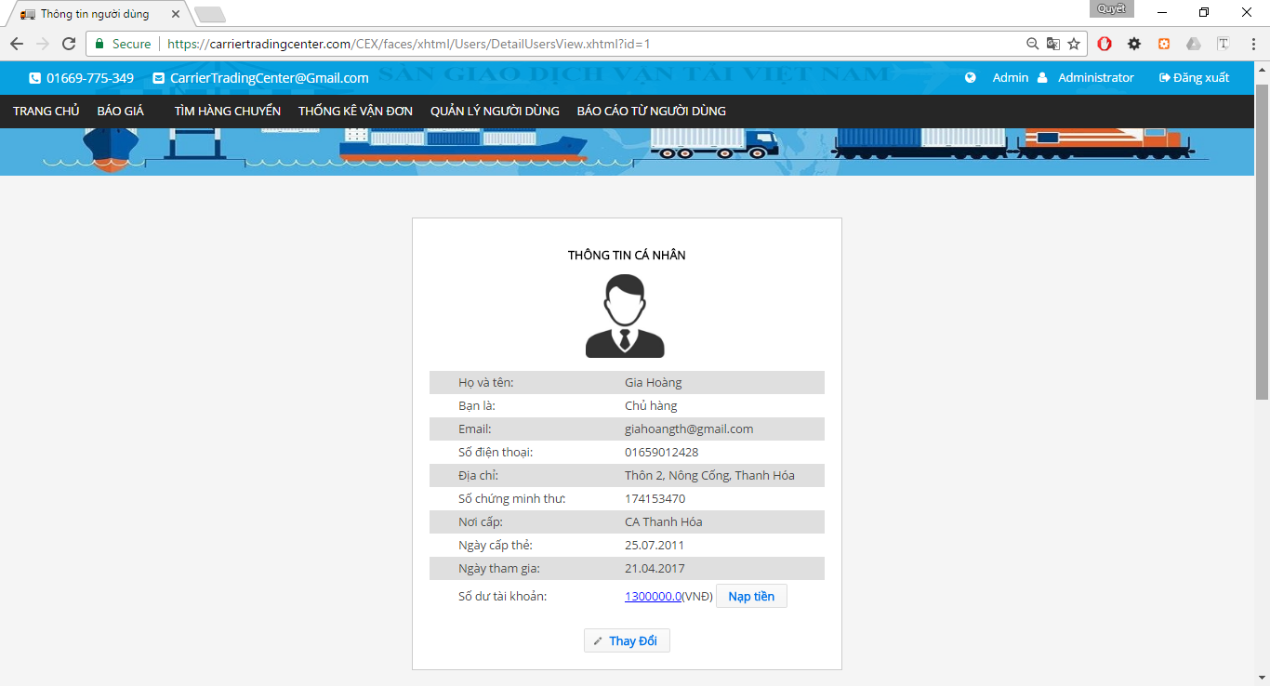

Figure 4.2‑47 User Profile (part 1)



Figure 4.2‑48 User Profile (part 2)

|  |  |  |  |  |  |  |
| --- | --- | --- | --- | --- | --- | --- |
| **No** | **Object/Control Name** | **Object/Control Name in English** | **Type** | **Required** | **Length** | **Description** |
| 1 | Thông tin cá nhân | userDeatilInformation | panelGrid | Yes |  |  |
| 2 | Thông tin công ty | companyInformation | panelGrid | No |  |  |
|  | Thay đổi |  | commandButton |  |  |  |
|  | Thêm thông tin công ty. |  | commandButton |  |  |  |

###### Case Exist Company Information

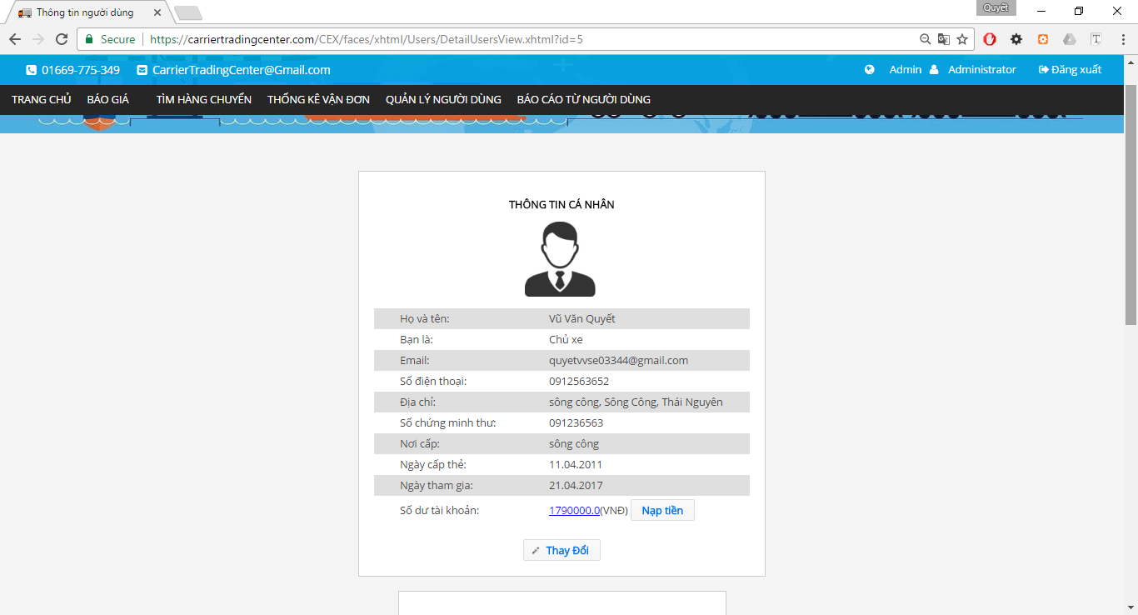

Figure 4.2‑49 User Profile (part 1)



Figure 4.2‑50 User Profile (part 2)

|  |  |  |  |  |  |  |
| --- | --- | --- | --- | --- | --- | --- |
| **No** | **Object/Control Name** | **Object/Control Name in English** | **Type** | **Required** | **Length** | **Description** |
| 1 | Thông tin cá nhân | userDeatilInformation | panelGrid | Yes |  |  |
| 2 | Thông tin công ty | companyInformation | panelGrid | No |  |  |
| 3 | Thay đổi |  | commandButton |  |  |  |
| 4 | Thay đổi |  | commandButton |  |  |  |

##### Sequence Diagram



Figure 4.2‑51 User Profile Sequence Diagram

#### Admin activate user

##### Class Diagram



Figure 4.2‑52 Active User Class Diagram

##### Screen Design



Figure 4.2‑53 Activate User

|  |  |  |  |  |  |  |
| --- | --- | --- | --- | --- | --- | --- |
| **No** | **Object/Control Name** | **Object/Control Name in English** | **Type** | **Required** | **Length** | **Description** |
| 1 | Tên người dùng | fullName | inputText | No |  |  |
| 2 | Email | email | inputText | No |  |  |
| 3 | Tỉnh | province | selectOneMenu | No |  |  |
| 4 | Quyền truy cập | role | selectOneMenu | No |  |  |
| 5 | Tìm kiếm | btn_search | btn_search |  |  |  |
| 6 | Danh sách người dùng | table_users | table_users |  |  |  |
| 7 | Kích hoạt | activate | commandButton |  |  |  |
| 8 | Ngưng kích hoạt | deactivate | commandButton |  |  |  |

##### Sequence Diagram



Figure 4.2‑54 Activate users Sequence Diagram

#### Admin deactivate user

##### Class Diagram



Figure 4.2‑55 Deactivate Users Class Diagram

##### Screen Design



Figure 4.2‑56 Activate User

|  |  |  |  |  |  |  |
| --- | --- | --- | --- | --- | --- | --- |
| **No** | **Object/Control Name** | **Object/Control Name in English** | **Type** | **Required** | **Length** | **Description** |
| 1 | Tên người dung | fullName | inputText | No |  |  |
| 2 | Email | email | inputText | No |  |  |
| 3 | Tỉnh | province | selectOneMenu | No |  |  |
| 4 | Quyền truy cập | role | selectOneMenu | No |  |  |
| 5 | Tìm kiếm | btn_search | btn_search |  |  |  |
| 6 | Danh sách người dùng | table_users | table_users |  |  |  |
| 7 | Kích hoạt | activate | commandButton |  |  |  |
| 8 | Ngưng kích hoạt | deactivate | commandButton |  |  |  |

##### Sequence Diagram



Figure 4.2‑57 Deactivate Users Sequence Diagram

#### Admin view fee list

##### Class Diagram



Figure 4.2‑58 Fee List Class Diagram

##### Screen Design



Figure 4.2‑59 Fee List

|  |  |  |  |  |  |  |
| --- | --- | --- | --- | --- | --- | --- |
| **No** | **Object/Control Name** | **Object/Control Name in English** | **Type** | **Required** | **Length** | **Description** |
| 1 | Search condition |  | selectOneMenu |  |  |  |
| 2 | Tìm kiếm | search | commandButton |  |  |  |
| 3 | Danh sách các loaị chi phí | feeDataTable | dataTable |  |  |  |

##### Sequence Diagram



Figure 4.2‑60 Fee List Sequence Diagram

#### Admin edit fee

##### Class Diagram



Figure 4.2‑61 Edit Operation Fee Class Diagram

##### Screen Design



Figure 4.2‑62 Edit Operation Fee

|  |  |  |  |  |  |  |
| --- | --- | --- | --- | --- | --- | --- |
| **No** | **Object/Control Name** | **Object/Control Name in English** | **Type** | **Required** | **Length** | **Description** |
| 1 | Bảng thôn tin chi phí |  | panelGrid |  |  |  |
| 2 | Tên chi phí | feeNameInput | inputText |  |  |  |
| 3 | Mã chi phí | operationFeeCode | inputText |  |  |  |
| 4 | Loại | type | selectOneRadio |  |  |  |
| 5 | Chi phí | fee | inputNumber |  |  |  |
| 6 | Tỉ lệ chi phí | feePercent | inputNumber |  |  |  |
| 7 | Mô tả | descriptioin | inputTextarea |  |  |  |
| 8 | Xác nhận | confirm | commandButton |  |  |  |
| 9 | Hủy bỏ | cancel | commandButton |  |  |  |

##### Sequence Diagram



Figure 4.2‑63 Edit Operation Fee Sequence Diagram

#### Admin edit reference fee

##### Class Diagram



Figure 4.2‑64 Edit Reference Fee Class Diagram

##### Screen Design



Figure 4.2‑65 Edit reference fee

|  |  |  |  |  |  |  |
| --- | --- | --- | --- | --- | --- | --- |
| **No** | **Object/Control Name** | **Object/Control Name in English** | **Type** | **Required** | **Length** | **Description** |
| 1 | Loại hàng hóa | goodsType | outputLable |  |  |  |
| 2 | Fee tham chiếu | referenceFee | inputText |  |  |  |
| 3 | Xác nhận | confirm | commandButton |  |  |  |
| 4 | Hủy bỏ | cancel | commandButton |  |  |  |

##### Sequence Diagram



Figure 4.2‑66 Edit Reference Fee Sequence Diagram

#### Admin add new fee

##### Class Diagram



Figure 4.2‑67 Add Operation Fee Class Diagram

##### Screen Design



Figure 4.2‑68 Add New Operation Fee

|  |  |  |  |  |  |  |
| --- | --- | --- | --- | --- | --- | --- |
| **No** | **Object/Control Name** | **Object/Control Name in English** | **Type** | **Required** | **Length** | **Description** |
| 1 | Bảng thôn tin chi phí |  | panelGrid |  |  |  |
| 2 | Tên chi phí | feeNameInput | inputText |  |  |  |
| 3 | Mã chi phí | operationFeeCode | inputText |  |  |  |
| 4 | Loại | type | selectOneRadio |  |  |  |
| 5 | Chi phí | fee | inputNumber |  |  |  |
| 6 | Tỉ lệ chi phí | feePercent | inputNumber |  |  |  |
| 7 | Mô tả | descriptioin | inputTextarea |  |  |  |
| 8 | Thêm mới | confirm | commandButton |  |  |  |
| 9 | Hủy bỏ | cancel | commandButton |  |  |  |

##### Sequence Diagram



Figure 4.2‑69 Add New Operation Fee Sequence Diagram

#### Admin search report

##### Class Diagram



Figure 4.2‑70 Search Report Class Diagram

##### Screen Design



Figure 4.2‑71 Search Report

|  |  |  |  |  |  |  |
| --- | --- | --- | --- | --- | --- | --- |
| **No** | **Object/Control Name** | **Object/Control Name in English** | **Type** | **Required** | **Length** | **Description** |
| 1 | Hỗ trợ tìm kiếm | search_support | panelGrid |  |  |  |
| 2 | Tên tài khoản | fullname | inputText |  |  |  |
| 3 | Tiêu đề báo cáo | reportTitle | inputText |  |  |  |
| 4 | Từ ngày | dateBegin | calendar |  |  |  |
| 5 | Đén ngày | dateEnd | calendar |  |  |  |
| 6 | Danh sách bảo cáo | listReport | dataTable |  |  |  |

##### Sequence Diagram



Figure 4.2‑72 Search Report Sequence Diagram

#### Admin view list report

##### Class Diagram



Figure 4.2‑73 List Report Class Diagram

##### Screen Design



Figure 4.2‑74 List Report

|  |  |  |  |  |  |  |
| --- | --- | --- | --- | --- | --- | --- |
| **No** | **Object/Control Name** | **Object/Control Name in English** | **Type** | **Required** | **Length** | **Description** |
| 1 | Hỗ trợ tìm kiếm | search_support | panelGrid |  |  |  |
| 2 | Tên tài khoản | fullname | inputText |  |  |  |
| 3 | Tiêu đề báo cáo | reportTitle | inputText |  |  |  |
| 4 | Từ ngày | dateBegin | calendar |  |  |  |
| 5 | Đén ngày | dateEnd | calendar |  |  |  |
| 6 | Danh sách bảo cáo | listReport | dataTable |  |  |  |

##### Sequence Diagram



Figure 4.2‑75 List Report Sequence Diagram

#### Admin response report

##### Class Diagram



Figure 4.2‑76 Response report

##### Screen Design



Figure 4.2‑77 Response Report

|  |  |  |  |  |  |  |
| --- | --- | --- | --- | --- | --- | --- |
| **No** | **Object/Control Name** | **Object/Control Name in English** | **Type** | **Required** | **Length** | **Description** |
| 1 | Báo cáo chi tiết | reportDetail | panelGrid |  |  |  |
| 2 | Tiêu đề báo cáo | fullName | outputText |  |  |  |
| 3 | Người gửi | userName | outputText |  |  |  |
| 4 | Tài khoản người gửi | userName | outputText |  |  |  |
| 5 | Người nhận |  | outputText |  |  |  |
| 6 | Ngày gửi | reportDate | outputLable |  |  |  |
| 7 | Câu hỏi từ người dung | reportQuestion | outputLable |  |  |  |
| 8 | Mong muốn xử lý | reportSolution | outputLable |  |  |  |
| 9 | Nội dung | reportContent | outputLable |  |  |  |
| 10 | Phản hồi | reportReply | inputTextarea |  |  |  |
| 11 | Phản hồi | submit | commandButton |  |  |  |
| 12 | Quay lại | goback | commandButton |  |  |  |

##### Sequence Diagram



Figure 4.2‑78 Response Report Sequence Diagram

#### Admin edit profile

##### Class Diagram



Figure 4.2‑79 Edit Profile Class Diagram

##### Screen Design



Figure 4.2‑80 Edit Profile

|  |  |  |  |  |  |  |
| --- | --- | --- | --- | --- | --- | --- |
| **No** | **Object/Control Name** | **Object/Control Name in English** | **Type** | **Required** | **Length** | **Description** |
| 1 | avatar | avatar | graphicImage |  |  |  |
| 2 | Chọn ảnh | chooseImg | fileUpload |  |  |  |
| 3 | Họ và tên | fullName | inputText |  |  |  |
| 4 | Bạn là | role | outputlable |  |  |  |
| 5 | Email | email | inputText |  |  |  |
| 6 | Số điện thoại | phoneNumber | inputText |  |  |  |
| 7 | Địa chỉ | address | inputText |  |  |  |
| 8 | Tỉnh/Thành phố | province | selectOneMenu |  |  |  |
| 9 | Quận/Huyện | district | selectOneMenu |  |  |  |
| 10 | Số chứng minh thư | identityCard | inputText |  |  |  |
| 11 | Nơi cấp | identityCardPlace | inputText |  |  |  |
| 12 | Ngày cấp | identityCardDate | inputText |  |  |  |
| 13 | Ngày tham gia | dateCreate | outputlable |  |  |  |
| 14 | Lưu thay đổi | save | commandButton |  |  |  |
| 15 | Hủy bỏ | cancel | commandButton |  |  |  |

##### Sequence Diagram



Figure 4.2‑81 Edit Profile Sequence Diagram

#### Admin edit user profile

##### Class Diagram



Figure 4.2‑79 Edit Profile Class Diagram

##### Screen Design



Figure 4.2‑80 Edit User Profile

|  |  |  |  |  |  |  |
| --- | --- | --- | --- | --- | --- | --- |
| **No** | **Object/Control Name** | **Object/Control Name in English** | **Type** | **Required** | **Length** | **Description** |
| 1 | avatar | avatar | graphicImage |  |  |  |
| 2 | Chọn ảnh | chooseImg | fileUpload |  |  |  |
| 3 | Họ và tên | fullName | inputText |  |  |  |
| 4 | Bạn là | role | outputlable |  |  |  |
| 5 | Email | email | inputText |  |  |  |
| 6 | Số điện thoại | phoneNumber | inputText |  |  |  |
| 7 | Địa chỉ | address | inputText |  |  |  |
| 8 | Tỉnh/Thành phố | province | selectOneMenu |  |  |  |
| 9 | Quận/Huyện | district | selectOneMenu |  |  |  |
| 10 | Số chứng minh thư | identityCard | inputText |  |  |  |
| 11 | Nơi cấp | identityCardPlace | inputText |  |  |  |
| 12 | Ngày cấp | identityCardDate | inputText |  |  |  |
| 13 | Ngày tham gia | dateCreate | outputlable |  |  |  |
| 14 | Lưu thay đổi | save | commandButton |  |  |  |
| 15 | Hủy bỏ | cancel | commandButton |  |  |  |

##### Sequence Diagram



Figure 4.2‑81 Edit User Profile Sequence Diagram

#### Admin change password

##### Class Diagram



Figure 4.2‑82 Change Password Class Diagram

##### Screen Design



Figure 4.2‑83 Update Password

|  |  |  |  |  |  |  |
| --- | --- | --- | --- | --- | --- | --- |
| **No** | **Object/Control Name** | **Object/Control Name in English** | **Type** | **Required** | **Length** | **Description** |
| 1 | Thay đổi mật khẩu | resetPassword | panelGrid |  |  |  |
| 2 | Mật khẩu cũ | fullName | password |  |  |  |
| 3 | Mật khẩu mới | role | password |  |  |  |
| 4 | Xác nhận mật khẩu | email | password |  |  |  |
| 5 | Đổi mật khẩu | phoneNumber | commandButton |  |  |  |

##### Sequence Diagram



Figure 4.2‑84 Update Password Sequence Diagram

#### Admin forgot password

##### Class Diagram



Figure 4.2‑85 Forgot Password Class Diagram

##### Screen Design



Figure 4.2‑86 Forgot Password

|  |  |  |  |  |  |  |
| --- | --- | --- | --- | --- | --- | --- |
| **No** | **Object/Control Name** | **Object/Control Name in English** | **Type** | **Required** | **Length** | **Description** |
| 1 | Quên mật khẩu | forgotPassword | panelGrid |  |  |  |
| 2 | Email đã đăng ký | email | inputText |  |  |  |
| 3 | Gửi | send | commandButton |  |  |  |



Figure 4.2‑87 Reset Password

|  |  |  |  |  |  |  |
| --- | --- | --- | --- | --- | --- | --- |
| **No** | **Object/Control Name** | **Object/Control Name in English** | **Type** | **Required** | **Length** | **Description** |
| 1 | Thay đổi mật khẩu | resetPassword | panelGrid |  |  |  |
| 2 | Địa chỉ email | chooseImg | inputText |  |  |  |
| 3 | Mật khẩu cũ | fullName | password |  |  |  |
| 4 | Mật khẩu mới | role | password |  |  |  |
| 5 | Xác nhận mật khẩu | email | password |  |  |  |
| 6 | Đổi mật khẩu | phoneNumber | commandButton |  |  |  |

##### Sequence Diagram



Figure 4.2‑88 Forgot Password Sequence Diagram

#### Admin login

##### Class Diagram



Figure 4.2‑89 Login Class Diagram

##### Screen Design



Figure 4.2‑90 Login

|  |  |  |  |  |  |  |
| --- | --- | --- | --- | --- | --- | --- |
| **No** | **Object/Control Name** | **Object/Control Name in English** | **Type** | **Required** | **Length** | **Description** |
| 1 | Đăng nhập | login | CommandButto |  |  |  |
| 2 | Email | email | inputText |  |  |  |
| 3 | Mật khẩu | password | password |  |  |  |
| 4 | Đăng ký | register | Hreflink |  |  |  |
| 5 | Quên mật khẩu | Forgot password | Hreflink |  |  |  |

##### Sequence Diagram



Figure 4.2‑91 Login Sequence Diagram

#### Admin logout

##### Class Diagram



Figure 4.2‑92 Logout Class Diagram

##### Screen Design



Figure 4.2‑93 Logout

|  |  |  |  |  |  |  |
| --- | --- | --- | --- | --- | --- | --- |
| **No** | **Object/Control Name** | **Object/Control Name in English** | **Type** | **Required** | **Length** | **Description** |
| 1 | Đăng xuất | logout | commandLink |  |  |  |

##### Sequence Diagram



Figure 4.2‑94 Logout Sequence Diagram

#### Admin view transaction history

##### Class Diagram



Figure 4.2‑95 View Transaction History Class Diagram

##### Screen Design



Figure 4.2‑96 Payment Detail

|  |  |  |  |  |  |  |
| --- | --- | --- | --- | --- | --- | --- |
| **No** | **Object/Control Name** | **Object/Control Name in English** | **Type** | **Required** | **Length** | **Description** |
| 1 | Thông tin về tài khoản | accountInformation | panelGrid | Yes |  |  |
| 2 | Hỗ trợ tìm kiếm | searchPanel | panel | No |  |  |
| 3 | Ngày bắt đầu | departureDate | calendar | No |  |  |
| 4 | Ngày kết thúc | arrivalDate | calendar | No |  |  |
| 5 | Tìm kiếm | search | commandButton |  |  |  |
| 6 | Liệt kê giao dịch | tablePaymentDetail | dataTable |  |  |  |

##### Sequence Diagram



Figure 4.2‑97 View Transaction History Sequence Diagram

#### Admin view fee table history

##### Class Diagram



Figure 4.2‑98 View Fee Table History Class Diagram

##### Screen Design



Figure 4.2‑99 History Fee

|  |  |  |  |  |  |  |
| --- | --- | --- | --- | --- | --- | --- |
| **No** | **Object/Control Name** | **Object/Control Name in English** | **Type** | **Required** | **Length** | **Description** |
| 1 | Search condition |  | selectOneMenu |  |  |  |
| 2 | Tìm kiếm | search | commandButton |  |  |  |
| 3 | Danh sách các loaị chi phí | feeDataTable | dataTable |  |  |  |

##### Sequence Diagram



Figure 4.2‑100 History fee Sequence Diagram

#### Admin recharge for user

##### Class Diagram



Figure 4.2‑101 Account Recharge Class Diagram

##### Screen Design



Figure 4.2‑102 Recharger Account

|  |  |  |  |  |  |  |
| --- | --- | --- | --- | --- | --- | --- |
| **No** | **Object/Control Name** | **Object/Control Name in English** | **Type** | **Required** | **Length** | **Description** |
| 1 | Số tiền(VND) | amount | inputText |  |  |  |
| 2 | Xác nhận | confirm | commandButton |  |  |  |
| 3 | Hủy bỏ | cancel | commandButton |  |  |  |

##### Sequence Diagram



Figure 4.2‑103 Recharge Account Sequence Diagram

#### Admin reference fee

##### Class Diagram



Figure 2.2‑118 View Reference Fee Class Diagram

##### Screen Design



Figure 2.2‑119 Reference Fee (part 1)



Figure 2.2‑120 Reference Fee (part 2)



Figure 2.2‑121 Reference Fee (part 3)

|  |  |  |  |  |  |  |
| --- | --- | --- | --- | --- | --- | --- |
| **No** | **Object/Control Name** | **Object/Control Name in English** | **Type** | **Required** | **Length** | **Description** |
| 1 | Bảng giá tham chiếu chi phí vận chuyển | goodsTypeList | dataTable |  |  |  |
| 2 | Bảng giá cước vận chuyển hàng hóa đường bộ từ TP.HCM đi các tỉnh |  | graphicImage |  |  |  |
| 3 | Bảng giá cước vận chuyển hàng hóa đường bộ từ Hà Nội đi các tỉnh |  | graphicImage |  |  |  |

##### Sequence Diagram



Figure 2.2‑122 View Reference Fee Sequence Diagram

#### Admin view profile

##### Class Diagram



Figure 2.2‑108 View Profile Class Diagram

##### Screen Design

###### Case does not Exist Company Information



Figure 2.2‑109 User Profile (part 1)



|  |  |  |  |  |  |  |
| --- | --- | --- | --- | --- | --- | --- |
| **No** | **Object/Control Name** | **Object/Control Name in English** | **Type** | **Required** | **Length** | **Description** |
| 1 | Thông tin cá nhân | userDeatilInformation | panelGrid | Yes |  |  |
| 2 | Thông tin công ty | companyInformation | panelGrid | No |  |  |
|  | Thay đổi |  | commandButton |  |  |  |
|  | Thêm thông tin công ty. |  | commandButton |  |  |  |

###### Case Exist Company Information



Figure 2.2‑110 Profile (part 1)



Figure 2.2‑111 Profile (part 2)

|  |  |  |  |  |  |  |
| --- | --- | --- | --- | --- | --- | --- |
| **No** | **Object/Control Name** | **Object/Control Name in English** | **Type** | **Required** | **Length** | **Description** |
| 1 | Thông tin cá nhân | userDeatilInformation | panelGrid | Yes |  |  |
| 2 | Thông tin công ty | companyInformation | panelGrid | No |  |  |
| 3 | Thay đổi |  | commandButton |  |  |  |
| 4 | Thay đổi |  | commandButton |  |  |  |

##### Sequence Diagram



Figure 2.2‑112 User Profile Sequence Diagram

##### Screen Design



Figure 2.2‑113 Edit Company Information’s

|  |  |  |  |  |  |  |
| --- | --- | --- | --- | --- | --- | --- |
| **No** | **Object/Control Name** | **Object/Control Name in English** | **Type** | **Required** | **Length** | **Description** |
| 1 | Thông tin công ty | companyInformation | panelGrid |  |  |  |
| 2 | Tên công ty | comapnyName | inputText |  | 100 |  |
| 3 | Email | email | inputText |  | 50 |  |
| 4 | Số điện thoại | phoneNumber | inputText |  | 11 |  |
| 5 | Fax | fax | inputText |  | 20 |  |
| 6 | Địa chỉ | address | inputText |  | 100 |  |
| 7 | Mã số thuế | taxCode | inputText |  | 20 |  |
| 8 | Lưu thay đổi | confirm | commandButton |  |  |  |
| 9 | Hủy bỏ | cancel | commandButton |  |  |  |

##### Sequence Diagram



Figure 2.2‑114 Edit Company Information's Sequence Diagram

#### Admin add company information

##### Class Diagram



Figure 4.2‑104

##### Screen Design



Figure 4.2‑105 Add Company Class Diagram

|  |  |  |  |  |  |  |
| --- | --- | --- | --- | --- | --- | --- |
| **No** | **Object/Control Name** | **Object/Control Name in English** | **Type** | **Required** | **Length** | **Description** |
| 1 | Thông tin công ty | companyInformation | panelGrid |  |  |  |
| 2 | Tên công ty | comapnyName | inputText |  | 100 |  |
| 3 | Email | email | inputText |  | 50 |  |
| 4 | Số điện thoại | phoneNumber | inputText |  | 11 |  |
| 5 | Fax | fax | inputText |  | 20 |  |
| 6 | Địa chỉ | address | inputText |  | 100 |  |
| 7 | Mã số thuế | taxCode | inputText |  | 20 |  |
| 8 | Lưu thay đổi | confirm | commandButton |  |  |  |
| 9 | Hủy bỏ | cancel | commandButton |  |  |  |

##### Sequence Diagram



Figure 4.2‑106 Add Company Sequence Diagram

#### Admin edit company information

##### Class Diagram



Figure 4.2‑107 Edit Company Information’s Class Diagram

##### Screen Design



Figure 4.2‑108 Edit Company Information’s

|  |  |  |  |  |  |  |
| --- | --- | --- | --- | --- | --- | --- |
| **No** | **Object/Control Name** | **Object/Control Name in English** | **Type** | **Required** | **Length** | **Description** |
| 1 | Thông tin công ty | companyInformation | panelGrid |  |  |  |
| 2 | Tên công ty | comapnyName | inputText |  | 100 |  |
| 3 | Email | email | inputText |  | 50 |  |
| 4 | Số điện thoại | phoneNumber | inputText |  | 11 |  |
| 5 | Fax | fax | inputText |  | 20 |  |
| 6 | Địa chỉ | address | inputText |  | 100 |  |
| 7 | Mã số thuế | taxCode | inputText |  | 20 |  |
| 8 | Lưu thay đổi | confirm | commandButton |  |  |  |
| 9 | Hủy bỏ | cancel | commandButton |  |  |  |

##### Sequence Diagram



Figure 4.2‑109 Edit Company Information's Sequence Diagram

#### Goods owner view list bill of lading

##### Class Diagram



Figure 4.2‑110 Goods Owner View List Bills of Lading

##### Screen Design



Figure 4.2‑111 List Bills of Lading

|  |  |  |  |  |  |  |
| --- | --- | --- | --- | --- | --- | --- |
| **No** | **Object/Control Name** | **Object/Control Name in English** | **Type** | **Required** | **Length** | **Description** |
| 1 | Loại Hàng | goodTypeId | selectOneMenu | No |  |  |
| 2 | Hình thức đóng gói | packageFormId | selectOneMenu | No |  |  |
| 3 | Khối lượng | weight | inputText | No |  |  |
| 4 | Thể tích | volume | inputText | No |  |  |
| 5 | Địa điểm đi | slbDepartureProvinceID | selectOneMenu | No |  |  |
| 6 | Địa điêm đến | slbArrivalProvinceID | selectOneMenu | No |  |  |
| 7 | Thời gian đi | departureDate | calendar | No |  |  |
| 8 | Thời gian đến | arrivalDate | calendar | No |  |  |
| 9 | Tìm kiếm | search | commandButton |  |  |  |
| 10 | Danh sách đơn hàng | table_billoflading | dataTable |  |  |  |

##### Sequence Diagram



Figure 4.2‑112 List Bill of Lading Sequence Diagram

#### Goods owner view detail bill of lading

##### Class Diagram



Figure 4.2‑113 Detail Bills of Lading

##### Screen Design

###### Owned



Figure 4.2‑114 Detail Bills of Lading (part 1)



Figure 4.2‑115 Detail Bills of Lading (part 2)

|  |  |  |  |  |  |  |
| --- | --- | --- | --- | --- | --- | --- |
| **No** | **Object/Control Name** | **Object/Control Name in English** | **Type** | **Required** | **Length** | **Description** |
| 1 | Thông tin hàng hóa cần vận chuyển | goodInformation | selectOneMenu |  |  |  |
| 2 | Google Map | map | javaScript |  |  |  |
| 3 | Hủy giao dịch | cancelBillOflading | commandButton |  |  |  |
| 4 | Hỏi đáp |  | panelGroup |  |  |  |

###### Other



Figure 4.2‑116 Detail Bills of Lading

|  |  |  |  |  |  |  |
| --- | --- | --- | --- | --- | --- | --- |
| **No** | **Object/Control Name** | **Object/Control Name in English** | **Type** | **Required** | **Length** | **Description** |
| 1 | Thông tin hàng hóa cần vận chuyển | goodInformation | selectOneMenu |  |  |  |
| 2 | Google Map | map | javaScript |  |  |  |

##### Sequence Diagram



Figure 4.2‑117 Detail Bills of Lading Sequence Diagram

#### Goods owner search bill of lading

##### Class Diagram



Figure 4.2‑118 Search Bill of Lading class Diagram

##### Screen Design



Figure 4.2‑119 Search Bills of Lading

|  |  |  |  |  |  |  |
| --- | --- | --- | --- | --- | --- | --- |
| **No** | **Object/Control Name** | **Object/Control Name in English** | **Type** | **Required** | **Length** | **Description** |
| 1 | Loại Hàng | goodTypeId | selectOneMenu | No |  |  |
| 2 | Hình thức đóng gói | packageFormId | selectOneMenu | No |  |  |
| 3 | Khối lượng | weight | inputText | No |  |  |
| 4 | Thể tích | volume | inputText | No |  |  |
| 5 | Địa điểm đi | slbDepartureProvinceID | selectOneMenu | No |  |  |
| 6 | Địa điêm đến | slbArrivalProvinceID | selectOneMenu | No |  |  |
| 7 | Thời gian đi | departureDate | calendar | No |  |  |
| 8 | Thời gian đến | arrivalDate | calendar | No |  |  |
| 9 | Tìm kiếm | search | commandButton |  |  |  |
| 10 | Danh sách đơn hàng | table_billoflading | dataTable |  |  |  |

##### Sequence Diagram



Figure 4.2‑120 Search Bill of Lading Sequence Diagram

#### Goods owner view carrier auction success

##### Class Diagram



Figure 4.2‑121 View Auction Success Class Diagram

##### Screen Design



Figure 4.2‑122 Auction Success

|  |  |  |  |  |  |  |
| --- | --- | --- | --- | --- | --- | --- |
| **No** | **Object/Control Name** | **Object/Control Name in English** | **Type** | **Required** | **Length** | **Description** |
| 1 | Thông tin hàng hóa cần vận chuyển | goodInformation | selectOneMenu |  |  |  |
| 2 | Google Map | map | javaScript |  |  |  |
| 3 | Hủy giao dịch | cancelBillOflading | commandButton |  |  |  |
| 4 | Hỏi đáp |  | panelGroup |  |  |  |

##### Sequence Diagram



Figure 4.2‑123 View Auction Success Sequence Diagram

#### Goods owner view transaction history

##### Class Diagram



Figure 4.2‑124 View Transaction History Class Diagram

##### Screen Design



Figure 4.2‑125 Payment Detail

|  |  |  |  |  |  |  |
| --- | --- | --- | --- | --- | --- | --- |
| **No** | **Object/Control Name** | **Object/Control Name in English** | **Type** | **Required** | **Length** | **Description** |
| 1 | Thông tin về tài khoản | accountInformation | panelGrid | Yes |  |  |
| 2 | Hỗ trợ tìm kiếm | searchPanel | panel | No |  |  |
| 3 | Ngày bắt đầu | departureDate | calendar | No |  |  |
| 4 | Ngày kết thúc | arrivalDate | calendar | No |  |  |
| 5 | Tìm kiếm | search | commandButton |  |  |  |
| 6 | Liệt kê giao dịch | tablePaymentDetail | dataTable |  |  |  |

##### Sequence Diagram



Figure 4.2‑126 View Transaction History Sequence Diagram

#### Goods owner register a new bill of lading

##### Class Diagram



Figure 4.2‑127 Register new Bill of Lading

##### Screen Design



Figure 4.2‑128 Post Bill of Lading (part 1)



Figure 4.2‑129 Post Bill of Lading (part 2)



Figure 4.2‑130 Post Bill of Lading (part 3)



Figure 4.2‑131 Post Bill of Lading (part 4)

|  |  |  |  |  |  |  |
| --- | --- | --- | --- | --- | --- | --- |
| **No** | **Object/Control Name** | **Object/Control Name in English** | **Type** | **Required** | **Length** | **Description** |
| 1 | Mã vận đơn | Code | inputText | No | 20 |  |
| 2 | Loại hàng | goodsType | selectOneMenu | Yes |  |  |
| 3 | Hình thức đóng gói. | packageForm | selectOneMenu | Yes |  |  |
| 4 | Họ và tên người gửi | sender | inputText | Yes | 50 |  |
| 5 | Số điện thoại | sender PhoneNumber | inputText | Yes | 12 |  |
| 6 | Họ và tên người nhận | receiver | inputText | Yes | 50 |  |
| 7 | Số điện thoại | receiverPhoneNumber | inputText | Yes | 12 |  |
| 8 | Địa điêm gửi | departureProvince | selectOneMenu | Yes |  |  |
| 9 | Địa điểm nhận | arrivalProvince | selectOneMenu | Yes |  |  |
| 10 | Đi từ quận/ huyện | departureDistrict | selectOneMenu | Yes |  |  |
| 11 | Đến quận/huyện | arrivalDistrict | selectOneMenu | Yes |  |  |
| 12 | Địa chỉ nơi gửi | departureAddress | inputText | Yes | 100 |  |
| 13 | Địa chỉ nơi nhận | arrivalAddress | inputText | Yes | 100 |  |
| 14 | Đặc điểm nơi gửi | departureCharacteristicPlace | inputText | No | 100 |  |
| 15 | Đặc điểm nơi nhận | arrivalCharacteristicPlace | inputText | No | 100 |  |
| 16 | Ngày gửi | departureDate | calendar | Yes |  |  |
| 17 | Ngày nhận | arrivalDate | calendar | Yes |  |  |
| 18 | Quãng đường | distance | inputNumber | Yes |  |  |
| 19 | Khối lượng | weight | inputNumber | Yes |  |  |
| 20 | Số lượng | quantity | inputNumber | No |  |  |
| 21 | Dài | lenght | inputNumber | Yes |  |  |
| 22 | Rộng | width | inputNumber | Yes |  |  |
| 23 | Cao | height | inputNumber | Yes |  |  |
| 24 | Hàng đông lạnh | isFrozen | selectBooleanCheckbox | No |  |  |
| 25 | Hàng dễ vỡ | isFragile | selectBooleanCheckbox | No |  |  |
| 26 | Hình ảnh | goodsImage | fileUpload | No | 255 |  |
| 27 | Mô tả | description | inputTextarea | No | 200 |  |
| 28 | Fee đề xuất | fee | inputNumber | Yes |  |  |
| 29 | Thời gian kết thúc đấu giá | currentDate | calendar | Yes |  |  |
| 30 | Đăng ký |  | commandButton |  |  |  |
| 31 | Hủy bỏ |  | commandButton |  |  |  |

##### Sequence Diagram



Figure 4.2‑132 Post Bill of Lading Sequence Diagram

#### Goods owner cancel bill of Lading

##### Class Diagram



Figure 4.2‑133 Cancel Bill of Lading Class Diagram

##### Screen Design



Figure 4.2‑134 Cancel Bill of Lading

|  |  |  |  |  |  |  |
| --- | --- | --- | --- | --- | --- | --- |
| **No** | **Object/Control Name** | **Object/Control Name in English** | **Type** | **Required** | **Length** | **Description** |
| 1 | Thông tin hàng hóa cần vận chuyển | goodInformation | selectOneMenu |  |  |  |
| 2 | Google Map | map | javaScript |  |  |  |
| 3 | Hủy giao dịch | cancelBillOflading | commandButton |  |  |  |
| 4 | Hỏi đáp |  | panelGroup |  |  |  |

##### Sequence Diagram



Figure 4.2‑135 Cancel Bill of Lading Sequence Diagram

#### Goods owner edit profile

##### Class Diagram



Figure 4.2‑136 Edit Profile Class Diagram

##### Screen Design



Figure 4.2‑137 Edit profile

|  |  |  |  |  |  |  |
| --- | --- | --- | --- | --- | --- | --- |
| **No** | **Object/Control Name** | **Object/Control Name in English** | **Type** | **Required** | **Length** | **Description** |
| 1 | avatar | avatar | graphicImage |  |  |  |
| 2 | Chọn ảnh | chooseImg | fileUpload |  |  |  |
| 3 | Họ và tên | fullName | inputText |  |  |  |
| 4 | Bạn là | role | outputlable |  |  |  |
| 5 | Email | email | outputlable |  |  |  |
| 6 | Số điện thoại | phoneNumber | inputText |  |  |  |
| 7 | Địa chỉ | address | outputlable |  |  |  |
| 8 | Tỉnh/Thành phố | province | outputlable |  |  |  |
| 9 | Quận/Huyện | district | outputlable |  |  |  |
| 10 | Số chứng minh thư | identityCard | outputlable |  |  |  |
| 11 | Nơi cấp | identityCardPlace | outputlable |  |  |  |
| 12 | Ngày cấp | identityCardDate | outputlable |  |  |  |
| 13 | Ngày tham gia | dateCreate | outputlable |  |  |  |
| 14 | Lưu thay đổi | save | commandButton |  |  |  |
| 15 | Hủy bỏ | cancel | commandButton |  |  |  |

##### Sequence Diagram



Figure 4.2‑138 Edit Profile Sequence Diagram

#### Goods owner forgot password

##### Class Diagram



Figure 4.2‑139 Forgot Password Class Diagram

##### Screen Design



Figure 4.2‑140 Send Mail Reset Password

|  |  |  |  |  |  |  |
| --- | --- | --- | --- | --- | --- | --- |
| **No** | **Object/Control Name** | **Object/Control Name in English** | **Type** | **Required** | **Length** | **Description** |
| 1 | Quên mật khẩu | forgotPassword | panelGrid |  |  |  |
| 2 | Email đã đăng ký | email | inputText |  |  |  |
| 3 | Gửi | send | commandButton |  |  |  |



Figure 4.2‑141 Reset Password

|  |  |  |  |  |  |  |
| --- | --- | --- | --- | --- | --- | --- |
| **No** | **Object/Control Name** | **Object/Control Name in English** | **Type** | **Required** | **Length** | **Description** |
| 1 | Thay đổi mật khẩu | resetPassword | panelGrid |  |  |  |
| 2 | Địa chỉ email | chooseImg | inputText |  |  |  |
| 3 | Mật khẩu cũ | fullName | password |  |  |  |
| 4 | Mật khẩu mới | role | password |  |  |  |
| 5 | Xác nhận mật khẩu | email | password |  |  |  |
| 6 | Đổi mật khẩu | phoneNumber | commandButton |  |  |  |

##### Sequence Diagram



Figure 4.2‑142 Forgot Password Sequence Diagram

#### Goods owner change password

##### Class Diagram



Figure 4.2‑143 Change Password Class Diagram

##### Screen Design



Figure 4.2‑144 Update Password

|  |  |  |  |  |  |  |
| --- | --- | --- | --- | --- | --- | --- |
| **No** | **Object/Control Name** | **Object/Control Name in English** | **Type** | **Required** | **Length** | **Description** |
| 1 | Thay đổi mật khẩu | resetPassword | panelGrid |  |  |  |
| 2 | Mật khẩu cũ | fullName | password |  |  |  |
| 3 | Mật khẩu mới | role | password |  |  |  |
| 4 | Xác nhận mật khẩu | email | password |  |  |  |
| 5 | Đổi mật khẩu | phoneNumber | commandButton |  |  |  |

##### Sequence Diagram



Figure 4.2‑145 Update Password Sequence Diagram

#### Goods owner send report

##### Class Diagram



Figure 4.2‑146 Send Report Class Diagram

##### Screen Design



Figure 4.2‑147 Add new Report

|  |  |  |  |  |  |  |
| --- | --- | --- | --- | --- | --- | --- |
| **No** | **Object/Control Name** | **Object/Control Name in English** | **Type** | **Required** | **Length** | **Description** |
| 1 | Chủ đề bạn muốn báo cáo là gì? | reporTtitle | inputText |  |  |  |
| 2 | Câu hỏi của bạn là gì? | reportQuestion | inputText |  |  |  |
| 3 | Bạn mong muốn xử lý như thế nào | reportSolution | outputText |  |  |  |
| 4 | Nội dung bảo cáo của bạn | reportContent | outputText |  |  |  |
| 5 | Gửi báo cáo | addNewReport | commandButton |  |  |  |
| 6 | Quay lại | goback | commandButton |  |  |  |

##### Sequence Diagram



Figure 4.2‑148 Send Report Sequence Diagram

#### Goods owner view Profile

##### Class Diagram



Figure 4.2‑149 View User Profile Class Diagram

##### Screen Design

###### Case does not Exist Company Information



Figure 4.2‑150 User Profile

|  |  |  |  |  |  |  |
| --- | --- | --- | --- | --- | --- | --- |
| **No** | **Object/Control Name** | **Object/Control Name in English** | **Type** | **Required** | **Length** | **Description** |
| 1 | Thông tin cá nhân | userDeatilInformation | panelGrid | Yes |  |  |
| 2 | Thông tin công ty | companyInformation | panelGrid | No |  |  |
| 3 | Thay đổi |  | commandButton |  |  |  |
| 4 | Thêm thông tin công ty. |  | commandButton |  |  |  |

###### Case Exist Company Information



Figure 4.2‑151 User Profile (part 1)



Figure 4.2‑152 User Profile (part 2)

|  |  |  |  |  |  |  |
| --- | --- | --- | --- | --- | --- | --- |
| **No** | **Object/Control Name** | **Object/Control Name in English** | **Type** | **Required** | **Length** | **Description** |
| 1 | Thông tin cá nhân | userDeatilInformation | panelGrid | Yes |  |  |
| 2 | Thông tin công ty | companyInformation | panelGrid | No |  |  |
| 3 | Thay đổi |  | commandButton |  |  |  |
| 4 | Thay đổi |  | commandButton |  |  |  |

##### Sequence Diagram



Figure 4.2‑153 User Profile Sequence Diagram

#### Goods owner view report list

##### Class Diagram



Figure 4.2‑154 View Report list

##### Screen Design



Figure 4.2‑155 List Report

|  |  |  |  |  |  |  |
| --- | --- | --- | --- | --- | --- | --- |
| **No** | **Object/Control Name** | **Object/Control Name in English** | **Type** | **Required** | **Length** | **Description** |
| 1 | Hỗ trợ tìm kiếm |  | panelGrid |  |  |  |
| 2 | Tiêu đề báo cáo | reportTitle | inputText | No | 75 |  |
| 3 | Từ ngày | reportDateBegin | calendar | No |  |  |
| 4 | Đén ngày | reportDateEnd | calendar | No |  |  |
| 5 | Tìm kiếm | search | commandButton |  |  |  |
| 6 | Danh sách bảo cáo | litsReport | dataTable |  |  |  |

##### Sequence Diagram



Figure 4.2‑156 List Report Sequence Diagram

#### Goods owner search report

##### Class Diagram



Figure 4.2‑157 Search Report Class Diagram

##### Screen Design



Figure 4.2‑158 Search Report

|  |  |  |  |  |  |  |
| --- | --- | --- | --- | --- | --- | --- |
| **No** | **Object/Control Name** | **Object/Control Name in English** | **Type** | **Required** | **Length** | **Description** |
| 1 | Hỗ trợ tìm kiếm |  | panelGrid |  |  |  |
| 2 | Tiêu đề báo cáo | reportTitle | inputText | No | 75 |  |
| 3 | Từ ngày | reportDateBegin | calendar | No |  |  |
| 4 | Đén ngày | reportDateEnd | calendar | No |  |  |
| 5 | Tìm kiếm | search | commandButton |  |  |  |
| 6 | Danh sách bảo cáo | litsReport | dataTable |  |  |  |

##### Sequence Diagram



Figure 4.2‑159 Search Report Sequence Diagram

#### Goods owner connect to carrier

##### Goods owner comment to carrier

###### Class Diagram



Figure 2.2‑171 Comment to carrier Class Diagram

###### Screen Design



|  |  |  |  |  |  |  |
| --- | --- | --- | --- | --- | --- | --- |
| **No** | **Object/Control Name** | **Object/Control Name in English** | **Type** | **Required** | **Length** | **Description** |
| 1 | Hỏi đáp | questionAnswer | panelGroup |  |  |  |
| 2 | Button Send | send | commandButton |  |  |  |

###### Sequence Diagram



Figure 2.2‑172 Write comment to Carrier Sequence Diagram

##### Goods owner answer to carrier

###### Class Diagram



Figure 2.2‑173 Answer to carrier

###### Screen Design

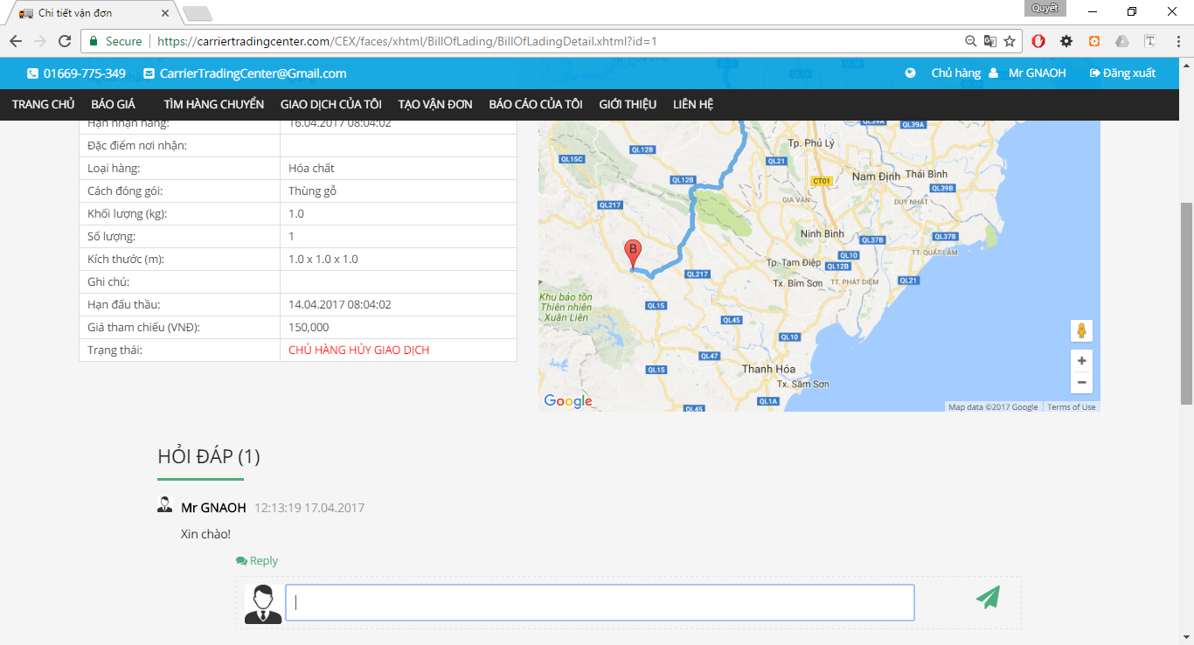

Figure 2.2‑174 Goods Owner Answer Comment

|  |  |  |  |  |  |  |
| --- | --- | --- | --- | --- | --- | --- |
| **No** | **Object/Control Name** | **Object/Control Name in English** | **Type** | **Required** | **Length** | **Description** |
| 1 | Hỏi đáp | questionAnswer | panelGroup |  |  |  |
| 2 | Trả lời | reply | inputText |  |  |  |
| 3 | Button Send | send | commandButton |  |  |  |

###### Sequence Diagram



Figure 2.2‑175 Answer comment Sequence Diagram

#### Goods owner account recharge

##### Class Diagram



Figure 4.2‑166 Goods Owner Account Recharge Class Diagram

##### Screen Design



Figure 4.2‑167 Account Recharge

|  |  |  |  |  |  |  |
| --- | --- | --- | --- | --- | --- | --- |
| **No** | **Object/Control Name** | **Object/Control Name in English** | **Type** | **Required** | **Length** | **Description** |
| 1 | Nạp tiền vào tài khoản | accountRecharge | NganLuong API |  |  |  |

##### Sequence Diagram



Figure 4.2‑168 Account Recharge Sequence Diagram

#### Goods owner reference fee

##### Class Diagram



Figure 4.2‑169 View Reference Fee Class Diagram

##### Screen Design



Figure 4.2‑170 Reference Fee (part 1)



Figure 4.2‑171 Reference Fee (part 2)



Figure 4.2‑172 Reference Fee (part 3)

|  |  |  |  |  |  |  |
| --- | --- | --- | --- | --- | --- | --- |
| **No** | **Object/Control Name** | **Object/Control Name in English** | **Type** | **Required** | **Length** | **Description** |
| 1 | Bảng giá tham chiếu chi phí vận chuyển | goodsTypeList | dataTable |  |  |  |
| 2 | Bảng giá cước vận chuyển hàng hóa đường bộ từ TP.HCM đi các tỉnh |  | graphicImage |  |  |  |
| 3 | Bảng giá cước vận chuyển hàng hóa đường bộ từ Hà Nội đi các tỉnh |  | graphicImage |  |  |  |

##### Sequence Diagram



Figure 4.2‑173 View Reference Fee Sequence Diagram

#### Goods owner confirm complete transaction

##### Class Diagram



Figure 4.2‑174 Confirm Complete Transaction Class Diagram

##### Screen Design



Figure 4.2‑175 Confirm Dialog

|  |  |  |  |  |  |  |
| --- | --- | --- | --- | --- | --- | --- |
| **No** | **Object/Control Name** | **Object/Control Name in English** | **Type** | **Required** | **Length** | **Description** |
| 1 | Xác nhận | confirm | commandButton |  |  |  |
| 2 | Hủy bỏ | cancel | commandButton |  |  |  |

##### Sequence Diagram



Figure 4.2‑176 Confirm Complete Transaction Sequence Diagram

#### Goods owner Login

##### Class Diagram



Figure 2.2‑193 Login

##### Screen Design



Figure 2.2‑194 Login

|  |  |  |  |  |  |  |
| --- | --- | --- | --- | --- | --- | --- |
| **No** | **Object/Control Name** | **Object/Control Name in English** | **Type** | **Required** | **Length** | **Description** |
| 1 | Đăng nhập | loginForm | panelGrid |  |  |  |
| 2 | Email | email | inputText |  |  |  |
| 3 | Mật khẩu | password | password |  |  |  |

##### Sequence Diagram



Figure 2.2‑195 Login Sequence Diagram

#### Goods owner logout

##### Class Diagram



Figure 2.2‑196 Logout Class Diagram

##### Screen Design

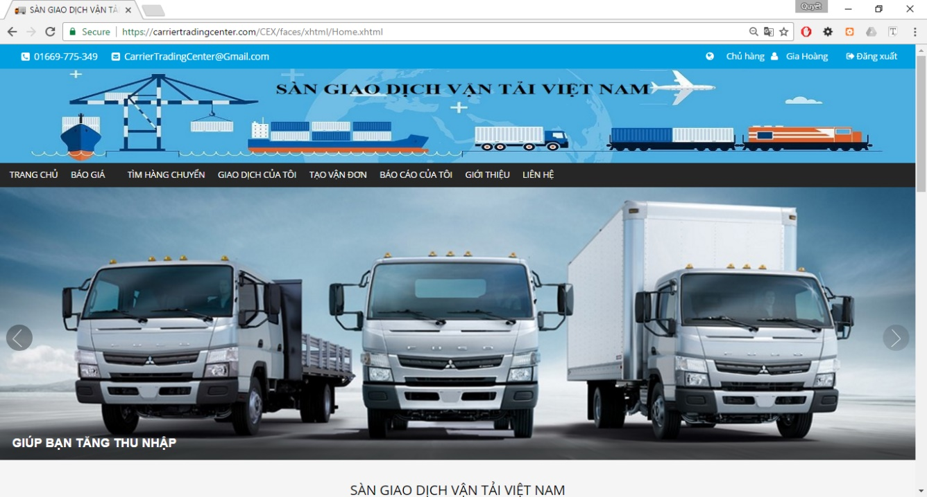

Figure 2.2‑197 Logout

|  |  |  |  |  |  |  |
| --- | --- | --- | --- | --- | --- | --- |
| **No** | **Object/Control Name** | **Object/Control Name in English** | **Type** | **Required** | **Length** | **Description** |
| 1 | Đăng xuất | logout | commandLink |  |  |  |

##### Sequence Diagram



Figure 2.2‑198 Logout Sequence Diagram

#### Goods owner cancel report

##### Class Diagram



Figure 2.2‑199 Cancel Report Class Diagram

##### Screen Design



Figure 2.2‑200 List Report

|  |  |  |  |  |  |  |
| --- | --- | --- | --- | --- | --- | --- |
| **No** | **Object/Control Name** | **Object/Control Name in English** | **Type** | **Required** | **Length** | **Description** |
| 1 | Hỗ trợ tìm kiếm |  | panelGrid |  |  |  |
| 2 | Tiêu đề báo cáo | reportTitle | inputText | No | 75 |  |
| 3 | Từ ngày | reportDateBegin | calendar | No |  |  |
| 4 | Đén ngày | reportDateEnd | calendar | No |  |  |
| 5 | Tìm kiếm | search | commandButton |  |  |  |
| 6 | Hủy bỏ | cancel | commandButton |  |  |  |
| 7 | Danh sách bảo cáo | litsReport | dataTable |  |  |  |

##### Sequence Diagram



Figure 2.2‑201 Cancel Report Sequence Diagram

#### Goods owner view fee list

##### Class Diagram



Figure 2.2‑190 Fee List Class Diagram

##### Screen Design



Figure 2.2‑191 Fee List

|  |  |  |  |  |  |  |
| --- | --- | --- | --- | --- | --- | --- |
| **No** | **Object/Control Name** | **Object/Control Name in English** | **Type** | **Required** | **Length** | **Description** |
| 1 | Danh sách các loaị chi phí | feeDataTable | dataTable |  |  |  |

##### Sequence Diagram



Figure 2.2‑192 Fee List Sequence Diagram

#### Goods owner add company

##### Class Diagram



Figure 4.2‑177 Goods Owner Add Company Class Diagram

##### Screen Design



Figure 4.2‑178 Add Company

|  |  |  |  |  |  |  |
| --- | --- | --- | --- | --- | --- | --- |
| **No** | **Object/Control Name** | **Object/Control Name in English** | **Type** | **Required** | **Length** | **Description** |
| 1 | Thông tin công ty | companyInformation | panelGrid |  |  |  |
| 2 | Tên công ty | comapnyName | inputText |  | 100 |  |
| 3 | Email | email | inputText |  | 50 |  |
| 4 | Số điện thoại | phoneNumber | inputText |  | 11 |  |
| 5 | Fax | fax | inputText |  | 20 |  |
| 6 | Địa chỉ | address | inputText |  | 100 |  |
| 7 | Mã số thuế | taxCode | inputText |  | 20 |  |
| 8 | Lưu thay đổi | confirm | commandButton |  |  |  |
| 9 | Hủy bỏ | cancel | commandButton |  |  |  |

##### Sequence Diagram



Figure 4.2‑179 Add Company Information Sequence Diagram

#### Carrier view list bill of lading

##### Class Diagram



Figure 4.2‑180 View List Bill of Lading

##### Screen Design



Figure 4.2‑181 List Bills of Lading

|  |  |  |  |  |  |  |
| --- | --- | --- | --- | --- | --- | --- |
| **No** | **Object/Control Name** | **Object/Control Name in English** | **Type** | **Required** | **Length** | **Description** |
| 1 | Loại Hàng | goodTypeId | selectOneMenu | No |  |  |
| 2 | Hình thức đóng gói | packageFormId | selectOneMenu | No |  |  |
| 3 | Khối lượng | weight | inputText | No |  |  |
| 4 | Thể tích | volume | inputText | No |  |  |
| 5 | Địa điểm đi | slbDepartureProvinceID | selectOneMenu | No |  |  |
| 6 | Địa điêm đến | slbArrivalProvinceID | selectOneMenu | No |  |  |
| 7 | Thời gian đi | departureDate | calendar | No |  |  |
| 8 | Thời gian đến | arrivalDate | calendar | No |  |  |
| 9 | Tìm kiếm | search | commandButton |  |  |  |
| 10 | Danh sách đơn hàng | table_billoflading | dataTable |  |  |  |

##### Sequence Diagram



Figure 4.2‑182 List Bill of Lading Sequence Diagram

#### Carrier owner view fee list

##### Class Diagram



Figure 2.2‑269 Fee List Class Diagram

##### Screen Design



Figure 2.2‑270 Fee List

|  |  |  |  |  |  |  |
| --- | --- | --- | --- | --- | --- | --- |
| **No** | **Object/Control Name** | **Object/Control Name in English** | **Type** | **Required** | **Length** | **Description** |
| 1 | Danh sách các loaị chi phí | feeDataTable | dataTable |  |  |  |

##### Sequence Diagram



Figure 2.2‑271 Fee List Sequence Diagram

#### Carrier connect to goods owner

##### Carrier comment to goods owner

###### Class Diagram



Figure 2.2‑252 Comments to Goods Owner Class Diagram

###### Screen Design



Figure 2.2‑253 Write Comment

|  |  |  |  |  |  |  |
| --- | --- | --- | --- | --- | --- | --- |
| **No** | **Object/Control Name** | **Object/Control Name in English** | **Type** | **Required** | **Length** | **Description** |
| 1 | Hỏi đáp | questionAnswer | panelGroup |  |  |  |
| 2 | Button Send | send | commandButton |  |  |  |

###### Sequence Diagram



Figure 2.2‑254 Comments to Goods Owner Sequence Diagram

##### Carrier answer to goods owner

###### Class Diagram



Figure 2.2‑255 Answers to Goods Owner Class Diagram

###### Screen Design



Figure 2.2‑256 Answer Comment

|  |  |  |  |  |  |  |
| --- | --- | --- | --- | --- | --- | --- |
| **No** | **Object/Control Name** | **Object/Control Name in English** | **Type** | **Required** | **Length** | **Description** |
| 1 | Hỏi đáp | questionAnswer | panelGroup |  |  |  |
| 2 | Trả lời | reply | inputText |  |  |  |
| 3 | Button Send | send | commandButton |  |  |  |

###### Sequence Diagram



Figure 2.2‑257 Answers to Goods Owner Sequence Diagram

#### Carrier cancel report

##### Class Diagram



Figure 2.2‑272 Cancel Report Class Diagram

##### Screen Design



Figure 2.2‑273 List Report

|  |  |  |  |  |  |  |
| --- | --- | --- | --- | --- | --- | --- |
| **No** | **Object/Control Name** | **Object/Control Name in English** | **Type** | **Required** | **Length** | **Description** |
| 1 | Hỗ trợ tìm kiếm |  | panelGrid |  |  |  |
| 2 | Tiêu đề báo cáo | reportTitle | inputText | No | 75 |  |
| 3 | Từ ngày | reportDateBegin | calendar | No |  |  |
| 4 | Đén ngày | reportDateEnd | calendar | No |  |  |
| 5 | Tìm kiếm | search | commandButton |  |  |  |
| 6 | Hủy bỏ | cancel | commandButton |  |  |  |
| 7 | Danh sách bảo cáo | litsReport | dataTable |  |  |  |

##### Sequence Diagram



Figure 2.2‑274 Cancel Report Sequence Diagram

#### Carrier view bill of lading detail

##### Class Diagram



Figure 4.2‑183 Detail Bills of Lading Class Diagram

##### Screen Design



Figure 4.2‑184 Detail Bills of Lading

|  |  |  |  |  |  |  |
| --- | --- | --- | --- | --- | --- | --- |
| **No** | **Object/Control Name** | **Object/Control Name in English** | **Type** | **Required** | **Length** | **Description** |
| 1 | Thông tin hàng hóa cần vận chuyển | goodInformation | selectOneMenu |  |  |  |
| 2 | Google Map | map | javaScript |  |  |  |
| 3 | Đấu thầu | auction | commandButton |  |  |  |

##### Sequence Diagram



Figure 4.2‑185 Detail Bills of Lading Sequence Diagram

#### Carrier auction bill of lading

##### Class Diagram



Figure 4.2‑186 Auction Bill of Lading Class Diagram

##### Screen Design



Figure 4.2‑187 Auction Bills of Lading

|  |  |  |  |  |  |  |
| --- | --- | --- | --- | --- | --- | --- |
| **No** | **Object/Control Name** | **Object/Control Name in English** | **Type** | **Required** | **Length** | **Description** |
| 1 | Thông tin hàng hóa cần vận chuyển | good_information | panelGrid |  |  |  |
| 2 | Gmap | gmap | Java script |  |  |  |
| 3 | Đấu thầu | auction | commandButton |  |  |  |

##### Sequence Diagram



Figure 4.2‑188 Auction Bill of Lading Sequence Diagram

#### Carrier account recharge

##### Class Diagram



Figure 4.2‑189 Account Recharge Class Diagram

##### Screen Design



Figure 4.2‑190 Account Recharge

|  |  |  |  |  |  |  |
| --- | --- | --- | --- | --- | --- | --- |
| **No** | **Object/Control Name** | **Object/Control Name in English** | **Type** | **Required** | **Length** | **Description** |
| 1 | Nạp tiền vào tài khoản | accountRecharge | NganLuong API |  |  |  |

##### Sequence Diagram



Figure 4.2‑191 Account Recharge Sequence Diagram

#### Carrier search bill of lading

##### Class Diagram



Figure 4.2‑192 Search Bill of Lading Class Diagram

##### Screen Design



Figure 4.2‑193 Search Bills of lading

|  |  |  |  |  |  |  |
| --- | --- | --- | --- | --- | --- | --- |
| **No** | **Object/Control Name** | **Object/Control Name in English** | **Type** | **Required** | **Length** | **Description** |
| 1 | Loại Hàng | goodTypeId | selectOneMenu | No |  |  |
| 2 | Hình thức đóng gói | packageFormId | selectOneMenu | No |  |  |
| 3 | Khối lượng | weight | inputText | No |  |  |
| 4 | Thể tích | volume | inputText | No |  |  |
| 5 | Địa điểm đi | slbDepartureProvinceID | selectOneMenu | No |  |  |
| 6 | Địa điêm đến | slbArrivalProvinceID | selectOneMenu | No |  |  |
| 7 | Thời gian đi | departureDate | calendar | No |  |  |
| 8 | Thời gian đến | arrivalDate | calendar | No |  |  |

##### Sequence Diagram



Figure 4.2‑194 Search Bill of Lading Sequence Diagram

#### Carrier cancel bill of lading

##### Class Diagram



Figure 4.2‑195 Cancel Bill of Lading Class Diagram

##### Screen Design



Figure 4.2‑196 Cancel Bill of Lading

|  |  |  |  |  |  |  |
| --- | --- | --- | --- | --- | --- | --- |
| **No** | **Object/Control Name** | **Object/Control Name in English** | **Type** | **Required** | **Length** | **Description** |
| 1 | Thông tin hàng hóa cần vận chuyển | good_information | panelGrid |  |  |  |
| 2 | Gmap | gmap | Java script |  |  |  |
| 3 | Hủy đấu thầu | cancelBillOfLading | commandButton |  |  |  |

##### Sequence Diagram



Figure 4.2‑197 Carrier Cancel Bill of Lading Sequence Diagram

#### Carrier view profile

##### Class Diagram



Figure 4.2‑198 View Profile

##### Screen Design

###### Case does not Exist Company Information



Figure 4.2‑199 User Detail Information (part 1)

|  |  |  |  |  |  |  |
| --- | --- | --- | --- | --- | --- | --- |
| **No** | **Object/Control Name** | **Object/Control Name in English** | **Type** | **Required** | **Length** | **Description** |
| 1 | Thông tin cá nhân | userDeatilInformation | panelGrid | Yes |  |  |
| 2 | Thông tin công ty | companyInformation | panelGrid | No |  |  |
| 3 | Thay đổi | change | commandButton |  |  |  |
| 4 | Thêm mới | addNew | commandButton |  |  |  |

###### Case Exist Company Information



Figure 4.2‑200 User Detail Information (part 2.1)



Figure 4.2‑201 User Detail Information (part 2.2)

|  |  |  |  |  |  |  |
| --- | --- | --- | --- | --- | --- | --- |
| **No** | **Object/Control Name** | **Object/Control Name in English** | **Type** | **Required** | **Length** | **Description** |
| 1 | Thông tin cá nhân | userDeatilInformation | panelGrid | Yes |  |  |
| 2 | Thông tin công ty | companyInformation | panelGrid | No |  |  |
| 3 | Thay đổi |  | commandButton |  |  |  |
| 4 | Thay đổi |  | commandButton |  |  |  |

##### Sequence Diagram



Figure 4.2‑202 View Profile Sequence Diagram

#### Carrier edit profile

##### Class Diagram



Figure 4.2‑203 Edit Profile Class Diagram

##### Screen Design



Figure 4.2‑204 Edit Profile

|  |  |  |  |  |  |  |
| --- | --- | --- | --- | --- | --- | --- |
| **No** | **Object/Control Name** | **Object/Control Name in English** | **Type** | **Required** | **Length** | **Description** |
|  | avatar | avatar | graphicImage |  |  |  |
|  | Chọn ảnh | chooseImg | fileUpload |  |  |  |
|  | Họ và tên | fullName | inputText |  |  |  |
|  | Email | email | outputlable |  |  |  |
|  | Số điện thoại | phoneNumber | inputText |  |  |  |
|  | Địa chỉ | address | outputlable |  |  |  |
|  | Tỉnh/Thành phố | province | outputlable |  |  |  |
|  | Quận/Huyện | district | outputlable |  |  |  |
|  | Số chứng minh thư | identityCard | outputlable |  |  |  |
|  | Nơi cấp | identityCardPlace | outputlable |  |  |  |
|  | Ngày cấp | identityCardDate | outputlable |  |  |  |
|  | Ngày tham gia | dateCreate | outputlable |  |  |  |
|  | Lưu thay đổi | save | commandButton |  |  |  |
|  | Hủy bỏ | cancel | commandButton |  |  |  |

##### Sequence Diagram



Figure 4.2‑205 Edit profile Sequence Diagram

#### Carrier change password

##### Class Diagram



Figure 4.2‑206 Change Password Class Diagram

##### Screen Design



Figure 4.2‑207 Update Password

|  |  |  |  |  |  |  |
| --- | --- | --- | --- | --- | --- | --- |
| **No** | **Object/Control Name** | **Object/Control Name in English** | **Type** | **Required** | **Length** | **Description** |
| 1 | Thay đổi mật khẩu | resetPassword | panelGrid |  |  |  |
| 2 | Mật khẩu cũ | fullName | password |  |  |  |
| 3 | Mật khẩu mới | role | password |  |  |  |
| 4 | Xác nhận mật khẩu | email | password |  |  |  |
| 5 | Đổi mật khẩu | phoneNumber | commandButton |  |  |  |

##### Sequence Diagram



Figure 4.2‑208 Update Password Sequence Diagram

#### Carrier forgot password

##### Class Diagram



Figure 4.2‑209 Forgot Password Class Diagram

##### Screen Design



Figure 4.2‑210 Send Mail Reset Password

|  |  |  |  |  |  |  |
| --- | --- | --- | --- | --- | --- | --- |
| **No** | **Object/Control Name** | **Object/Control Name in English** | **Type** | **Required** | **Length** | **Description** |
| 1 | Quên mật khẩu | forgotPassword | panelGrid |  |  |  |
| 2 | Email đã đăng ký | email | inputText |  |  |  |
| 3 | Gửi | send | commandButton |  |  |  |



Figure 4.2‑211 Reset Password

|  |  |  |  |  |  |  |
| --- | --- | --- | --- | --- | --- | --- |
| **No** | **Object/Control Name** | **Object/Control Name in English** | **Type** | **Required** | **Length** | **Description** |
| 1 | Thay đổi mật khẩu | resetPassword | panelGrid |  |  |  |
| 2 | Địa chỉ email | chooseImg | inputText |  |  |  |
| 3 | Mật khẩu cũ | fullName | password |  |  |  |
| 4 | Mật khẩu mới | role | password |  |  |  |
| 5 | Xác nhận mật khẩu | email | password |  |  |  |
| 6 | Đổi mật khẩu | phoneNumber | commandButton |  |  |  |

##### Sequence Diagram



Figure 4.2‑212 Forgot Password Sequence Diagram

#### Carrier send report

##### Class Diagram



Figure 4.2‑213 Send Report Class Diagram

##### Screen Design



Figure 4.2‑214 Add new Report

|  |  |  |  |  |  |  |
| --- | --- | --- | --- | --- | --- | --- |
| **No** | **Object/Control Name** | **Object/Control Name in English** | **Type** | **Required** | **Length** | **Description** |
| 1 | Chủ đề bạn muốn báo cáo là gì? | reporTtitle | inputText |  |  |  |
| 2 | Câu hỏi của bạn là gì? | reportQuestion | inputText |  |  |  |
| 3 | Bạn mong muốn xử lý như thế nào | reportSolution | outputText |  |  |  |
| 4 | Nội dung bảo cáo của bạn | reportContent | outputText |  |  |  |
| 5 | Gửi báo cáo | addNewReport | commandButton |  |  |  |
| 6 | Quay lại | goback | commandButton |  |  |  |

##### Sequence Diagram



Figure 4.2‑215 Send Report Sequence Diagram

#### Carrier view list report

##### Class Diagram



Figure 4.2‑216 View List Report Class Diagram

##### Screen Design



Figure 4.2‑217 List Carrier's Report

|  |  |  |  |  |  |  |
| --- | --- | --- | --- | --- | --- | --- |
| **No** | **Object/Control Name** | **Object/Control Name in English** | **Type** | **Required** | **Length** | **Description** |
| 1 | Hỗ trợ tìm kiếm |  | panelGrid |  |  |  |
| 2 | Tiêu đề báo cáo | reportTitle | inputText | No | 75 |  |
| 3 | Từ ngày | reportDateBegin | calendar | No |  |  |
| 4 | Đén ngày | reportDateEnd | calendar | No |  |  |
| 5 | Tìm kiếm | search | commandButton |  |  |  |
| 6 | Danh sách bảo cáo | litsReport | dataTable |  |  |  |

##### Sequence Diagram



Figure 4.2‑218 List Report Sequence Diagram

#### Carrier search report

##### Class Diagram



Figure 4.2‑219 Search Report Class Diagram

##### Screen Design



Figure 4.2‑220 Search Report

|  |  |  |  |  |  |  |
| --- | --- | --- | --- | --- | --- | --- |
| **No** | **Object/Control Name** | **Object/Control Name in English** | **Type** | **Required** | **Length** | **Description** |
| 1 | Hỗ trợ tìm kiếm |  | panelGrid |  |  |  |
| 2 | Tiêu đề báo cáo | reportTitle | inputText | No | 75 |  |
| 3 | Từ ngày | reportDateBegin | calendar | No |  |  |
| 4 | Đén ngày | reportDateEnd | calendar | No |  |  |
| 5 | Tìm kiếm | search | commandButton |  |  |  |
| 6 | Danh sách bảo cáo | litsReport | dataTable |  |  |  |

##### Sequence Diagram



Figure 4.2‑221 Search Report Sequence Diagram

#### Carrier view transaction history

##### Class Diagram



Figure 4.2‑222 View Transaction History Class Diagram

##### Screen Design



Figure 4.2‑223 Payment Detail

|  |  |  |  |  |  |  |
| --- | --- | --- | --- | --- | --- | --- |
| **No** | **Object/Control Name** | **Object/Control Name in English** | **Type** | **Required** | **Length** | **Description** |
| 1 | Thông tin về tài khoản | accountInformation | panelGrid | Yes |  |  |
| 2 | Hỗ trợ tìm kiếm | searchPanel | panel | No |  |  |
| 3 | Ngày bắt đầu | departureDate | calendar | No |  |  |
| 4 | Ngày kết thúc | arrivalDate | calendar | No |  |  |
| 5 | Tìm kiếm | search | commandButton |  |  |  |
| 6 | Liệt kê giao dịch | tablePaymentDetail | dataTable |  |  |  |

##### Sequence Diagram



Figure 4.2‑224 View Transaction History Sequence Diagram

#### Carrier Login

##### Class Diagram



Figure 4.2‑225 Login

##### Screen Design



Figure 4.2‑226 Login

|  |  |  |  |  |  |  |
| --- | --- | --- | --- | --- | --- | --- |
| **No** | **Object/Control Name** | **Object/Control Name in English** | **Type** | **Required** | **Length** | **Description** |
| 1 | Đăng nhập | loginForm | panelGrid |  |  |  |
| 2 | Email | email | inputText |  |  |  |
| 3 | Mật khẩu | password | password |  |  |  |

##### Sequence Diagram



Figure 4.2‑227 Login Sequence Diagram

#### Carrier logout

##### Class Diagram



Figure 4.2‑228 Logout Class Diagram

##### Screen Design



Figure 4.2‑229 Logout

|  |  |  |  |  |  |  |
| --- | --- | --- | --- | --- | --- | --- |
| **No** | **Object/Control Name** | **Object/Control Name in English** | **Type** | **Required** | **Length** | **Description** |
| 1 | Đăng xuất | logout | commandLink |  |  |  |

##### Sequence Diagram



Figure 4.2‑230 Logout Sequence Diagram

#### Carrier reference fee

##### Class Diagram



Figure 4.2‑237 View Reference Fee Class Diagram

##### Screen Design



Figure 4.2‑238 Reference Fee (part 1)



Figure 4.2‑239 Reference Fee (part 2)



Figure 4.2‑240 Reference Fee (part 3)

|  |  |  |  |  |  |  |
| --- | --- | --- | --- | --- | --- | --- |
| **No** | **Object/Control Name** | **Object/Control Name in English** | **Type** | **Required** | **Length** | **Description** |
| 1 | Bảng giá tham chiếu chi phí vận chuyển | goodsTypeList | dataTable |  |  |  |
| 2 | Bảng giá cước vận chuyển hàng hóa đường bộ từ TP.HCM đi các tỉnh |  | graphicImage |  |  |  |
| 3 | Bảng giá cước vận chuyển hàng hóa đường bộ từ Hà Nội đi các tỉnh |  | graphicImage |  |  |  |

##### Sequence Diagram



Figure 4.2‑241 View Reference Fee Sequence Diagram

#### Carrier confirm complete transaction

##### Class Diagram



Figure 4.2‑242 Confirm Complete Transaction Class Diagram

##### Screen Design



Figure 4.2‑243 Confirm Complete Transaction

|  |  |  |  |  |  |  |
| --- | --- | --- | --- | --- | --- | --- |
| **No** | **Object/Control Name** | **Object/Control Name in English** | **Type** | **Required** | **Length** | **Description** |
| 1 | Xác nhận | confirm | commandButton |  |  |  |
| 2 | Hủy bỏ | cancel | commandButton |  |  |  |

##### Sequence Diagram



Figure 4.2‑244 Confirm Complete Transaction Sequence Diagram

#### Carrier add company

##### Class Diagram



Figure 4.2‑245 Add Company Class Diagram

##### Screen Design



Figure 4.2‑246 Add Company

|  |  |  |  |  |  |  |
| --- | --- | --- | --- | --- | --- | --- |
| **No** | **Object/Control Name** | **Object/Control Name in English** | **Type** | **Required** | **Length** | **Description** |
| 1 | Thông tin công ty | companyInformation | panelGrid |  |  |  |
| 2 | Tên công ty | comapnyName | inputText |  | 100 |  |
| 3 | Email | email | inputText |  | 50 |  |
| 4 | Số điện thoại | phoneNumber | inputText |  | 11 |  |
| 5 | Fax | fax | inputText |  | 20 |  |
| 6 | Địa chỉ | address | inputText |  | 100 |  |
| 7 | Mã số thuế | taxCode | inputText |  | 20 |  |
| 8 | Lưu thay đổi | confirm | commandButton |  |  |  |
| 9 | Hủy bỏ | cancel | commandButton |  |  |  |

##### Sequence Diagram



Figure 4.2‑247 Add Company Class Diagram

## Database design

### Database Diagram



Figure 4.3‑1 Database Diagram

### Table Descriptions

#### Table answercomment

|  |  |  |  |  |
| --- | --- | --- | --- | --- |
| No. | Attribute | Type | Constraints | Description |
| 1 | Id | int(11) | NOT NULL  PRIMARY KEY |  |
| 2 | Content | varchar(100) | NOT NULL |  |
| 3 | CommentId | int(11) | NOT NULL  FOREIGN KEY |  |
| 4 | CreatedUserId | int(11) | NOT NULL  FOREIGN KEY |  |
| 5 | Created | datetime | NOT NULL |  |

#### Table billoflading

|  |  |  |  |  |
| --- | --- | --- | --- | --- |
| No | Attribute | Type | Constraints | Description |
| 1 | Id | int(11) | NOT NULL  PRIMARY KEY |  |
| 2 | Code | varchar(20) | DEFAULT NULL |  |
| 3 | GoodsTypeId | Int(11) | NOT NULL  FOREIGN KEY |  |
| 4 | PackagedFormId | int(11) | DEFAULT NULL  FOREIGN KEY |  |
| 5 | GoodsImage | varchar(255) | DEFAULT NULL |  |
| 6 | Weight | float | NOT NULL |  |
| 7 | Volume | float | NOT NULL |  |
| 8 | Quantity | int(11) | DEFAULT NULL |  |
| 9 | Length | float | NOT NULL |  |
| 10 | Width | float | NOT NULL |  |
| 11 | Height | varchar(50) | NOT NULL |  |
| 12 | Description | varchar(12) | DEFAULT NULL |  |
| 13 | IsFrozen | varchar(50) | DEFAULT NULL |  |
| 14 | IsFragile | varchar(50) | DEFAULT NULL |  |
| 15 | Sender | varchar(100) | DEFAULT NULL |  |
| 16 | SenderPhoneNumber | varchar(100) | DEFAULT NULL |  |
| 17 | DepartureProvince | varchar(50) | NOT NULL |  |
| 18 | DepartureDistrict | varchar(50) | NOT NULL |  |
| 19 | DepartureAddress | varchar(100) | NOT NULL |  |
| 20 | DepartureCharacteristicPlace | varchar(100) | DEFAULT NULL |  |
| 21 | DepartureDate | datetime | NOT NULL |  |
| 22 | Receiver | varchar(50) | DEFAULT NULL |  |
| 23 | ReceiverPhoneNumber | varchar(12) | DEFAULT NULL |  |
| 24 | ArrivalProvince | varchar(50) | NOT NULL |  |
|  |  |  | NOT NULL |  |
| 25 | ArrivalDistrict | varchar(50) | NOT NULL |  |
| 26 | ArrivalAddress | varchar(100) | DEFAULT NULL |  |
| 27 | ArrivalCharacteristicPlace | varchar(100) | NOT NULL |  |
| 28 | ArrivalDate | datetime | NOT NULL |  |
| 29 | Distance | float | NOT NULL |  |
| 30 | Fee | float | NOT NULL |  |
| 31 | AuctionPeriod | datetime | NOT NULL |  |
| 32 | Status | int(11) | NOT NULL |  |
| 33 | Notification | bit(1) | DEFAULT NULL |  |
| 34 | CreatedUserId | int(11) | DEFAULT NULL |  |
| 35 | Created | datetime | DEFAULT NULL |  |
| 36 | Modified | datetime | NOT NULL |  |

#### Table carrierauction

|  |  |  |  |  |
| --- | --- | --- | --- | --- |
| No | Attribute | Type | Constraints | Description |
| 1 | Id | int(11) | NOT NULL  PRIMARY KEY |  |
| 2 | BillOfLadingId | int(11) | DEFAULT NULL  FOREIGN KEY |  |
| 3 | CarrierId | int(11) | DEFAULT NULL  FOREIGN KEY |  |
| 4 | AuctionDate | datetime | NOT NULL |  |
| 5 | Modified | datetime | DEFAULT NULL |  |
| 6 | AuctionFee | float | NOT NULL |  |
| 7 | Status | int(11) | NOT NULL |  |
| 8 | notification | bit(1) | NOT NULL |  |
| 9 | Note | varchar(255) | DEFAULT NULL |  |

#### Table comment

|  |  |  |  |  |
| --- | --- | --- | --- | --- |
| No | Attribute | Type | Constraints | Description |
| 1 | Id | int(11) | NOT NULL  PRIMARY KEY |  |
| 2 | Content | varchar(100) | NOT NULL  FOREIGN KEY |  |
| 3 | BillOfLadingId | int(11) | NOT NULL  FOREIGN KEY |  |
| 4 | CreatedUserId | int(11) | NOT NULL |  |
| 5 | Created | datetime | NOT NULL |  |

#### Table company

|  |  |  |  |  |
| --- | --- | --- | --- | --- |
| No | Attribute | Type | Constraints | Description |
| 1 | Id | int(11) | NOT NULL  PRIMARY KEY |  |
| 2 | Name | varchar(100) | NOT NULL |  |
| 3 | TaxCode | varchar(20) | NOT NULL |  |
| 4 | Email | varchar(50) | DEFAULT NULL |  |
| 5 | PhoneNumber | varchar(11) | DEFAULT NULL |  |
| 6 | Fax | varchar(20) | DEFAULT NULL |  |
| 7 | address | varchar(100) | NOT NULL |  |

#### Table district

|  |  |  |  |  |
| --- | --- | --- | --- | --- |
| No | Attribute | Type | Constraints | Description |
| 1 | Id | int(11) | NOT NULL  PRIMARY KEY |  |
| 2 | Code | varchar(10) | NOT NULL  UNIQUE KEY |  |
| 3 | Name | varchar(50) | NOT NULL |  |
| 4 | Type | varchar(200) | DEFAULT NULL |  |
| 5 | ProvinceCode | varchar(10) | DEFAULT NULL |  |

#### Table goodstype

|  |  |  |  |  |
| --- | --- | --- | --- | --- |
| No | Attribute | Type | Constraints | Description |
| 1 | Id | int(11) | NOT NULL  PRIMARY KEY |  |
| 2 | Code | varchar(20) | NOT NULL |  |
| 3 | Name | varchar(50) | NOT NULL |  |
| 4 | Description | varchar(200) | DEFAULT NULL |  |
| 5 | ReferenceFee | float | DEFAULT NULL |  |

#### Table operationfee

|  |  |  |  |  |
| --- | --- | --- | --- | --- |
| No | Attribute | Type | Constraints | Description |
| 1 | Id | int(11) | NOT NULL  PRIMARY KEY |  |
| 2 | Code | varchar(10) | NOT NULL |  |
| 3 | FeeName | varchar(50) | NOT NULL |  |
| 4 | Type | bit(1) | NOT NULL |  |
| 5 | Fee | float | DEFAULT NULL |  |
| 6 | Percent | float | DEFAULT NULL |  |
| 7 | Description | longtext |  |  |
| 8 | Status | int(11) | NOT NULL |  |
| 9 | Modified | datetime | DEFAULT NULL |  |
| 10 | Created | datetime | DEFAULT NULL |  |

#### Table packagedform

|  |  |  |  |  |
| --- | --- | --- | --- | --- |
| No | Attribute | Type | Constraints | Description |
| 1 | Id | int(11) | NOT NULL  PRIMARY KEY |  |
| 2 | Code | varchar(20) | NOT NULL |  |
| 3 | Name | varchar(50) | NOT NULL |  |
| 4 | Description | varchar(200) | DEFAULT NULL |  |

#### Table paymentdetail

|  |  |  |  |  |
| --- | --- | --- | --- | --- |
| No | Attribute | Type | Constraints | Description |
| 1 | Id | int(11) | NOT NULL  PRIMARY KEY |  |
| 2 | Amounts | float | NOT NULL |  |
| 3 | PaymentDate | datetime | DEFAULT NULL |  |
| 4 | Type | bit(1) | DEFAULT NULL |  |
| 5 | Description | varchar(100) | DEFAULT NULL |  |
| 6 | Balance | float | DEFAULT NULL |  |
| 7 | BillOfLadingId | int(11) | DEFAULT NULL |  |
| 8 | UserId | int(11) | NOT NULL  FOREIGN KEY |  |

#### Table province

|  |  |  |  |  |
| --- | --- | --- | --- | --- |
| No | Attribute | Type | Constraints | Description |
| 1 | Id | int(11) | NOT NULL  PRIMARY KEY |  |
| 2 | Code | varchar(10) | NOT NULL  UNIQUE KEY |  |
| 3 | Name | varchar(50) | NOT NULL |  |
| 4 | Type | varchar(20) | DEFAULT NULL |  |

#### Table report

|  |  |  |  |  |
| --- | --- | --- | --- | --- |
| No | Attribute | Type | Constraints | Description |
| 1 | Id | int(11) | NOT NULL  PRIMARY KEY |  |
| 2 | UserId | int(11) | NOT NULL  FOREIGN KEY |  |
| 3 | ReportDate | datetime | NOT NULL |  |
| 4 | ReportTitle | varchar(75) | NOT NULL |  |
| 5 | ReportQuestio | varchar(75) | DEFAULT NULL |  |
| 6 | ReportSolutio | varchar(200) | DEFAULT NULL |  |
| 7 | ReportContent | varchar(200) | DEFAULT NULL |  |
| 8 | ReportReply | varchar(200) | DEFAULT NULL |  |
| 9 | Status | bit(1) | DEFAULT NULL |  |

#### Table users

|  |  |  |  |  |
| --- | --- | --- | --- | --- |
| No | Attribute | Type | Constraints | Description |
| 1 | Id | int(11) | NOT NULL  PRIMARY KEY |  |
| 2 | FullName | varchar(50) | NOT NULL |  |
| 3 | Email | varchar(50) | NOT NULL |  |
| 4 | Password | varchar(50) | NOT NULL |  |
| 5 | PhoneNumber | varchar(20) | NOT NULL |  |
| 6 | Address | varchar(100) | DEFAULT NULL |  |
| 7 | DistrictCode | varchar(10) | DEFAULT NULL  FOREIGN KEY |  |
| 8 | IdentityCard | varchar(20) | DEFAULT NULL |  |
| 9 | IdentityCardPlace | varchar(100) | DEFAULT NULL |  |
| 10 | IdentityCardDate | date | DEFAULT NULL |  |
| 11 | IdentityCardImage | varchar(255) | DEFAULT NULL |  |
| 12 | Role | int(11) | DEFAULT NULL |  |
| 13 | Status | int(11) | NOT NULL |  |
| 14 | Created | datetime | NOT NULL |  |
| 15 | CompanyId | int(11) | NOT NULL  FOREIGN KEY |  |
| 16 | UserAvatar | varchar(255) | DEFAULT NULL |  |

#### Table usersaccount

|  |  |  |  |  |
| --- | --- | --- | --- | --- |
| No | Attribute | Type | Constraints | Description |
| 1 | UserId | int(11) | NOT NULL  PRIMARY KEY  FOREIGN KEY |  |
| 2 | Balance | Float | NOT NULL | DEFAULT 0 |
| 3 | Modified | Datetime | NOT NULL |  |

# SOFTWARE TEST DOCUMENT

## Introduction

### Purpose

The purpose of this document is to plan all the activities needed to perform testing for the system including test strategy and test control. This document also defines scope, requirements, and constraints, risks of testing stages.

### System overview

CTC is an online system that can run on web application. It is flexible and convenient to use every time and everywhere that can connect to the internet. The system is divided into multiple modules for each specific kind of user. The combination of these modules makes the workflow of the whole system become unified, so it can work fluently. On CTC, that system provides these main functions

#### Client features

##### Guest features

* **Register:**
* Register a new account: guest can register a new account to become a new user to use CTC service.
* **List bill of lading:**
* Search bill of lading: guest can search bill of lading on CTC with key words
* View bill of lading list: guest can view bill of lading are auctioning on CTC.
* **Fee list:**
* View fee: guest can view fee list on CTC.
* Reference fee: guest can reference fee actual fee system updated.

##### Goods owner features

* **List bill of lading:**
* View bill of lading list: goods owner can view bill of lading are auctioning on CTC.
* View bill of lading detail: goods owner can view detail of bill of lading on CTC.
* Search bill of lading: goods owner can search bill of lading on CTC with key words.
* View carrier auction success: When bill of lading of goods owner is successful, they can view who got their bill of lading.
* Confirm complete transaction: when receiver received goods, goods owner had to confirm with system to get the arrange payment.
* Register a new bill of lading: when goods owner has goods for transport they can create a bill of lading to post on CTC to find carrier.
* Cancel bill of lading: when goods owner doesn’t want to send their goods, they can be using cancel function to remove their bill of lading.
* **Manage profile:**
* Edit profile: goods owner can edit their profile on system.
* View profile: goods owner can view their profile on system.
* Change password: goods owner can change their password for raise security.
* Forget password: when goods owner do not remember their password, they can send request to system to reset password.
* Add company: goods owner can add company’s information to their detail.
* **Manage report:**
* Send report: goods owner can send report to admin.
* Search report: goods owner can search report in their report list with title of report, time sent.
* View report list: goods owner can view their report on their report list.
* Cancel report: goods owner can cancel their report.
* **Fee list:**
* Reference fee: goods owner can view fee list on CTC.
* View fee list: goods owner can reference fee actual fee system updated.
* Account recharge: goods owner can recharge to their account for use CTC’s services.
* **Transaction history:**
* Transaction history: goods owner can check money in their account and check what did they do with their money.
* **Login:**
* Login: goods owner can login to CTC to use CTC’s service.
* **Logout:**
* Logout: goods owner can logout CTC.
* **Connect to carrier:**
* Connect to carrier: when goods owner is success on auction bill of lading, they can contact to carrier who got the auction and will distribute their goods.

##### Carrier feature

* **List bill of lading**
* View bill of lading list: carrier can view bill of lading are auctioning on CTC.
* Confirm complete transaction: when receiver got goods, carrier have to confirm with system to get down payment.
* View bill of lading detail: carrier can view bill of lading detail on CTC
* Auction bill of lading: when carrier want to transport goods, they can find a bill of lading and then auction it.
* Search bill of lading: carrier can search bill of lading on CTC with key words.
* Cancel bill of lading: because some reason carrier cannot transport continue, they can be cancel bill of lading.
* **Manage profile:**
* Edit profile: carrier can edit their profile on system.
* View profile: carrier can view their profile on system.
* Change password: carrier can change their password for raise security.
* Forget password: carrier do not remember their password, they can send request to system to reset password.
* Add company: carrier can add company’s information to their information.
* **Manage report:**
* Send report: carrier can send report to admin.
* Search report: carrier can search report in their report list with title of report, time sent.
* View report list: carrier can view their report on their report list.
* Cancel report: carrier can cancel their report.
* **Fee list:**
* Reference fee: carrier can view fee list on CTC.
* View fee list: carrier can reference fee actual fee system updated.
* **Account recharge:**
* Account recharge: carrier can recharge their account for use CTC’s services.
* Transaction history: carrier can check money in their account and keep track what did they do with their money.
* **Login:**
* Login: carrier can login to CTC to use CTC’s service.
* **Logout:**
* Logout: carrier can logout CTC.
* **Connect to goods owner:**
* Connect to goods owner: when goods owner is success on auction bill of lading, they can connect to goods owner who have goods they carry.

#### Admin features

* **List bill of lading:**
* View bill of lading list: admin can view bill of lading are auctioning on CTC.
* View bill of lading detail: admin can view bill of lading detail on CTC.
* Search bill of lading: admin can search bill of lading on CTC with key words.
* View carrier auction success: When bill of lading of goods owner is successful, admin can view how are get their bill of lading.
* Summary all bill of lading: admin can summary all bill of lading.
* View carrier list who are auctioning: admin can view how many carrier are auctioning a bill of lading and who are auctioning bill of lading.
* **Manage user:**
* Search user: admin can search user with name of user, email address, province, role of user keyword.
* View user profile: admin can view user profile.
* Edit user profile: admin can edit user profile.
* Active user: admin can active user to allow this user can use CTC’s service.
* Deactivate user: admin can deactivate user to disallow user use CTC’s service.
* Add company: admin can add company’s information to user detail.
* Account recharge for user: admin can recharge directly to account of user.
* Edit company information: admin can edit user’s company’s information.
* **Fee list:**
* Reference fee: admin can view fee list on CTC.
* View fee list: admin can reference fee actual fee system updated.
* Add a new fee: admin can add a new fee to fee list on CTC.
* Edit fee list: admin can edit fee on fee list on CTC.
* View fee table history: admin can view history of fee table.
* Edit reference fee: admin can edit reference fee.
* **Manage report:**
* Send report: admin can response report to goods owner and carrier.
* Search report: admin can search report in their report list with title of report, time sent.
* View report list: admin can view their report on their report list.
* **Transaction history:**
* Transaction history: admin can check money in their account and keep track what did they do with their money.
* **Login:**
* Login: admin can login to CTC to use CTC’s service.
* **Logout:**
* Logout: admin can logout CTC.
* **Manage profile:**
* Edit profile: admin can edit their profile on system.
* View profile: admin can view their profile on system.
* Change password: admin can change their password to raise account’s security.
* Forget password: admin do not remember their password, they can send request to system to reset password.

## Test plan

## Scope of testing

The scope of testing in the project include:

* **Stages of testing**: the team has responsibility to conduct Unit testing, Integration testing and System testing
* **Types of testing**: The test team have to test functional and user interface testing
* **Range of testing**: Team performs testing all functions defined in the SRS based on the approved version. Test cases of each function are defined in the Test cases document that will be tested to determine if they meet the requirements and result at the moment will also be checked according to the SRS

### Requirement for testing

#### Test items

|  |  |  |  |
| --- | --- | --- | --- |
| UC No. | Group Of Functions | Function | Glossary |
| **Guest** | | | |
| UC001 | **Register** | Register a new account |  |
| UC002 | **Bill of lading list** | Search bill of lading |  |
| UC003 | View bill of lading list |  |
| UC004 | **Fee list** | View fee |  |
| UC005 | Reference fee |  |
| **Admin** | | | |
| UC006 | **Bill of lading list** | View bill of lading detail |  |
| UC007 | Search bill of lading |  |
| UC008 | View bill of lading list |  |
| UC009 | View carrier auction success |  |
| UC010 | Summary all bill of lading |  |
| UC011 | View carrier list who are auctioning |  |
| UC012 | **Manage user** | Search user |  |
| UC013 | View user profile |  |
| UC014 | Edit user profile |  |
| UC015 | Add company |  |
| UC016 | Account recharge for user |  |
| UC017 | Active user |  |
| UC018 | Deactivate user |  |
| UC019 | Edit company information |  |
| UC020 | View user list |  |
| UC021 | **Fee list** | View fee list |  |
| UC022 | Add a new fee |  |
| UC023 | View fee table history |  |
| UC024 | Edit fee list |  |
| UC025 | Reference fee |  |
| UC026 | Edit reference fee |  |
| UC027 | **Transaction history** | Transaction History |  |
| UC028 | **Login** | Login |  |
| UC029 | **Logout** | Logout |  |
| UC030 | **Manage report** | Search report |  |
| UC031 | Response report |  |
| UC032 | View report list |  |
| UC033 | **Manage profile** | View profile |  |
| UC034 | Edit profile |  |
| UC035 | Forget password |  |
| UC036 | Change password |  |
| **Goods owner** | | | |
| UC037 | **Bill of lading list** | View bill of lading list |  |
| UC038 | View bill of lading detail |  |
| UC039 | Search bill of lading |  |
| UC040 | View carrier auction success |  |
| UC041 | Confirm complete transaction |  |
| UC042 | Post a new bill of lading |  |
| UC043 | Cancel bill of lading |  |
| UC044 | **Manage profile** | Edit profile |  |
| UC045 | View profile |  |
| UC046 | Change password |  |
| UC047 | Forget password |  |
| UC048 | Add company |  |
| UC049 | **Manage report** | Send report |  |
| UC050 | Search report |  |
| UC051 | View report list |  |
| UC052 | **Fee list** | Reference fee |  |
| UC053 | View fee list |  |
| UC054 | **Account recharge** | Account recharge |  |
| UC055 | **Transaction history** | Transaction history |  |
| UC056 | **Login** | Login |  |
| UC057 | **Logout** | Logout |  |
| UC058 | **Connect to carrier** | Connect to carrier |  |
| **Carrier** | | | |
| UC059 | **Bill of lading list** | View bill of lading list |  |
| UC060 | Confirm complete transaction |  |
| UC061 | View bill of lading detail |  |
| UC062 | Auction bill of lading |  |
| UC063 | Search bill of lading |  |
| UC064 | Cancel bill of lading |  |
| UC065 | **Manage profile** | Edit profile |  |
| UC066 | View profile |  |
| UC067 | Change password |  |
| UC068 | Forget password |  |
| UC069 | Add company |  |
| UC070 | **Manage report** | View report list |  |
| UC071 | Search report |  |
| UC072 | Send report |  |
| UC073 | **Fee list** | Reference fee |  |
| UC074 | View fee list |  |
| UC075 | **Transaction history** | Transaction history |  |
| UC076 | **Login** | Login |  |
| UC077 | **Logout** | Logout |  |
| UC078 | **Connect to goods owner** | Connect to goods owner |  |
| UC079 | **Account recharge** | Account recharge |  |

**Table 5.3-1: Test item**

#### Acceptance Test Criteria

* System does not have customers to perform acceptance test.

#### Constraints

* Testing team only has 2 members
* The program has many functions so the number of line of code is very high, which leads to have more number of test cases.

##### Risk list

The project could face with some risks:

* Tester has not familiar with CTC so that the progress testing is slower than plan, team may not keep the deadline as planned
* Test devices may shut-down or corrupted.
* Lack of time and resources for testing
* Members may get sick during project implementation

### Test strategy

#### Test policy

* Test without moral and ethic.
* Find bugs as soon as possible and always make sure they have been fixed.
* No outstanding high severity faults.
* Ensuring the product covers key features and attributes requirements.

#### Test model

Using V-Model to implement testing process

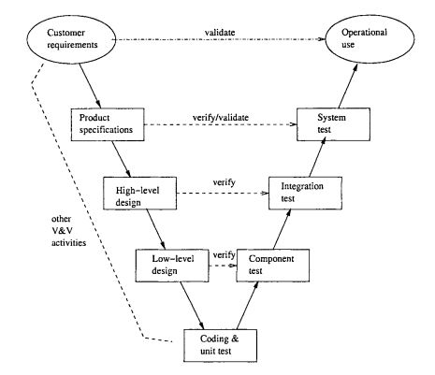

**Figure 5.3-1: V-Model to implement testing process**

Due to scope of CTC project and project must always fulfill user requirements. With V-Model, software development is separated into two appropriate phases’ groups: development and testing. Testing phase is carried out simultaneously from the early of project, the requirement specification phase. Therefore, tester could study and understand the entire requirement as well as business of project

Moreover, there are many variations among planning, design and implementation during the whole project. To catch up with all changes and ensure logic as well as business, V-model is choose as a solution to help testers control and follow the actual workflows.

This testing is executed to ensure that all requirements mentioned in SRS, included both functional requirements and non-functional requirements which are implemented correctly.

* **Technique:**
* **Integration test**: Base on requirement in SRS and validation in database, test team will test as black box testing method to check if the input and output display as expected and does that flow work fluently
* **System** **testing**: Based on requirements in SRS, test team will create scenarios for system testing (ST) to ensure project’s business. In ST, tester will create test cases based on these scenarios and run to verify functional and non-functional requirements.
* **Completion criteria:**
* All planned test cases have been executed compared with expected result in test cases.
* System test cases must be green (passed) at least 97%
* All defects must be logged into test documents and re-tested after it is fixed.
* All defects, which are accepted by customer or project technical leader and project manager, will be marked as accepted and not be retested.
* All defects must be resolved or accepted.
* These criteria will be applied for all test types.
* **Special considerations:**
* Test databases will be required
* Testing may be stopped when:
* A certain number of defects found
* Time runs out
* Test coverage > 97%
* Stop when testing becomes unproductive.

#### Type of testing

##### Functional Testing

Function testing of the target-of-test should focus on any requirements for test that can be traced directly to use cases or business functions and business rules.  The goals of these tests are to verify proper data acceptance, processing, and retrieval, and the appropriate implementation of the business rules.  This type of testing is based upon black box a 1application via the Graphical User Interface (GUI) and analyzing the output or results.  Identified below is an outline of the testing recommended for each application

|  |  |
| --- | --- |
| Test Objective: | The type of this test is to ensure proper target-of-test functionality, including user interaction, all function defined in specification document implemented correctly. |
| Technique: | The test team will execute each use case, use-case flow, or function, using valid and invalid data, to verify the following:   * The expected results occur when valid data is used. * The appropriate error or warning messages are displayed when invalid data is used. * Each business rule is properly applied. |
| Completion Criteria: | All planned tests have been executed.  All identified defects have been addressed and closed |
| Special Considerations: | Testing may be stopped when   * Time runs out * A certain number of defects found * Test coverage > 97% * Stop when testing becomes unproductive |

Table 5.3: Functional testing

##### User Interface Testing

User Interface (UI) testing verifies a user’s interaction with the software. The goal of UI testing is to ensure that the User Interface provides the user with the appropriate access and navigation through the functions of the target-of-test.  In addition, UI testing ensures that the objects within the UI function as expected and conform to corporate or industry standards.

|  |  |
| --- | --- |
| Test Objective: | Verify the following: Navigation through the target-of-test properly reflects business functions and requirements, including window-to-window, field-to-field, and use of access methods (tab keys, mouse movements, accelerator keys |
| Technique: | Create or modify tests for each page to verify proper navigation and object states for each page |
| Completion Criteria: | Each window successfully verified to remain consistent with benchmark version or within acceptable standard |

Table 5.3-3: User Interface testing

#### Test stage

Clearly state the stage in which the test will be executed. Identified below are the stages in which common test are executed

|  |  |  |  |
| --- | --- | --- | --- |
| Type of Tests | Stage of Test | | |
| Unit | Integration | System |
| Function Test | x | X | x |
| User Interface test | x |  | x |

Table 5.3-4: Test stages

#### Tools

|  |  |  |  |
| --- | --- | --- | --- |
| Purpose | Tool | Vendor/In-house | Version |
| Access to website | Chrome |  |  |
| Firefox |  |  |
| Keep tracking defects | Hostedredmine.com |  |  |
| Test Plan | MS Word |  | Office 2016 |
| Test Case, Test Report | MS Excel |  | Office 2016 |

Table 5.3-5: Tools

#### Resources

This table shows the staffing assumptions for the project.

|  |  |
| --- | --- |
| Worker/Doer | Specific Responsibilities/Comments |
| Trịnh Đình Quyết  Đặng Lê Tuấn | * Manage Test resource and assign test tasks * Create Test Plan * Review Test Cases * Create Test Report * Execute Test |

Table 5.3-6: Human resource

## Test case

|  |  |  |  |  |  |
| --- | --- | --- | --- | --- | --- |
| ID | Test case description | Test case procedure | Expect output | Result |  |
| [Admin-1] | Sign in with empty username & password | 1. Click button "Đăng nhập" in navigation bar 2. Sign up with empty username & password. 3. Click "Đăng nhập". | 1. Show 2 messages "Bạn chưa nhập Email!" and "Bạn chưa nhập Mật khẩu!" | Pass |  |
| [Admin-2] | Sign in with wrong username & empty password | 1. Click button "Đăng nhập" in navigation bar 2. Sign in with wrong username & empty password 3. Click "Đăng nhập". | 1. Show Error Message “Bạn chưa nhập Mật khẩu!” | Pass |  |
| [Admin-3] | Sign in with correct username & empty password | 1. Click button "Đăng nhập" in navigation bar 2. Sign in with empty username & password 3. Click "Đăng nhập". | 1. Show Error Message “Bạn chưa nhập Mật khẩu!” | Pass |  |
| [Admin-4] | Sign in with empty username & wrong password | 1. Click button "Đăng nhập" in navigation bar 2. Sign in with correct username & empty password 3. Click "Đăng nhập". | 1. Show Error Message “Bạn chưa nhập Email!” | Pass |  |
| [Admin-5] | Sign in with wrong username & password | 1. Click button "Đăng nhập" in navigation bar 2. Sign in with wrong username & password 3. Click "Đăng nhập". | 1. Show pop-up error message "Email và mật khẩu chưa đúng!" | Pass |  |
| [Admin-6] | Sign in with correct username & wrong password | 1. Click button "Đăng nhập" in navigation bar 2. Sign in with correct username & wrong password 3. Click "Đăng nhập". | 1. Show pop-up error message "Email và mật khẩu chưa đúng!" | Pass |  |
| [Admin-7] | Sign in with empty username & correct password | 1. Click button "Đăng nhập" in navigation bar 2. Sign in with empty username & correct password 3. Click "Đăng nhập". | 1. Show error message "Bạn chưa nhập Email!" | Pass |  |
| [Admin-8] | Sign in with wrong username & correct password | 1. Click button "Đăng nhập" in navigation bar 2. Sign in with wrong username & correct password 3. Click "Đăng nhập". | 1. Show pop-up error message "Email và mật khẩu chưa đúng!" | Pass |  |
| [Admin-9] | Sign in with correct username & correct password | 1. Click button "Đăng nhập" in navigation bar 2. Sign in with correct username & correct password 3. Click "Đăng nhập". | 1. Redirect to homepage | Pass |  |
| [Admin-10] | Go to Change password page | 1. Hover on the username in navigation link 2. Click on "Thay đổi mật khẩu" | 1. Redirect link to change password page | Pass |  |
| [Admin-11] | Empty value on all field in change password page | 1. Goods owner not input anything on the change password page 2. Click on "Đổi mật khẩu" | 1. Return message for all field required "Mật khẩu cũ không được để trống!" and "Mật khẩu mới không được để trống!" and "Xác nhận mật khẩu không được để trống!" 2. Decline goods owner request to change password | Pass |  |
| [Admin-12] | Input wrong old password | 1. Goods owner input all correct-form password in the new password and confirm new password 2. Input wrong old password 3. Click on "Đổi mật khẩu" | 1. Redirect to home page | Pass |  |
| [Admin-13] | Input correct old password and not input in other field | 1. Goods owner not input all correct-form password in the new password and confirm new password 2. Input correct old password 3. Click on "Đổi mật khẩu" | 1. Return message "Mật khẩu mới không được để trống!" and "Xác nhận mật khẩu không được để trống!" 2. Decline goods owner request to change password | Pass |  |
| [Admin-14] | Input correct old password and not input in confirm new password | 1. Goods owner not input all correct-form password in the new password and confirm new password 2. Input correct old password 3. Click on "Đổi mật khẩu" | 1. Return message "Mật khẩu mới không trùng nhau!" 2. Decline goods owner request to change password | Pass |  |
| [Admin-15] | Input correct old password and input new password without uppercase | 1. Goods owner input correct-form without uppercase password in the new password and confirm new password 2. Input correct old password 3. Click on "Đổi mật khẩu" | 1. Return message "Mật khẩu phải có từ 6 đến 20 ký tự, có ít nhất 1 chữ số, 1 chữ cái viết hoa và một trong các ký tự (?, !, #, @, *, %)." 2. Decline goods owner request to change password | Pass |  |
| [Admin-16] | Input correct old password and input new password without number | 1. Goods owner input correct-form without number password in the new password and confirm new password 2. Input correct old password 3. Click on "Đổi mật khẩu" | 1. Return message "Mật khẩu phải có từ 6 đến 20 ký tự, có ít nhất 1 chữ số, 1 chữ cái viết hoa và một trong các ký tự (?, !, #, @, *, %)." 2. Decline goods owner request to change password | Pass |  |
| [Admin-17] | Input correct old password and input new password without special symbol | 1. Goods owner input correct-form without special symbol password in the new password and confirm new password 2. Input correct old password 3. Click on "Đổi mật khẩu" | 1. Return message "Mật khẩu phải có từ 6 đến 20 ký tự, có ít nhất 1 chữ số, 1 chữ cái viết hoa và một trong các ký tự (?, !, #, @, *, %)." 2. Decline goods owner request to change password | Pass |  |
| [Admin-18] | Input correct old password and input new password least than 6 characters | 1. Goods owner input correct-form with least than 6 characters password in the new password and confirm new password 2. Input correct old password 3. Click on "Đổi mật khẩu" | 1. Return message "Mật khẩu phải có từ 6 đến 20 ký tự, có ít nhất 1 chữ số, 1 chữ cái viết hoa và một trong các ký tự (?, !, #, @, *, %)." 2. Decline goods owner request to change password | Pass |  |
| [Admin-19] | Input correct old password and input new password more than 21 characters | 1. Goods owner input correct-form with more than 20 characters password in the new password and confirm new password 2. Input correct old password 3. Click on "Đổi mật khẩu" | 1. Return message "Mật khẩu phải có từ 6 đến 20 ký tự, có ít nhất 1 chữ số, 1 chữ cái viết hoa và một trong các ký tự (?, !, #, @, *, %)." 2. Decline goods owner request to change password | Pass |  |
| [Admin-20] | Input correct old password and mismatch correct-form of new password and confirm new password | 1. Goods owner input all correct-form password in the new password and confirm new password but mismatch 2. Input correct old password 3. Click on "Đổi mật khẩu" | 1. Return pop-up message "Mật khẩu mới không trùng nhau!" 2. Decline goods owner request to change password | Pass |  |
| [Admin-21] | Input all correct value in all field | 1. Goods owner input all correct-form password in the new password and confirm new password 2. Input correct old password 3. Click on "Đổi mật khẩu" | 1. Return pop-up message "Thay đổi mật khẩu thành công!" 2. Accept goods owner request to change password 3. Redirect to homepage | Pass |  |
| [Admin-22] | Sign out | 1. Carrier clicks his/her full name on top right of navigation bar. 2. Carrier clicks “Đăng xuất”. | 1. Redirect to Homepage | Pass |  |
| [Admin-23] | View list of users under table page | 1. Log in with admin's account 2. Click on "Quản lý người dùng" on navigation page 3. View all information of each user under list | 1. Show all information of all users registered in page 2. All key information list in table form 3. There's 2 buttons to using with each user in 2 columns "Kích hoạt" and "Chi tiết" | Pass |  |
| [Admin-24] | Not input anything in search form | 1. Log in with admin's account 2. Click on "Quản lý người dùng" on navigation page 3. Left all input box in search form empty and click "Tìm kiếm" | 1. Show all information of all users registered in page 2. All key information list in table form 3. There's 2 buttons to using with each user in 2 columns "Kích hoạt" and "Chi tiết" | Pass |  |
| [Admin-25] | Input value in input box "Email" and left others empty in search form | 1. Log in with admin's account 2. Click on "Quản lý người dùng" on navigation page 3. Left all input box in search form empty and click "Tìm kiếm" except input box "Email" | 1. Show all information of all users registered in page 2. All key information list in table form match the value input in search form 3. There's 2 buttons to using with each user in 2 columns "Kích hoạt" and "Chi tiết" | Pass |  |
| [Admin-26] | Input value in input box "Tỉnh" and left others empty in search form | 1. Log in with admin's account 2. Click on "Quản lý người dùng" on navigation page 3. Left all input box in search form empty and click "Tìm kiếm" except input box "Tỉnh" | 1. Show all information of all users registered in page 2. All key information list in table form match the value input in search form 3. There's 2 buttons to using with each user in 2 columns "Kích hoạt" and "Chi tiết" | Pass |  |
| [Admin-27] | Select value from drop down list "Quyền truy cập" and left others empty in search form | 1. Log in with admin's account 2. Click on "Quản lý người dùng" on navigation page 3. Left all input box in search form empty and click "Tìm kiếm" except combo box "Quyền truy cập" | 1. Show all information of all users registered in page 2. All key information list in table form match the value input in search form 3. There's 2 buttons to using with each user in 2 columns "Kích hoạt" and "Chi tiết" | Pass |  |

**Table 5.4-1**: Test Item

For more details about all test suites, please look at file “**CTC_TestCase_Final.xlsx”**

## Check list

### Checklists about general

#### Screen design

|  |  |  |  |  |
| --- | --- | --- | --- | --- |
| No | Question | Yes | No | N/A |
| 1 | Screen elements are consistent, and important information is above the fold? |  |  |  |
| 2 | Text is over plain background, and there is high contrast between the two? |  |  |  |

**Table 5.5-1**: Screen design checklist

#### Fonts and graphics

|  |  |  |  |  |
| --- | --- | --- | --- | --- |
| No | Question | Yes | No | N/A |
| 1 | Graphics are properly optimized |  |  |  |
| 2 | Text in graphics is generally avoided. |  |  |  |
| 3 | Fonts, when enlarged, do not destroy layout. |  |  |  |
| 4 | Fonts are large enough and scalable. |  |  |  |

**Table 5.5-2**: Fonts and graphics checklist

#### Content design

|  |  |  |  |  |
| --- | --- | --- | --- | --- |
| No | Question | Yes | No | N/A |
| 1 | Uses lists, very short paragraphs, etc. to make content scan able |  |  |  |
| 2 | No moving text; most is left justified; no upper case sentences/paragraphs; italics and bold are used sparingly. |  |  |  |

**Table 5.5-3**: Content design checklist

#### 3.1.4 Writing

|  |  |  |  |  |
| --- | --- | --- | --- | --- |
| No | Question | Yes | No | N/A |
| 1 | Writing is brief, concise, and well edited |  |  |  |
| 2 | Uses simple sentence structures and words. |  |  |  |

**Table 5.5-6**: Writing checklist

### Checklists for user interface testing

#### Contents

|  |  |  |  |  |
| --- | --- | --- | --- | --- |
| No | Question | Yes | No | N/A |
| 1 | All fonts to be the same? |  |  |  |
| 2 | Are all the screen prompts specified in the correct screen font? |  |  |  |
| 3 | Is all text properly aligned? |  |  |  |
| 4 | Is the text in all fields specified in the correct screen font? |  |  |  |
| 5 | Is all the headings left aligned? |  |  |  |

**Table 5.5-8**: Content checklist

#### Color

|  |  |  |  |  |
| --- | --- | --- | --- | --- |
| No | Question | Yes | No | N/A |
| 1 | Are hyperlink colors standard? |  |  |  |
| 2 | Are the field backgrounds the correct color? |  |  |  |
| 3 | Are all the buttons are in standard format and size? |  |  |  |
| 4 | Is the general screen background the correct color? |  |  |  |
| 5 | Are the screen and field colors adjusted correctly for non-editable mode? |  |  |  |

**Table 5.5-9**: Color checklist

#### Usability

|  |  |  |  |  |
| --- | --- | --- | --- | --- |
| No | Question | Yes | No | N/A |
| 1 | Are checkboxes, radio button, dropdown list… showing data correctly and updated? |  |  |  |
| 2 | Are all the field prompts spelt correctly? |  |  |  |
| 3 | Are fonts too large or too small to read? |  |  |  |
| 4 | Are names in command button & option box names are not abbreviations |  |  |  |
| 5 | Assure that option boxes, option buttons, and command buttons are logically grouped together in clearly demarcated areas "Group Box" |  |  |  |
| 6 | Can users run the system without frustration? |  |  |  |

**Table 5.5-10**: Usability checklist

## Test logs

### Defect log

* CTC project used <http://www.hostedredmine.com/> to manager tasks, bugs and defects.
* Every member of CTC project created an account in HostedRedmine to take part in activities: control bugs, fix bugs, re-test bugs and close bug. Bug will be log by tester or developer in developmessnt progress.

### Test report

|  |  |  |  |
| --- | --- | --- | --- |
| Project Name | Carrier Trading Center | Creator | QuyetTD |
| Project Code | CTC | Reviewer/Approver | SangNV |
| Document Code | CTC_TestReport | Issue Date | 06/04/2017 |

**Table 5.6-1: Test report**

|  |  |  |  |  |  |  |  |  |  |
| --- | --- | --- | --- | --- | --- | --- | --- | --- | --- |
| No. | Function | Test case | | | | Checklist | | | Total |
| Yes | No | Untested | N/A | Yes | No | N/A |
| **Guest** | | | | | | | | | |
| 01 | Register a new account | 50 |  |  |  | 24 |  | 2 | 76 |
| 02 | Search bill of lading | 17 |  |  |  | 22 |  | 4 | 43 |
| 03 | View bill of lading list | 6 |  |  |  | 22 |  | 4 | 32 |
| 04 | View fee | 1 |  |  |  | 22 |  | 4 | 27 |
| 05 | Reference fee | 1 |  |  |  | 22 |  | 4 | 27 |
| **Admin** | | | | | | | | | |
| 06 | View bill of lading detail | 7 |  |  |  | 22 |  | 4 | 33 |
| 07 | Search bill of lading | 23 |  |  |  | 22 |  | 4 | 59 |
| 08 | View bill of lading list | 1 |  |  |  | 24 |  | 2 | 27 |
| 09 | View carrier auction success | 1 |  |  |  | 24 |  | 2 | 27 |
| 10 | Summary all bill of lading | 17 |  |  |  | 24 |  | 2 | 43 |
| 11 | View carrier list who are auctioning | 1 |  |  |  | 24 |  | 2 | 27 |
| 12 | Search user | 12 |  |  |  | 22 |  | 4 | 38 |
| 13 | View user profile | 1 |  |  |  | 22 |  | 4 | 27 |
| 14 | Edit user profile | 38 |  |  |  | 24 |  | 2 | 64 |
| 15 | Add company | 26 |  |  |  | 24 |  | 2 | 52 |
| 16 | Account recharge for user | 4 |  |  |  | 24 |  | 2 | 30 |
| 17 | Active user | 1 |  |  |  | 24 |  | 2 | 27 |
| 18 | Deactivate user | 1 |  |  |  | 24 |  | 2 | 27 |
| 19 | Edit company information | 27 |  |  |  | 24 |  | 2 | 53 |
| 20 | View user list | 4 |  |  |  | 24 |  | 2 | 30 |
| 21 | View fee list | 5 |  |  |  | 24 |  | 2 | 31 |
| 22 | Add a new fee | 22 |  |  |  | 24 |  | 2 | 48 |
| 23 | View fee table history | 1 |  |  |  | 22 |  | 4 | 27 |
| 24 | Edit fee list | 19 |  |  |  | 22 |  | 4 | 45 |
| 25 | Reference fee | 1 |  |  |  | 24 |  | 2 | 27 |
| 26 | Edit reference fee | 5 |  |  |  | 24 |  | 2 | 31 |
| 27 | Transaction History | 3 |  |  |  | 24 |  | 2 | 29 |
| 28 | Login | 9 |  |  |  | 24 |  | 2 | 35 |
| 29 | Logout | 1 |  |  |  | 24 |  | 2 | 27 |
| 30 | Search report | 10 |  |  |  | 24 |  | 2 | 36 |
| 31 | Response report | 1 |  |  |  | 24 |  | 2 | 27 |
| 32 | View report list | 13 |  |  |  | 24 |  | 2 | 39 |
| 33 | View profile | 1 |  |  |  | 24 |  | 2 | 27 |
| 34 | Edit profile | 51 |  |  |  | 24 |  | 2 | 77 |
| 35 | Forget password | 3 |  |  |  | 24 |  | 2 | 29 |
| 36 | Change password | 11 |  |  |  | 24 |  | 2 | 37 |
| **Goods Owner** | | | | | | | | | |
| 37 | View bill of lading list | 6 |  |  |  | 22 |  | 4 | 32 |
| 38 | View bill of lading detail | 1 |  |  |  | 22 |  | 4 | 27 |
| 39 | Search bill of lading | 52 |  |  |  | 24 |  | 2 | 78 |
| 40 | View carrier auction success | 1 |  |  |  | 24 |  | 2 | 27 |
| 41 | Confirm complete transaction | 1 |  |  |  | 24 |  | 2 | 27 |
| 42 | Post a new bill of lading | 66 |  |  |  | 24 |  | 2 | 92 |
| 43 | Cancel bill of lading | 2 |  |  |  | 22 |  | 4 | 28 |
| 44 | Edit profile | 9 |  |  |  | 22 |  | 4 | 35 |
| 45 | View profile | 1 |  |  |  | 24 |  | 2 | 27 |
| 46 | Change password | 12 |  |  |  | 24 |  | 2 | 38 |
| 47 | Forget password | 3 |  |  |  | 24 |  | 2 | 29 |
| 48 | Add company | 27 |  |  |  | 24 |  | 2 | 53 |
| 49 | Send report | 13 |  |  |  | 24 |  | 2 | 39 |
| 50 | Search report | 4 |  |  |  | 24 |  | 2 | 30 |
| 51 | View report list | 14 |  |  |  | 24 |  | 2 | 40 |
| 52 | Reference fee | 1 |  |  |  | 24 |  | 2 | 27 |
| 53 | View fee list | 1 |  |  |  | 24 |  | 2 | 27 |
| 54 | Account recharge for user | 2 |  |  |  | 22 |  | 4 | 28 |
| 55 | Transaction history | 10 |  |  |  | 22 |  | 4 | 36 |
| 56 | Login | 9 |  |  |  | 24 |  | 2 | 35 |
| 57 | Logout | 1 |  |  |  | 24 |  | 2 | 27 |
| 58 | Connect to carrier | 2 |  |  |  | 24 |  | 2 | 28 |
| 59 | Cancel report | 2 |  |  |  | 22 |  | 4 | 28 |
| **Carrier** | | | | | | | | | |
| 60 | View bill of lading list | 6 |  |  |  | 22 |  | 4 | 32 |
| 61 | Confirm complete transaction | 1 |  |  |  | 22 |  | 4 | 27 |
| 62 | View bill of lading detail | 1 |  |  |  | 24 |  | 2 | 27 |
| 63 | Auction bill of lading | 5 |  |  |  | 24 |  | 2 | 31 |
| 64 | Search bill of lading | 52 |  |  |  | 24 |  | 2 | 78 |
| 65 | Cancel bill of lading | 2 |  |  |  | 24 |  | 2 | 28 |
| 66 | Edit profile | 9 |  |  |  | 22 |  | 4 | 35 |
| 67 | View profile | 1 |  |  |  | 22 |  | 4 | 27 |
| 68 | Change password | 12 |  |  |  | 24 |  | 2 | 38 |
| 69 | Forget password | 3 |  |  |  | 24 |  | 2 | 29 |
| 70 | Add company | 27 |  |  |  | 24 |  | 2 | 53 |
| 71 | View report list | 14 |  |  |  | 24 |  | 2 | 40 |
| 72 | Search report | 4 |  |  |  | 24 |  | 2 | 30 |
| 73 | Send report | 13 |  |  |  | 24 |  | 2 | 39 |
| 74 | Reference fee | 1 |  |  |  | 24 |  | 2 | 27 |
| 75 | View fee list | 1 |  |  |  | 24 |  | 2 | 27 |
| 76 | Transaction history | 10 |  |  |  | 24 |  | 2 | 36 |
| 77 | Login | 9 |  |  |  | 22 |  | 4 | 35 |
| 78 | Logout | 1 |  |  |  | 22 |  | 4 | 27 |
| 79 | Connect to goods owner | 1 |  |  |  | 24 |  | 2 | 27 |
| 80 | Account recharge | 2 |  |  |  | 22 |  | 4 | 28 |
| 81 | Cancel reports | 2 |  |  |  | 22 |  | 4 | 28 |
|  | |  |  |  |  |  |  |  |  |
| Total | | 813 |  |  |  | 1894 |  | 212 | 2919 |
| Test coverage | | 100% | | | | | | | |
| Test successful coverage | | 100% | | | | | | | |

**Table 5.6-2: Test result**

# USER’S GUIDE

## Introduction

This document contains guidelines to deploy “Carrier Trading Center” Web app on AWS Elastic Beanstalk, Mysql with Amazon RDS, register a domain name for a web app, configure to use SSL with AWS certificate manager and Amazon Route 53 to route end users to the Web app.

### Environment

Following are the software required to setup the Ca System:

* For Client:
* Web browser as Firefox, Chrome, Safari or alternatively.
* For Server:
* Web server: AWS Elastic Beanstalk running Tomcat 8.0.41, Java 8
* Database: Amazon RDS for MySQL 5.7

### Deployment Guide

Creating and deploying “Carrier Trading center” Web app on AWS Elastic Beanstalk

#### Export WAR file from Eclipse

**Step 1**: Right click on a Web project folder and select Export from the pop-up menu. Then select WAR file.

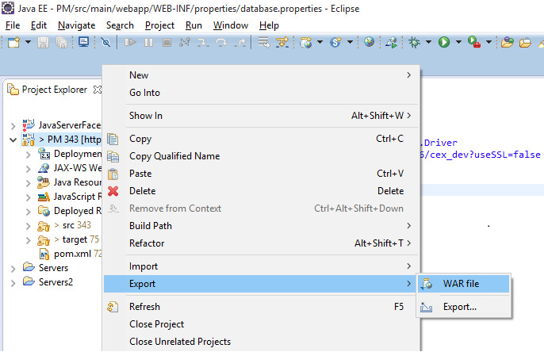

**Step 2**: Specify the Web project you want to export, and specify a location for the new WAR file.

**Optional:** select Optimize for a specific server runtime, then click Finish.

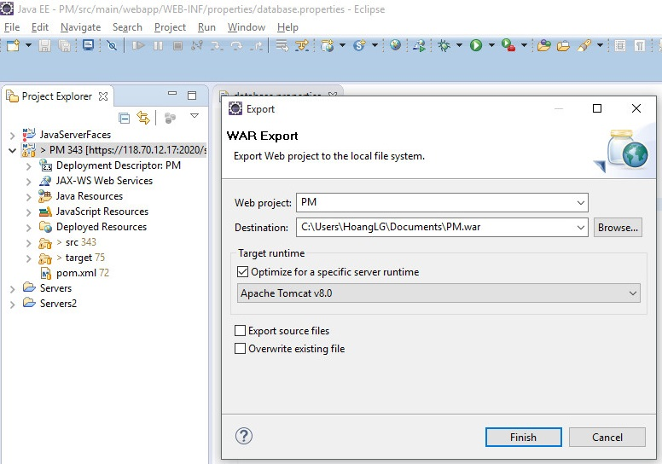

#### Creating an AWS Elastic Beanstalk Environment

**Step 1**: Open the [Elastic Beanstalk console](https://console.aws.amazon.com/elasticbeanstalk).

**Step 2**: Choose an application or [create a new one](http://docs.aws.amazon.com/elasticbeanstalk/latest/dg/applications.html).

**Step 3**: In the upper right corner, choose **Create New Environment** from the **Actions** menu.

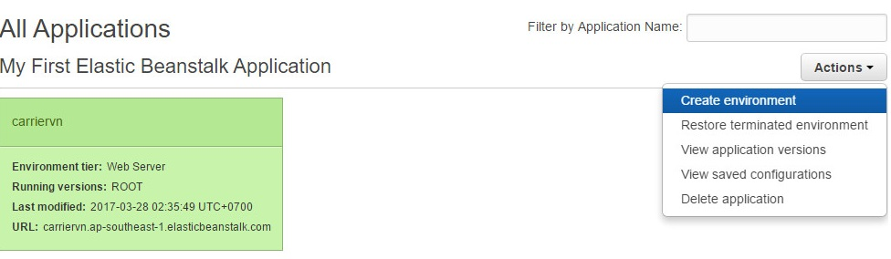

**Step 4:** Choose Web Server as Tier, Tomcat as Preconfigured platform and choose Create environment.

**Optional**: you can upload WAR file in this step.

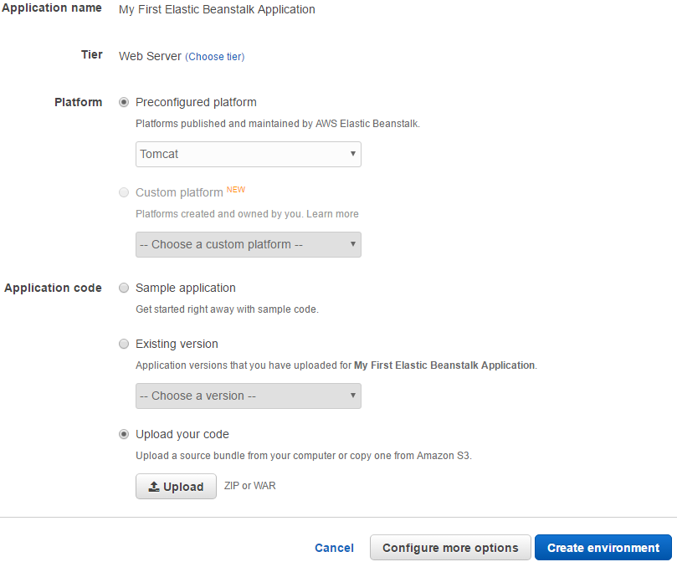

Go back to [Elastic Beanstalk console](https://console.aws.amazon.com/elasticbeanstalk), you could see result in the picture below:

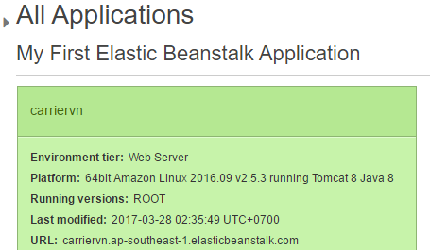

**Step 5**: Update time zone

1.Edit File /etc/sysconfig/clock as:

ZONE="Asia/Ho_Chi_Minh"

UTC=true

2. Running following command:

sudo ln -sf /usr/share/zoneinfo/Asia/Ho_Chi_Minh /etc/localtime

3. Reboot EC2 instance to take effect.

#### Upload WAR file to AWS Elastic Beanstalk and config secure port

**Step 1**: Open AWS Elastic Beanstalk Environment Management Console

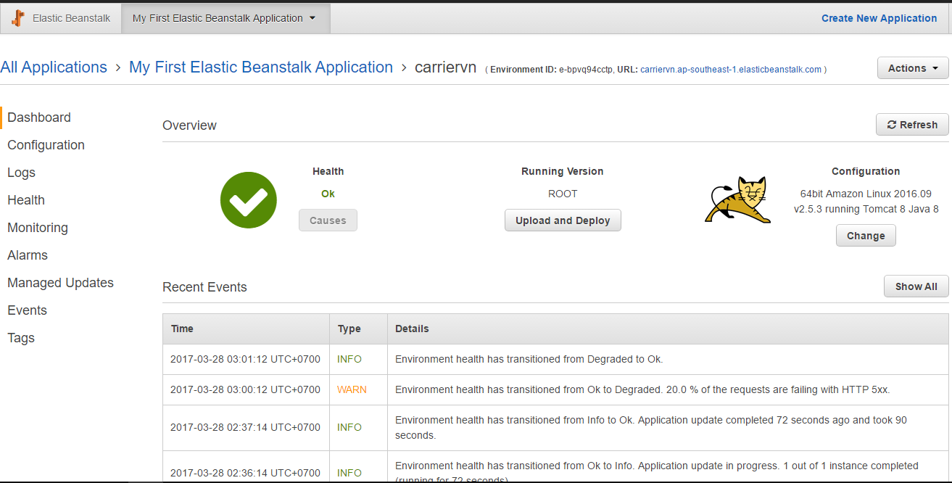

**Step 2**: Choose Upload and Deploy to deploy WAR file from Export WAR file from Eclipse.

#### Create an RDS DB (Mysql) Instance

**Step 1**: Sign in to the AWS Management Console and open the Amazon RDS console at<https://console.aws.amazon.com/rds/>.

**Step 2**: In the top-right corner of the AWS Management Console, choose the region in which you want to create the DB instance. We use Singapore Region

**Step 3**: Choose **Instances**.

**Step 4**: Choose **Launch DB Instance**.

**Step 5**: On the **Select Engine** page, shown following, choose the MySQL DB engine, and then

choose **Select**.

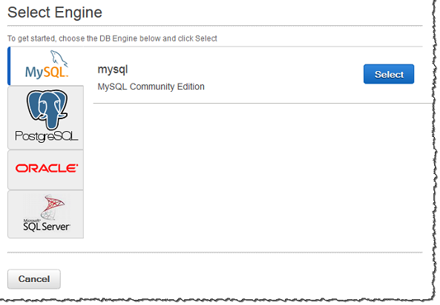

**Step 6**: On the **Specify DB Details** page, shown following, set these values:

* **DB Engine Version:** Use the default value.
* **DB Instance Class:** db.t2.micro
* **Multi-AZ Deployment:** No
* **Storage Type:** Magnetic
* **Allocated Storage:** 50 GB
* **DB Instance Identifier:** tutorial-db-instance
* **Master Username:** choose a username
* **Master Password:** Choose a password.
* **Confirm Password:** Retype the password.

**Step 7**: Configure parameter group as the image below:

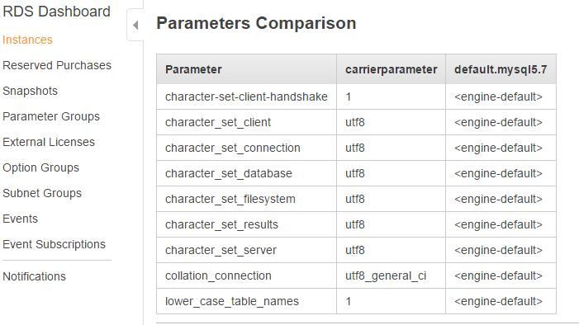

**Step 8**: Config time zone as tutorial below: <http://docs.aws.amazon.com/AWSEC2/latest/UserGuide/set-time.html>

**Step 9:** Reboot Amazon RDS Instance.

#### Configure SSL, domain name for AWS Elastic Beanstalk

To use a custom domain name: first, create a hosted zone for your domain. A hosted zone contains the name server and start of authority (SOA) records that specify the DNS hosts that will resolve requests for your domain name.

##### Creating a hosted zone

**Step 1:** Sign in to the AWS Management Console and open the Amazon Route 53 console at <https://console.aws.amazon.com/route53/>.

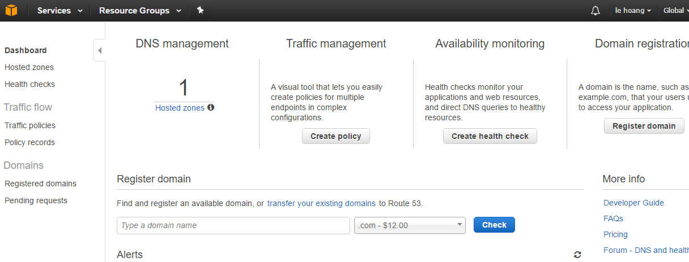

**Step 2**: If you're new to Amazon Route 53, choose to **Get Started Now** under **DNS Management**.

If you're already using Amazon Route 53, choose **Hosted Zones** in the **navigation** pane.

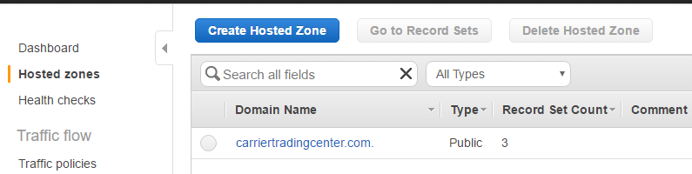

**Step 3:** Choose to **Create Hosted Zone**.

**Step 4:** In the **Create Hosted Zone** pane, enter a domain name and, optionally, a comment. For more information about a setting, pause the mouse pointer over its label to see a tool tip.

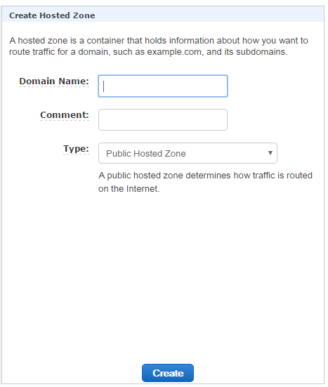

**Step 5:** Choose **Create**

##### Change Z.com DNS Configuration to Amazon Route 53 as the DNS service

**Step 1**: In the Amazon Route 53 console, get the name servers for your Amazon Route 53 hosted zone:

1. Sign in to the AWS Management Console and open the Amazon Route 53 console at <https://console.aws.amazon.com/route53/>.
2. In the navigation pane, click **Hosted Zones**.
3. On the **Hosted Zones** page, choose the radio button (not the name) for the hosted zone.
4. In the right pane, make note of the four servers listed for **Name Servers**.

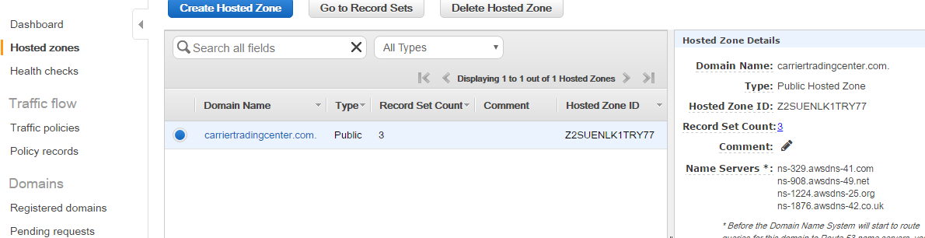

**Step 2**:  Replace the name servers in the registrar's NS records (z.com) with the four Amazon Route 53 name servers

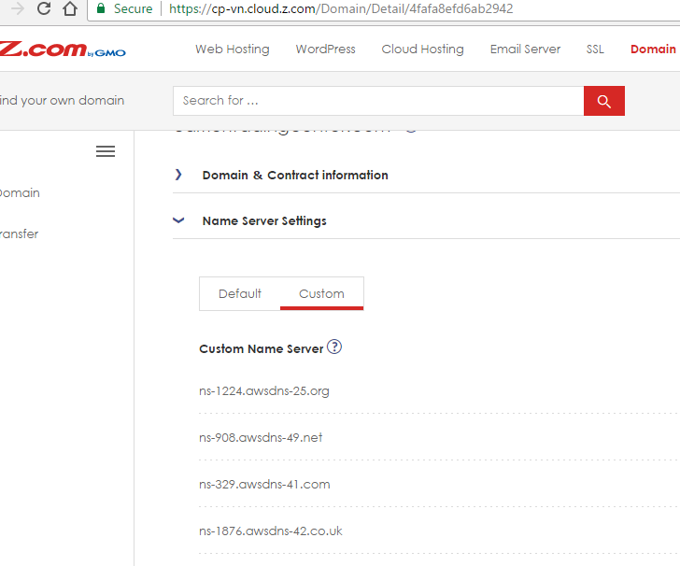

Next, add a record to the hosted zone that resolves your domain name to your environment.

##### Add an alias resource record set in Amazon Route 53

**Step 1:** Open the Amazon Route 53 console at <https://console.aws.amazon.com/route53/>.

**Step 2:** Select the hosted zone that you just created for your domain.

**Step 3:** Choose **Go to Record Sets**.

**Step 4:** Choose **Create Record Set**.

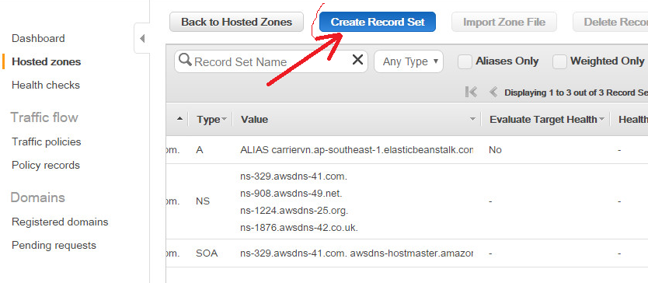

**Step 5:** For **Create Record Set**, do the following:

1. Leave the default name, which is the name of your domain.
2. For **Type**, select **A — IPv4 address**.
3. For **Alias**, choose **Yes**. An alias enables Amazon Route 53 to associate your domain name with an AWS resource, such as a load balancer.
4. Choose **Alias Target**. Select your load balancer from the list. The console adds the dual stack prefix.
5. For **Routing Policy**, select **Simple**.
6. Leave **Evaluate Target Health** set to **No**.
7. Choose to **Create**.

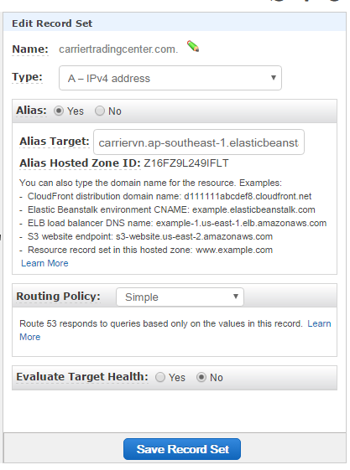

##### Configure HTTPS for Elastic Beanstalk Environment

**Step 1:** Request a certificate

1. Log into your AWS Management Console. You'll find Certificate Manager under the Security & Identity section.

2. Click Request a certificate.

Enter your domain name or subdomain name.

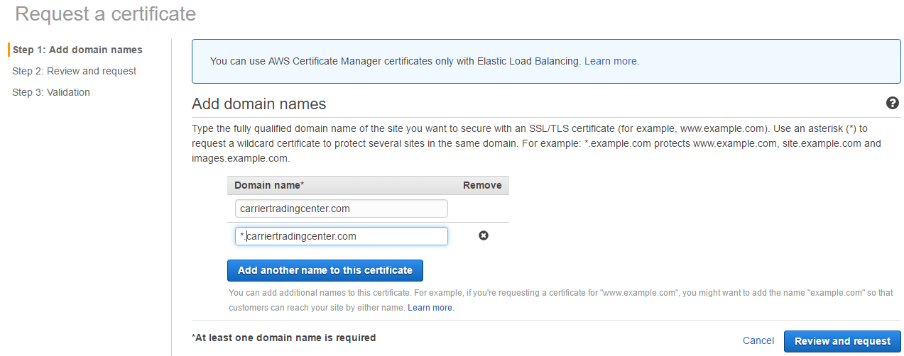

Confirm and continue.

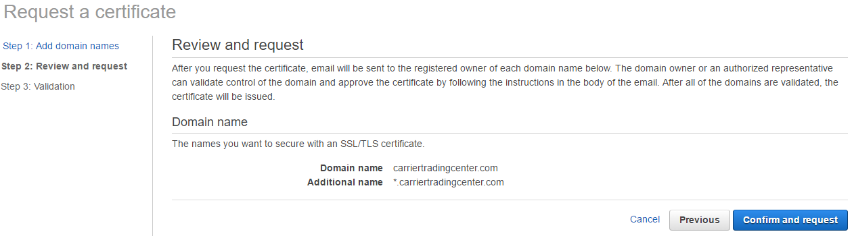

Check your email(admin@carriertradingcenter.com) — it may take several minutes — and approve the certificate request.

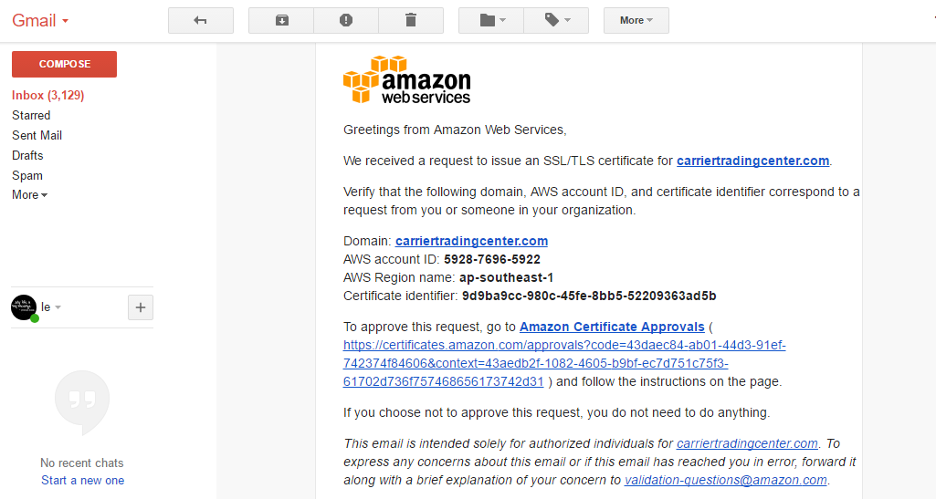

**Step 2:** Assign a certificate to environment’s load balancer

* 1. Open the [Elastic Beanstalk console](https://console.aws.amazon.com/elasticbeanstalk).
  2. Navigate to the [management page](http://docs.aws.amazon.com/elasticbeanstalk/latest/dg/environments-console.html) for your environment.
  3. Choose **Configuration**
  4. In the Network Tier section, choose the gear icon next to **Load Balancing.**
  5. In the secure listener port: choose 443 and Protocol choose HTTPS
  6. In the **Load** **Balancer** section**,** choose your certificate from the **SSL certificate ID to** drop down menu.

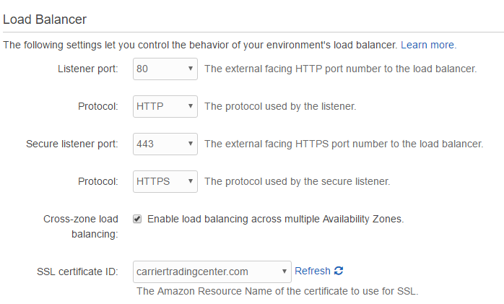

##### Configure Security Group, Reverse Proxy, Tomcat, connect web app in Elastic Beanstalk to Amazon RDS(Mysql)

**Step 1:** **Security group for Elastic Beanstalk, Amazon RDS:**

1.Elastic Beanstalk

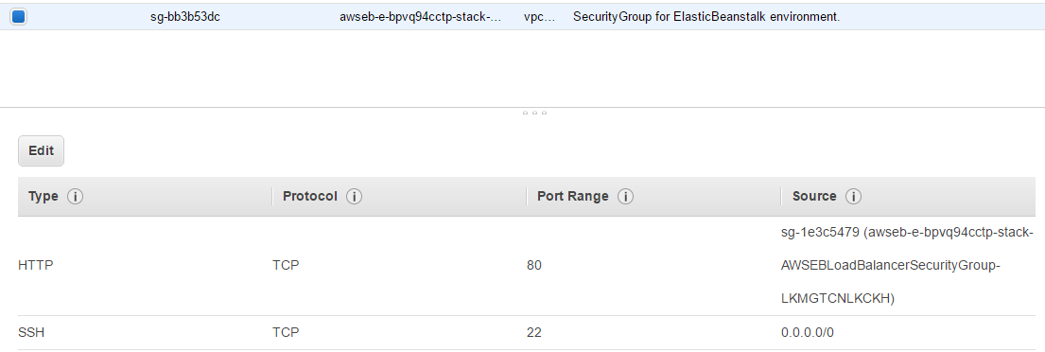

2.Amazon RDS

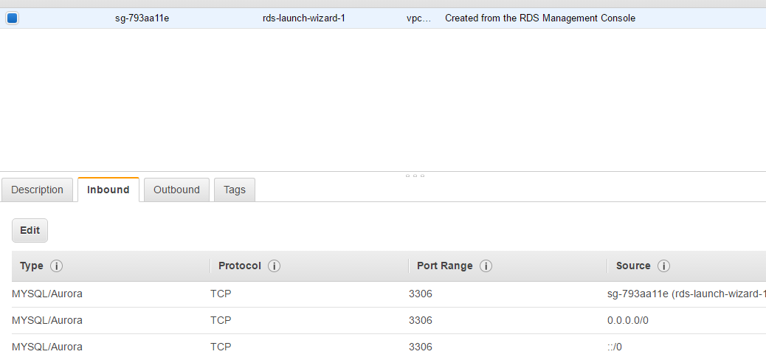

**Step 2:** **Setting reverse proxy**

1.Open file and edit file :/etc/httpd/conf.d/elasticbeanstalk/00_application.conf with following line:

LoadModule rewrite_module modules/mod_rewrite.so

RewriteEngine on

RewriteCond %{HTTP:X-Forwarded-Proto} =http

RewriteRule ^ https://%{HTTP_HOST}%{REQUEST_URI} [L,R=301]

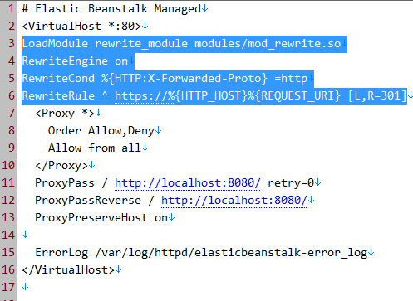

**Step 3**: **Setting tomcat**

Add the following line to /etc/tomcat8/server.xml :

<Context path="/CEX" docBase="ROOT/">

<WatchedResource>WEB-INF/web.xml</WatchedResource>

</Context>

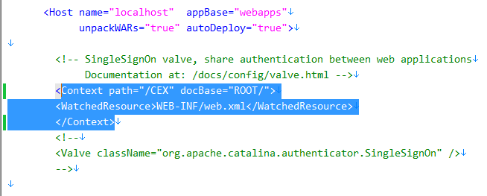

**Step 4**: Edit file /usr/share/tomcat8/webapps/ROOT/WEB-INF/properties/database.properties in the web apps with following content:

jdbc.driverClassName=com.mysql.jdbc.Driver

jdbc.url=jdbc:mysql://172.31.0.103:3306/cex_dev?useSSL=false

jdbc.username=root

jdbc.password=rootroot

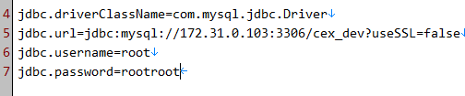

**Step 4**: Create Elastic beanstalk share folder that allow web app save file to it:

1.Connect Elastic beanstalk via putty and run following command:

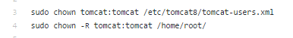

## User’s guide

### Guest

#### Register Account

Typically for using <https://carriertradingcenter.com/> guest will register as Goods Owner or Carrier as who they really are.

Follow these steps to register:

**Step 1**: Go to home page <https://carriertradingcenter.com/> then click “Đăng kí” at top rightmost corner, Guest will be redirected to Register page

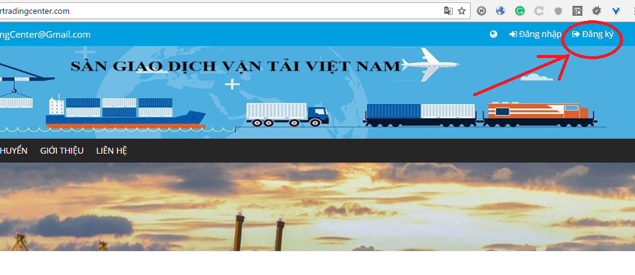

**Step 2:** Enter require information and click “Đăng Kí” at the bottom of the page.

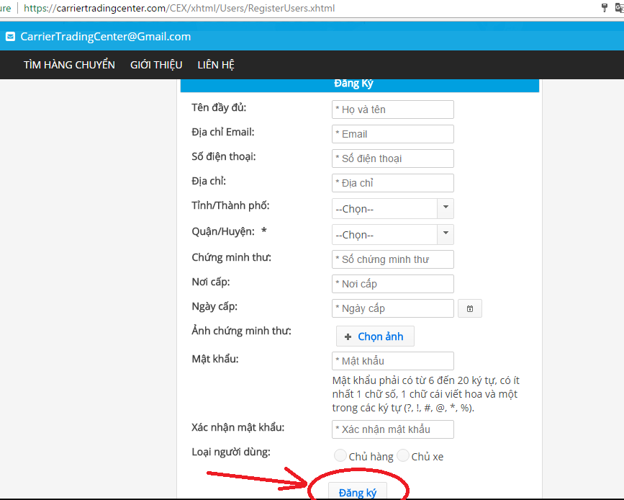

**Step 3**: Confirmation emails

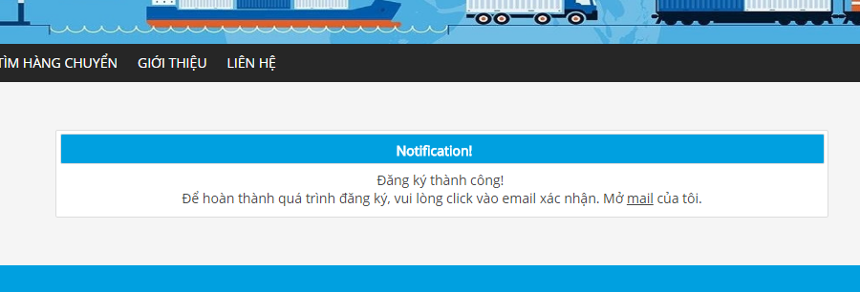

**Step 4**:Go to your mailbox, you will see something like this:

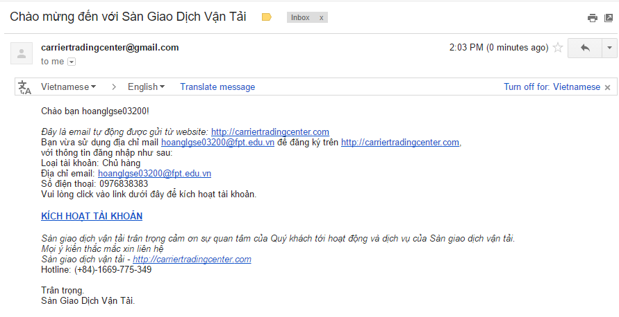

**Step 5:**Click on “KÍCH HOẠT TÀI KHOẢN” in new page to active your account:

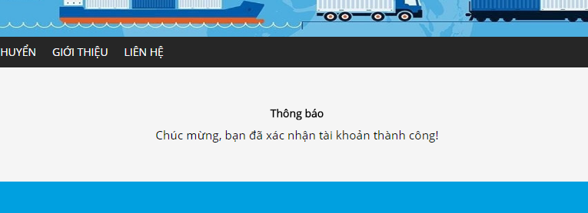

#### View fee list

To view fee list, Goods Owner click on “BÁO GIÁ” in navigation bar, then click “HỆ THỐNG” as image below

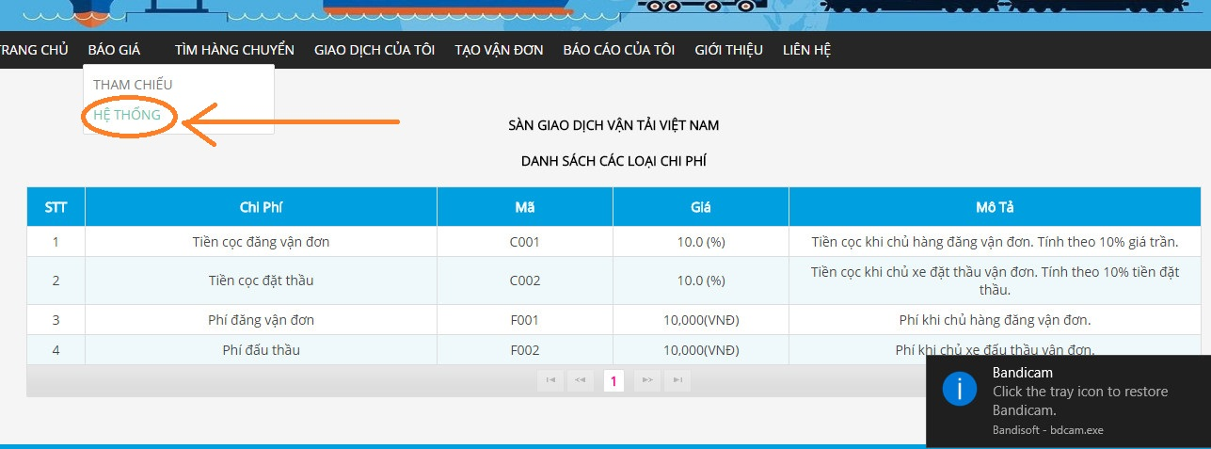

#### View reference fee

To view Reference fee, Guest click on “BÁO GIÁ” in navigation bar then click “THAM CHIẾU” as image below

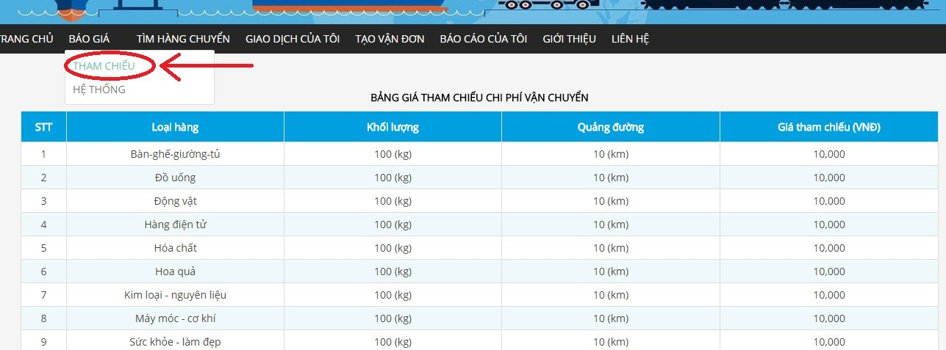

#### Bill of lading

##### View bill of lading list

Guest can quickly access bill of lading list whenever they are on any specific page of <https://carriertradingcenter.com/> by click “Giao Dịch Của Tôi” in Navigation Bar

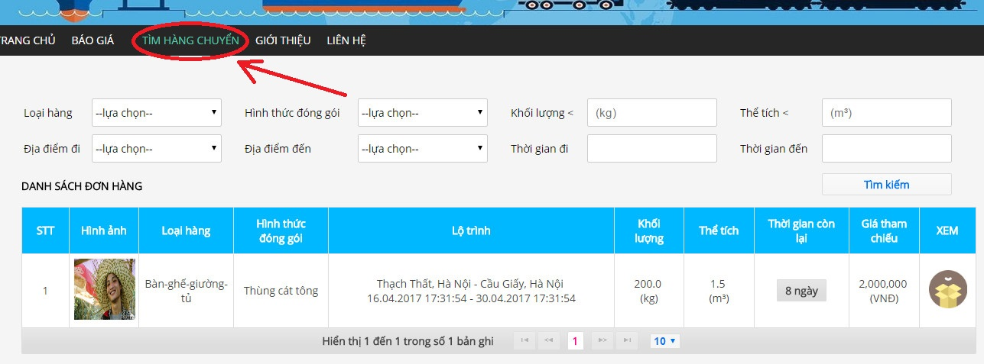

##### Search bill of lading

If Guest want to find Bill of lading that created by other Users in <https://carriertradingcenter.com/> they can search them by click “TÌM HÀNG CHUYỂN” in Navigation Bar

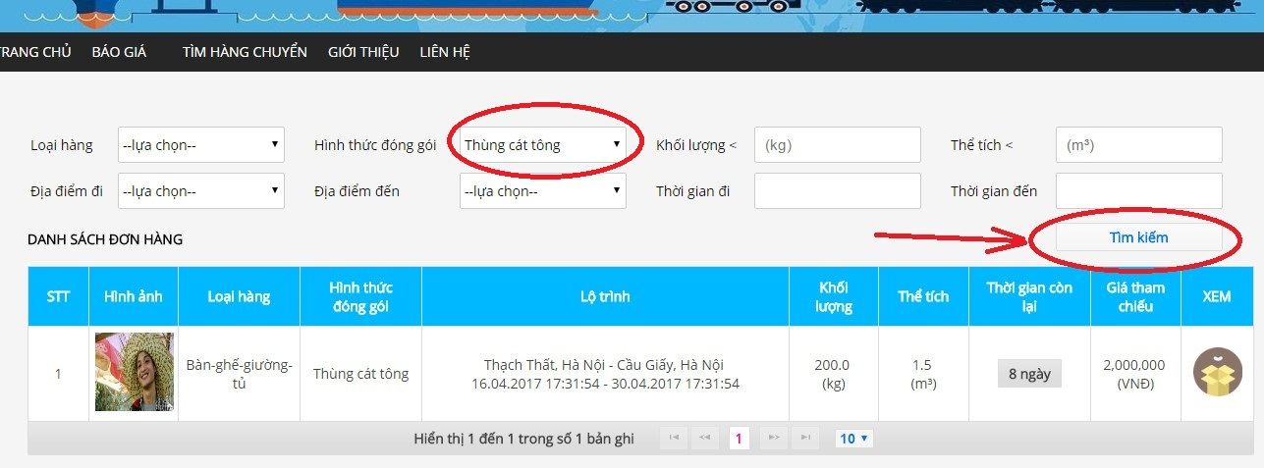

In the top of “TÌM HÀNG CHUYỂN” page, Guest can set filter condition and then click Search to find concise Bill of Lading that they want.

### Goods Owner

#### Bill of lading list

##### View bill of lading list

Goods Owner can quickly access bill of lading list whenever they are on any specific page of <https://carriertradingcenter.com/> by click “Giao Dịch Của Tôi” in Navigation Bar

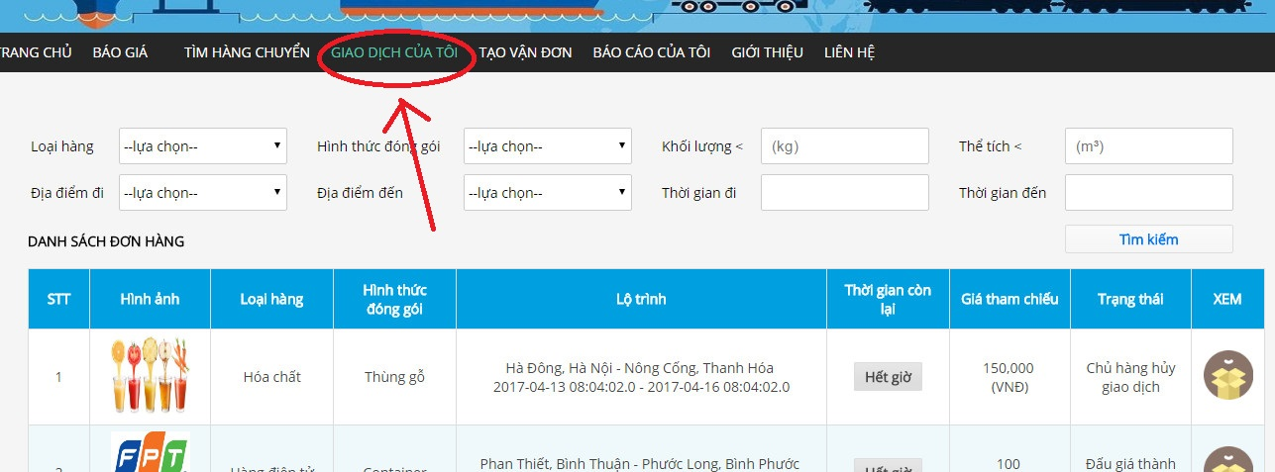

##### View bill of lading detail

In bill of lading list screen Goods Owner can only see just few information about bill of lading, to get more information Goods Owner can click on Image at rightmost of item in the bill of lading list to go to Bill of Lading Detail page

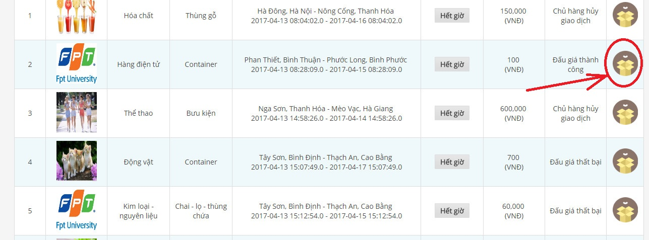

Then it Goods Owner will be redirected to Bill Of Lading Detail page

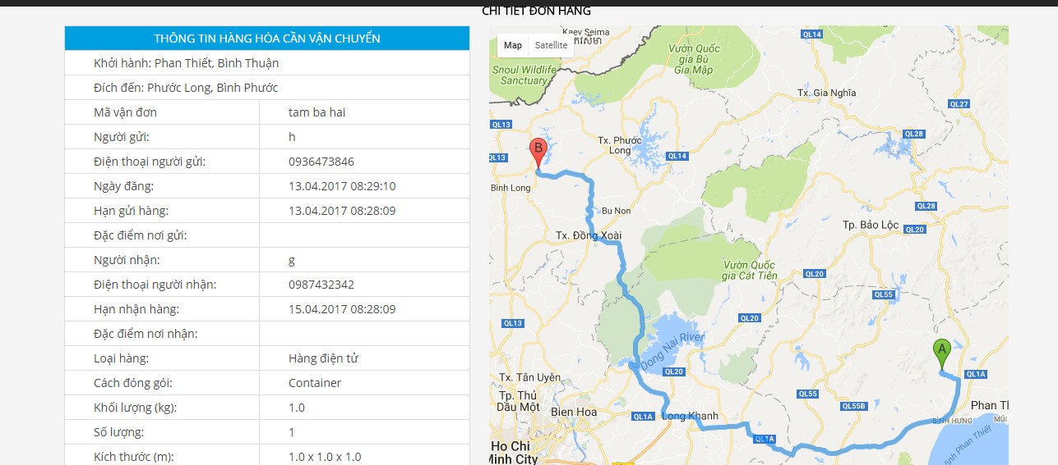

##### Search bill of lading

If Goods Owner want to find Bill of lading that created by other Goods Owner in <https://carriertradingcenter.com/> they can search them by click “TÌM HÀNG CHUYỂN” in Navigation Bar

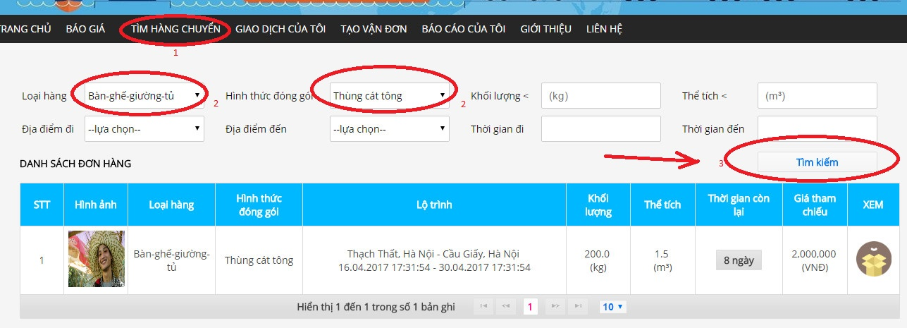

In the top of “TÌM HÀNG CHUYỂN” page, Goods Owner can set filter condition and then click Search to find concise Bill of Lading that they want.

##### View carrier auction success

When the auction meets a deadline it can be a success or not.

Goods owner can see auction status by go to Bill of lading detail

**Step 1:** Go to “GIAO DỊCH CỦA TÔI” page via Item’s in Navigation Bar



**Step 2:** Click on image under “XEM” column corresponding with each Auction to view detail

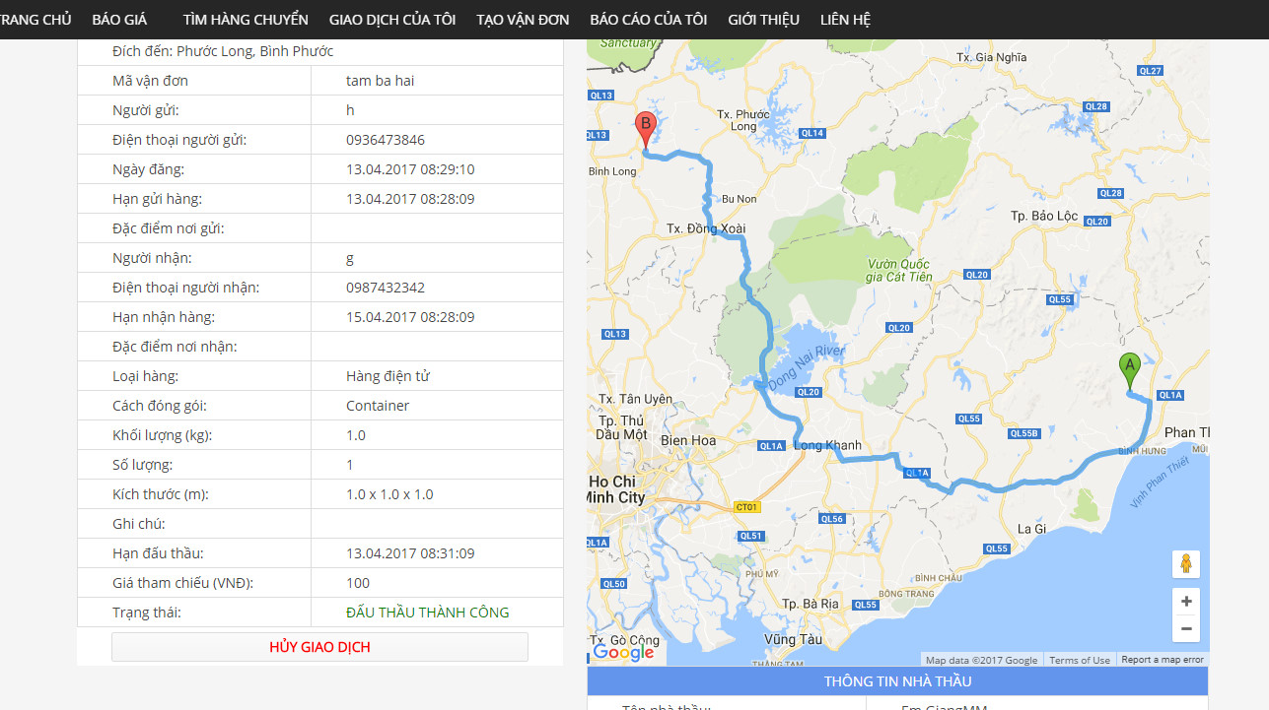

**Step 3:** In leftmost and bottom of the page, Goods Owner will see information about Carrier who auction success.

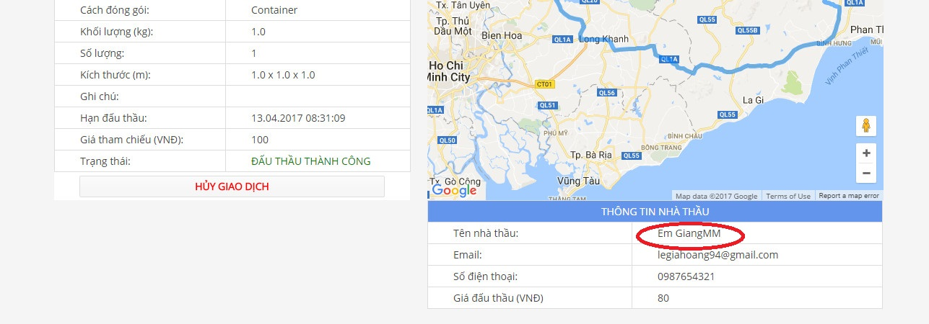

##### Confirm complete transaction

After knowing that goods have been sent to the destination, Goods owner has to confirm this thing.

**Step 1:** Go to Detail Auction page

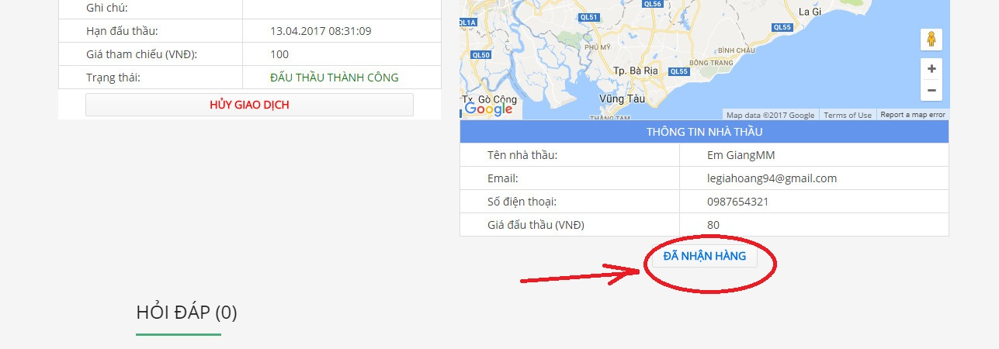

**Step 2:** Click on “ĐÃ NHẬN HÀNG” button to confirm that you Auction have been completed

##### Register a new bill of lading

The main function that distinguishes Goods Owner and Carrier is who create can create a new Bill of Lading. Goods Owner can create Bill of Lading by following steps:

Step 1: Go to “TẠO VẬN ĐƠN” page: by click “TẠO VẬN ĐƠN” in the navigation bar.

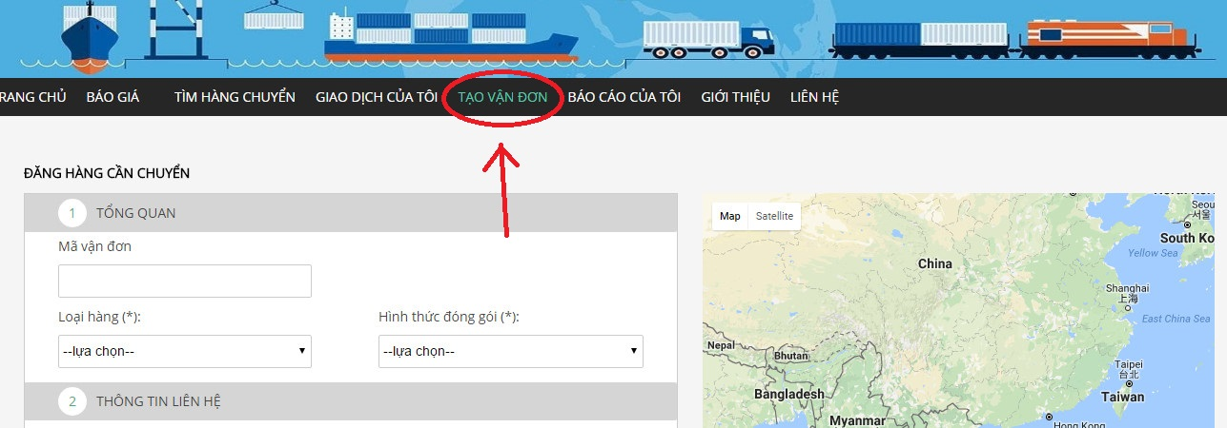

**Step 2:** It’s up to you to input information in the optional field but you have to input all require field.

**Step 3:** Then click “Đăng kí” in bottom of the page

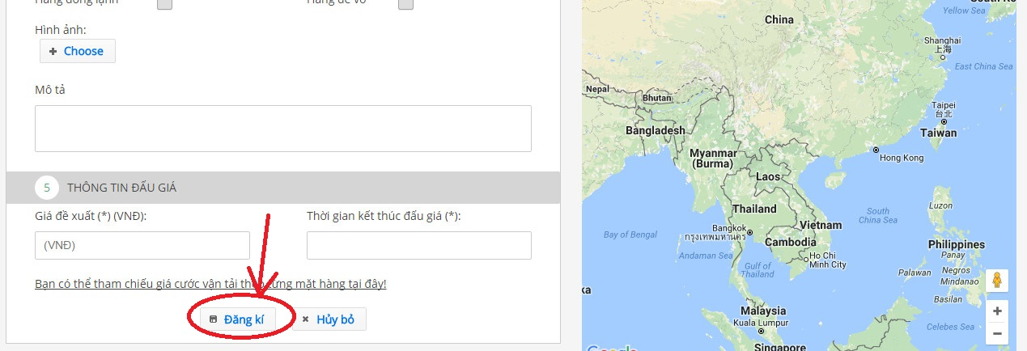

##### Cancel bill of lading

If auction is incomplete Goods Owner are able to cancel Auction buy click “HỦY GIAO DỊCH” on Bill of lading detail page:

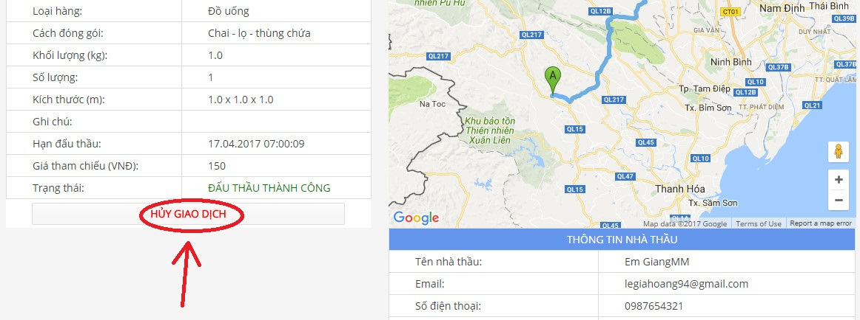

#### Manage Profile

##### View profile

To view profile, Goods Owner hover mouse over Goods Owner name in top-right corner and click “Thông tin cá nhân”, after that Goods Owner will be redirected to page with title “Thông tin người dùng”

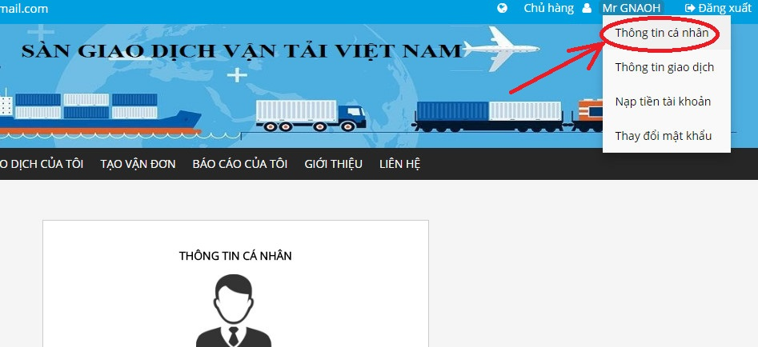

##### Edit profile

**Step 1:** Go to “Thông tin cá nhân” page by hover mouse over the name of Goods Owner in top-rightmost of the page.



**Step 2:** In the “Thông tin người dùng” click “Thay đổi”.New pop-up will be show

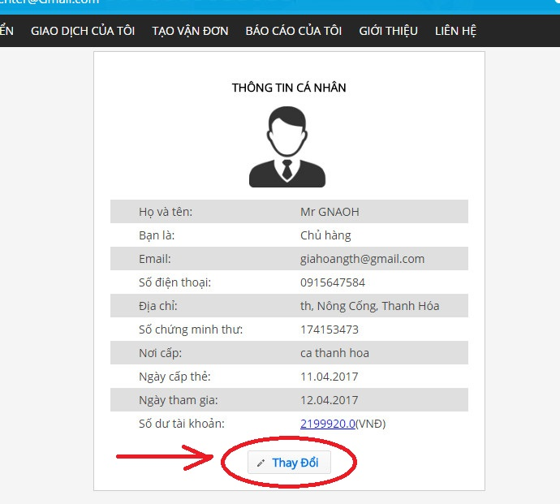

**Step 3:** Edit the information that you want to change and then click “Xác nhận”

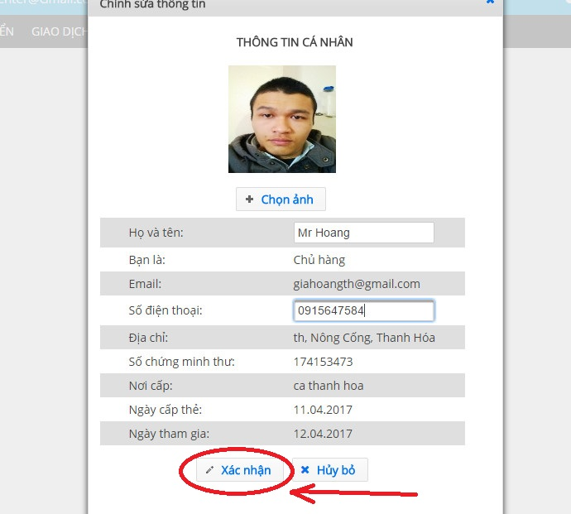

##### Change password

A Strong Password is defined as a password that is reasonably difficult to guess in a short period of time either through human guessing or the use of specialized software.

A Strong password should:

* Be at least 6 characters in length
* Contain both upper and lowercase alphabetic characters (e.g.A-Z,a-z)
* Have at least one numerical character (e.g. 0-9)
* Have at least one special character (e.g. ~!@#$%^&*()_-+=)

To change any user’s password you must specify a *Strong* *Password*

Step 1: Hover mouse over Goods Owner name in the top-right corner and select “Thay đổi mật khẩu” to go to “Thay đổi mật khẩu” page.

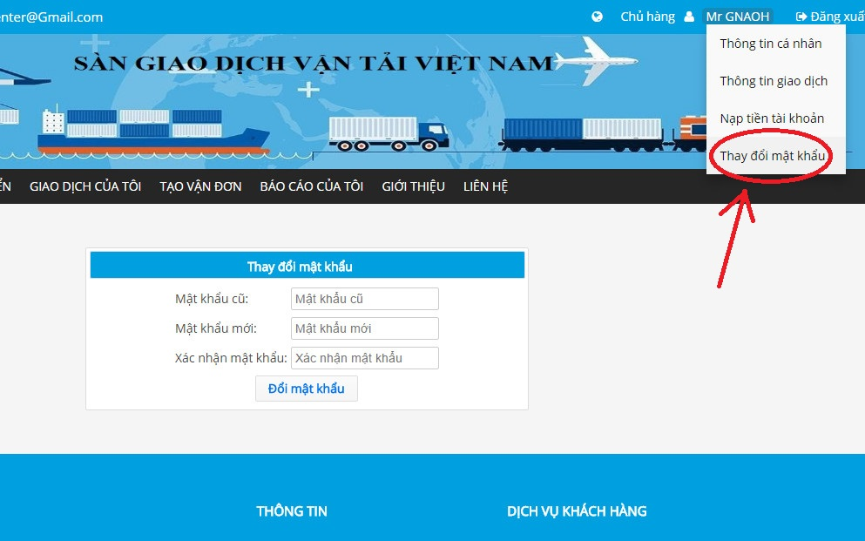

**Step 2:** Input your old password and a new *Strong Password*

**Step 3:** Click “Đổi mật khâủ” to save the new *Strong Password*

##### Add company

**Step 1:** Go to “Thông tin cá nhân” page by hover mouse over the name of Goods Owner in top-right of the page.



**Step 2:** Click “Thêm mới” under “THÔNG TIN CÔNG TY” section.

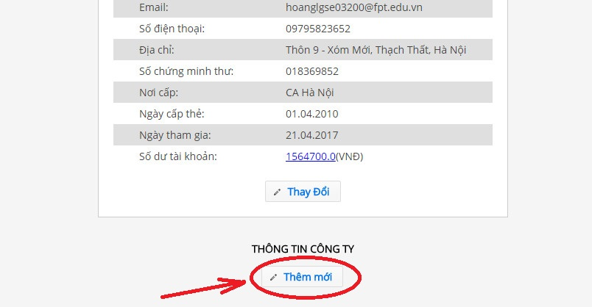

**Step 3:** Enter company information then click “Xác nhân”

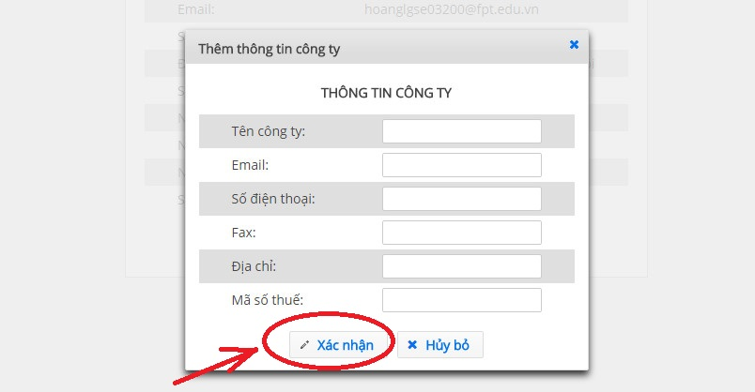

##### Forget password

**Step 1:** To be able to reset your Password, go to the “Đăng nhập” page and click “Quên mật khẩu” under the Login form

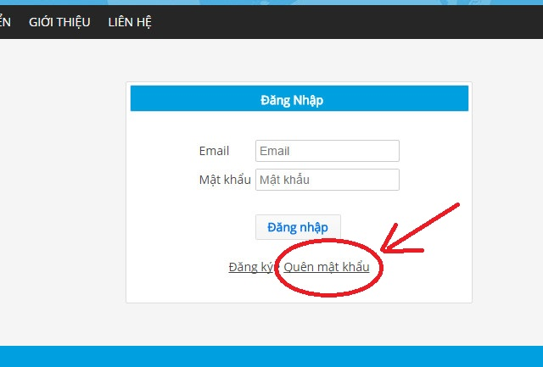

**Step 2:** Enter your email address, then click “Gửi”

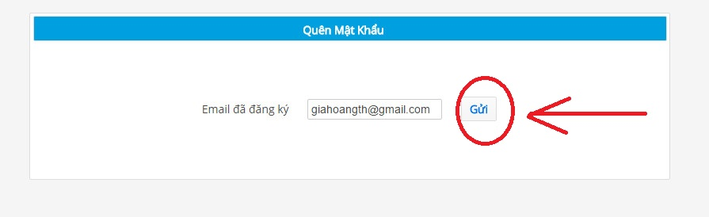

**Step 3:** Open your mailbox to get temporary password

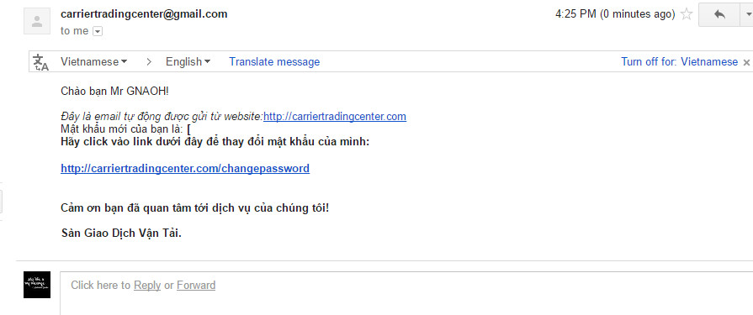

**Step 4:** Open the link <https://carriertradingcenter.com/CEX/faces/xhtml/Users/ResetPasswod.xhtml> and enter the information to change to new *Strong Password*

Pay attention to: “Mật khẩu cũ” already provided within your email.

#### Report

##### View report list

Goods Owner can see a list of reports when going to “Báo cáo của tôi” page by click “BÁO CÁO CỦA TÔI” in the navigation bar.

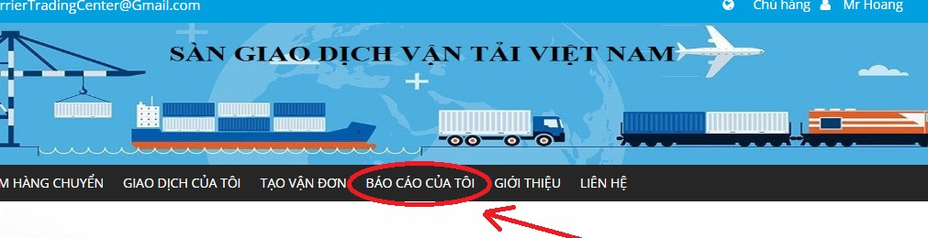

##### Send report

Step 1: Go to page “Báo cáo của tôi” by click “BÁO CÁO CỦA TÔI” in navigation bar



Step 2: Click “Tạo báo cáo mới”

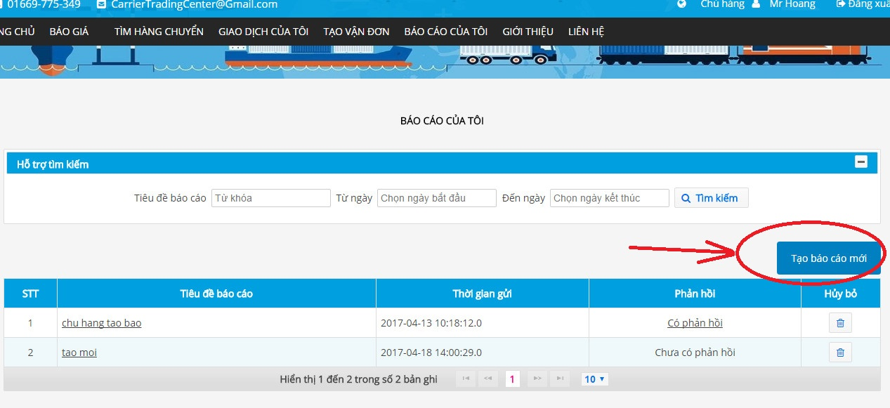

**Step 3:** Enter the information into the form, then click “Gửi báo cáo”

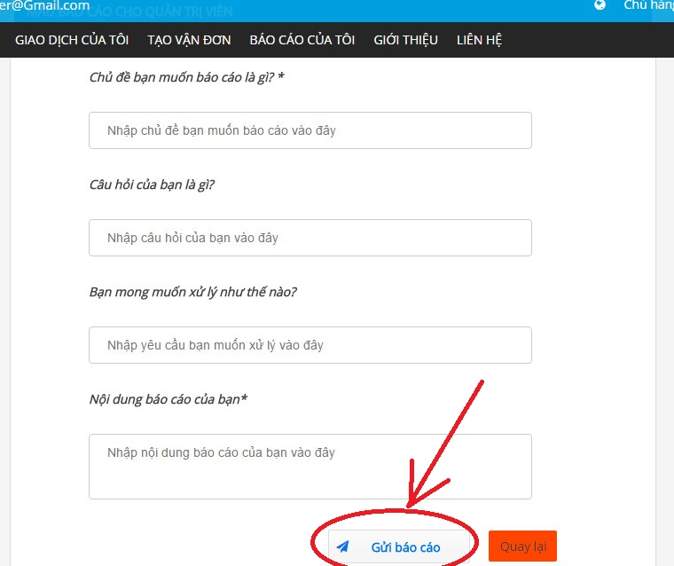

##### Cancel Report

**Step 1:** Open report list screen by click on “BÁO CÁO CỦA TÔI” in the navigation bar.



**Step 2**: Click “Recycle bin” Icon at right-most of report line to cancel it.

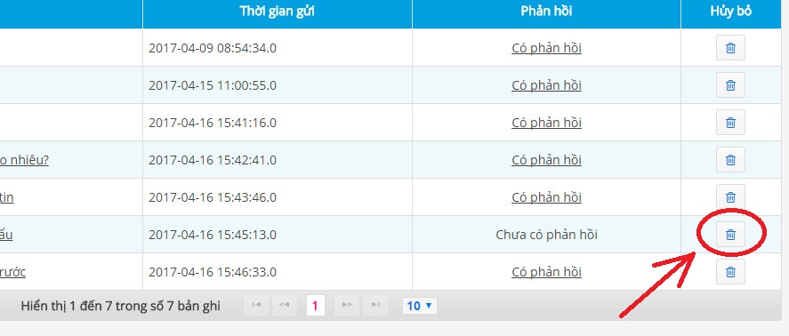

##### Search report

In the page “Báo cáo của tôi”, Goods Owner can search report by entering information as “Tiêu đề báo cáo” or “từ ngày”, then click “Tìm kiếm” to find report

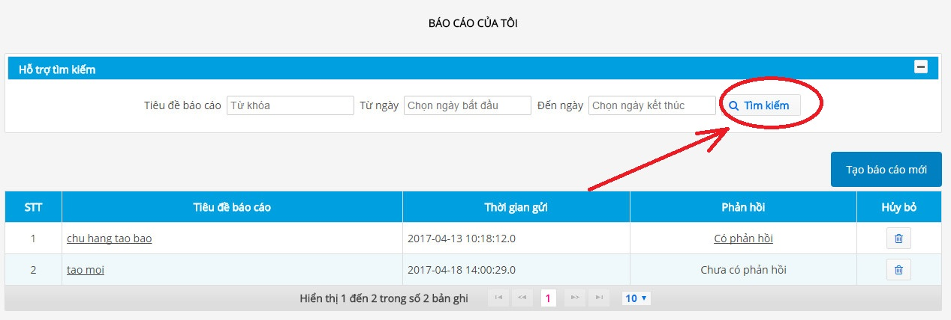

#### Fee

##### Reference fee

To view Reference fee, Goods Owner click on “BÁO GIÁ” in navigation bar then click “THAM CHIẾU” as image below

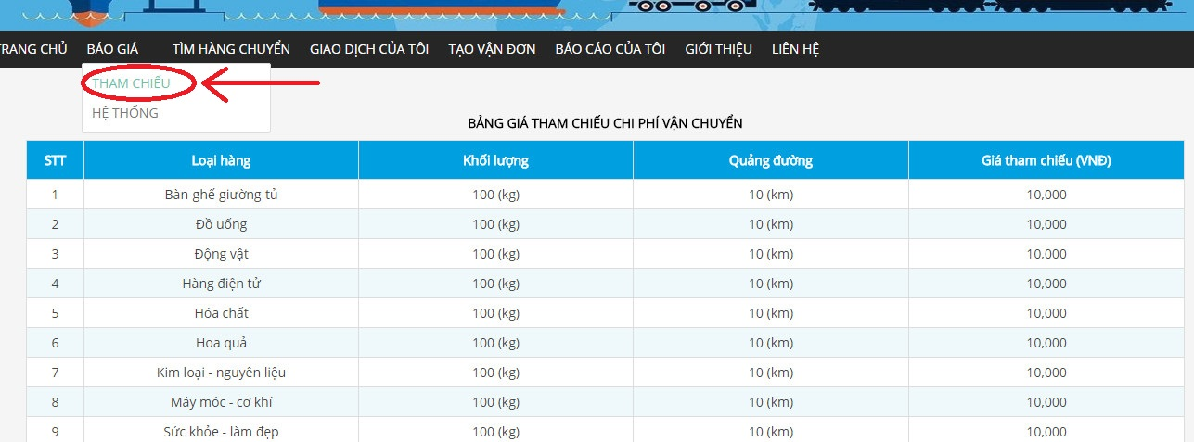

##### View fee list

To view fee list, Goods Owner click on “BÁO GIÁ” in navigation bar then click “HỆ THỐNG” as image below



#### Account Recharge

**Step 1:**The quickest way to recharge your account is lower mouse Name of Goods Owner in Top Rightmost corner, then click “Nạp tiền tài khoản” in drop-down list.

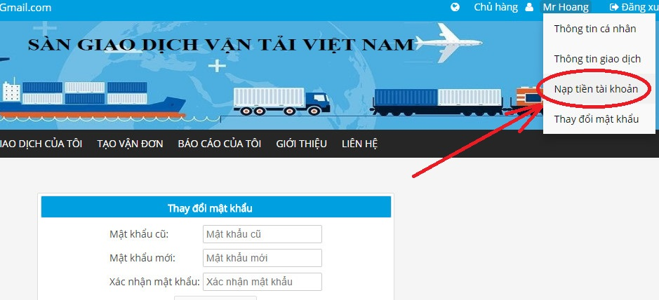

**Step 2:** Choose your payments method

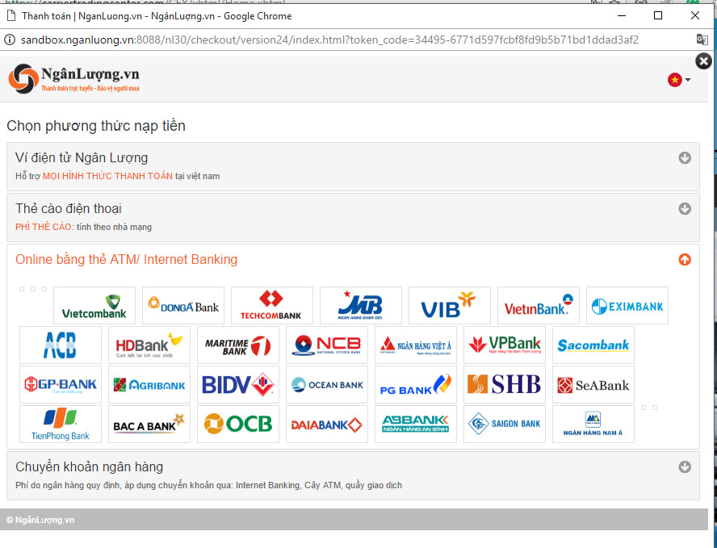

**Step 3:** Enter payment information to recharge.

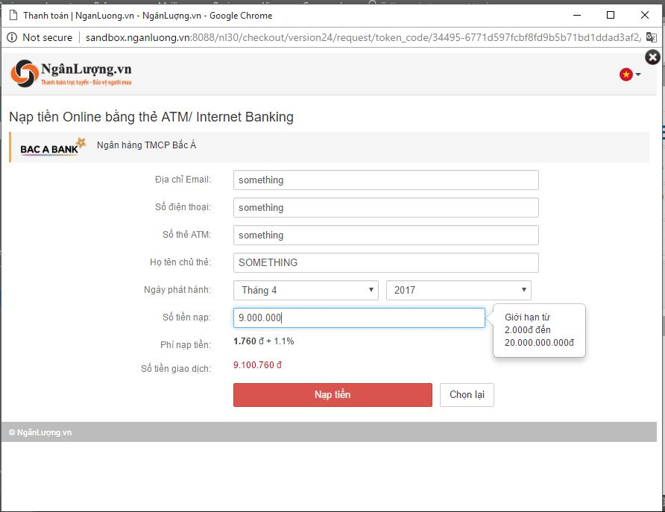

#### Transaction History

To view transaction history Goods Owner have to hover mouse Name of Goods Owner in Top Rightmost corner, then click “Thông tin giao dịch”

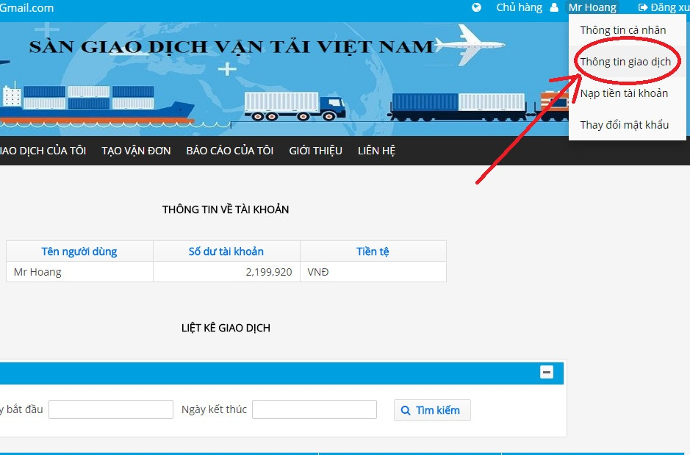

#### Connect to carrier

When status of Bill of Lading change to “ĐẤU THẦU THÀNH CÔNG” Goods can know contact information of Carrier by seeing in bottom-left corner of Bill of Lading detail page

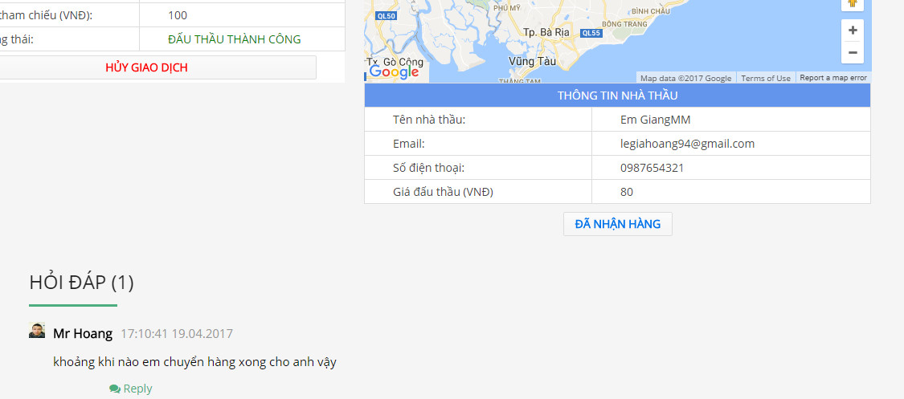

From there Goods Owner can make contact with Carrier

#### Login

**Step1**: Open home page with link <https://carriertradingcenter.com/CEX/faces/xhtml/Home.xhtml>  
**Step2**: Click “Đăng Nhập” at right most corner of screen  
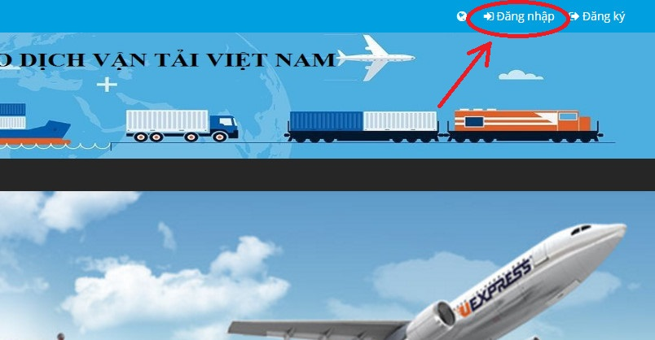

**Step3:** Input your Goods Owner ‘s email and password then click “Đăng Nhập”

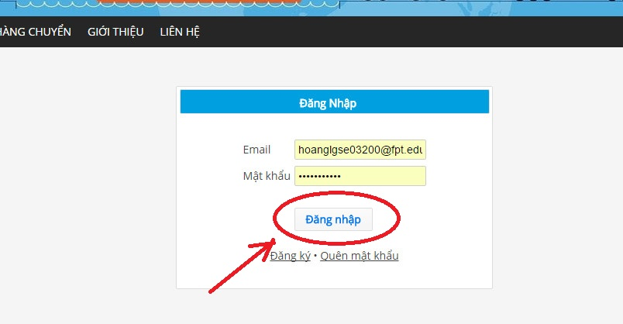

#### Logout

To log out, Goods Owner can click “Đăng Xuất” in Top Rightmost corner screen.

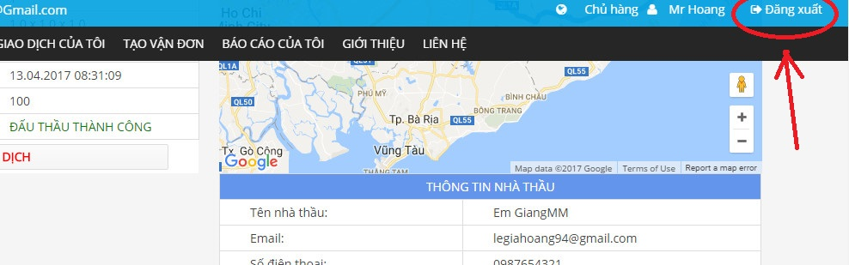

### Carrier

#### Bill of lading list

##### View bill of lading list

Carrier can quickly access bill of lading list whenever they are on any specific page of <https://carriertradingcenter.com/> by click “Giao Dịch Của Tôi” in Navigation Bar



##### Confirm complete transaction

After bring goods to destination, Carrier have to make a confirmation with Goods Owner

**Step 1:** In bill of lading list screen Carrier can only see just few information about bill of lading, to get more information Carrier can click on Image at rightmost of item in the list to go to Bill of Lading Detail page



Step 2: Click “ĐÃ GIAO HÀNG” in detail bill of lading page

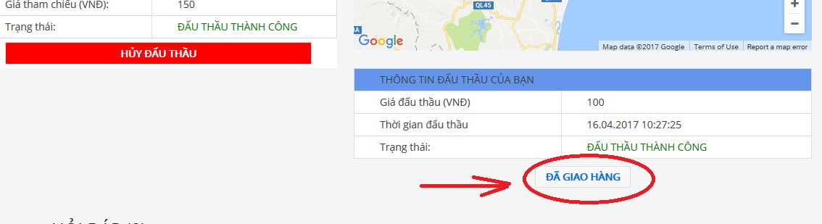

##### View bill of lading detail

In the bill of lading list screen Carrier can only see just few information about the bill of lading, to get more information Carrier can click on Image at rightmost of the item in the bill of lading list to go to Bill of Lading Detail page.



##### Auction bill of lading

**Step 1:** Click “TÌM HÀNG CHUYỂN” in navigation bar

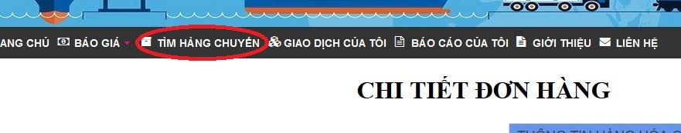

**Step 2:** Click on Image at rightmost of item in the list to go to Bill of Lading Detail page



**Step 3:** Click “ĐẤU THẤU” at bottom of detail bill of lading page.

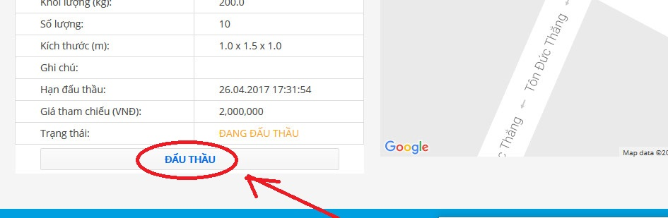

##### Account recharge

**Step 1:** The quickest way to recharge your account is lower mouse Name of Carrier in Top Rightmost corner, then click “Nạp tiền tài khoản” in the drop-down list.



**Step 2:** Choose your payments method



**Step 3:** Enter payment information to recharge.



##### Search bill of lading

If Carrier want to find Bill of lading that created by Goods Owner in <https://carriertradingcenter.com/> they can search them by click “TÌM HÀNG CHUYỂN” in Navigation Bar



In the top of “TÌM HÀNG CHUYỂN” page, Carrier can set filter condition and then click Search to find concise Bill of Lading that they want.

##### Cancel bill of lading

If auction is incomplete Carrier are able to cancel Auction buy click “HỦY GIAO DỊCH” on Bill of lading detail page:

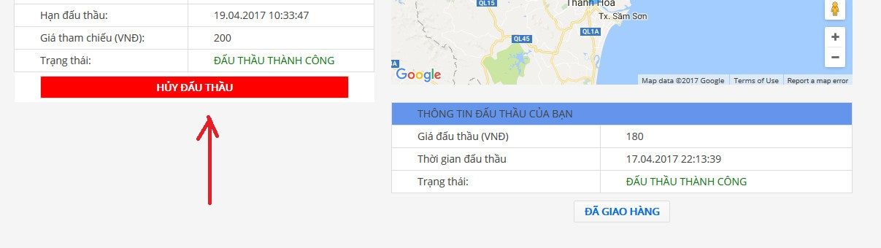

#### Manage profile

##### View profile

To view profile, Carrier hover mouse over Carrier name in top-rightmost and click “Thông tin cá nhân”, after that Carrier will be redirected to page with title “Thông tin người dùng”



##### Edit profile

**Step 1:** Go to “Thông tin cá nhân” page by hover mouse over the name of Carrier in top-rightmost of the page.



**Step 2:** In the “Thông tin người dùng” click “Thay đổi”.New pop-up will be show

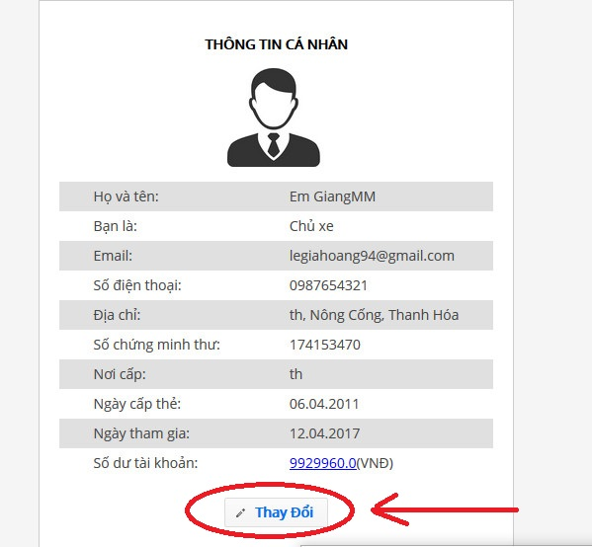

**Step 3:** Edit the information that you want to change and then click “Lưu thay đổi”

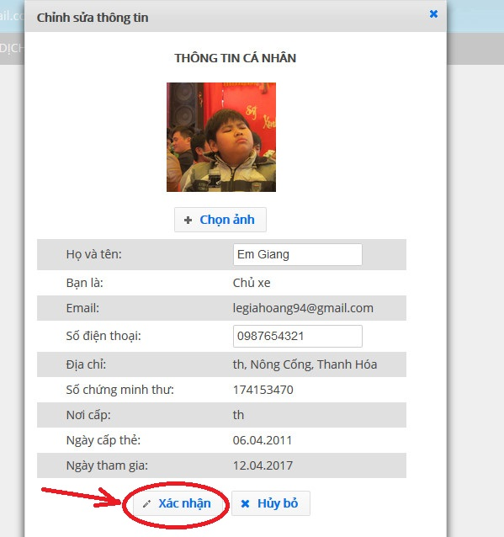

##### Change password

A Strong Password is defined as a password that is reasonably difficult to guess in a short period of time either through human guessing or the use of specialized software.

A Strong password should:

* Be at least 6 characters in length
* Contain both upper and lowercase alphabetic characters (e.g.A-Z,a-z)
* Have at least one numerical character (e.g. 0-9)
* Have at least one special character (e.g. ~!@#$%^&*()_-+=)

To change any user’s password you must specify a *Strong* *Password*

**Step 1:** Hover mouse over Carrier name in the top-right corner and select “Thay đổi mật khẩu” to go to “Thay đổi mật khẩu” page.



**Step 2:** Input your old password and a new *Strong Password*

**Step 3:** Click “Đổi mật khâủ” to save the new *Strong Password*

##### Add company

**Step 1:** Go to “Thông tin cá nhân” page by hover mouse over the name of Carrier in top-rightmost of the page.

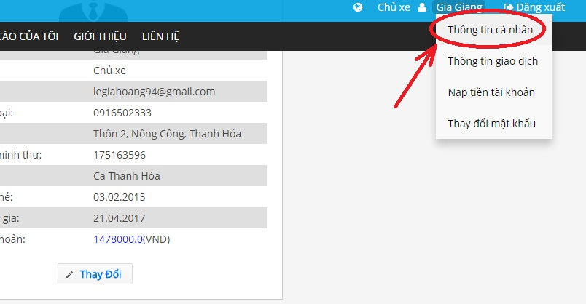

**Step 2:** Click “Thêm mới” under “THÔNG TIN CÔNG TY” section.

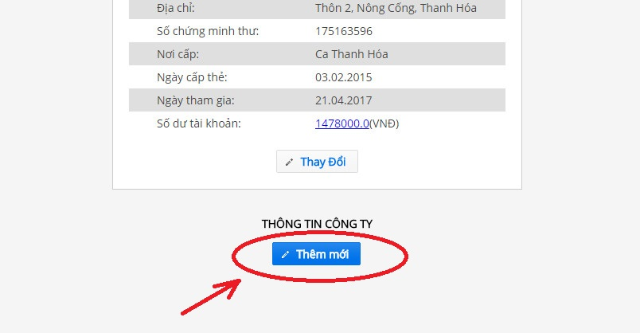

**Step 3:** Enter company information then click “Xác nhân”



##### Forget password

**Step 1:** To be able to reset your Password, go to the “Đăng nhập” page and click “Quên mật khẩu” under the Login form



**Step 2:** Enter your email address, then click “Gửi”



**Step 3:** Open your mailbox to get temporary password

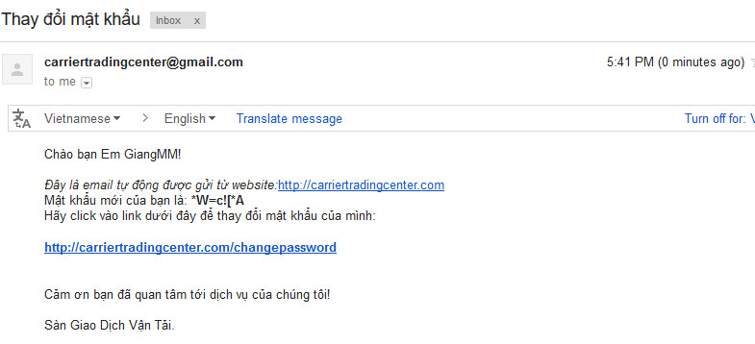

**Step 4:** Open the link <https://carriertradingcenter.com/CEX/faces/xhtml/Users/ResetPasswod.xhtml> and enter the information to change to new *Strong Password*

Pay attention to: “Mật khẩu cũ” already provided within your email.

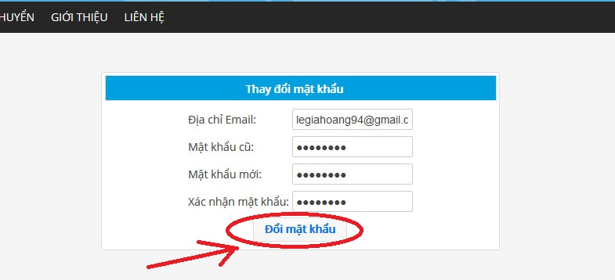

#### Report

##### View report list

Carrier can see a list of Report when going to “Báo cáo của tôi” page by click “BÁO CÁO CỦA TÔI” in the navigation bar.



##### Send report

**Step 1:** Go to page “Báo cáo của tôi” by click “BÁO CÁO CỦA TÔI” in navigation bar



**Step 2**: Click “Tạo báo cáo mới”



**Step 3:** Enter the information into the form, then click “Gửi báo cáo”

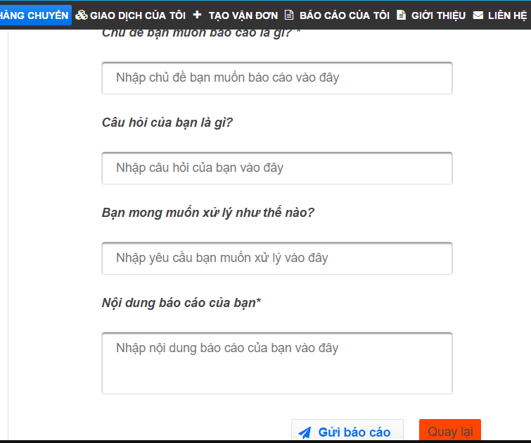

##### Search report

In the page “Báo cáo của tôi”, Carrier can search report by entering information as “Tiêu đề báo cáo” or “ngày và giờ”, then click “Tìm kiếm” to find report



#### Fee

##### Reference fee

To view fee list, Carrier click on “BÁO GIÁ” in navigation bar then click “THAM CHIẾU” as image below



##### View fee list

To view Reference fee, Carrier click on “BÁO GIÁ” in navigation bar then click “HỆ THỐNG” as image below



#### Transaction history

To view transaction history Carrier have to hover mouse Name of Carrier in Top Rightmost corner, then click “Thông tin giao dịch”

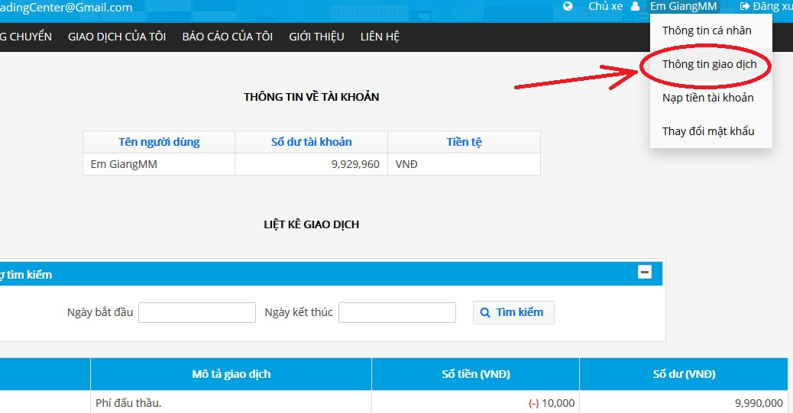

#### Connect to goods owner

By seeing bill of lading detail Carrier can see information about Goods Owner, so they can contact to Goods Owner by phone number:

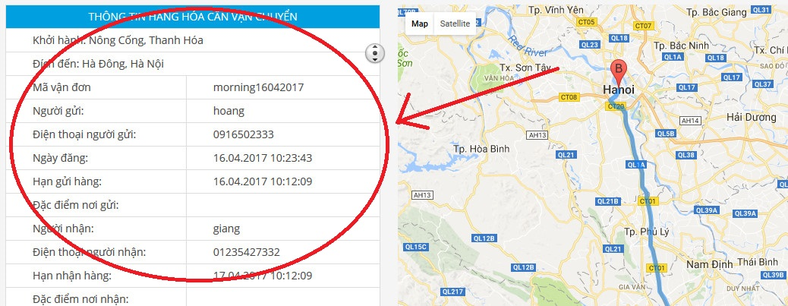

#### Login

**Step1**: Open home page with link <https://carriertradingcenter.com/CEX/faces/xhtml/Home.xhtml>  
**Step2**: Click “Đăng Nhập” at right most corner of screen  


**Step3:** Input your Carrier’s email and password then click “Đăng Nhập”.  
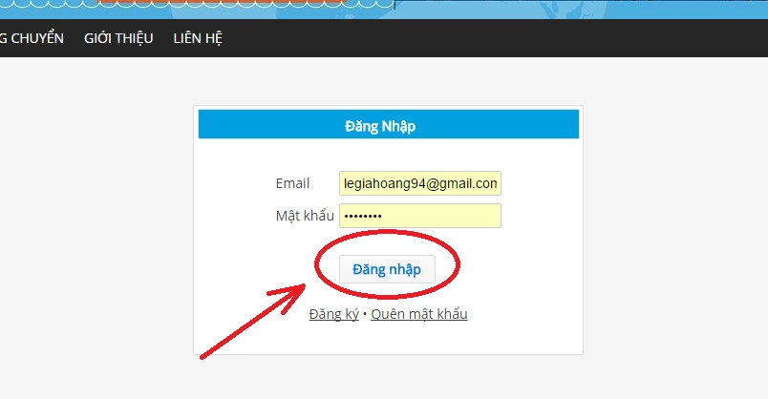

#### Logout

To log out, Carrier can click “Đăng Xuất” in Top Rightmost corner screen.

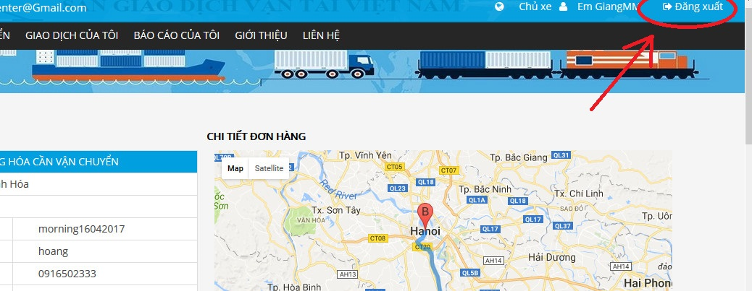

### Admin

#### Bill of lading list

##### View bill of lading list

Admin can quickly access bill of lading list whenever they are on any specific page of <https://carriertradingcenter.com/> by click “Tìm hàng chuyển” in Navigation Bar

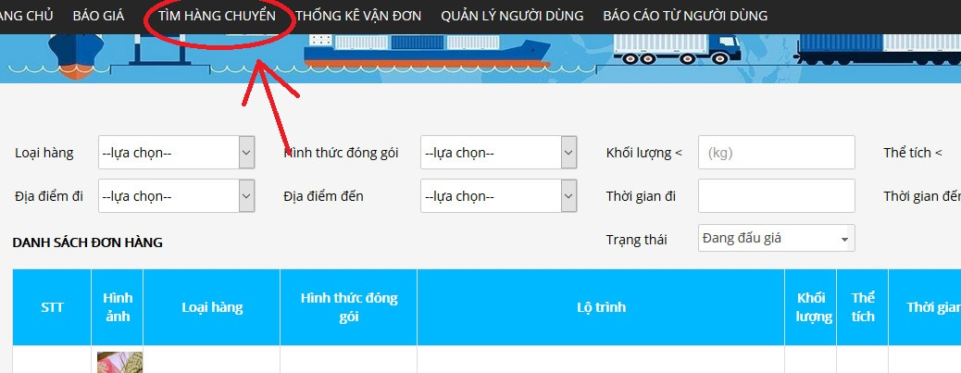

##### View bill of lading detail

In the bill of lading list screen Admin can only see just few information about the bill of lading, to get more information Admin can click on Image at rightmost of the item in the list to go to Bill of Lading Detail page.



Then browser will redirect to Bill Of Lading Detail page

##### Search bill of lading

If Admin want to find Bill of lading that created by other Admin in <https://carriertradingcenter.com/> they can search them by click “TÌM HÀNG CHUYỂN” in Navigation Bar



In the top of “TÌM HÀNG CHUYỂN” page, Admin can set filter condition and then click Search to find concise Bill of Lading that they want.

##### View carrier auction success

When the auction meets a deadline it can be a success or not.

Admin can see auction status by going to Bill of lading detail

**Step 1**: Go to “TÌM HÀNG CHUYỂN” page via Item’s in Navigation Bar

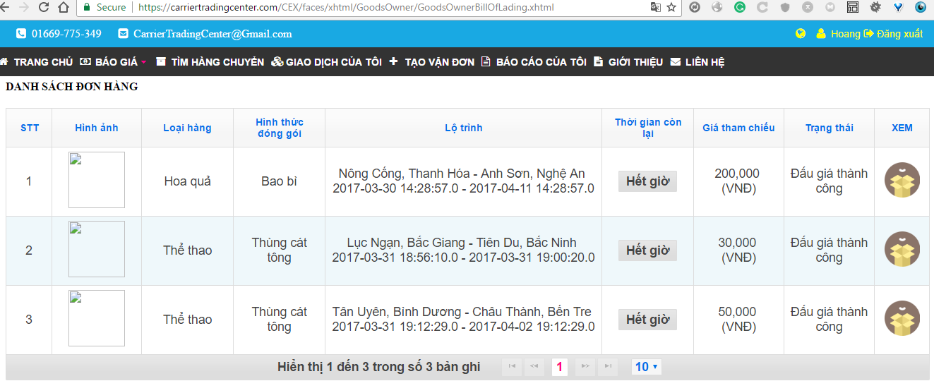

**Step 2:** Search bill of lading with condition “Đấu Thầu thành Công”, then click “Tìm kiếm” button

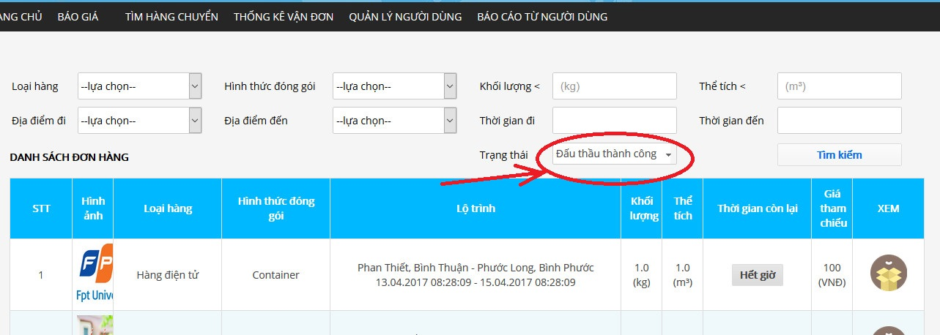

**Step 3**: Click on image under “XEM” column corresponding with each Auction to view detail

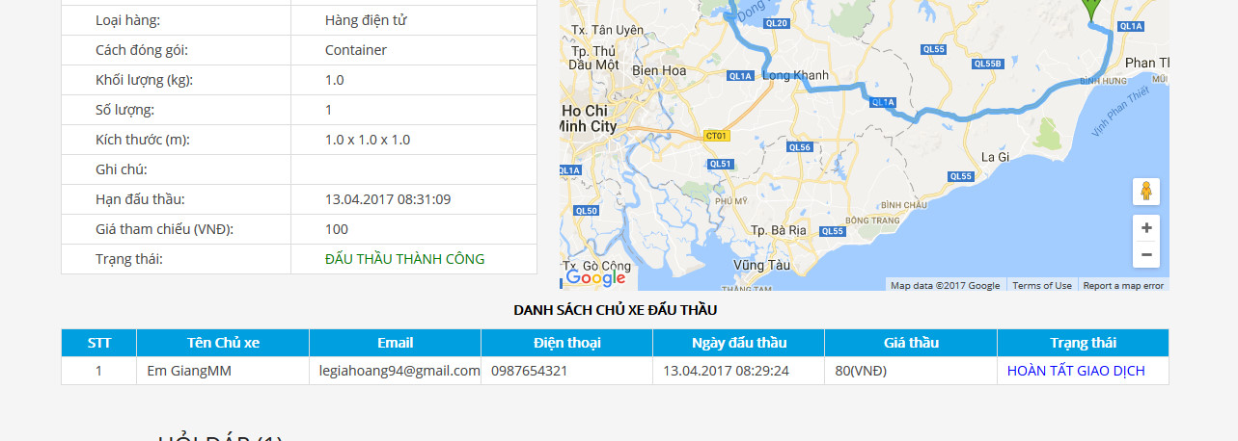

**Step 4:** In bottom of the page, Admin will see information about Carrier who auction success.

##### Summary all bill of lading

Admin can click “THỐNG KÊ VẬN ĐƠN” in the navigation bar to see summary all bill of lading as the image below:

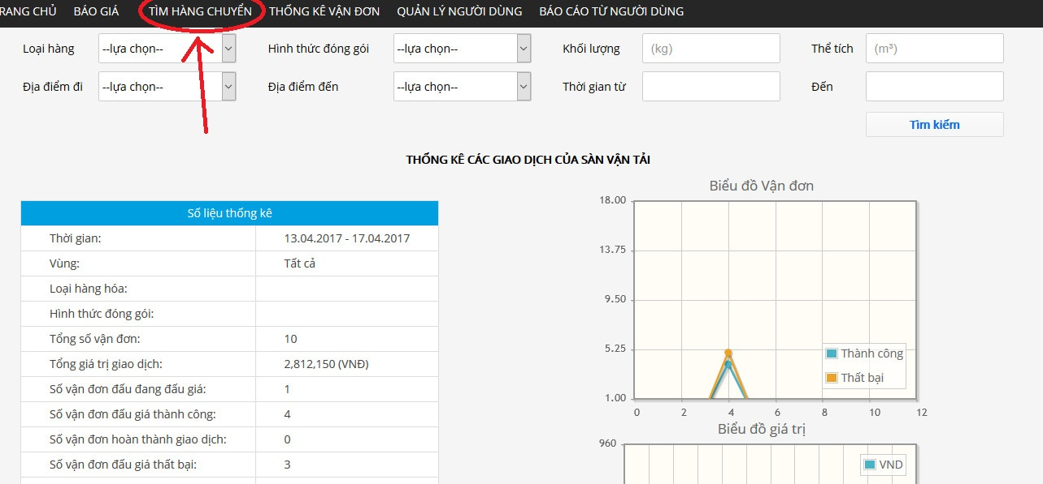

##### View list of Carrier who are auctioning

**Step 1:** Go to “TÌM HÀNG CHUYỂN” page by click “TÌM HÀNG CHUYỂN” in navigation bar



**Step 2:**

Click on Image at rightmost of item in the list to go to Bill Of Lading Detail page



Information about carrier will be show.

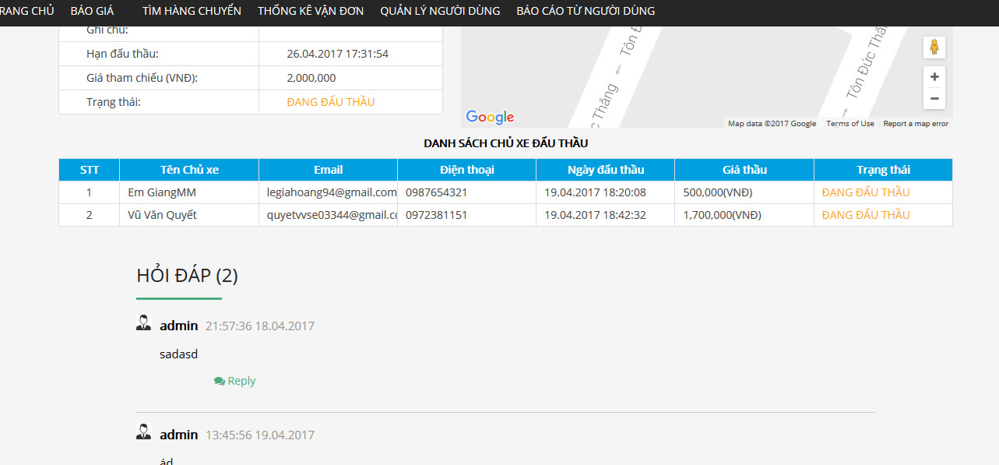

#### Manage user

##### View User list

By click “QUẢN LÍ NGƯỜI DÙNG” in navigation bar Admin can view user list at bottom of page.

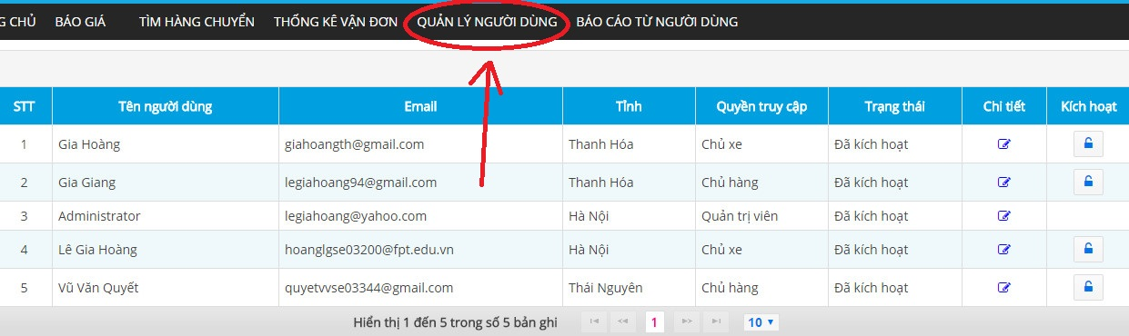

##### Search user

Step 1: Go to the “QUẢN LÍ NGƯỜI DÙNG” page by click “QUẢN LÍ NGƯỜI DÙNG” in the navigation bar.

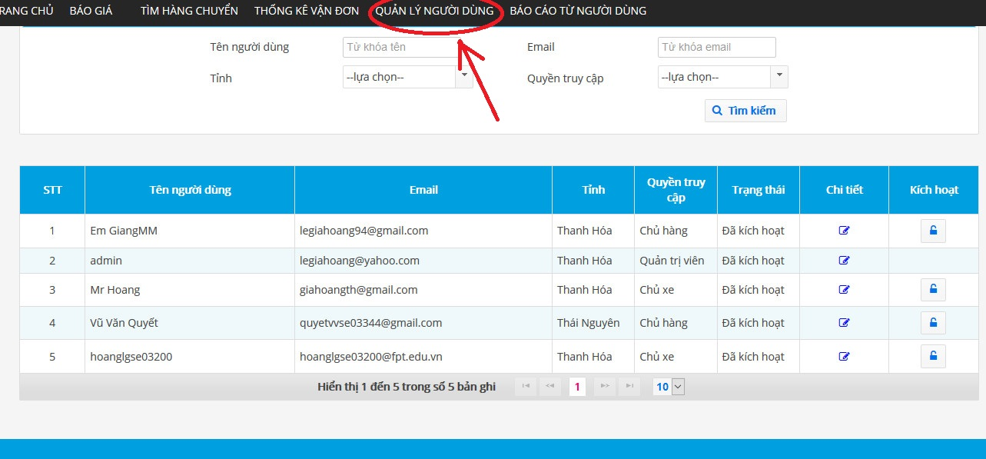

**Step 2**: Enter information into the form on the top of the page, then click “Tìm kiếm” to search user.

##### View user profile

**Step 1**: Go to the “QUẢN LÍ NGƯỜI DÙNG” page by click “QUẢN LÍ NGƯỜI DÙNG” in navigation bar.

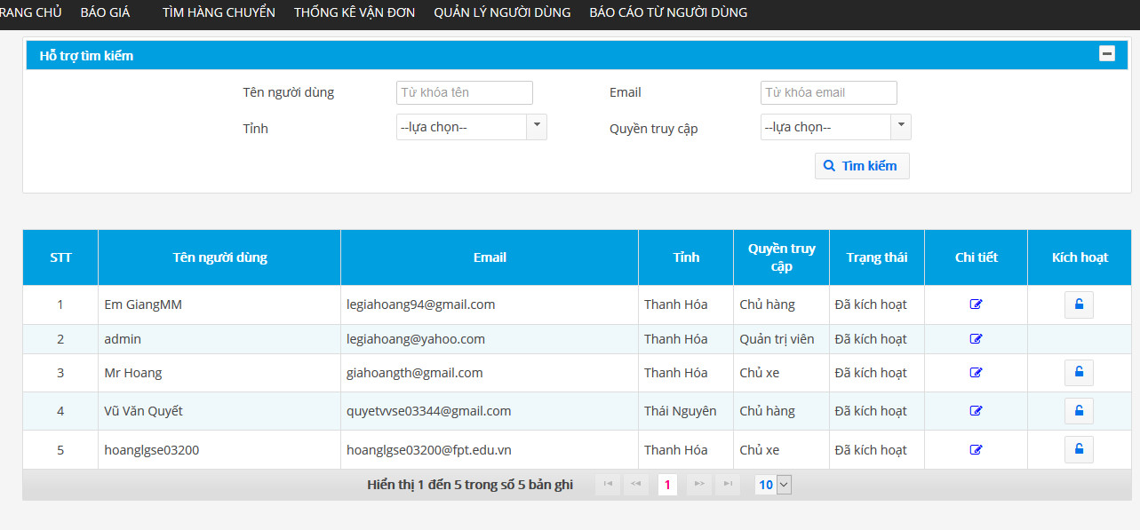

**Step 2:** Click edit icon under edit column corresponding to each row(user)

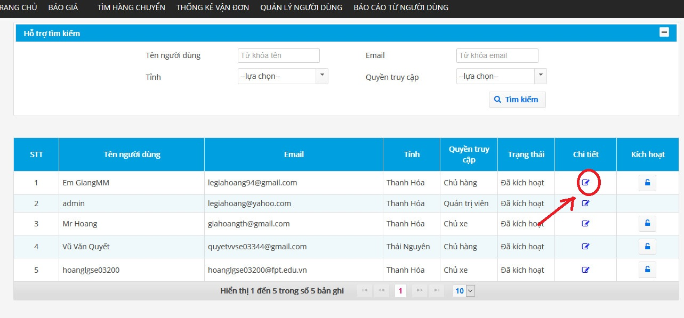

##### Add company

**Step 1:** In the User detail page, Admin can add company by click “Thêm thông tin công ty” at bottom of the page:

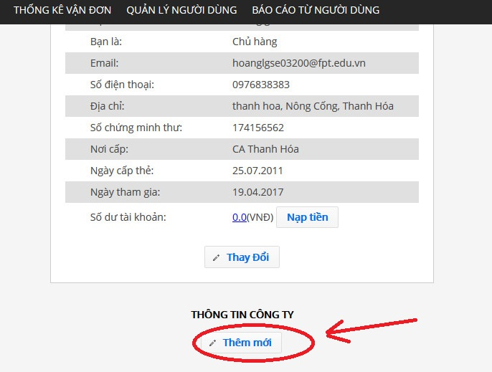

**Step2:** Enter information in new pop-up

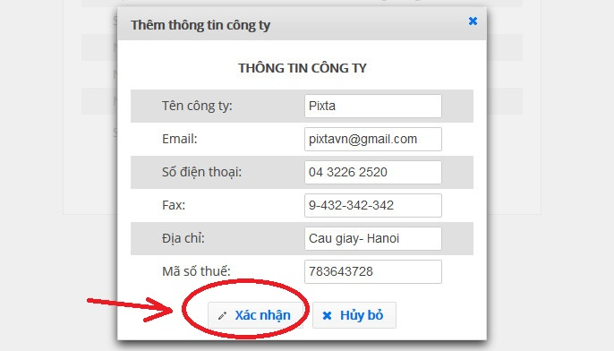

Then click “Lưu Thay Đổi” to save changes

##### Account recharge for User

**Step 1**: In the Goods owner or Carrier detail page, Admin can recharge by click “Nạp tiền”

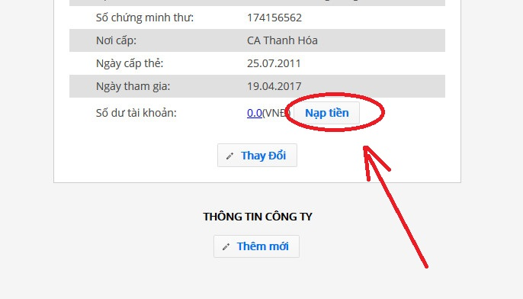

**Step 2:** Enter amount of money to new pop-up

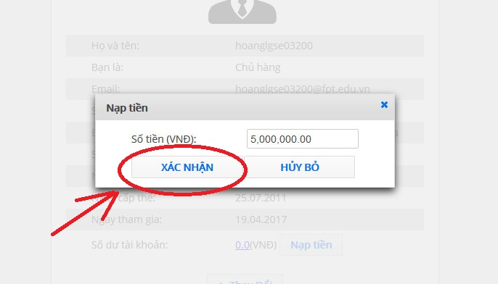

**Step 3:** then click “XÁC NHẬN” to finish.

##### Edit user profile

**Step 1:** Go to the “QUẢN LÍ NGƯỜI DÙNG” page by click “QUẢN LÍ NGƯỜI DÙNG” in the navigation bar.



**Step 2:** Click item edit icon under edit column corresponding with each row(user)



**Step 3:** Click “Thay Đổi” in bottom-left of new page.

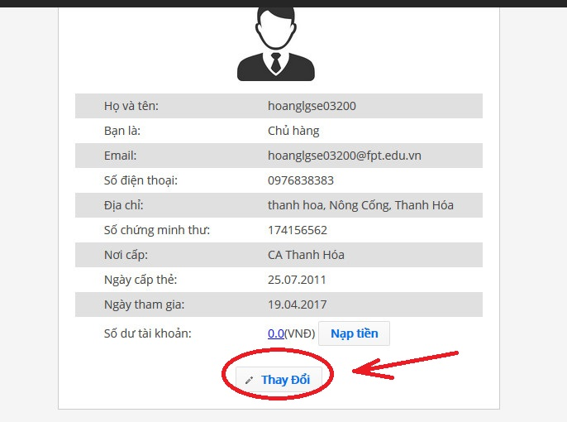

**Step 4:** Edit the information that you want to change and then click “Xác nhận”

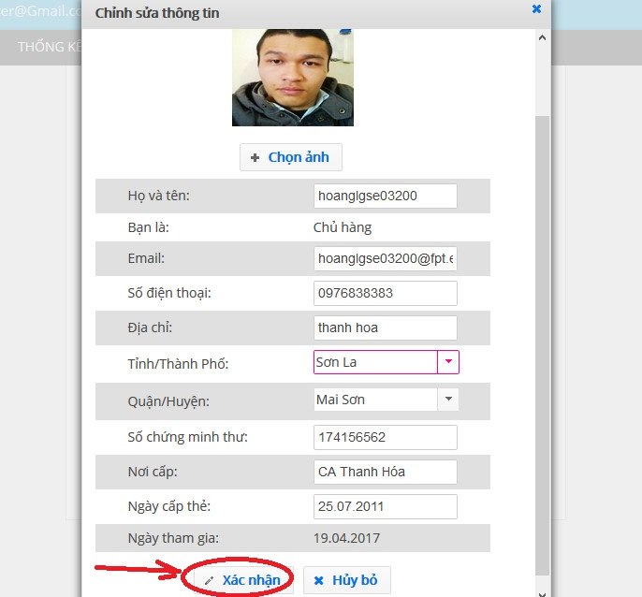

##### Edit company information

**Step 1**: Amin open “Quản lí người dùng” page by click “QUẢN LÍ NGƯỜI DÙNG” in navigation bar.

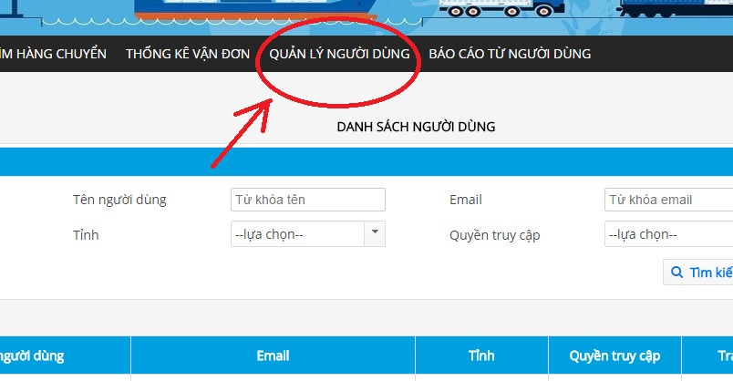

**Step 2:** Click edit icon in the end of row that corresponding with user account to view detail

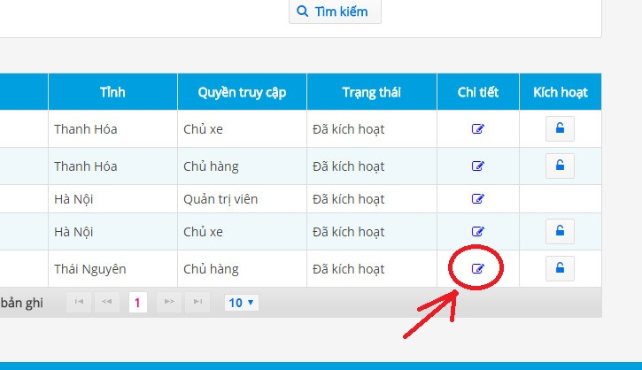

**Step 3:** Click “Thay đổi” button at bottom of new page

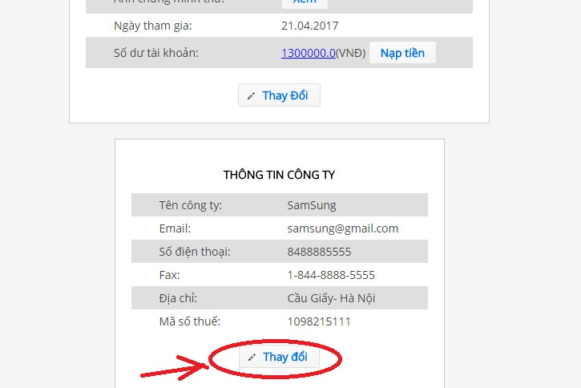

**Step 4:** Enter information that you want to change, then click “Xác nhận”

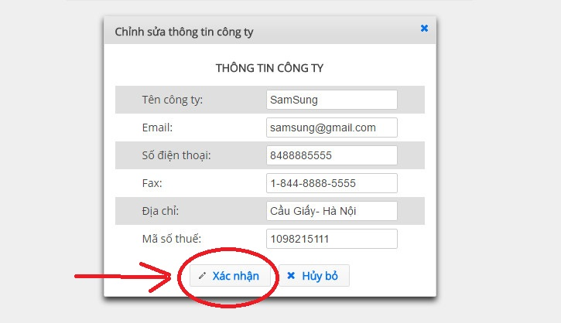

##### Active user

**Step 1:** Go to the “QUẢN LÍ NGƯỜI DÙNG” page by click “QUẢN LÍ NGƯỜI DÙNG” in the navigation bar.



**Step 2:** Click “lock” icon under “Kích hoạt” column corresponding with each row(user)

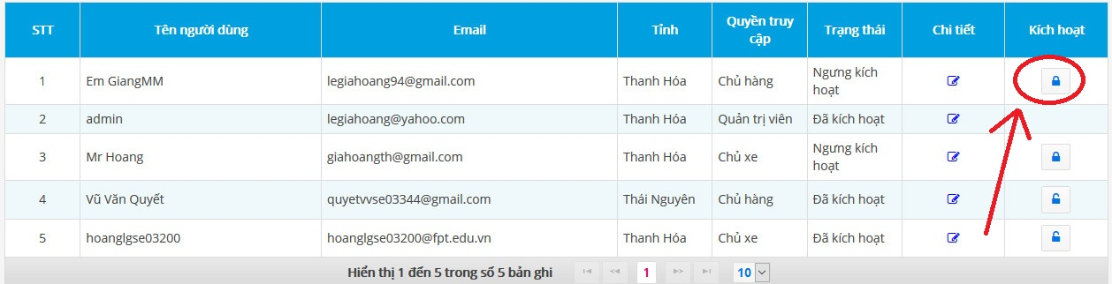

**Step 3:** click “OK” in new Pop-up.

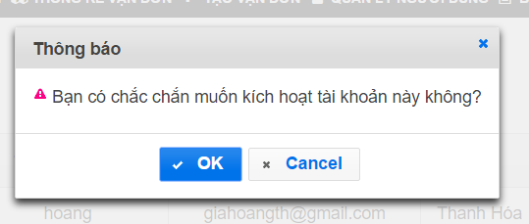

##### Deactivate user

**Step 1:** Go to the “QUẢN LÍ NGƯỜI DÙNG” page by click “QUẢN LÍ NGƯỜI DÙNG” in the navigation bar.



**Step 2:** Click “lock” icon under “Kích hoạt” column corresponding with each row(user)

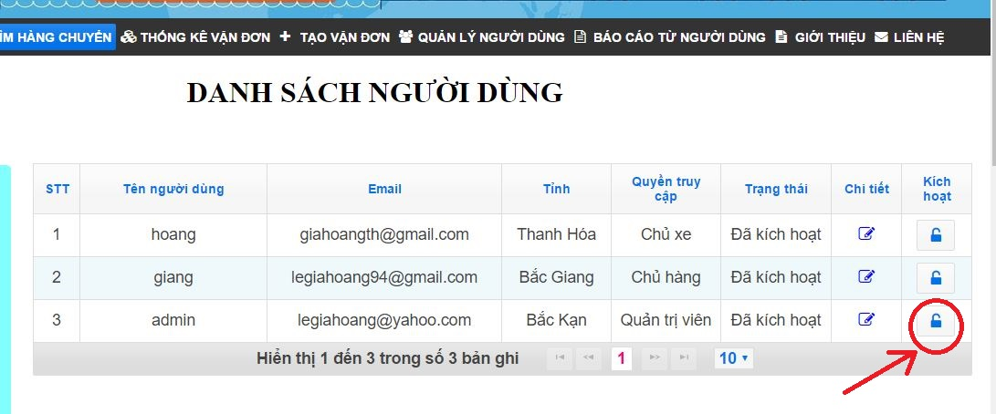

**Step 3:** click “OK” in new Pop-up.

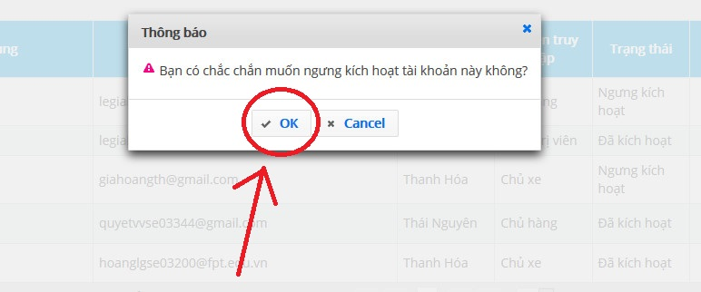

#### Fee list

##### View fee list

To view fee list, Admin click on “BÁO GIÁ” in navigation bar then click “HỆ THỐNG” as image below

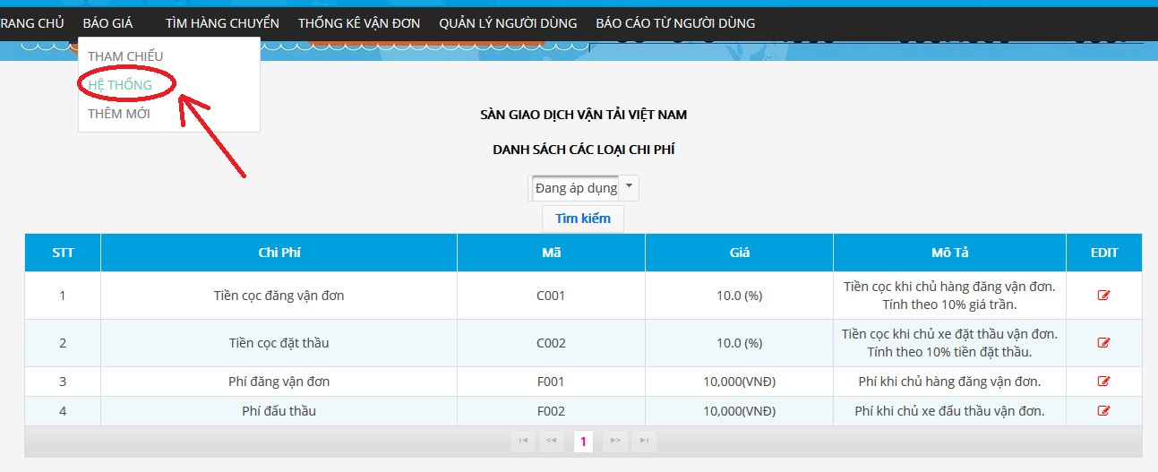

##### View fee table history

**Step 1:** Admin click on “BÁO GIÁ” in navigation bar, then click “HỆ THỐNG” as image below



**Step 2:** In bottom of new page, select drop-down list and choose “Lịch sử” to see fee table history

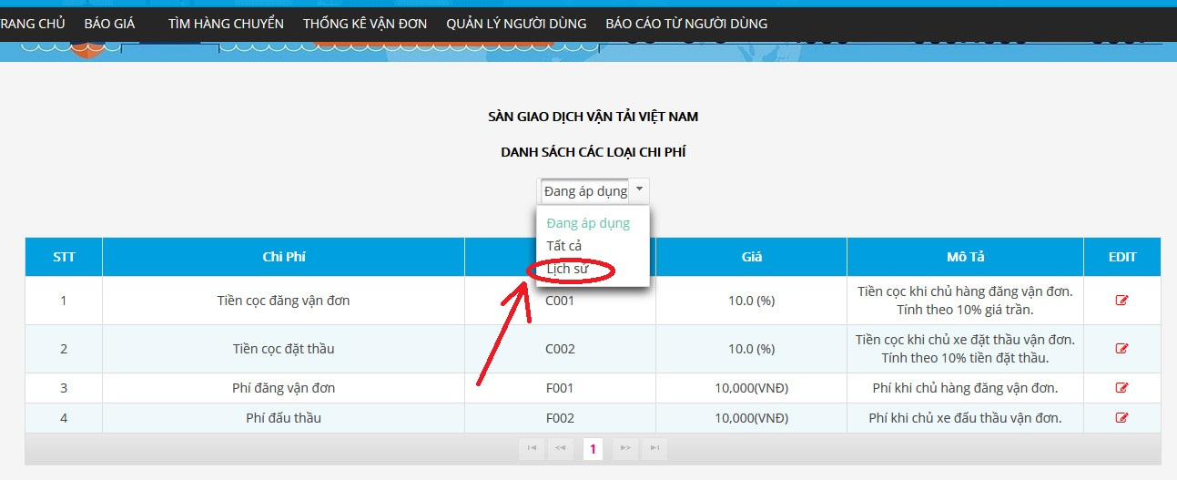

##### Add a new fee

**Step 1:** Admin click on “BÁO GIÁ” in navigation bar then click “THÊM MỚI” as image below

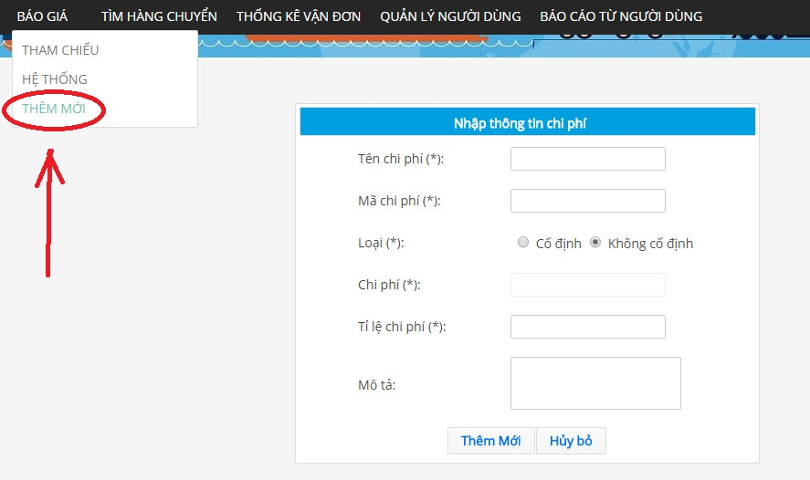

**Step 2**: Enter information into the form, then click “Thêm Mới”.

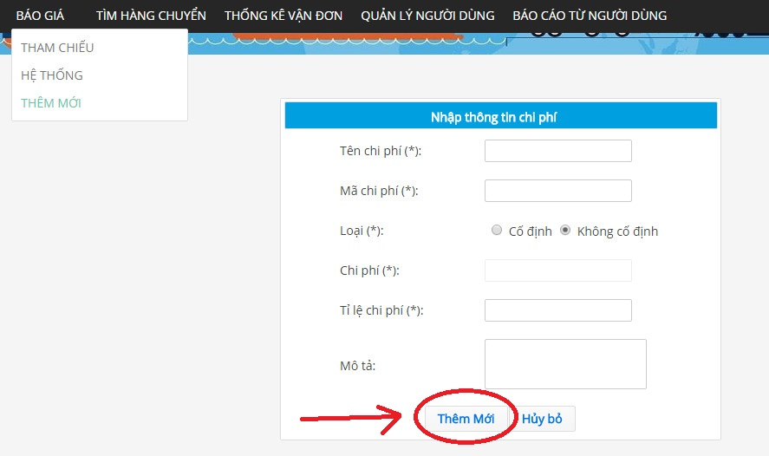

##### Edit reference fee

**Step 1:** Open reference fee screen by click on “BÁO GIÁ” in navigation bar then click “THAM CHIẾU” as image below

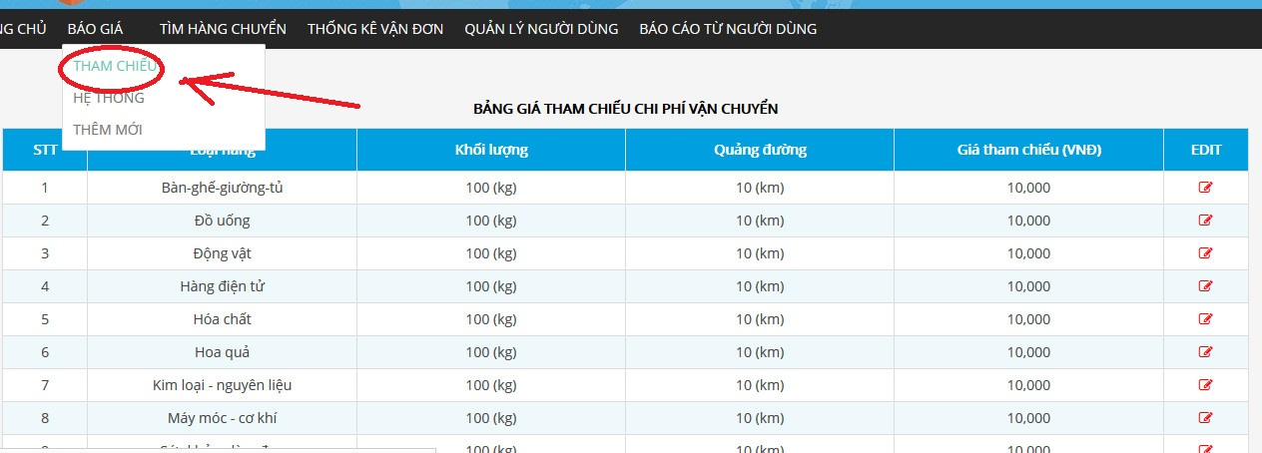

**Step** 2: Open detail reference free by click icon edit at the end of row that corresponding to each reference fee

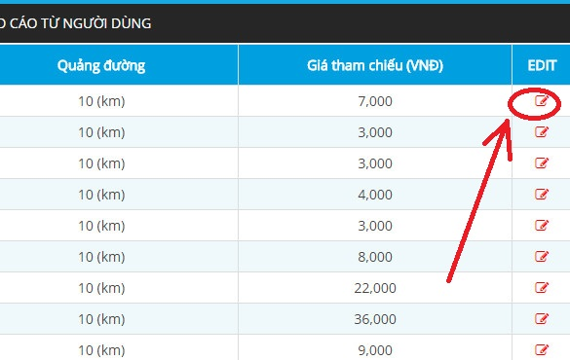

**Step 3:** Enter information that you want to change, then click “Xác nhận” to finish..

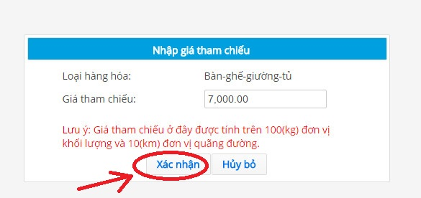

##### Edit fee list

**Step 1:** Admin click on “BÁO GIÁ” in navigation bar then click “HỆ THỐNG” as image below

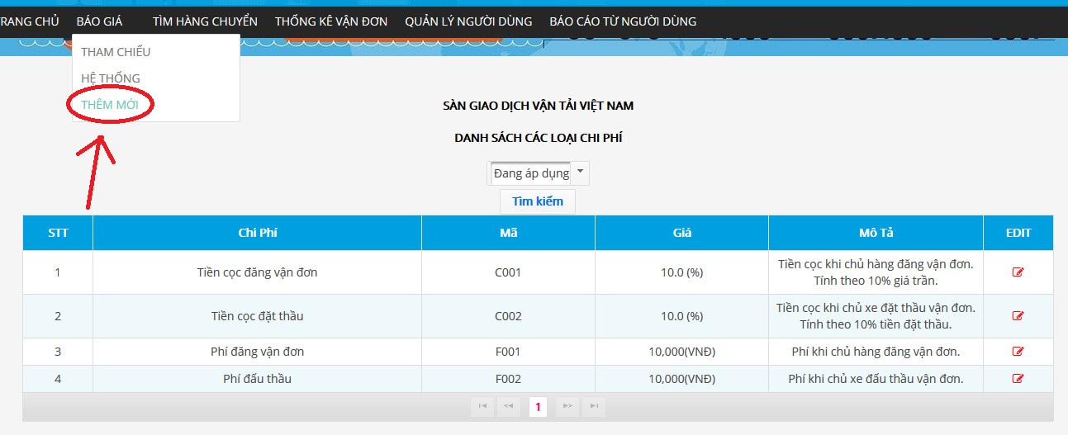

**Step 2:** Click “edit” icon under EDIT column corresponding with each user(row). Admin will be redirected to edit page

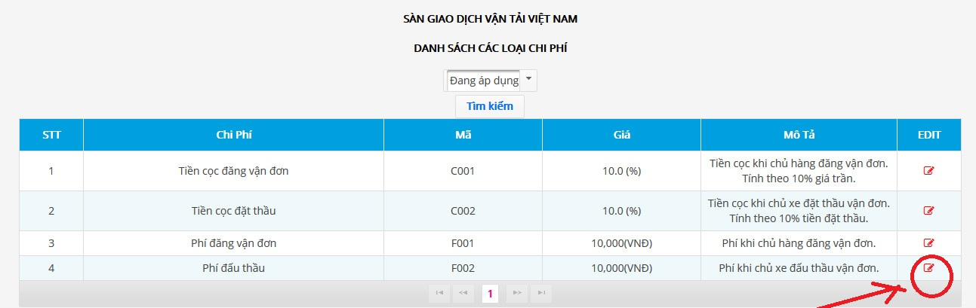

**Step 3:** Enter information, then click “Xác nhận” to save changes.

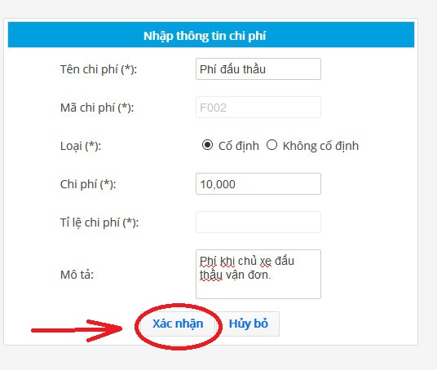

##### View reference fee

To view Reference fee, Admin click on “BÁO GIÁ” in navigation bar then click “THAM CHIẾU” as image below



#### Transaction history

To view transaction history Admin have to hover mouse Name of Admin in Top Rightmost corner, then click “Thông tin giao dịch”

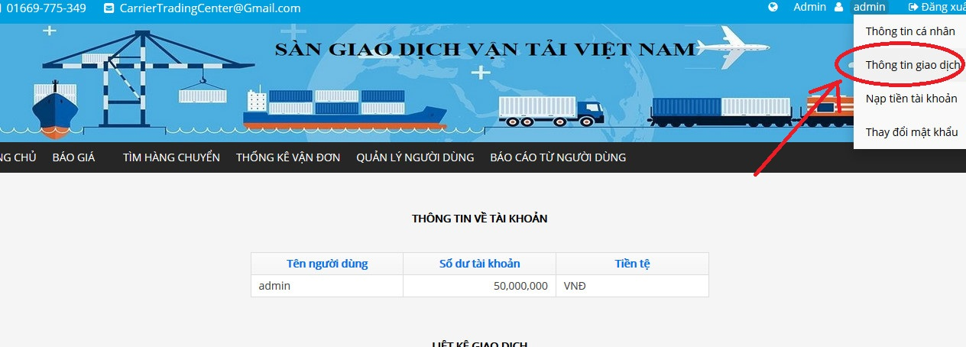

#### Manage report

##### View report list

Admin can see a list of reports by going to “BÁO CÁO TỪ NGƯỜI DÙNG” page by click “BÁO CÁO TỪ NGƯỜI DÙNG” in the navigation bar.

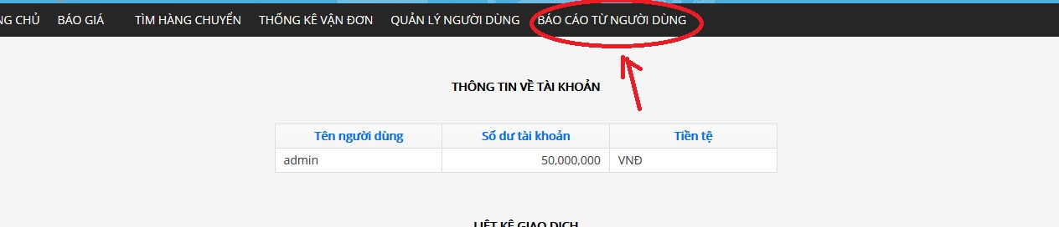

##### Search report

**Step 1:** Go to to “BÁO CÁO TỪ NGƯỜI DÙNG” page by click “BÁO CÁO TỪ NGƯỜI DÙNG” in the navigation bar.



**Step 2:** Enter filter value into form at top-center of page, then click “Tìm kiếm”

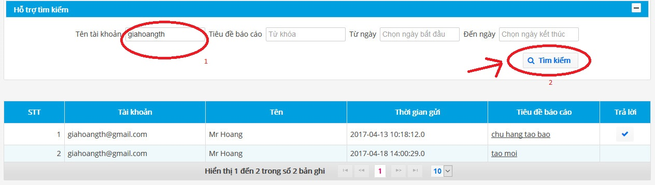

##### Response report

**Step 1:** Go to to “BÁO CÁO TỪ NGƯỜI DÙNG” page by click “BÁO CÁO TỪ NGƯỜI DÙNG” in the navigation bar.



**Step 2:** Click underline text under column “Tiêu đề báo cáo” corresponding with each Report to open Detail Report page

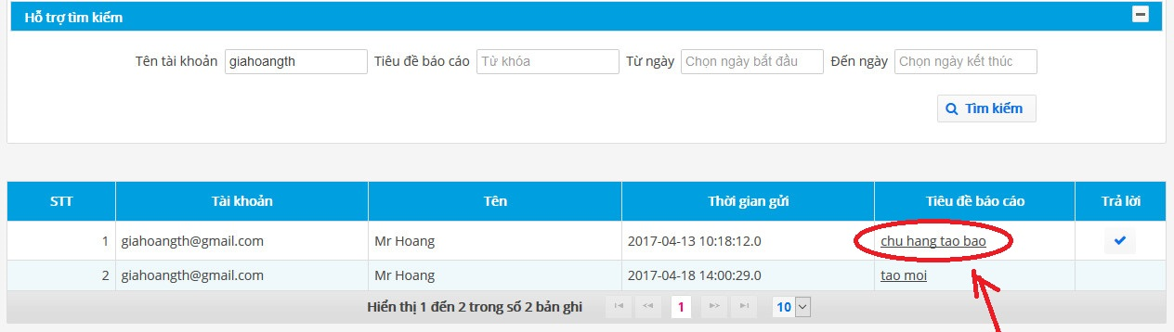

**Step 3:** Enter information into text are besides “Nội dung” title, then click “Phản hồi”

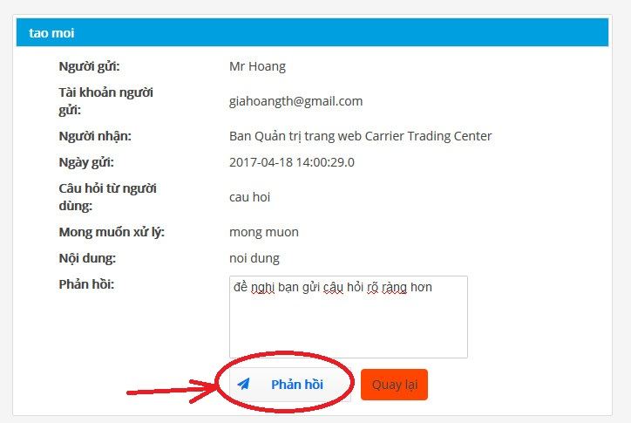

#### Manage profile

##### View profile

To view profile, Admin hover mouse over Admin name in top-right corner and click “Thông tin cá nhân”, after that Carrier will be redirected to page with title “Thông tin người dùng”

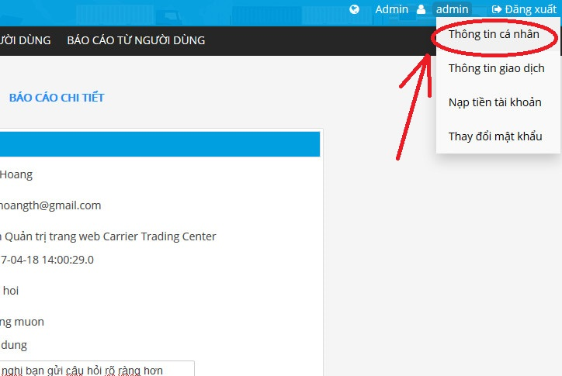

##### Edit profile

**Step 1:** View Profile as 2.4.6.1

**Step 2:** Click “Thay Đổi” in a new page as the image below:

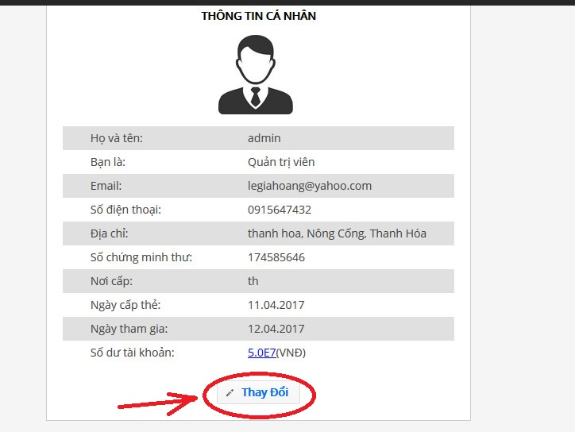

**Step 3**: Enter information in new pop-up appear, the click “Lưu Thay Đổi”

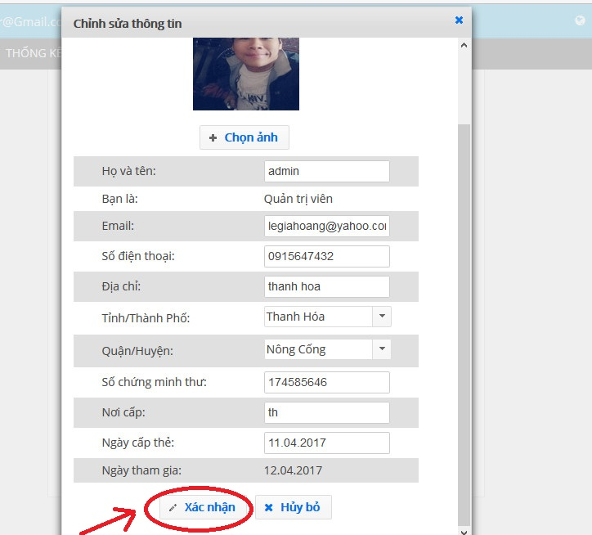

##### Forget password

**Step 1:** To be able to reset your Password, go to the “Đăng nhập” page and click “Quên mật khẩu” under the Login form



**Step 2:** Enter your email address, then click “Gửi”



**Step 3:** Open your mailbox to get temporary password

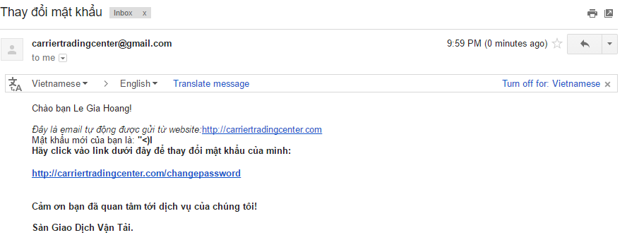

**Step 4:** Open the link <https://carriertradingcenter.com/CEX/faces/xhtml/Users/ResetPasswod.xhtml> and enter the information to change to new *Strong Password*

Pay attention to: “Mật khẩu cũ” already provided within your email.



##### Change password

A Strong Password is defined as a password that is reasonably difficult to guess in a short period of time either through human guessing or the use of specialized software.

A Strong password should:

* Be at least 6 characters in length
* Contain both upper and lowercase alphabetic characters (e.g.A-Z,a-z)
* Have at least one numerical character (e.g. 0-9)
* Have at least one special character (e.g. ~!@#$%^&*()_-+=)

To change any user’s password you must specify a *Strong* *Password*

**Step 1:** Hover mouse over Admin name in the top-right corner and select “Thay đổi mật khẩu” to go to “Thay đổi mật khẩu” page.

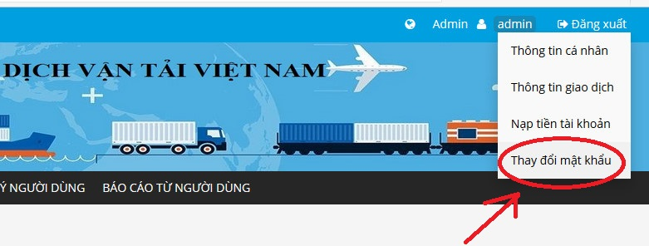

**Step 2:** Input your old password and a new *Strong Password*

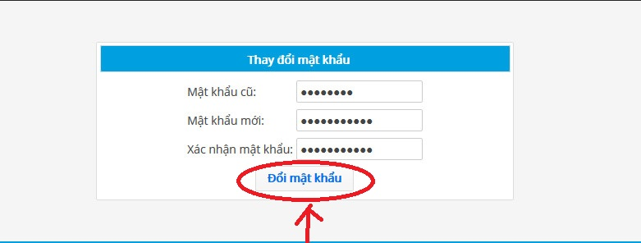

**Step 3:** Click “Đổi mật khâủ” to save the new *Strong Password*

#### Login

**Step1**: Open home page with link <https://carriertradingcenter.com/CEX/faces/xhtml/Home.xhtml>  
**Step2**: Click “Đăng Nhập” at top right most corner of screen  


**Step3:** Input your Admin’s email and password then click “Đăng Nhập”

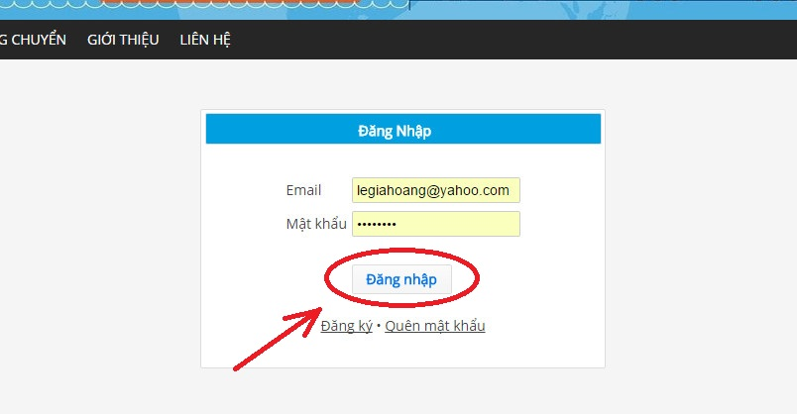

#### Logout

To log out, Carrier has to click “Đăng Xuất” at top right corner screen.



## Project result report

### Product Judging

#### Advantage of CTC system

* As a Trading Center Online: Carrier Trading Center does not simply allow Goods Owner to ship goods and connect with Carrier. CTC is a form of the online auction website. Each user will be granted a trading account, users can recharge through the payment gateway, or recharge directly with the system
* **Safety**: Users will be bound to participate when user join the auction. When posting or bidding for a bill of lading, the user will pay a posting fee with a deposit to secure. If a user cancels a bid, he or she will be subject to a penalty, which may result in a loss of the deposit. When the user confirms completion of the transaction, the full deposit will be refunded.
* **Fairness**: Car owners and owners can only connect when successful order matching. This means that after successfully bidding (with the lowest fee and the earliest time), it is possible to connect with the Goods owner. The system only has a detention function that does not involve the bidding process.
* **Reference Fee**: The CTC system will list a bill of lading by type of goods, and will provide the closest reference fee to the fee on the CTC. Help Carrier, as well as Goods Owner, get a reasonable fee to consult with their transactions. The CTC system will automatically update reference fees after fixed amount of time.

#### Current Limitations

* Doesn’t support mobile version for people using mobile yet.
* Guest cannot have a live chat with supporter of CTC
* Language used is only Vietnamese

#### Expectation in the future

* Develop more functionalities for Carrier, Goods Owner, Admin.
* Provide CTC version in mobile
* Develop live chat functionality between user with supporter of CTC
* Develop functionality allow users to be able to change between English and Vietnamese.

### Project Summary

|  |  |  |  |
| --- | --- | --- | --- |
| **Project title** | | CTC | |
| **Project advisor** | | Mr Nguyen Van Sang | |
| **committers: 5** | | | |
| 1 | Project manager | Lê Văn Dương | [duonglvse03290@fpt.edu.vn](mailto:duonglvse03290@fpt.edu.vn) |
| 2 | Technical Leader, Developer | Vũ Văn Quyết | quyetvvse03344@fpt.edu.vn |
| 3 | Designer, Tester, Developer | Đặng Lê Tuấn | tuandlse03807@fpt.edu.vn |
| 4 | Tester Leader, QA | Trịnh Đình Quyết | quyettdse03159@fpt.edu.vn |
| 5 | Developer | Lê Gia Hoàng | hoanglgse03200@fpt.edu.vn |
| **Main objective** | | Create a web application that connect Goods Owner and Carrier with to minimize transportation costs. | |
| **Purpose** | | Create a new system in circumstance there is no similar system exists. | |
| **Items** | | **Plan** | **Actual** |
| Release date | | 05 May 2017 | 05 May 2017 |
| Release version | | 1.0 | 1.0 |
| Days | | 105 | 105 |
| Weeks | | 16 | 16 |
| Months | | 4 | 4 |
| Test cases + checklists | |  | 2919 |
| Documentation pages | |  | 462 |
| Lines of code | |  | Approximately 22809 |

Table 6.3.1: CTC project summary

### Lessons Learnt

#### Technical skill

* Programming languages: Java, Javascript
* Knowing how to deploy website on Amazon Web Service with setting up domain, SSL
* Learned how to write software documentations and used tools as Astah, Microsoft Project, Word, Excel, Redmine more efficiently
* Gain knowledge using Version control systems: Git, SVN
* Understand software architecture, software testing

#### Project management skill

* **Scheduling:** We have to create a plan for weekly to ensure the project will reach it’s goal at fixed time. All member always have tasks to finish.
* **Time management:** Typically working in specific task took longer time than we supposed. Because of that, we set priority to each task and these tasks with height priority will finish first.
* **Task management:** Task will be assigned via Gmail to each one depend on each team member characteristic and preferences.
* **Meetings management:** Via Gmail, Messenger all member of the team will know meeting time, address. Therefore, we go to meeting with preparation. In meetings, we always note the information that seems difficult to memorable.

#### Soft skill

* **Critical thinking:** To take the best solution or choices, we consider in a thoughtful way the problems and subjects that come with a range of one’s experiences and then we choose the best solutions among all one’s idea.
* **Decision making:** Decision making is hard. We have to take a decision in a lot of question that rising while doing the project like who doing this task, why website display something like this, instead of like that…blah.
* **Problems solving:** We using search from google a lot, reading StackOverflow answer, discussion with other’s team member to find a solution to each specific problem.
* **Motivating:** Each one have to do different task, somethings it’s quite hard to finish at the right time, and we always motivate other go get through difficult situation.
* **Communicating:** We communicate a lot via daily meeting, messenger.
* **Managing expectations:** We want to make a lot of future in this capstone, but time is limited. There fore we have to keep balance between our expectation and the time we actually have.